CDS Training Exercise Manual
Release edition 18 September 2026
This manual collects the CDS learning pages and all 94 published exercise setups. Each exercise identifies its task, connected models, data transfers, checkpoints and limitations. Work through the setup before changing inputs, and use the stated reference or validation scope to decide what the result demonstrates. Numerical teaching data should not be substituted for qualified design allowables.

How to use this manual
Read the assumptions before choosing a model. Keep units consistent, inspect solver notices and use the recorded checks to distinguish a completed calculation from a validated result. Chapter links lead to the interactive website; exercise links open the Workbench. Account-controlled database downloads and classroom materials remain subject to their existing access rules.
Equations are editable Word mathematics. This PDF is exported from the same Word document. Historical reference chapters retain their stated scope; the current workflow and exercise chapters describe the available CDS implementation.

Contents
1 Work through published composite cases.
2 Predict T700/PR520 effective lamina properties.
3 Design a balanced T700/epoxy tube laminate.
4 Resolve a thick-panel cure cycle and exotherm.
5 Screen a pressurized AS4/3501-6 cylinder.
6 Published cases. Solver-visible results.
7 Analyses . Solver-visible results.
8 Laminates . Solver-visible results.
9 Micromechanics . Solver-visible results.
10 Open. Inspect. Run and adapt.
11 CDS Training Manual learn by completing a study.
12 Rule of mixtures: fibre volume fraction
13 Compare transverse micromechanics models
14 Short fibers: aspect ratio and shear-lag transfer
15 01 · Rule of mixtures · continuous fibers
16 FSDT plate bending: thin-to-thick comparison
17 Micro optimization: stiffness, voids and density
18 02 · Halpin–Tsai · transverse stiffness
19 FSDT cross-ply plate: buckling and natural frequencies
20 Laminate optimization: minimum mass under axial loading
21 03 · Short fibers · shear-lag transfer
22 FSDT soft-core plate: shear-dominated bending
23 Process optimization: cycle time and thermal uniformity
24 04 · Hybrid fibers · orientation distribution
25 Sandwich FSDT: clamped panel bending
26 NASA · T700/PR520 lamina analysis
27 T700S / 180C Epoxy UD · stored-ply elasticity
28 IM7 / Toughened Epoxy UD · stored-ply elasticity
29 T800S / BMI UD · stored-ply elasticity
30 AS4 / PEEK UD · stored-ply elasticity
31 T300 / EPON 862 Epoxy UD Prepreg · stored-ply elasticity
32 T800S / 977-3-Type Epoxy UD Prepreg · stored-ply elasticity
33 AS4 / LY 1564-Type Epoxy UD Prepreg · stored-ply elasticity
34 T300 / Phenolic Plain Weave · stored-ply elasticity
35 Laminate orientation and tensile response
36 ±45° coupon: in-plane shear
37 Three-point bending: span and stiffness
38 Thin-wall pressure vessel
39 05 · Tensile coupon · laminate orientation
40 Sandwich FSDT: biaxial compression buckling
41 06 · ±45° laminate · in-plane shear
42 Sandwich FSDT: directional-core natural frequencies
43 07 · Stored lamina material · bypass Micro
44 08 · Mixed stored/solved plies · unequal thickness
45 09 · Three-point bend · deflection
46 10 · Cylinder · internal pressure
47 11 · Lap joint · two adherends and adhesive
48 12 · Sandwich bend · skins, core and bond screening
49 Hybrid short fibers: orientation and volume balance
50 T700/Epoxy Quasi-Isotropic · stored-data layup
51 IM7/Toughened Epoxy Bending-Optimized · stored-data layup
52 T800/BMI Balanced Cylinder · stored-data layup
53 AS4/PEEK Quasi-Isotropic · stored-data layup
54 T800/BMI Hoop-Dominant Cylinder · stored-data layup
55 T700/Epoxy Cross-Ply · stored-data layup
56 T700/Epoxy Balanced Angle-Ply · stored-data layup
57 IM7/Toughened Epoxy Unidirectional · stored-data layup
58 AS4/PEEK Cross-Ply · stored-data layup
59 T300/Phenolic Woven Symmetric · stored-data layup
60 T300/EPON 862 Quasi-Isotropic · stored-data layup
61 T800/977-3 Quasi-Isotropic · stored-data layup
62 AS4/LY 1564 Quasi-Isotropic · stored-data layup
63 IM7/8552-Type Quasi-Isotropic · stored-data layup
64 Quasi-Isotropic Plate in Uniaxial Tension · resultant response
65 Cross-Ply Plate under Pure Bending · resultant response
66 Angle-Ply Plate under Biaxial Load and Shear · resultant response
67 NASA · Balanced T700/epoxy tube laminate
68 Thermal cycle: surface-to-core lag
69 Pultrusion: heated die and residence time
70 Pultrusion: multi-zone die and pulling speed
71 UV cure: exposure, penetration and exotherm
72 Moisture conditioning and diffusion
73 Bonded joint: two adherends and adhesive
74 NASA · AS4/3501-6 pressure-cylinder screening
75 NASA · Thick T700S/TC380 cure process
76 Coupled cure, thermal, moisture and structural response
77 13 · Thermal cycle · surface/core lag
78 14 · Moisture conditioning · diffusion
79 15 · Pultrusion · multi-zone die
80 16 · UV cure · penetration and exotherm
81 17 · Moisture expansion + structural load
82 18 · Mixed Micro recipes · cure + structural response
83 19 · Cure + thermal + moisture + structural
84 20 · Coupled ply damage + delamination growth
85 D6641 · Compression coupon
86 D5379 / D7078 · Shear coupon
87 D5528 · DCB opening
88 D7905 · ENF sliding
89 D6671 · Mixed-mode fracture envelope
90 D5229 · Moisture uptake calibration
91 D5961 · Bearing / bypass screening
92 D6484 · Open-hole compression
93 D6742 · Filled-hole comparison
94 D7136 / D7137 · Impact & CAI assessment
95 Wiener series and parallel
96 Looyenga / Landau–Lifshitz–Looyenga
97 Maxwell–Garnett
98 Normal-incidence laminate TMM
99 Bruggeman symmetric EMT
100 EM Mori–Tanaka
101 EM self-consistent
102 Differential effective medium
103 Coated sphere and interphase
104 Generalized multiphase EMT
105 Oblique polarized laminate TMM
106 1D transmission line matrix
107 1D Floquet–Bloch periodic layers
108 Open-hole strength
109 Creep & stress relaxation
110 Analytical bonded joint
111 LaRC04 failure initiation
112 Tool-release shape
113 Fatigue residual properties
114 Cylinder buckling
115 Uncertainty & sensitivity

1 Work through published composite cases
Online chapter
Each study starts with a real public engineering example, shows exactly what to build in CDS, defines review checkpoints, and distinguishes a learning comparison from a qualified design value.
Current Workbench, reference editions and downloads
Use the online User Guide for current controls, the released model directory for selectable models and compatibility, and the Training Manual for connected exercises. Wider theory references do not mean every formulation is enabled in Workbench.
Dated GUI captures and compiled Web r18 PDF manuals retain their stated scope; they are not a substitute for current hosted Workbench instructions. Find the overview PDF, guides and exercise databases in Your CDS library .

Exercise curriculum
Shared CDS database
CREATE Design a starting point
DISCOVER Explore the live laminate
SIMULATE Launch Workbench
Search exercises
Application
Model
Geometry
Resource type
Group / sort by
4 of 4 resources
Exercises
Click to preview · double-click or Enter to open in Workbench.
Two-row simulation workflow · Open full-size map
Linked-input preview, not solved results. Gray blocks are not configured.
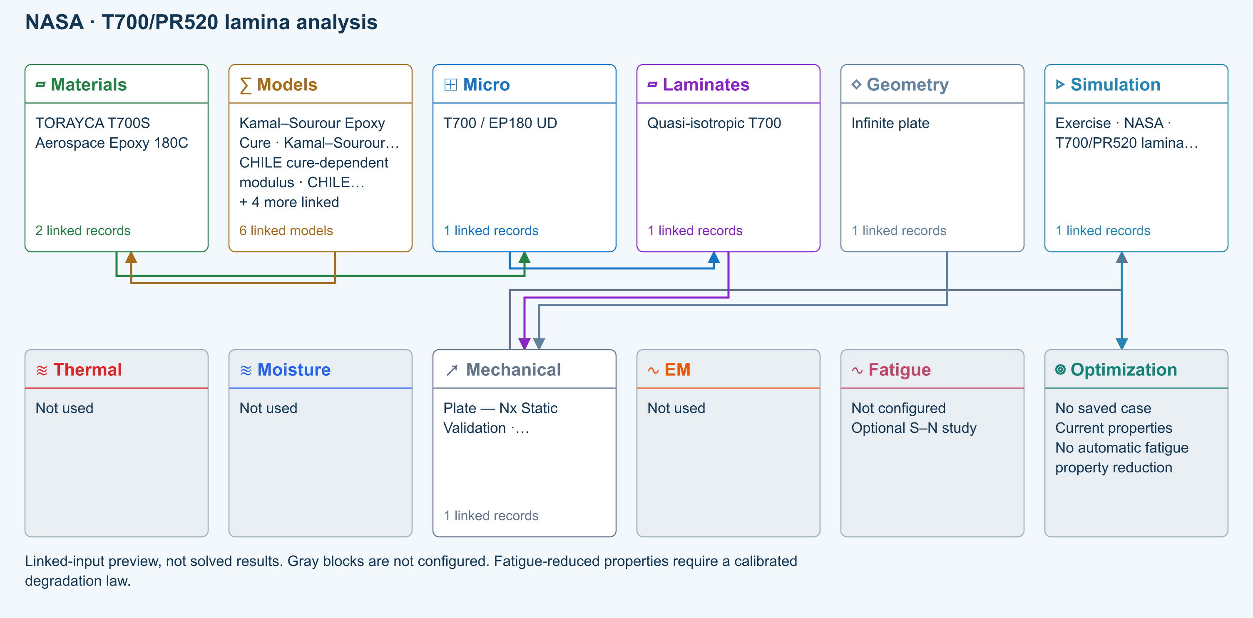
∑ Selected models & submodels
These are the exercise’s linked choices, not solved results. Open a first-layer model to see its submodels and scope.
Kamal–Sourour autocatalytic · Kamal–Sourour Epoxy Cure
Reusable material model. It contributes only when assigned to a material used by this simulation; separate model records can supply independent properties.
Calibration & applicability
Illustrative model defaults — replace with characterized resin kinetics
∑ Theory & assumptions
CHILE (degree of cure) · CHILE cure-dependent modulus
Reusable material model. It contributes only when assigned to a material used by this simulation; separate model records can supply independent properties. Cure-dependent modulus does not automatically scale strength allowables.
Calibration & applicability
CHILE(α), section 2.4 of Materials 2019, 12, 259. Example parameters, not measured EP180 data. Fixed Poisson ratio; no viscoelastic relaxation or Tg softening. Incremental elastic stress integration at saved process intervals: check time-step convergence. Strength allowables are independent measured inputs, not scaled with modulus.
∑ Theory & assumptions
Temperature-dependent tabular · Temperature-dependent Thermal
Reusable material model. It contributes only when assigned to a material used by this simulation; separate model records can supply independent properties. Micro uses the 23 °C reference; Process evaluates the same table at local temperature, without extrapolation.
Calibration & applicability
Check source data, applicable environment and validity limits in the model record; saved defaults are not experimental validation.
∑ Theory & assumptions
1D Fickian diffusion · Layered Fickian Diffusion
Reusable material model. It contributes only when assigned to a material used by this simulation; separate model records can supply independent properties.
Calibration & applicability
Check source data, applicable environment and validity limits in the model record; saved defaults are not experimental validation.
∑ Theory & assumptions
Halpin–Tsai · T700 / EP180 UD
One compatible homogenization model per Micro recipe. Separate recipes compare models; their predictions are not blended.
∑ Theory & assumptions
CLT · Linear static with failure indices · Plate — Nx Static Validation · Unidirectional lamina
Shared laminate stiffness drives this membrane/CLT path. Failure criteria are independent comparisons, not blended models. Fatigue is a separate assessment.
Failure criterion · Maximum stress
Primary criterion. Additional envelope comparisons are chosen in Response → Failure; they run independently.
∑ Theory & assumptions
Data travelling between blocks
Micro → Laminates
Predicted ply stiffness, strength, density and expansion properties.
Materials → Micro
Constituent stiffness, strength, density and thermal / moisture properties.
Models → Materials
Model choices and calibrated parameters.
Mechanical → Simulation
SIMULATION selects this case and its analysis model; the case owns its applicable cycle and input references.
Laminates → Mechanical
Ply angles and thicknesses, stiffness, mass and ply properties.
Geometry → Mechanical
Shape and dimensions for the selected structural analysis.
Simulation → Optimization
Linked inputs and current-property response for candidate evaluation.
Web case study
45
min

NASA T700/PR520 lamina analysis
1. Getting started · case-lamina-analysis
Application
Constituent-to-lamina comparison
Models
Halpin–Tsai · Rule of mixtures · MAC/GMC comparison
Geometry
Unidirectional lamina
Open in Workbench Database downloads in user portal →
Setup required: The copied T700/EP180 database is a connected starter, not T700/PR520. Complete the constituent setup below before comparing with NASA.

Reference validation 2026-09-18
Not benchmark validated
No matched quantitative reference comparison completed for the full exercise.
Recorded baseline only—not a certification of the current database, edited inputs, or every output. Analytical agreement is not experimental material or failure validation.
Source validation, comparisons and tested inputs
Execution: Completed (not validation)
The copied T700/EP180 database is a connected starter, not T700/PR520. Complete the constituent setup below before comparing with NASA.
- NASA/TM—2015-218814 — Experimental and Numerical Analysis of Triaxially Braided Composites Utilizing a Modified Subcell Modeling Approach Tables 3–4, printed page 7 / PDF page 11 . MAC/GMC calculated effective ply data, not measured UD coupon properties.

Tested inputs
Input SHA-256: f332a9c41bf7dc1aaa5eb2521be80c1e6feeef085db48ea61d81a3475b42b7b9
Solver source SHA-256: 30c8a614b6cb004a26da8adaf8ab7c534c37c4d534836921939f35a549e1bcc5
- Constituent-to-lamina screening only. The NASA braid subcells, calibrated LS-DYNA damage and coupon validation are not reproduced.
Separate published-data fixture: Benchmark discrepancy
Source-matched constituent fixture compared with NASA MAC/GMC, 1% exploratory equivalence criterion declared before running. A different homogenization model need not match; mismatch is retained, not fitted away.
Quantity | CDS | Reference | Error % | Tolerance (relative + absolute) | Result
E1 at Vf=0.375 ( GPa ) | 88.75 | 88.5 | 0.2824859 | 1 % + 0.00002 GPa | Pass
E2 at Vf=0.375 ( GPa ) | 5.51724 | 6.22 | -11.29839 | 1 % + 0.00002 GPa | Discrepancy
G12 at Vf=0.375 ( GPa ) | 2.23256 | 2.6 | -14.13231 | 1 % + 0.00002 GPa | Discrepancy
E1 at Vf=0.733 ( GPa ) | 169.658 | 169.5 | 0.09321534 | 1 % + 0.00002 GPa | Pass
E2 at Vf=0.733 ( GPa ) | 8.64927 | 9.9 | -12.63364 | 1 % + 0.00002 GPa | Discrepancy
G12 at Vf=0.733 ( GPa ) | 4.70445 | 7 | -32.79357 | 1 % + 0.00002 GPa | Discrepancy
E1 at Vf=0.8 ( GPa ) | 184.8 | 184.7 | 0.05414185 | 1 % + 0.00002 GPa | Pass
E2 at Vf=0.8 ( GPa ) | 9.67742 | 10.9 | -11.21633 | 1 % + 0.00002 GPa | Discrepancy
G12 at Vf=0.8 ( GPa ) | 5.93407 | 6 | -1.098833 | 1 % + 0.00002 GPa | Discrepancy

- NASA/TM—2015-218814 — Experimental and Numerical Analysis of Triaxially Braided Composites Utilizing a Modified Subcell Modeling Approach Tables 3–4, printed page 7 / PDF page 11 . MAC/GMC calculated effective ply data, not measured UD coupon properties.
Fixture inputs
{
"fiber": {
"E1": 230,
"E2": 15,
"G12": 27,
"nu12": 0.2
},
"matrix": {
"E": 4,
"G": 1.44,
"nu": 0.38
},
"volumeFractions": [
0.375,
0.733,
0.8
],
"voidFraction": 0,
"model": "Rule of mixtures"
}
Separate published-data fixture: Benchmark discrepancy
Source-matched constituent fixture compared with NASA MAC/GMC, 1% exploratory equivalence criterion declared before running. A different homogenization model need not match; mismatch is retained, not fitted away.
Quantity | CDS | Reference | Error % | Tolerance (relative + absolute) | Result
E1 at Vf=0.375 ( GPa ) | 88.75 | 88.5 | 0.2824859 | 1 % + 0.00002 GPa | Pass
E2 at Vf=0.375 ( GPa ) | 6.62252 | 6.22 | 6.471383 | 1 % + 0.00002 GPa | Discrepancy
G12 at Vf=0.375 ( GPa ) | 2.90406 | 2.6 | 11.69462 | 1 % + 0.00002 GPa | Discrepancy
E1 at Vf=0.733 ( GPa ) | 169.658 | 169.5 | 0.09321534 | 1 % + 0.00002 GPa | Pass
E2 at Vf=0.733 ( GPa ) | 10.47761 | 9.9 | 5.834444 | 1 % + 0.00002 GPa | Discrepancy
G12 at Vf=0.733 ( GPa ) | 7.00011 | 7 | 0.001571429 | 1 % + 0.00002 GPa | Pass
E1 at Vf=0.8 ( GPa ) | 184.8 | 184.7 | 0.05414185 | 1 % + 0.00002 GPa | Pass
E2 at Vf=0.8 ( GPa ) | 11.43662 | 10.9 | 4.923119 | 1 % + 0.00002 GPa | Discrepancy
G12 at Vf=0.8 ( GPa ) | 8.80865 | 6 | 46.81083 | 1 % + 0.00002 GPa | Discrepancy

- NASA/TM—2015-218814 — Experimental and Numerical Analysis of Triaxially Braided Composites Utilizing a Modified Subcell Modeling Approach Tables 3–4, printed page 7 / PDF page 11 . MAC/GMC calculated effective ply data, not measured UD coupon properties.
Fixture inputs
{
"fiber": {
"E1": 230,
"E2": 15,
"G12": 27,
"nu12": 0.2
},
"matrix": {
"E": 4,
"G": 1.44,
"nu": 0.38
},
"volumeFractions": [
0.375,
0.733,
0.8
],
"voidFraction": 0,
"model": "Halpin–Tsai model"
}
Download source-validation evidence (JSON) · Full 104 -exercise study

Prepare the study
- Open this exercise in Workbench. Confirm the selected simulation and follow the workflow arrows to its linked records.
- Review the setup note, units, material sources and model limits below. Preserve shared reference records: duplicate a record before making an independent variation.
- Check the connected input summary and any validation notices before running. A preview diagram is not a solved result.

Complete the exercise
- Open the linked web walkthrough and NASA/TM–2015-218814. Rename the copied constituents for this study; enter T700 E1/E2/G12 = 230/15/27 GPa, ν12 = 0.20 and density 1.80 g/cm³. Enter PR520 E/ν/G = 4.0 GPa/0.38/1.44 GPa and density 1.25 g/cm³. Preserve the research citation; do not substitute the starter resin properties.
- Use continuous unidirectional micromechanics with zero voids. Evaluate Vf = 0.375, 0.733 and 0.800, holding every other input fixed. Save three copies or an optimization comparison.
- Compare E1/E2/G12 against 88.5/6.22/2.60, 169.5/9.90/7.00 and 184.7/10.9/6.00 GPa respectively. Report 100 × (CDS − reference) / reference; compare another supported homogenization model.
- Save the chosen predicted lamina and source links. Leave unsupported strength and transport data unavailable; do not carry over unrelated starter allowables.

Review checkpoints
- Published MAC/GMC values are external comparison data, not exact acceptance targets for Halpin–Tsai.
- Keep the three local fiber-volume regions separate; averaging braid subcells needs justification.

Record your conclusion
Save the study with its inputs and capture the relevant output plot or table, units, solver notices and the comparison requested above. State whether each checkpoint was met and explain discrepancies. Claim benchmark validation only where the source-validation panel explicitly supports it.
User Guide · operating the Workbench → · ∑ Theory Manual · equations and assumptions →

Model limits
Constituent-to-lamina screening only. The NASA braid subcells, calibrated LS-DYNA damage and coupon validation are not reproduced.

Reference material
- Related case study: NASA lamina analysis
- Edit material properties and units
- Create and connect a lamina
- Review effective properties
- Connected inputs and result freshness
- Run and review a model
How the shared curriculum works
- Read the reference
- Select an exercise from the shared CDS database
- Trace inputs in Simulation
- Run and inspect fields
- Compare checkpoints and record limits
SIMULATION selects the Thermal, Moisture, Mechanical and EM cases to run, with None available in each slot. Geometry owns shared specimen dimensions; Laminate owns plies and thickness. Each case owns one analysis model, its applied conditions and its applicable cycle; there is no separate Process block. Surrounding blocks manage available records. Run updates results; completed does not mean validated or passed.
All 104 exercises select connected records from one shared default database. Opening an exercise does not add duplicate materials. Changes to shared records affect studies using them; duplicate a record for an independent variation. Downloads provide self-contained subsets of that database and require sign-in and an active CDS license. Exercise links open the matching guide; they do not run a solver or replace your database. Historical files remain in a separate portal archive.
Catalogue revision 2026-09-09 . Source-data case studies require the setup and calibration described in their guides.

2 Predict T700/PR520 effective lamina properties
Online chapter
A bottom-up micromechanics study using constituent values and three fiber-volume regions published for a NASA triaxial-braid model.
Current Workbench, reference editions and downloads
Use the online User Guide for current controls, the released model directory for selectable models and compatibility, and the Training Manual for connected exercises. Wider theory references do not mean every formulation is enabled in Workbench.
Dated GUI captures and compiled Web r18 PDF manuals retain their stated scope; they are not a substitute for current hosted Workbench instructions. Find the overview PDF, guides and exercise databases in Your CDS library .
Two-row simulation workflow · Open full-size map
Linked-input preview, not solved results. Gray blocks are not configured.
∑ Selected models & submodels
These are the exercise’s linked choices, not solved results. Open a first-layer model to see its submodels and scope.
Kamal–Sourour autocatalytic · Kamal–Sourour Epoxy Cure
Reusable material model. It contributes only when assigned to a material used by this simulation; separate model records can supply independent properties.
Calibration & applicability
Illustrative model defaults — replace with characterized resin kinetics
∑ Theory & assumptions
CHILE (degree of cure) · CHILE cure-dependent modulus
Reusable material model. It contributes only when assigned to a material used by this simulation; separate model records can supply independent properties. Cure-dependent modulus does not automatically scale strength allowables.
Calibration & applicability
CHILE(α), section 2.4 of Materials 2019, 12, 259. Example parameters, not measured EP180 data. Fixed Poisson ratio; no viscoelastic relaxation or Tg softening. Incremental elastic stress integration at saved process intervals: check time-step convergence. Strength allowables are independent measured inputs, not scaled with modulus.
∑ Theory & assumptions
Temperature-dependent tabular · Temperature-dependent Thermal
Reusable material model. It contributes only when assigned to a material used by this simulation; separate model records can supply independent properties. Micro uses the 23 °C reference; Process evaluates the same table at local temperature, without extrapolation.
Calibration & applicability
Check source data, applicable environment and validity limits in the model record; saved defaults are not experimental validation.
∑ Theory & assumptions
1D Fickian diffusion · Layered Fickian Diffusion
Reusable material model. It contributes only when assigned to a material used by this simulation; separate model records can supply independent properties.
Calibration & applicability
Check source data, applicable environment and validity limits in the model record; saved defaults are not experimental validation.
∑ Theory & assumptions
Halpin–Tsai · T700 / EP180 UD
One compatible homogenization model per Micro recipe. Separate recipes compare models; their predictions are not blended.
∑ Theory & assumptions
CLT · Linear static with failure indices · Plate — Nx Static Validation · Unidirectional lamina
Shared laminate stiffness drives this membrane/CLT path. Failure criteria are independent comparisons, not blended models. Fatigue is a separate assessment.
Failure criterion · Maximum stress
Primary criterion. Additional envelope comparisons are chosen in Response → Failure; they run independently.
∑ Theory & assumptions
Data travelling between blocks
Micro → Laminates
Predicted ply stiffness, strength, density and expansion properties.
Materials → Micro
Constituent stiffness, strength, density and thermal / moisture properties.
Models → Materials
Model choices and calibrated parameters.
Mechanical → Simulation
SIMULATION selects this case and its analysis model; the case owns its applicable cycle and input references.
Laminates → Mechanical
Ply angles and thicknesses, stiffness, mass and ply properties.
Geometry → Mechanical
Shape and dimensions for the selected structural analysis.
Simulation → Optimization
Linked inputs and current-property response for candidate evaluation.

Reference validation 2026-09-18
Not benchmark validated
No matched quantitative reference comparison completed for the full exercise.
Recorded baseline only—not a certification of the current database, edited inputs, or every output. Analytical agreement is not experimental material or failure validation.
Source validation, comparisons and tested inputs
Execution: Completed (not validation)
The copied T700/EP180 database is a connected starter, not T700/PR520. Complete the constituent setup below before comparing with NASA.
- NASA/TM—2015-218814 — Experimental and Numerical Analysis of Triaxially Braided Composites Utilizing a Modified Subcell Modeling Approach Tables 3–4, printed page 7 / PDF page 11 . MAC/GMC calculated effective ply data, not measured UD coupon properties.

Tested inputs
Input SHA-256: f332a9c41bf7dc1aaa5eb2521be80c1e6feeef085db48ea61d81a3475b42b7b9
Solver source SHA-256: 30c8a614b6cb004a26da8adaf8ab7c534c37c4d534836921939f35a549e1bcc5
- Constituent-to-lamina screening only. The NASA braid subcells, calibrated LS-DYNA damage and coupon validation are not reproduced.
Separate published-data fixture: Benchmark discrepancy
Source-matched constituent fixture compared with NASA MAC/GMC, 1% exploratory equivalence criterion declared before running. A different homogenization model need not match; mismatch is retained, not fitted away.
Quantity | CDS | Reference | Error % | Tolerance (relative + absolute) | Result
E1 at Vf=0.375 ( GPa ) | 88.75 | 88.5 | 0.2824859 | 1 % + 0.00002 GPa | Pass
E2 at Vf=0.375 ( GPa ) | 5.51724 | 6.22 | -11.29839 | 1 % + 0.00002 GPa | Discrepancy
G12 at Vf=0.375 ( GPa ) | 2.23256 | 2.6 | -14.13231 | 1 % + 0.00002 GPa | Discrepancy
E1 at Vf=0.733 ( GPa ) | 169.658 | 169.5 | 0.09321534 | 1 % + 0.00002 GPa | Pass
E2 at Vf=0.733 ( GPa ) | 8.64927 | 9.9 | -12.63364 | 1 % + 0.00002 GPa | Discrepancy
G12 at Vf=0.733 ( GPa ) | 4.70445 | 7 | -32.79357 | 1 % + 0.00002 GPa | Discrepancy
E1 at Vf=0.8 ( GPa ) | 184.8 | 184.7 | 0.05414185 | 1 % + 0.00002 GPa | Pass
E2 at Vf=0.8 ( GPa ) | 9.67742 | 10.9 | -11.21633 | 1 % + 0.00002 GPa | Discrepancy
G12 at Vf=0.8 ( GPa ) | 5.93407 | 6 | -1.098833 | 1 % + 0.00002 GPa | Discrepancy

- NASA/TM—2015-218814 — Experimental and Numerical Analysis of Triaxially Braided Composites Utilizing a Modified Subcell Modeling Approach Tables 3–4, printed page 7 / PDF page 11 . MAC/GMC calculated effective ply data, not measured UD coupon properties.
Fixture inputs
{
"fiber": {
"E1": 230,
"E2": 15,
"G12": 27,
"nu12": 0.2
},
"matrix": {
"E": 4,
"G": 1.44,
"nu": 0.38
},
"volumeFractions": [
0.375,
0.733,
0.8
],
"voidFraction": 0,
"model": "Rule of mixtures"
}
Separate published-data fixture: Benchmark discrepancy
Source-matched constituent fixture compared with NASA MAC/GMC, 1% exploratory equivalence criterion declared before running. A different homogenization model need not match; mismatch is retained, not fitted away.
Quantity | CDS | Reference | Error % | Tolerance (relative + absolute) | Result
E1 at Vf=0.375 ( GPa ) | 88.75 | 88.5 | 0.2824859 | 1 % + 0.00002 GPa | Pass
E2 at Vf=0.375 ( GPa ) | 6.62252 | 6.22 | 6.471383 | 1 % + 0.00002 GPa | Discrepancy
G12 at Vf=0.375 ( GPa ) | 2.90406 | 2.6 | 11.69462 | 1 % + 0.00002 GPa | Discrepancy
E1 at Vf=0.733 ( GPa ) | 169.658 | 169.5 | 0.09321534 | 1 % + 0.00002 GPa | Pass
E2 at Vf=0.733 ( GPa ) | 10.47761 | 9.9 | 5.834444 | 1 % + 0.00002 GPa | Discrepancy
G12 at Vf=0.733 ( GPa ) | 7.00011 | 7 | 0.001571429 | 1 % + 0.00002 GPa | Pass
E1 at Vf=0.8 ( GPa ) | 184.8 | 184.7 | 0.05414185 | 1 % + 0.00002 GPa | Pass
E2 at Vf=0.8 ( GPa ) | 11.43662 | 10.9 | 4.923119 | 1 % + 0.00002 GPa | Discrepancy
G12 at Vf=0.8 ( GPa ) | 8.80865 | 6 | 46.81083 | 1 % + 0.00002 GPa | Discrepancy

- NASA/TM—2015-218814 — Experimental and Numerical Analysis of Triaxially Braided Composites Utilizing a Modified Subcell Modeling Approach Tables 3–4, printed page 7 / PDF page 11 . MAC/GMC calculated effective ply data, not measured UD coupon properties.
Fixture inputs
{
"fiber": {
"E1": 230,
"E2": 15,
"G12": 27,
"nu12": 0.2
},
"matrix": {
"E": 4,
"G": 1.44,
"nu": 0.38
},
"volumeFractions": [
0.375,
0.733,
0.8
],
"voidFraction": 0,
"model": "Halpin–Tsai model"
}
Download source-validation evidence (JSON) · Full 104 -exercise study
Objective
Predict how T700/PR520 effective ply stiffness changes across the three local fiber-volume regions used in NASA’s absorbed-matrix braid model.
CDS scope
CDS reproduces a constituent-to-lamina comparison. It does not reproduce the report’s complete braid subcell, LS-DYNA damage calibration, or coupon validation.
Published basis
1 primary source
NASA/TM—2015-218814
Experimental and Numerical Analysis of Triaxially Braided Composites Utilizing a Modified Subcell Modeling Approach
Tables 3 and 4 provide T700 and PR520 constituent properties and MAC/GMC effective-ply values for Vf = 37.5%, 73.3% and 80%.
Starting data
Enter in the displayed units
Variable | Value | How it is used
T700 density | 1.80 g/cm³ | Fiber physical property
T700 E1 / E2 | 230 / 15 GPa | Fiber axial and transverse modulus
T700 ν12 / G12 | 0.20 / 27 GPa | Fiber coupling and shear
PR520 density | 1.25 g/cm³ | Matrix physical property
PR520 E / ν / G | 4.0 GPa / 0.38 / 1.44 GPa | Isotropic matrix elasticity
Fiber volume fractions | 37.5%, 73.3%, 80.0% | Three separate micromechanics evaluations

Review checkpoints
Comparison, not certification
Result | Published reference | Interpretation
Vf 37.5%: E1 / E2 / G12 | 88.5 / 6.22 / 2.60 GPa | B-braider effective ply
Vf 73.3%: E1 / E2 / G12 | 169.5 / 9.90 / 7.00 GPa | A/C-braider effective ply
Vf 80.0%: E1 / E2 / G12 | 184.7 / 10.9 / 6.00 GPa | A-axial effective ply

All exercises, case studies and simulation examples → · Your CDS library: overview, manuals and database downloads →

Create traceable constituent records
Duplicate the nearest carbon-fiber and thermoset records so the library baselines remain unchanged.
- Name the records T700 — NASA case study and PR520 — NASA case study.
- Enter the density and elastic values from the starting-data table. For the isotropic matrix, use E = 4.0 GPa, ν = 0.38 and G = 1.44 GPa.
- Add the NASA report as the source, mark the values as published research inputs, and leave unsupported strength or transport terms visibly incomplete.
Good practice
Do not relabel these literature inputs as qualified allowables.

Link a continuous-fiber micromechanics model
Create or duplicate a unidirectional micromechanics record and link the T700 fiber and PR520 matrix.
- Choose a model that reports the full orthotropic lamina stiffness.
- Set void fraction to zero for the baseline comparison and keep empirical closure parameters at their documented defaults.
- Confirm Live Microstructure and the dependency summary point to the two case-study constituent records.

Sweep the three published fiber fractions
Use Lamina / Micro optimization or three duplicated model records to evaluate Vf = 37.5%, 73.3% and 80.0%.
- Hold all other inputs fixed and evaluate each volume fraction.
- Plot Vf against E1, E2 and G12; use a line view for the trend and the table for exact values.
- Save one optimization snapshot or export one comparison table containing all three cases.

Compare the effective lamina response
Compare CDS output with NASA’s MAC/GMC values in the checkpoint table. Expect the longitudinal trend to be strongest and model-dependent differences in transverse and shear response.
- Calculate percent difference as 100 × (CDS − reference) / reference for each modulus.
- Inspect the selected model’s assumptions before attributing differences to input data.
- Repeat with another supported homogenization model to show model-form sensitivity.
Good practice
NASA used MAC/GMC and an absorbed-matrix subcell interpretation. A different CDS homogenization method should reproduce the engineering trend, not necessarily every table entry.

Save the predicted lamina for downstream work
Create a new lamina material from the selected prediction and retain the model and source links.
- Choose the fiber fraction appropriate to the intended region rather than averaging the three NASA subcells without justification.
- Save the generated material with Prediction status.
- Open the new record and verify that its provenance identifies both constituents and the micromechanics model.
Workbench availability: released models, inputs and compatible study paths . The wider theory library includes reference formulations not available in every Workbench solve.

3 Design a balanced T700/epoxy tube laminate
Online chapter
Rebuild NASA’s [±45]₄ thin-wall tube calculation, compare effective properties, and then explore the angle design space without losing the published baseline.
Current Workbench, reference editions and downloads
Use the online User Guide for current controls, the released model directory for selectable models and compatibility, and the Training Manual for connected exercises. Wider theory references do not mean every formulation is enabled in Workbench.
Dated GUI captures and compiled Web r18 PDF manuals retain their stated scope; they are not a substitute for current hosted Workbench instructions. Find the overview PDF, guides and exercise databases in Your CDS library .
Two-row simulation workflow · Open full-size map
Linked-input preview, not solved results. Gray blocks are not configured.
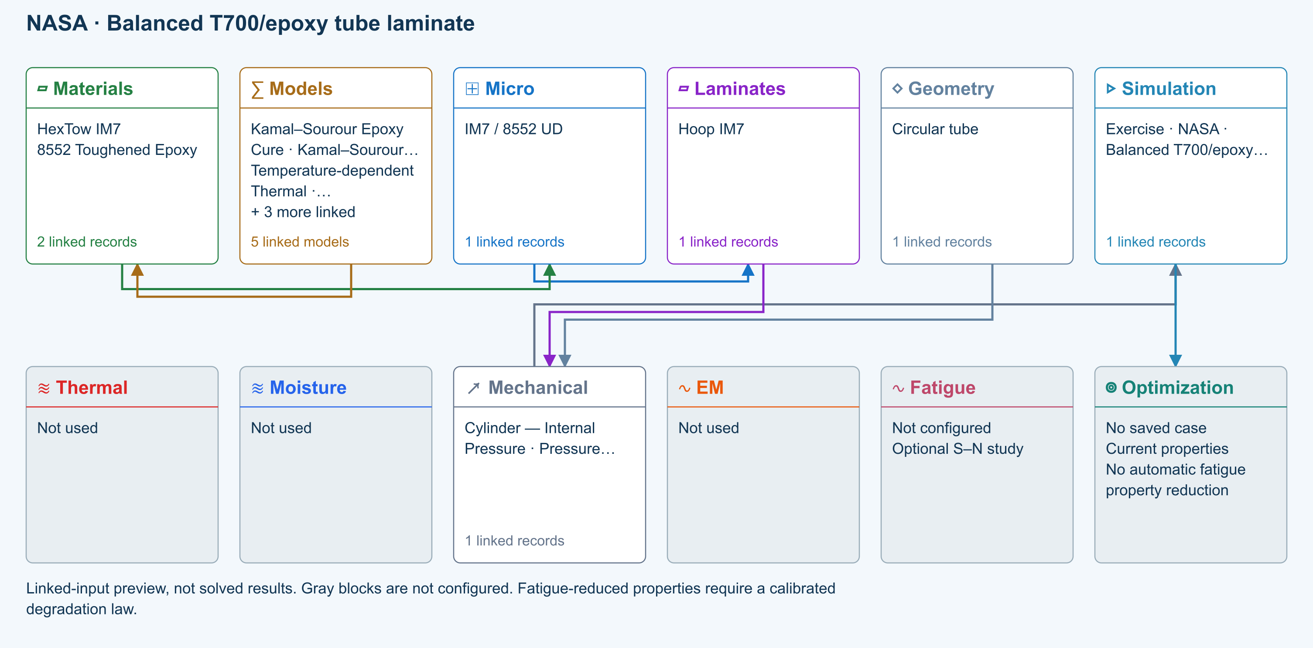
∑ Selected models & submodels
These are the exercise’s linked choices, not solved results. Open a first-layer model to see its submodels and scope.
Kamal–Sourour autocatalytic · Kamal–Sourour Epoxy Cure
Reusable material model. It contributes only when assigned to a material used by this simulation; separate model records can supply independent properties.
Calibration & applicability
Illustrative model defaults — replace with characterized resin kinetics
∑ Theory & assumptions
Temperature-dependent tabular · Temperature-dependent Thermal
Reusable material model. It contributes only when assigned to a material used by this simulation; separate model records can supply independent properties. Micro uses the 23 °C reference; Process evaluates the same table at local temperature, without extrapolation.
Calibration & applicability
Check source data, applicable environment and validity limits in the model record; saved defaults are not experimental validation.
∑ Theory & assumptions
1D Fickian diffusion · Layered Fickian Diffusion
Reusable material model. It contributes only when assigned to a material used by this simulation; separate model records can supply independent properties.
Calibration & applicability
Check source data, applicable environment and validity limits in the model record; saved defaults are not experimental validation.
∑ Theory & assumptions
Halpin–Tsai · IM7 / 8552 UD
One compatible homogenization model per Micro recipe. Separate recipes compare models; their predictions are not blended.
∑ Theory & assumptions
CLT · Linear thin-wall membrane · Cylinder — Internal Pressure · Pressure vessel
Shared laminate stiffness drives this membrane/CLT path. Failure criteria are independent comparisons, not blended models. Fatigue is a separate assessment.
∑ Theory & assumptions
Data travelling between blocks
Micro → Laminates
Predicted ply stiffness, strength, density and expansion properties.
Materials → Micro
Constituent stiffness, strength, density and thermal / moisture properties.
Models → Materials
Model choices and calibrated parameters.
Mechanical → Simulation
SIMULATION selects this case and its analysis model; the case owns its applicable cycle and input references.
Laminates → Mechanical
Ply angles and thicknesses, stiffness, mass and ply properties.
Geometry → Mechanical
Shape and dimensions for the selected structural analysis.
Simulation → Optimization
Linked inputs and current-property response for candidate evaluation.

Reference validation 2026-09-18
Not benchmark validated
No matched quantitative reference comparison completed for the full exercise.
Recorded baseline only—not a certification of the current database, edited inputs, or every output. Analytical agreement is not experimental material or failure validation.
Source validation, comparisons and tested inputs
Execution: Completed (not validation)
The copied IM7 pressure-vessel records are scaffolding. Replace the ply source and dimensions with the published T700/epoxy inputs; a pressure load is not an axial or torsional test.
- NASA/TM—2014-216635 — Engineered Polymer Composites Through Electrospun Nanofiber Coating of Fiber Tows Tables 1–2, printed pages 11–12 / PDF pages 15–16 . Published estimated ply inputs and CLPT tube properties, not qualified or experimentally validated strengths.

Tested inputs
Input SHA-256: 8a86a623acc8d1dbf229bcb467cc07faef12e797aff844c6cc071a5fa1cb8be4
Solver source SHA-256: 30c8a614b6cb004a26da8adaf8ab7c534c37c4d534836921939f35a549e1bcc5
- Classical-laminate and first-ply screening. Manufacturing variation and qualification are excluded; the source describes estimated ply data.
Separate published-data fixture: Benchmark validated — published calculation
Separate source-matched stiffness fixture, NOT the unchanged IM7 starter. Only Ex, Gxy and νxy. No experimental or strength validation.
Quantity | CDS | Reference | Error % | Tolerance (relative + absolute) | Result
Ex ( GPa ) | 27.71415 | 27.7 | 0.05108303 | 1 % + 0.00002 GPa | Pass
Gxy ( GPa ) | 39.54424 | 39.6 | -0.1408081 | 1 % + 0.00002 GPa | Pass
νxy ( — ) | 0.67558 | 0.68 | -0.65 | 1 % + 0.00002 — | Pass

- NASA/TM—2014-216635 — Engineered Polymer Composites Through Electrospun Nanofiber Coating of Fiber Tows Tables 1–2, printed pages 11–12 / PDF pages 15–16 . Published estimated ply inputs and CLPT tube properties, not qualified or experimentally validated strengths.
Fixture inputs
{
"E1GPa": 153,
"E2GPa": 10.5,
"G12GPa": 8.27,
"nu12": 0.3,
"stack": "[45/-45]4",
"thicknessMm": 2.345
}
Download source-validation evidence (JSON) · Full 104 -exercise study
Objective
Reproduce the classical-laminate response of a balanced [±45]₄ T700/epoxy tube and use it as a controlled starting point for a design study.
CDS scope
CDS can reproduce the laminate constitutive and first-ply screening calculations. It does not reproduce manufacturing variation or certify the report’s estimated input properties.
Published basis
1 primary source
NASA/TM—2014-216635
Engineered Polymer Composites Through Electrospun Nanofiber Coating of Fiber Tows
Tables 1 and 2 report estimated T700/epoxy ply properties, [±45]₄ tube dimensions, and CLPT-based laminate properties.
Starting data
Enter in the displayed units
Variable | Value | How it is used
Ply E1 / E2 / G12 | 153 / 10.5 / 8.27 GPa | Orthotropic lamina elasticity
Ply ν12 | 0.30 | In-plane Poisson coupling
Xt / Xc | 2760 / 781 MPa | Longitudinal tension and compression
Yt / Yc / S | 76.5 / 233 / 89.6 MPa | Transverse and shear failure inputs
Layup | [+45/−45]₄ | Eight equal-thickness plies
Tube OD / ID | 52.95 / 48.26 mm | Nominal wall thickness and geometry

Review checkpoints
Comparison, not certification
Result | Published reference | Interpretation
Axial modulus | 27.7 GPa | Published thin-wall CLPT estimate
Shear modulus | 39.6 GPa | Published [±45]₄ laminate estimate
Axial Poisson ratio | 0.68 | Large extension coupling expected for the angle-ply tube
Tension / compression / torsion | 179 MPa / 176 MPa / 290 MPa | Estimated laminate strengths, not qualified allowables

All exercises, case studies and simulation examples → · Your CDS library: overview, manuals and database downloads →

Create the published T700/epoxy ply
Create a separate orthotropic lamina record using the estimated ply properties reported by NASA.
- Enter the elastic constants and five in-plane strength values from the table.
- Set the record status to Representative and attach the NASA report as its source.
- Keep out-of-plane and environmental terms incomplete unless a documented source is available.
Good practice
The report describes these as best-guess T700/epoxy estimates because a complete property set for the experimental towpreg was unavailable.

Build the balanced tube laminate
Create eight plies in the sequence [45/−45]₄ with equal thickness.
- Use the published OD and ID to calculate the nominal wall thickness: (52.95 − 48.26)/2 = 2.345 mm.
- Set each of eight plies to approximately 0.2931 mm so the stack matches that nominal wall.
- Confirm the LiveStack shows four balanced ±45 pairs and that A16 and A26 are near zero.

Review effective laminate properties
Run the laminate calculation and compare the axial modulus, in-plane shear modulus and major Poisson ratio with the published CLPT estimates.
- Open the laminate Summary and export Ex, Gxy and νxy.
- Record the absolute and percentage differences from 27.7 GPa, 39.6 GPa and 0.68.
- Inspect whether the thickness convention or transverse shear treatment explains any discrepancy.

Explore the design space without changing the benchmark
Preserve the baseline, then use a duplicate for a carpet or optimization study.
- Sweep the ±45 family while holding ply count, material and total wall thickness fixed.
- Map axial modulus against shear modulus and display extrema.
- Save the baseline and the best candidate as separate snapshots so the NASA configuration remains available for comparison.
Good practice
A stiffness optimum is not automatically a strength, stability, fatigue or manufacturing optimum.

Run a first-ply screening check
Apply axial or torsional loading separately and compare the predicted onset with the report’s estimated laminate strengths.
- Select a failure criterion supported by the available in-plane allowables.
- Run axial tension, axial compression and torsion as separate cases.
- Use the reported 179 MPa tension, 176 MPa compression and 290 MPa shear only as study checkpoints.
Workbench availability: released models, inputs and compatible study paths . The wider theory library includes reference formulations not available in every Workbench solve.

4 Resolve a thick-panel cure cycle and exotherm
Online chapter
Use a published T700S/TC380 oven schedule to examine thermal lag, reaction heat, cure state, evolving modulus, and cycle optimization.
Current Workbench, reference editions and downloads
Use the online User Guide for current controls, the released model directory for selectable models and compatibility, and the Training Manual for connected exercises. Wider theory references do not mean every formulation is enabled in Workbench.
Dated GUI captures and compiled Web r18 PDF manuals retain their stated scope; they are not a substitute for current hosted Workbench instructions. Find the overview PDF, guides and exercise databases in Your CDS library .
Two-row simulation workflow · Open full-size map
Linked-input preview, not solved results. Gray blocks are not configured.
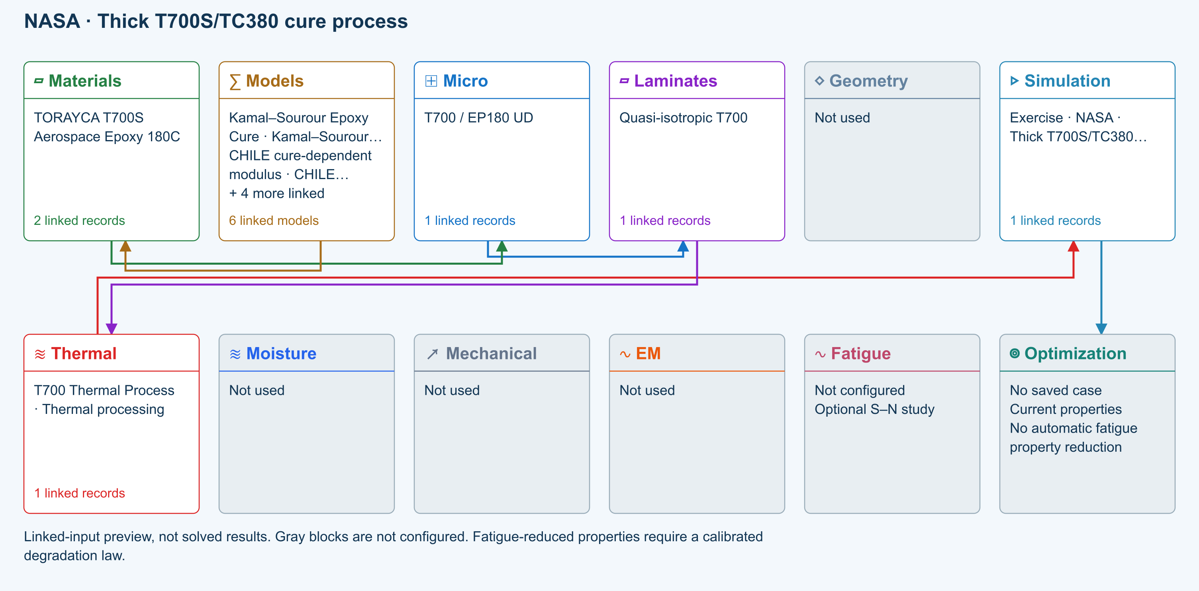
∑ Selected models & submodels
These are the exercise’s linked choices, not solved results. Open a first-layer model to see its submodels and scope.
Kamal–Sourour autocatalytic · Kamal–Sourour Epoxy Cure
Reusable material model. It contributes only when assigned to a material used by this simulation; separate model records can supply independent properties.
Calibration & applicability
Illustrative model defaults — replace with characterized resin kinetics
∑ Theory & assumptions
CHILE (degree of cure) · CHILE cure-dependent modulus
Reusable material model. It contributes only when assigned to a material used by this simulation; separate model records can supply independent properties. Cure-dependent modulus does not automatically scale strength allowables.
Calibration & applicability
CHILE(α), section 2.4 of Materials 2019, 12, 259. Example parameters, not measured EP180 data. Fixed Poisson ratio; no viscoelastic relaxation or Tg softening. Incremental elastic stress integration at saved process intervals: check time-step convergence. Strength allowables are independent measured inputs, not scaled with modulus.
∑ Theory & assumptions
Temperature-dependent tabular · Temperature-dependent Thermal
Reusable material model. It contributes only when assigned to a material used by this simulation; separate model records can supply independent properties. Micro uses the 23 °C reference; Process evaluates the same table at local temperature, without extrapolation.
Calibration & applicability
Check source data, applicable environment and validity limits in the model record; saved defaults are not experimental validation.
∑ Theory & assumptions
1D Fickian diffusion · Layered Fickian Diffusion
Reusable material model. It contributes only when assigned to a material used by this simulation; separate model records can supply independent properties.
Calibration & applicability
Check source data, applicable environment and validity limits in the model record; saved defaults are not experimental validation.
∑ Theory & assumptions
Halpin–Tsai · T700 / EP180 UD
One compatible homogenization model per Micro recipe. Separate recipes compare models; their predictions are not blended.
∑ Theory & assumptions
1D transient heat transfer · T700 Thermal Process · Thermal processing
Needs linked laminate properties and a compatible process schedule. A linked cycle is not a solved temperature history.
∑ Theory & assumptions
Data travelling between blocks
Micro → Laminates
Predicted ply stiffness, strength, density and expansion properties.
Materials → Micro
Constituent stiffness, strength, density and thermal / moisture properties.
Models → Materials
Model choices and calibrated parameters.
Thermal → Simulation
SIMULATION selects this case and its analysis model; the case owns its applicable cycle and input references.
Laminates → Thermal
Ply angles and thicknesses, stiffness, mass and ply properties.
Simulation → Optimization
Linked inputs and current-property response for candidate evaluation.

Reference validation 2026-09-18
Not benchmark validated
No matched quantitative reference comparison completed for the full exercise.
Recorded baseline only—not a certification of the current database, edited inputs, or every output. Analytical agreement is not experimental material or failure validation.
Source validation, comparisons and tested inputs
Execution: Completed (not validation)
The starter resin and cycle are not TC380 calibration. The source supplies the schedule and measured checkpoints, but not all kinetics, heat-of-reaction or transport inputs. Source those inputs before a quantitative comparison.
- NASA — Evaluation of Temperature Gradients During Cure of a Thick Carbon Fiber/Epoxy Composite Source study identified; quantitative reproduction not established . TC380 kinetics, reaction heat, transport, boundary characterization and digitized measurements still required.

Tested inputs
Input SHA-256: bf765b769c16e22bd102d6e21b2eabccdfbb0052ff58ca608a19c3e6bd41f127
Solver source SHA-256: 30c8a614b6cb004a26da8adaf8ab7c534c37c4d534836921939f35a549e1bcc5
- One-dimensional through-thickness study, not oven airflow or a general 3D process model. Missing TC380 calibration remains a setup requirement, never a default validated result.
Download source-validation evidence (JSON) · Full 104 -exercise study
Objective
Model a 40-ply, 25.4 mm T700S/TC380 panel through a two-stage oven cure and determine how core lag and cure exotherm change the process window.
CDS scope
CDS reproduces a one-dimensional through-thickness process study. The NASA experiment supplies the cycle and thermal checkpoints; separate qualified data are required for kinetics, reaction heat and transport.
Published basis
2 primary sources
NASA GRC-E-DAA-TN70457
Evaluation of Temperature Gradients During Cure of a Thick Carbon Fiber/Epoxy Composite
Reports T700S/TC380 braided panels, the recommended two-stage cure cycle, embedded thermocouples, exotherm, and through-thickness conversion differences.
NASA Tech Briefs
Designing Cure Cycles for Matrix/Fiber Composite Parts
Describes two-stage ramp-and-hold cure-cycle design as an optimization problem rather than trial and error.
Starting data
Enter in the displayed units
Variable | Value | How it is used
Panel | 40 plies; 25.4 mm | Published 1 inch thick comparison case
Ramp 1 | Room temperature → 107°C at 1.1°C/min | First oven segment
Dwell 1 | 107°C for 60 min | Intermediate hold
Ramp 2 | 107°C → 180°C at 1.1°C/min | Second oven segment
Dwell 2 | 180°C for 120 min | High-temperature hold
Cool | ≤ 3°C/min to < 49°C | Controlled cooldown

Review checkpoints
Comparison, not certification
Result | Published reference | Interpretation
40-ply exotherm above commanded cure temperature | 18°F ≈ 10°C | Published measured overshoot for the 40-ply panel
Maximum through-thickness variation | ≤ 10°C | Reported across the tested thicknesses
At 180°C: center conversion | approximately 85% | Published estimate at onset of vitrification
At 170°C: tool-side conversion | approximately 68% | Demonstrates cure-state mismatch through thickness

All exercises, case studies and simulation examples → · Your CDS library: overview, manuals and database downloads →

Create the thick-panel baseline
Create a 40-ply T700S/TC380 laminate representing the 1 inch panel reported in the NASA thermal-gradient data.
- Use the linked TC380 cure-kinetics, reaction-heat and cure-dependent-modulus records when qualified inputs are available.
- Set total laminate thickness to 25.4 mm and assign through-thickness conductivity, density and specific heat from traceable records.
- Use enough through-thickness nodes to resolve the core and the two surfaces.
Good practice
The NASA cycle and measured temperatures do not provide every constitutive input required by the CDS cure model. Missing kinetics and transport values must remain visible and sourced separately.

Enter the two-stage oven cycle
Build the published vacuum-bag-only schedule as a transient upper and lower boundary history.
- Start at the selected room reference temperature and ramp to 107°C at 1.1°C/min.
- Hold at 107°C for 60 minutes.
- Ramp to 180°C at 1.1°C/min and hold for 120 minutes.
- Cool at no more than 3°C/min until the part is below 49°C.
- Model the separate two-hour 180°C post-cure as a second cycle when it is included in the study.

Resolve thermal lag before adding reaction heat
Run the transient conduction model with cure exotherm disabled to establish the boundary-to-core lag.
- Plot oven or surface temperature with the core and tool-side node histories.
- Check the 107°C and 180°C transitions for adequate time resolution.
- Save the no-exotherm result as the conduction baseline.

Enable cure exotherm and evolving modulus
Turn on reaction heat and the cure-dependent modulus model, then rerun the same cycle.
- Compare peak core temperature, core-to-tool gradient and degree of cure with the baseline.
- Inspect when the core crosses the cure model’s gelation or vitrification transitions.
- Review the process-stress history only after the thermal and cure histories are credible.
Good practice
NASA observed thicker-panel exotherm and reported less than 10°C maximum through-thickness variation in this study. Agreement requires compatible kinetics, reaction heat and transport data—not merely the same oven schedule.

Frame a process optimization
Duplicate the thermal case, including its own cycle, and optimize ramp or dwell variables against core-temperature and cure constraints.
- Choose a target core degree of cure and a maximum permitted core temperature or surface-to-core gradient.
- Allow the first ramp rate, intermediate dwell and second ramp rate to vary within manufacturing limits.
- Minimize cycle time subject to the thermal and cure constraints.
- Save the candidate snapshot, apply its cycle to the copied thermal case, and rerun the fully coupled case before comparing residual stress.
Workbench availability: released models, inputs and compatible study paths . The wider theory library includes reference formulations not available in every Workbench solve.

5 Screen a pressurized AS4/3501-6 cylinder
Online chapter
Recreate the global biaxial load state of a NASA pressure-cylinder program, compare stacking sequences, and define the boundary between laminate screening and detailed fracture analysis.
Current Workbench, reference editions and downloads
Use the online User Guide for current controls, the released model directory for selectable models and compatibility, and the Training Manual for connected exercises. Wider theory references do not mean every formulation is enabled in Workbench.
Dated GUI captures and compiled Web r18 PDF manuals retain their stated scope; they are not a substitute for current hosted Workbench instructions. Find the overview PDF, guides and exercise databases in Your CDS library .
Two-row simulation workflow · Open full-size map
Linked-input preview, not solved results. Gray blocks are not configured.
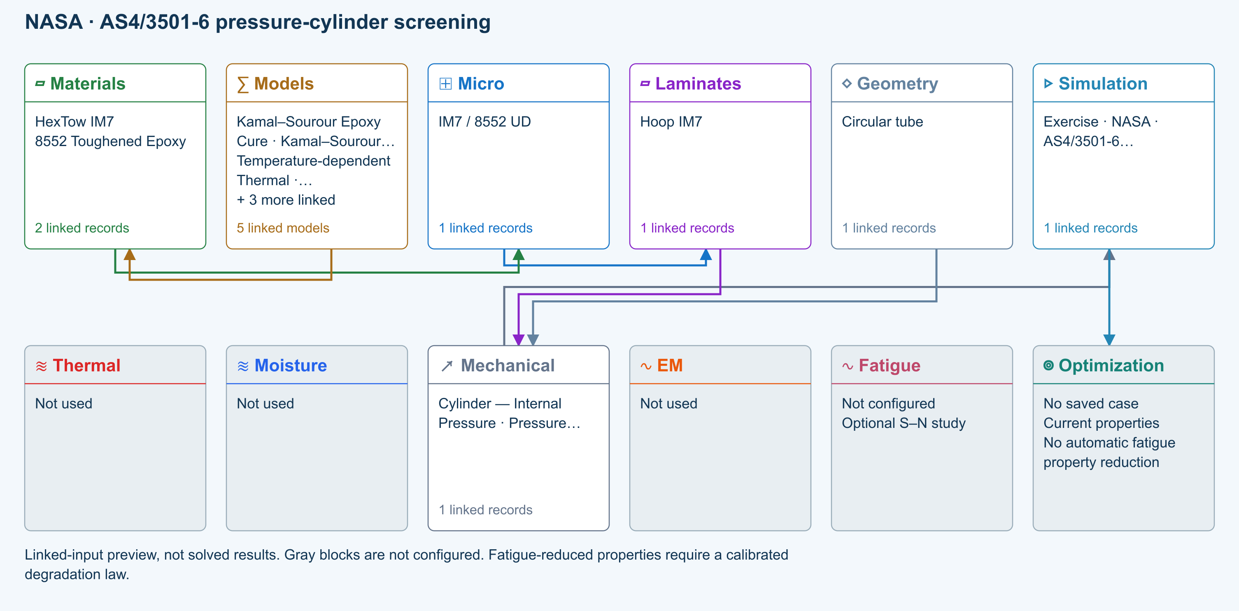
∑ Selected models & submodels
These are the exercise’s linked choices, not solved results. Open a first-layer model to see its submodels and scope.
Kamal–Sourour autocatalytic · Kamal–Sourour Epoxy Cure
Reusable material model. It contributes only when assigned to a material used by this simulation; separate model records can supply independent properties.
Calibration & applicability
Illustrative model defaults — replace with characterized resin kinetics
∑ Theory & assumptions
Temperature-dependent tabular · Temperature-dependent Thermal
Reusable material model. It contributes only when assigned to a material used by this simulation; separate model records can supply independent properties. Micro uses the 23 °C reference; Process evaluates the same table at local temperature, without extrapolation.
Calibration & applicability
Check source data, applicable environment and validity limits in the model record; saved defaults are not experimental validation.
∑ Theory & assumptions
1D Fickian diffusion · Layered Fickian Diffusion
Reusable material model. It contributes only when assigned to a material used by this simulation; separate model records can supply independent properties.
Calibration & applicability
Check source data, applicable environment and validity limits in the model record; saved defaults are not experimental validation.
∑ Theory & assumptions
Halpin–Tsai · IM7 / 8552 UD
One compatible homogenization model per Micro recipe. Separate recipes compare models; their predictions are not blended.
∑ Theory & assumptions
CLT · Linear thin-wall membrane · Cylinder — Internal Pressure · Pressure vessel
Shared laminate stiffness drives this membrane/CLT path. Failure criteria are independent comparisons, not blended models. Fatigue is a separate assessment.
∑ Theory & assumptions
Data travelling between blocks
Micro → Laminates
Predicted ply stiffness, strength, density and expansion properties.
Materials → Micro
Constituent stiffness, strength, density and thermal / moisture properties.
Models → Materials
Model choices and calibrated parameters.
Mechanical → Simulation
SIMULATION selects this case and its analysis model; the case owns its applicable cycle and input references.
Laminates → Mechanical
Ply angles and thicknesses, stiffness, mass and ply properties.
Geometry → Mechanical
Shape and dimensions for the selected structural analysis.
Simulation → Optimization
Linked inputs and current-property response for candidate evaluation.

Reference validation 2026-09-18
Not benchmark validated
No matched quantitative reference comparison completed for the full exercise.
Recorded baseline only—not a certification of the current database, edited inputs, or every output. Analytical agreement is not experimental material or failure validation.
Source validation, comparisons and tested inputs
Execution: Completed (not validation)
The starter uses IM7/8552, not AS4/3501-6. Supply traceable AS4/3501-6 ply properties, thickness and the source diameter convention before comparison. Slits are intentionally outside this pristine-cylinder model.
- NASA-CR-195101 — Damage Tolerance of Pressurized Graphite/Epoxy Tape Cylinders Under Uniaxial and Biaxial Loading Source study identified; matched slit-cylinder dataset not reproduced . Slit-tip damage and failure pressure are outside pristine membrane scope.

Tested inputs
Input SHA-256: f25f2006b61b91faeeba0759fa4d7a801d98047fe892d401285db11b9d1b9741
Solver source SHA-256: 30c8a614b6cb004a26da8adaf8ab7c534c37c4d534836921939f35a549e1bcc5
- Pristine-cylinder screening only. Slit-tip fracture, splitting, delamination, nonlinear local response and the source’s subcritical damage are not solved here.
Download source-validation evidence (JSON) · Full 104 -exercise study
Objective
Compare global membrane and first-ply response for two quasi-isotropic AS4/3501-6 stacking sequences under the two-to-one hoop-to-axial loading created by internal pressure.
CDS scope
CDS provides the pristine thin-wall cylinder and laminate-failure screen. The published slit-tip fracture, delamination, subcritical damage and nonlinear local response require a higher-fidelity model.
Published basis
2 primary sources
NASA-CR-195101
Damage Tolerance of Pressurized Graphite/Epoxy Tape Cylinders Under Uniaxial and Biaxial Loading
Reports 305 mm AS4/3501-6 cylinders, 12.7–50.8 mm axial slits, several symmetric stacking sequences, and sensitivity to subcritical damage.
NASA-CR-192618
Damage Tolerance and Arrest Characteristics of Pressurized Graphite/Epoxy Tape Cylinders
Documents quasi-isotropic and anisotropic AS4/3501-6 cylinders pressurized to a two-to-one biaxial far-field stress state.
Starting data
Enter in the displayed units
Variable | Value | How it is used
Material | AS4/3501-6 graphite/epoxy tape | Published cylinder material system
Cylinder diameter | 305 mm | Global tube geometry
Baseline layup | [90/0/+45/−45]s | Symmetric quasi-isotropic comparison
Stacking variant | [0/+45/−45/90]s | Similar in-plane response with different bending coupling
Slit lengths in source | 12.7–50.8 mm | Excluded local-damage feature to document
Pressure load ratio | Hoop : axial = 2 : 1 | Closed-cylinder far-field membrane loading

Review checkpoints
Comparison, not certification
Result | Published reference | Interpretation
Membrane load ratio | Nhoop / Naxial = 2 | Required thin-wall closed-cylinder equilibrium check
A-matrix comparison | Nearly equivalent quasi-isotropic in-plane response | Confirms material, thickness and orientation convention
D16 and D26 | Stacking-sequence dependent | Relevant to the different damage behavior discussed by NASA
Failure-pressure agreement | Not a CDS membrane checkpoint | Requires slit-tip fracture and subcritical-damage modeling

All exercises, case studies and simulation examples → · Your CDS library: overview, manuals and database downloads →

Create the pristine cylinder baseline
Build the published 305 mm diameter AS4/3501-6 cylinder as an undamaged membrane-screening case.
- Create or select a traceable AS4/3501-6 orthotropic ply record.
- Build the symmetric quasi-isotropic [90/0/+45/−45]s baseline and a duplicate [0/+45/−45/90]s stacking variant.
- Set the circular-tube geometry by inside diameter and laminate-derived wall thickness.
Good practice
The source cylinders contained axial slits. The baseline CDS case intentionally omits the slit so global membrane response can be checked before local fracture analysis.

Apply the pressure membrane resultants
For a closed thin-walled cylinder, internal pressure produces a two-to-one hoop-to-axial membrane stress state.
- Enter the internal pressure and verify LiveLoad identifies the hoop and axial directions.
- If entering resultants directly, use Nhoop = p r and Naxial = p r / 2 with consistent units.
- Run a low-pressure case first and confirm strain signs, hoop-to-axial load ratio and laminate orientation.

Screen first-ply and progressive response
Run supported maximum-stress, Hashin or other criteria using documented AS4/3501-6 strength inputs.
- Compare first-ply load factors for the two quasi-isotropic stacking sequences.
- Inspect D16 and D26 and the progressive stress–strain history rather than assuming that equal A-matrices give identical damage response.
- Save each case as a named simulation and compare the result tables.
Good practice
NASA found subcritical damage and stacking-sequence sensitivity. A global laminate criterion cannot resolve slit-tip splitting, delamination or fracture-path changes.

Identify the required higher-fidelity handoff
Use the CDS result to define loads and material state for a local finite-element or fracture-mechanics model.
- Export the laminate stiffnesses, strengths, pressure resultants and global strains.
- Model the 12.7–50.8 mm axial slit and local mesh outside the current CDS membrane idealization.
- Include nonlinear shell response, delamination and fracture calibration when comparing failure pressure.
- Return validated local-model limits to CDS as documented design constraints rather than hidden correction factors.

Document what the comparison proves
Record the source, exact stack, pressure convention, failure criterion and excluded physics with the saved run.
- Treat the NASA pressure-cylinder results as external validation context.
- Treat CDS output as a pristine-cylinder screening result unless a supported local-damage model is explicitly active.
- Do not claim agreement on slit failure pressure from an unnotched membrane model.
Workbench availability: released models, inputs and compatible study paths . The wider theory library includes reference formulations not available in every Workbench solve.

6 Published cases Solver-visible results
Online chapter
Choose an example library to explore published material systems, original research, NASA technical reports, and running CDS solver routes without working through one long page.
Traceable by design. Published values are transcribed from the linked primary source. CDS plots are calculated or reconstructed from the stated inputs and are clearly labeled; they are not presented as digitized experimental curves.
M05 Fiber-volume stiffness sweep Illustrated example · not a live run
Materials
Micro
Properties

1 Inputs
01
Ef1 230 GPa
02
Em 3.5 GPa
03
Vf 0.35–0.65
04
longitudinal ROM route
Keep these conditions unchanged when comparing with the answer.

2 Output visualization
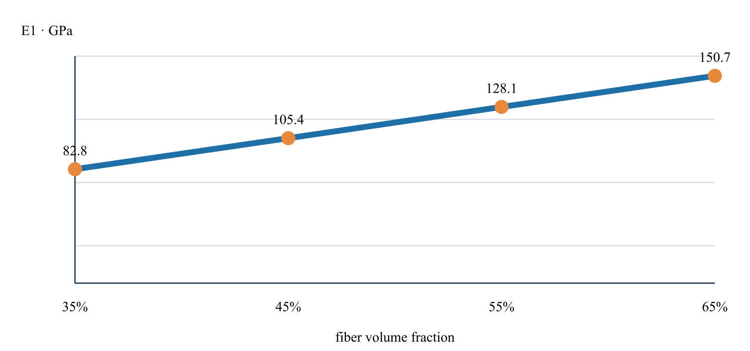
What the result shows
The solver increases E1 from 82.8 to 150.7 GPa across the selected fiber-volume range.
Result basis CDS r15 micromechanics sweep . Values and trends reproduce this page’s example; this is not a fresh solver result or an additional validation claim.
Explore micromechanics inputs and answer →
L01 Quasi-isotropic laminate family Illustrated example · not a live run
Ply properties
Laminates
Response

1 Inputs
01
QI-8
02
cross-ply
03
±45 angle-ply
04
0/±60 tri-axial
05
0.125 mm plies
Keep these conditions unchanged when comparing with the answer.

2 Output visualization
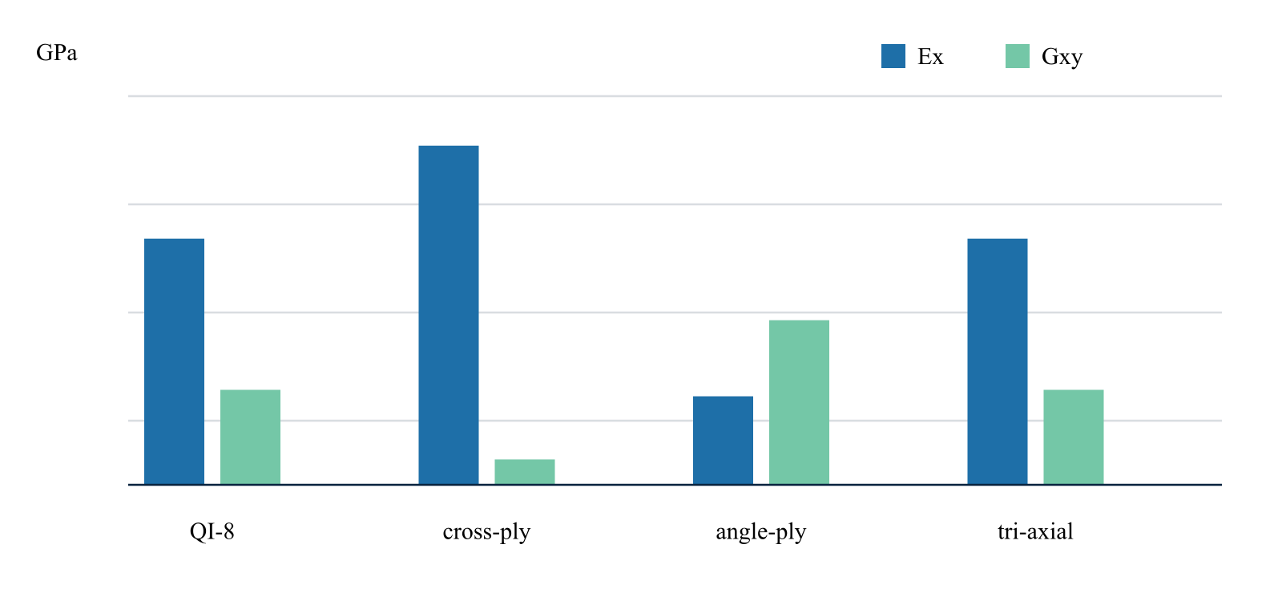
What the result shows
QI-8 and 0/±60 return the same Ex = Ey = 69.68 GPa and Gxy = 26.88 GPa.
Result basis Published layup families · CDS CLT . Values and trends reproduce this page’s example; this is not a fresh solver result or an additional validation claim.
Explore laminates inputs and answer →
A03 First-ply failure screen Illustrated example · not a live run
Laminate
Geometry / cycle
CASES
Response

1 Inputs
01
[0/45/−45/90]s
02
Nx 300 N/mm
03
1.0 mm total thickness
Keep these conditions unchanged when comparing with the answer.

2 Output visualization
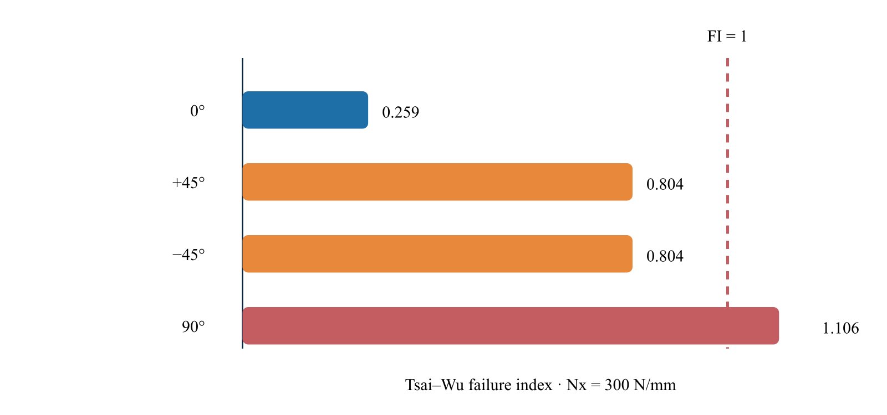
Failure threshold exceeded
The 90° plies reach FI 1.106 first; the example load is above predicted first-ply failure.
Result basis Published allowables · CDS CLT/Tsai–Wu . Values and trends reproduce this page’s example; this is not a fresh solver result or an additional validation claim.
Explore analyses inputs and answer →
Example subpages
Choose one focused library
10 cases

Micromechanics
Translate constituent, fiber-form, and published lamina data into solver-ready engineering properties.
Open library
8 cases

Laminates
Turn ply data and stacking sequences into extensional stiffness, equivalent laminate families, and design-level comparisons.
Open library
9 cases

Analyses
Exercise environmental, processing, and failure blocks with traceable material systems and explicit solver assumptions.
Open library
6 files

Starter files
Download runnable solver cases and compact CSV inputs for direct inspection and adaptation.
Open downloads

7 Analyses Solver-visible results
Online chapter
Exercise environmental, processing, and failure blocks with traceable material systems and explicit solver assumptions. Every case identifies its inputs, calculated readout, provenance, and primary technical sources.
Traceable by design. Published values are transcribed from linked primary sources. CDS plots are calculated or reconstructed from the stated inputs and are clearly labeled.
Example class

Analyses
Exercise environmental, processing, and failure blocks with traceable material systems and explicit solver assumptions.
A01 Published material system · CDS scenario

AS/3501-6 cure-cycle contour
Resolve temperature and cure-state evolution through laminate thickness, including the exotherm region that a surface thermocouple can miss.
Sources and theory ( 1 )
Loos & Springer (1983), curing of epoxy composites
A01 AS/3501-6 cure-cycle contour Illustrated example · not a live run
Laminate
Geometry / cycle
CASES
Response

1 Inputs
01
Hercules AS/3501-6
02
time × thickness grid
03
autocatalytic cure block
Keep these conditions unchanged when comparing with the answer.

2 Output visualization
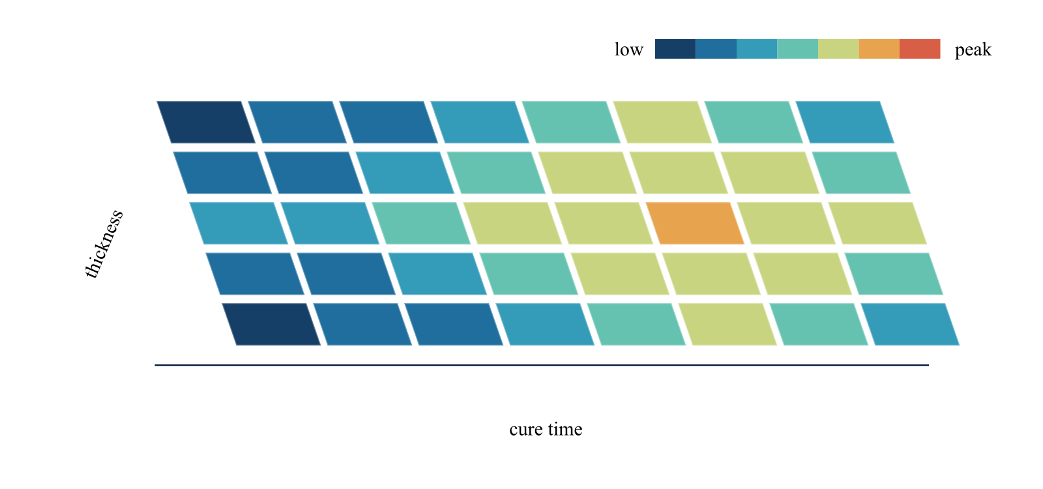
What the result shows
The contour exposes the modeled interior thermal peak before cooldown begins.
Result basis Published material system · CDS scenario . Values and trends reproduce this page’s example; this is not a fresh solver result or an additional validation claim.
A02 Published range · CDS Fickian curves

T300/Fiberite 1034 moisture uptake
Run the one-dimensional Fickian block across the original experimental temperature range and compare the approach to a 1.5% saturation case.
Sources and theory ( 2 )
Shen & Springer (1976), moisture absorption/desorption
Shen & Springer (1977), moisture/temperature strength tests
A02 T300/Fiberite 1034 moisture uptake Illustrated example · not a live run
Laminate
Geometry / cycle
CASES
Response

1 Inputs
01
T300/Fiberite 1034
02
300–425 K
03
256 h exposure
04
M∞ 1.5%
Keep these conditions unchanged when comparing with the answer.

2 Output visualization
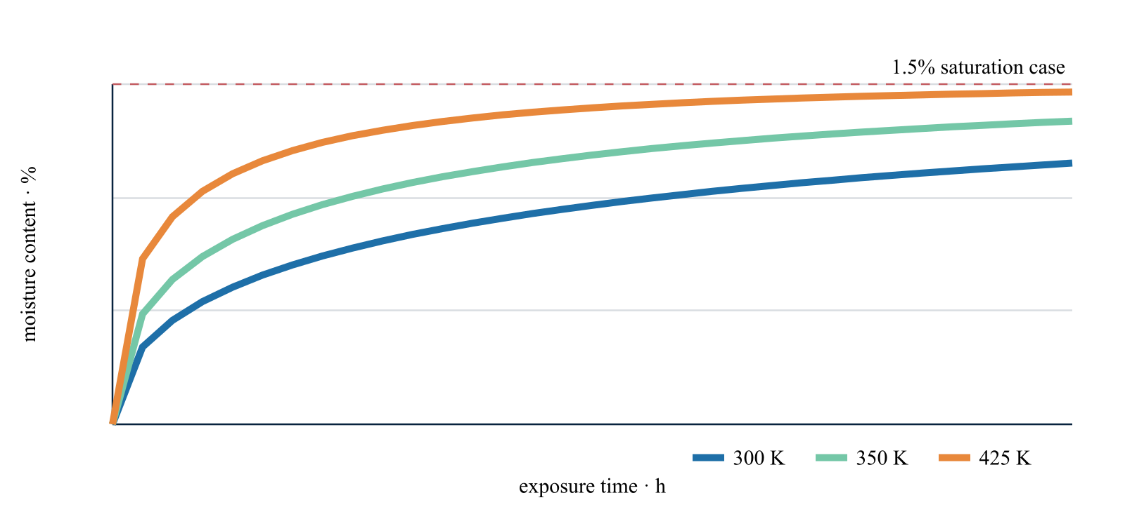
What the result shows
Higher-temperature scenarios approach saturation sooner while retaining the same equilibrium limit.
Result basis Published range · CDS Fickian curves . Values and trends reproduce this page’s example; this is not a fresh solver result or an additional validation claim.
A03 Published allowables · CDS CLT/Tsai–Wu

First-ply failure screen
Recover local ply stresses from CLT and apply Tsai–Wu to the quasi-isotropic T300/5208 plate under increasing axial membrane load.
Sources and theory ( 2 )
Tsai & Wu (1971), anisotropic strength theory
Hu et al. (2015), T300/5208 input data
A03 First-ply failure screen Illustrated example · not a live run
Laminate
Geometry / cycle
CASES
Response

1 Inputs
01
[0/45/−45/90]s
02
Nx 300 N/mm
03
1.0 mm total thickness
Keep these conditions unchanged when comparing with the answer.

2 Output visualization
Failure threshold exceeded
The 90° plies reach FI 1.106 first; the example load is above predicted first-ply failure.
Result basis Published allowables · CDS CLT/Tsai–Wu . Values and trends reproduce this page’s example; this is not a fresh solver result or an additional validation claim.
A04 Published lamina · CDS Revision 8 plate model

Plate boundary-condition sweep
Apply the same T300/5208 quasi-isotropic panel and load while changing the four edge IDs from simply supported to mixed and fully fixed support.
Sources and theory ( 1 )
Nettles (1994), NASA RP-1351
A04 Plate boundary-condition sweep Illustrated example · not a live run
Laminate
Geometry / cycle
CASES
Response

1 Inputs
01
0.60 × 0.40 m
02
[0/45/−45/90]s
03
2.5 kPa
04
edge IDs SSSS, CSCS, CCCC
Keep these conditions unchanged when comparing with the answer.

2 Output visualization
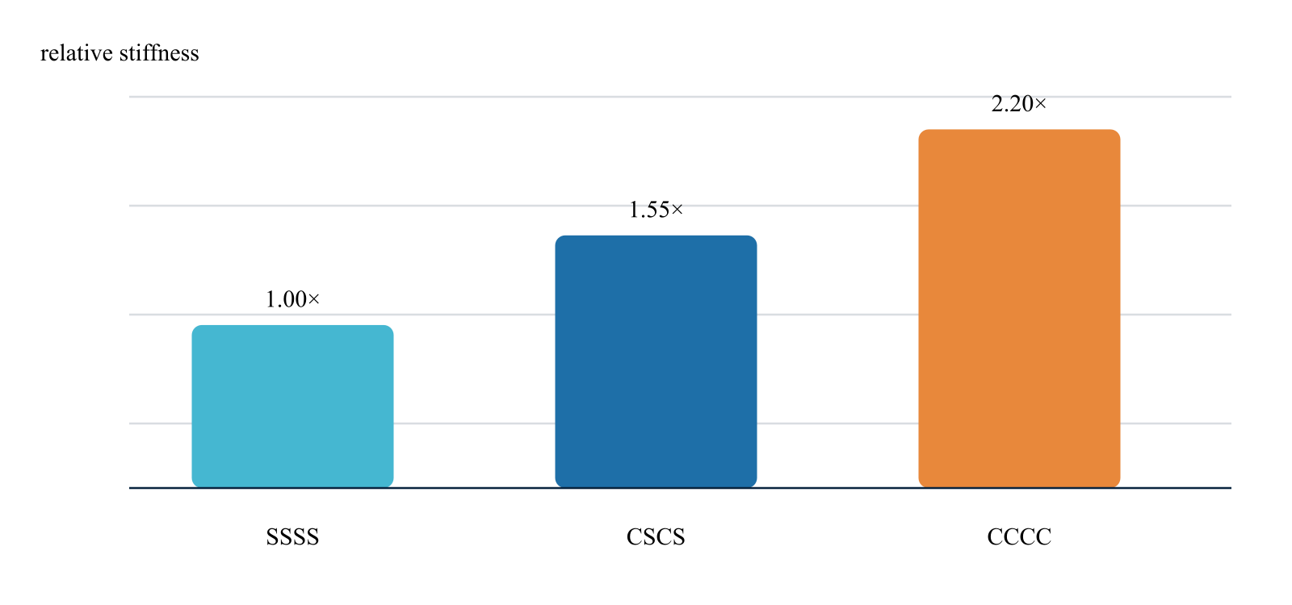
What the result shows
The Revision 8 Rayleigh screen shows increasing modal stiffness and first frequency as rotational restraint increases.
Result basis Published lamina · CDS Revision 8 plate model . Values and trends reproduce this page’s example; this is not a fresh solver result or an additional validation claim.
A05 Published CLT basis · CDS Revision 8 buckling screen

Orthotropic plate buckling surface
Map the critical membrane action as panel aspect ratio and axial/transverse compression direction change.
Sources and theory ( 1 )
Nettles (1994), NASA RP-1351
A05 Orthotropic plate buckling surface Illustrated example · not a live run
Laminate
Geometry / cycle
CASES
Response

1 Inputs
01
T300/5208 QI-8
02
a/b 0.5–2.0
03
simply supported edges
Keep these conditions unchanged when comparing with the answer.

2 Output visualization
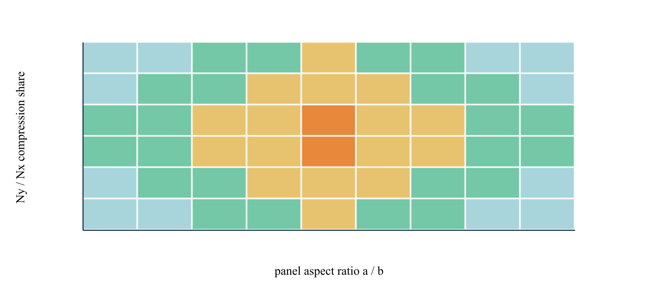
What the result shows
The contour exposes the aspect-ratio region where the governing buckling direction switches between Nx and Ny.
Result basis Published CLT basis · CDS Revision 8 buckling screen . Values and trends reproduce this page’s example; this is not a fresh solver result or an additional validation claim.
A06 CDS Revision 8 constant-section cylinder

Closed-end pressure-cylinder resultants
Convert internal pressure, axial force, and torque into the common axial–hoop–shear laminate resultant basis.
Sources and theory ( 1 )
CDS online structural theory structural geometry module
A06 Closed-end pressure-cylinder resultants Illustrated example · not a live run
Laminate
Geometry / cycle
CASES
Response

1 Inputs
01
ri 75 mm
02
L 0.8 m
03
Pi 2.5 MPa
04
Po 0.1 MPa
05
closed end
Keep these conditions unchanged when comparing with the answer.

2 Output visualization
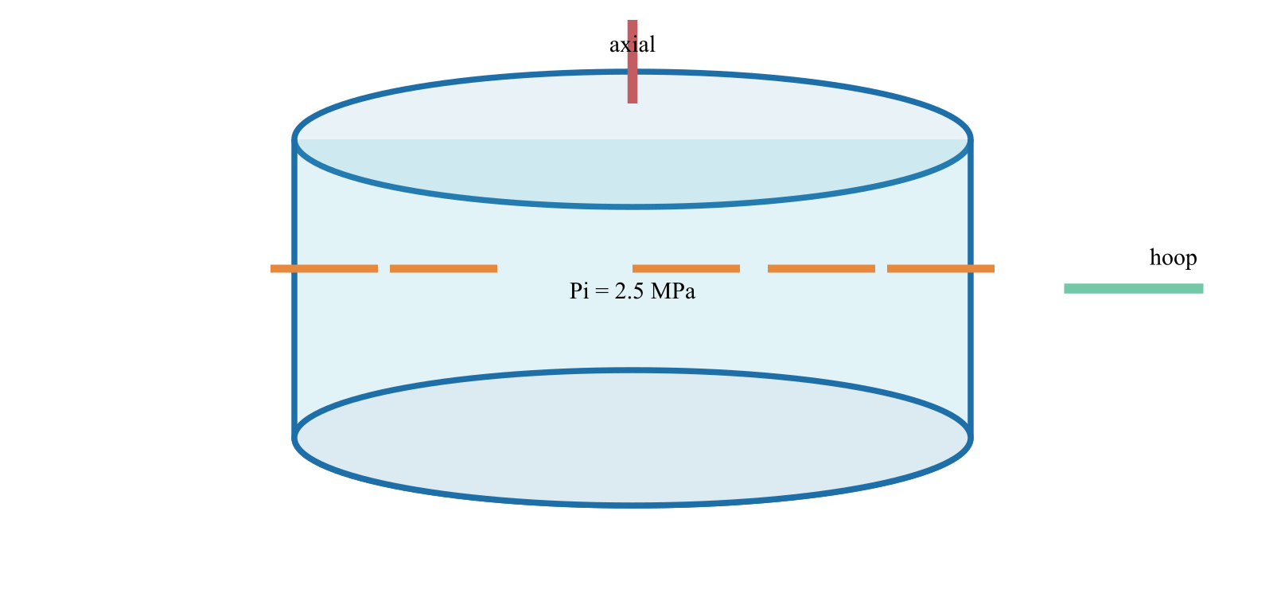
What the result shows
The hoop resultant remains the dominant membrane action; axial pressure-end force and applied axial force are superimposed explicitly.
Result basis CDS Revision 8 constant-section cylinder . Values and trends reproduce this page’s example; this is not a fresh solver result or an additional validation claim.
A07 Published methodology · CDS Revision 8 implementation

Hyer thick-cylinder radial response
Compare the shell path with the layer-by-layer generalized-plane-deformation solution for a thick cross-ply cylinder under hydrostatic pressure.
Sources and theory ( 1 )
Hyer (1988), thick laminated cylinders
A07 Hyer thick-cylinder radial response Illustrated example · not a live run
Laminate
Geometry / cycle
CASES
Response

1 Inputs
01
Cross-ply graphite/epoxy
02
radius/wall ratios 5 and 10
03
external pressure
Keep these conditions unchanged when comparing with the answer.

2 Output visualization
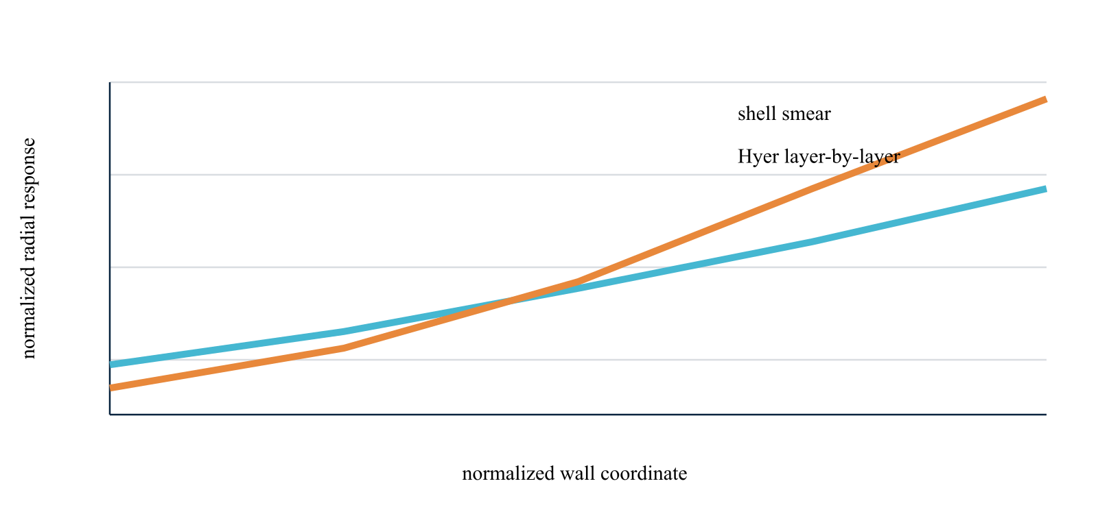
What the result shows
The Hyer path resolves through-wall radial displacement, traction continuity, and interlaminar stress instead of smearing the wall into one shell section.
Result basis Published methodology · CDS Revision 8 implementation . Values and trends reproduce this page’s example; this is not a fresh solver result or an additional validation claim.
A08 Published section mechanics · CDS Revision 8 member model

Composite beam section comparison
Hold span, laminate, mass budget, and loading constant while routing the section geometry through rectangle, I, circular-tube, and rectangular-tube formulas.
Sources and theory ( 1 )
Nettles (1994), laminate stiffness basis
A08 Composite beam section comparison Illustrated example · not a live run
Laminate
Geometry / cycle
CASES
Response

1 Inputs
01
L 1.2 m
02
T300/5208 QI laminate
03
equal outer envelope
04
fixed-fixed
Keep these conditions unchanged when comparing with the answer.

2 Output visualization
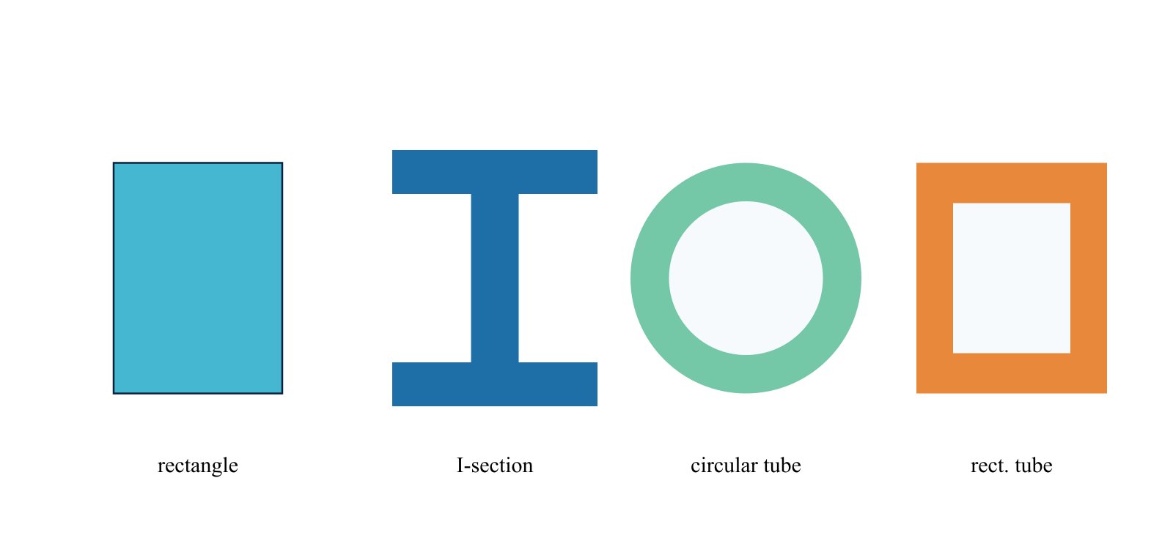
What the result shows
The I and tube sections place more laminate away from the neutral axis and therefore increase EI per unit material relative to a compact solid section.
Result basis Published section mechanics · CDS Revision 8 member model . Values and trends reproduce this page’s example; this is not a fresh solver result or an additional validation claim.
A09 Euler-Bernoulli analytical invariant · CDS 24-element solve

Beam support and frequency sweep
Use the calculated laminate density and EI to compare pinned-pinned, fixed-pinned, fixed-fixed, and cantilever first modes.
Sources and theory ( 1 )
CDS online structural theory beam and section mechanics
A09 Beam support and frequency sweep Illustrated example · not a live run
Laminate
Geometry / cycle
CASES
Response

1 Inputs
01
1.2 m I-section
02
common EI and mass/length
03
four support pairs
Keep these conditions unchanged when comparing with the answer.

2 Output visualization
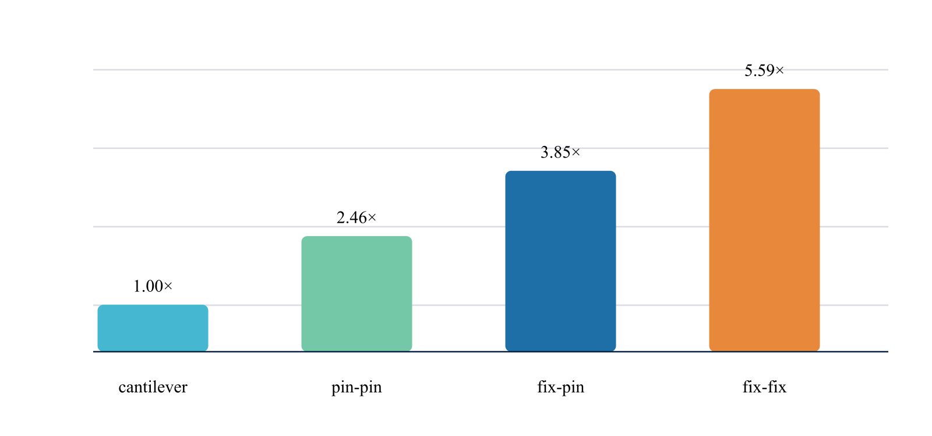
What the result shows
The fixed-fixed case is stiffest and highest-frequency; the cantilever is lowest, providing a direct boundary-condition QA trend.
Result basis Euler-Bernoulli analytical invariant · CDS 24-element solve . Values and trends reproduce this page’s example; this is not a fresh solver result or an additional validation claim.
Workbench availability: released models, inputs and compatible study paths . The wider theory library includes reference formulations not available in every Workbench solve.

8 Laminates Solver-visible results
Online chapter
Turn ply data and stacking sequences into extensional stiffness, equivalent laminate families, and design-level comparisons. Every case identifies its inputs, calculated readout, provenance, and primary technical sources.
Traceable by design. Published values are transcribed from linked primary sources. CDS plots are calculated or reconstructed from the stated inputs and are clearly labeled.
Example class

Laminates
Turn ply data and stacking sequences into extensional stiffness, equivalent laminate families, and design-level comparisons.
L01 Published layup families · CDS CLT

Quasi-isotropic laminate family
Compare four symmetric stacking families using the same T300/5208 lamina so differences come from architecture, not changing material cards.
Sources and theory ( 2 )
Nettles (1994), NASA RP-1351
Sullivan (1977), quasi-isotropic graphite/epoxy
L01 Quasi-isotropic laminate family Illustrated example · not a live run
Ply properties
Laminates
Response

1 Inputs
01
QI-8
02
cross-ply
03
±45 angle-ply
04
0/±60 tri-axial
05
0.125 mm plies
Keep these conditions unchanged when comparing with the answer.

2 Output visualization
What the result shows
QI-8 and 0/±60 return the same Ex = Ey = 69.68 GPa and Gxy = 26.88 GPa.
Result basis Published layup families · CDS CLT . Values and trends reproduce this page’s example; this is not a fresh solver result or an additional validation claim.
L02 CDS search · Tsai DD construction

Double-Double stiffness match
Search the Double-Double angle field for a compact laminate that preserves the in-plane stiffness of the default eight-ply quasi-isotropic construction.
Sources and theory ( 1 )
Tsai (2021), Double–Double laminate family
L02 Double-Double stiffness match Illustrated example · not a live run
Ply properties
Laminates
Response

1 Inputs
01
Target [0/45/−45/90]s
02
candidate [±22.5/±67.5]₂
03
T300/5208
Keep these conditions unchanged when comparing with the answer.

2 Output visualization
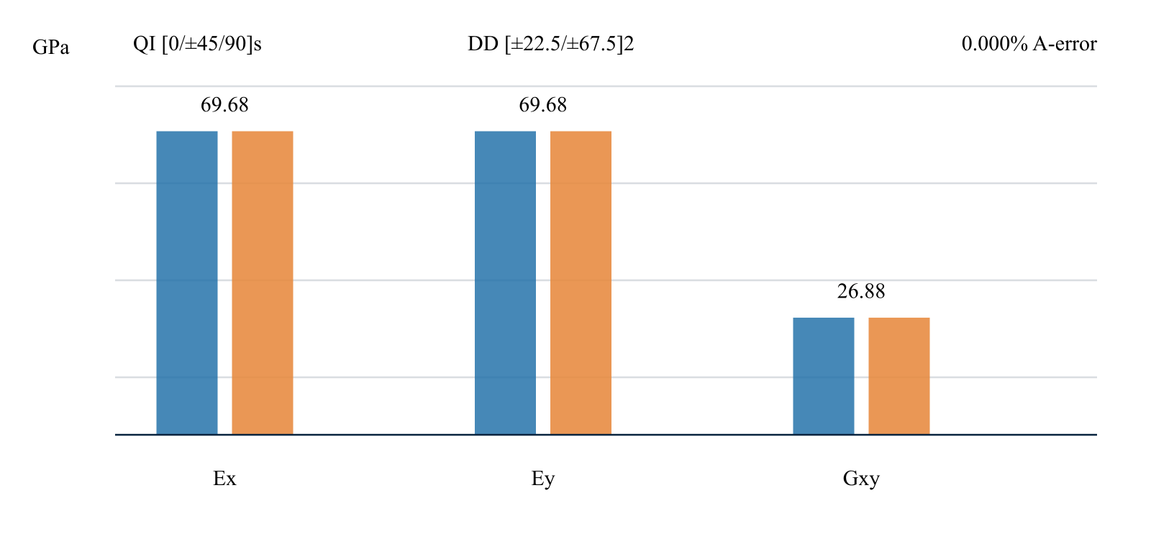
What the result shows
The 7.5° grid search reproduces Ex, Ey, Gxy, and the full A matrix to numerical precision.
Result basis CDS search · Tsai DD construction . Values and trends reproduce this page’s example; this is not a fresh solver result or an additional validation claim.
L03 NASA reported plateaus

Thick-laminate toughness plateaus
Compare reported thickness-independent fracture-toughness regions for three T300/5208 laminate families before selecting a layup for damage-tolerant design.
Sources and theory ( 1 )
Harris & Morris (1984), NASA CR-3784
L03 Thick-laminate toughness plateaus Illustrated example · not a live run
Ply properties
Laminates
Response

1 Inputs
01
8–120 plies
02
(0/90)ns
03
(0/±45/90)ns
04
(0/±45)ns
Keep these conditions unchanged when comparing with the answer.

2 Output visualization
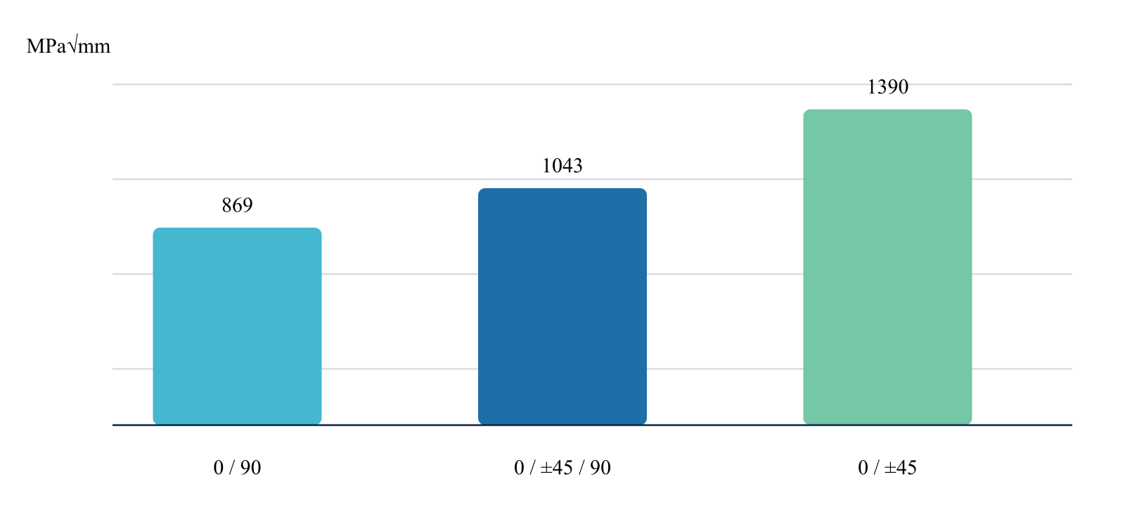
What the result shows
Reported plateaus range from 869 to 1390 MPa√mm; the 0/±45 family is highest.
Result basis NASA reported plateaus . Values and trends reproduce this page’s example; this is not a fresh solver result or an additional validation claim.
L04 CDS r15 ABD assembly

Symmetric versus unsymmetric coupling
Assemble ABD matrices for symmetric and unsymmetric stacks and compare the normalized extension–bending coupling magnitude.
Sources and theory ( 1 )
CDS laminate framework and ABD theory
L04 Symmetric versus unsymmetric coupling Illustrated example · not a live run
Ply properties
Laminates
Response

1 Inputs
01
[0/45/−45/90]s versus [0/45/90/−45]
02
0.125 mm plies
Keep these conditions unchanged when comparing with the answer.

2 Output visualization
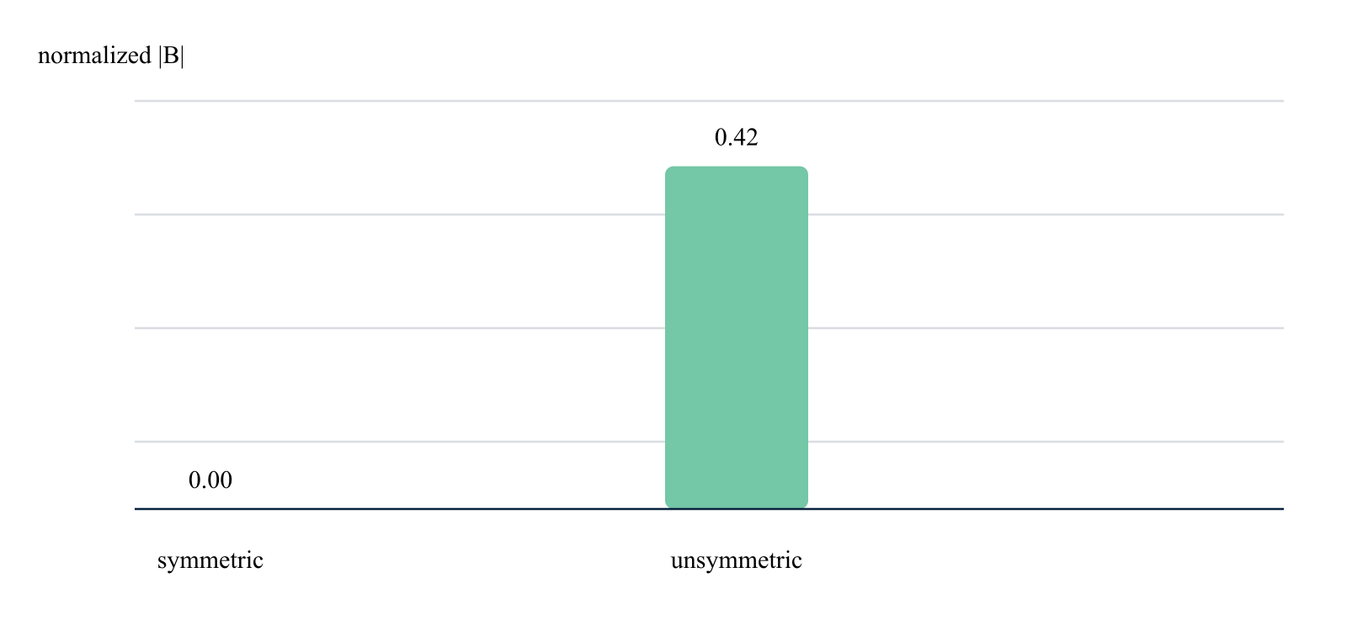
What the result shows
The symmetric stack returns zero B coupling while the unsymmetric stack retains a normalized coupling magnitude of 0.42.
Result basis CDS r15 ABD assembly . Values and trends reproduce this page’s example; this is not a fresh solver result or an additional validation claim.
L05 CDS r15 hygrothermal CLT solve

Thermal-curvature comparison
Apply the same through-thickness temperature change to balanced stacks with different symmetry and recover free laminate curvature.
Sources and theory ( 1 )
CDS hygrothermal laminate equations
L05 Thermal-curvature comparison Illustrated example · not a live run
Ply properties
Laminates
Response

1 Inputs
01
ΔT 80 K
02
symmetric, mildly unsymmetric, and strongly unsymmetric stacks
Keep these conditions unchanged when comparing with the answer.

2 Output visualization
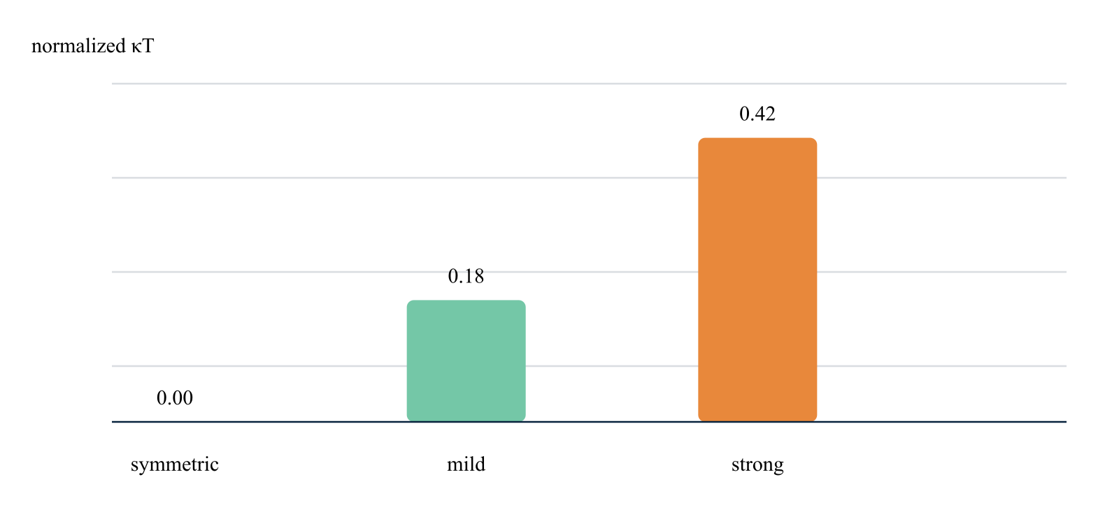
What the result shows
The symmetric laminate remains flat while increasing unsymmetry raises normalized thermal curvature to 0.42.
Result basis CDS r15 hygrothermal CLT solve . Values and trends reproduce this page’s example; this is not a fresh solver result or an additional validation claim.
L06 CDS r15 through-thickness recovery

Ply stress recovery by orientation
Recover local material-axis stresses through a quasi-isotropic stack under a common axial membrane load.
Sources and theory ( 1 )
CDS laminate stress recovery equations
L06 Ply stress recovery by orientation Illustrated example · not a live run
Ply properties
Laminates
Response

1 Inputs
01
[0/45/−45/90]s
02
Nx 300 N/mm
03
T300/5208
Keep these conditions unchanged when comparing with the answer.

2 Output visualization
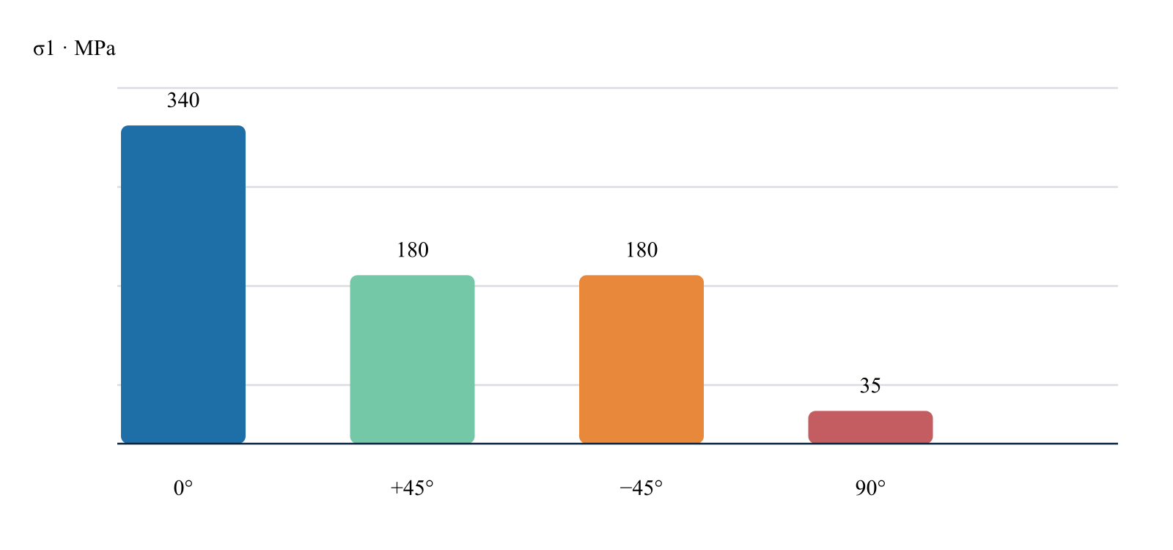
What the result shows
The 0° plies carry the largest local longitudinal stress while the 90° ply response remains transverse-dominated.
Result basis CDS r15 through-thickness recovery . Values and trends reproduce this page’s example; this is not a fresh solver result or an additional validation claim.
L07 CDS r15 progressive same-load loop

Progressive damage load path
Increase membrane load through the same-load progressive solver and track the governing failure index before and after initiation.
Sources and theory ( 1 )
CDS progressive update algorithm
L07 Progressive damage load path Illustrated example · not a live run
Ply properties
Laminates
Response

1 Inputs
01
QI-8
02
normalized load 0.25–1.25
03
Tsai–Wu with stiffness degradation
Keep these conditions unchanged when comparing with the answer.

2 Output visualization
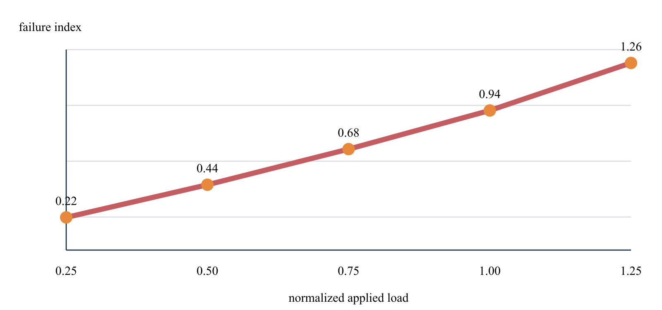
What the result shows
The governing index reaches 0.94 near the reference load and crosses unity at the next increment.
Result basis CDS r15 progressive same-load loop . Values and trends reproduce this page’s example; this is not a fresh solver result or an additional validation claim.
L08 CDS r15 effective-property assembly

Laminate transport-property assembly
Combine ply-level conductivity and density into reusable laminate properties for process and structural analyses.
Sources and theory ( 1 )
CDS effective laminate properties
L08 Laminate transport-property assembly Illustrated example · not a live run
Ply properties
Laminates
Response

1 Inputs
01
UD, quasi-isotropic, and cross-ply stacks
02
identical constituents and thickness
Keep these conditions unchanged when comparing with the answer.

2 Output visualization
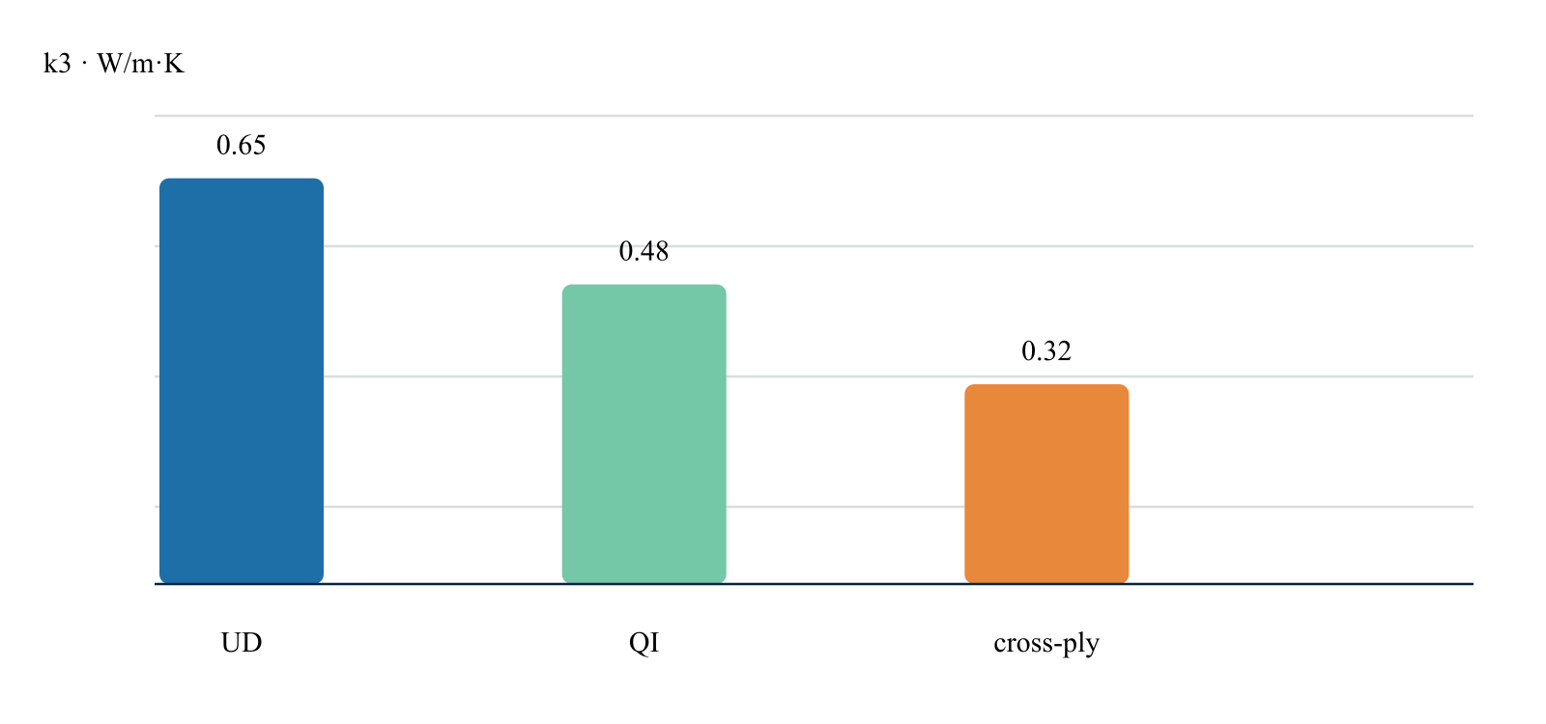
What the result shows
Orientation changes the effective through-thickness transport response while the constituent-derived mass basis remains consistent.
Result basis CDS r15 effective-property assembly . Values and trends reproduce this page’s example; this is not a fresh solver result or an additional validation claim.
Workbench availability: released models, inputs and compatible study paths . The wider theory library includes reference formulations not available in every Workbench solve.

9 Micromechanics Solver-visible results
Online chapter
Translate constituent, fiber-form, and published lamina data into solver-ready engineering properties. Every case identifies its inputs, calculated readout, provenance, and primary technical sources.
Traceable by design. Published values are transcribed from linked primary sources. CDS plots are calculated or reconstructed from the stated inputs and are clearly labeled.
Example class

Micromechanics
Translate constituent, fiber-form, and published lamina data into solver-ready engineering properties.
M01 Published material data

T300/5208 orthotropic property baseline
Load a published carbon/epoxy lamina dataset and inspect the stiffness contrast that drives every downstream laminate calculation.
Sources and theory ( 1 )
Hu et al. (2015), T300/5208 property table
M01 T300/5208 orthotropic property baseline Illustrated example · not a live run
Materials
Micro
Properties

1 Inputs
01
E1 181 GPa
02
E2 10.3 GPa
03
G12 7.17 GPa
04
G23 3.78 GPa
Keep these conditions unchanged when comparing with the answer.

2 Output visualization
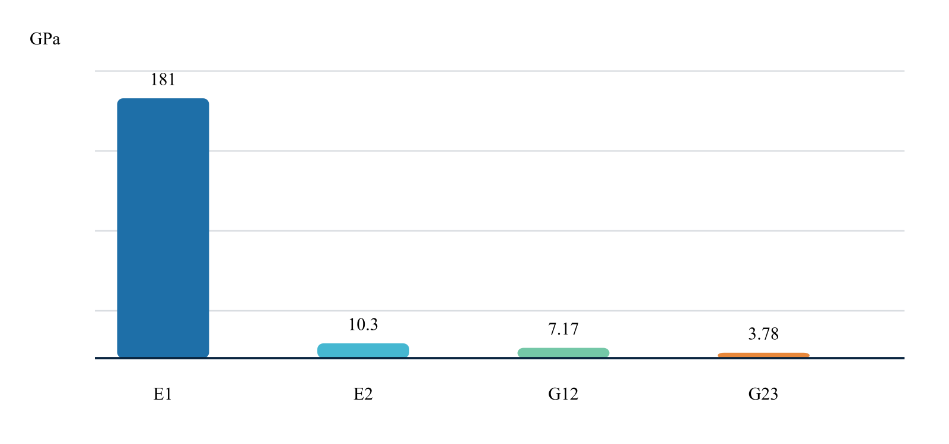
What the result shows
The longitudinal modulus is 17.6× E2, making orientation the dominant design variable.
Result basis Published material data . Values and trends reproduce this page’s example; this is not a fresh solver result or an additional validation claim.
M02 Published inputs · CDS comparison

T300/5208 strength-allowable map
Route tension, compression, and in-plane shear allowables into the failure-criterion block without hiding material-axis asymmetry.
Sources and theory ( 1 )
Hu et al. (2015), T300/5208 property table
M02 T300/5208 strength-allowable map Illustrated example · not a live run
Materials
Micro
Properties

1 Inputs
01
Xt/Xc 1500 MPa
02
Yt 40 MPa
03
Yc 246 MPa
04
S12 68 MPa
Keep these conditions unchanged when comparing with the answer.

2 Output visualization
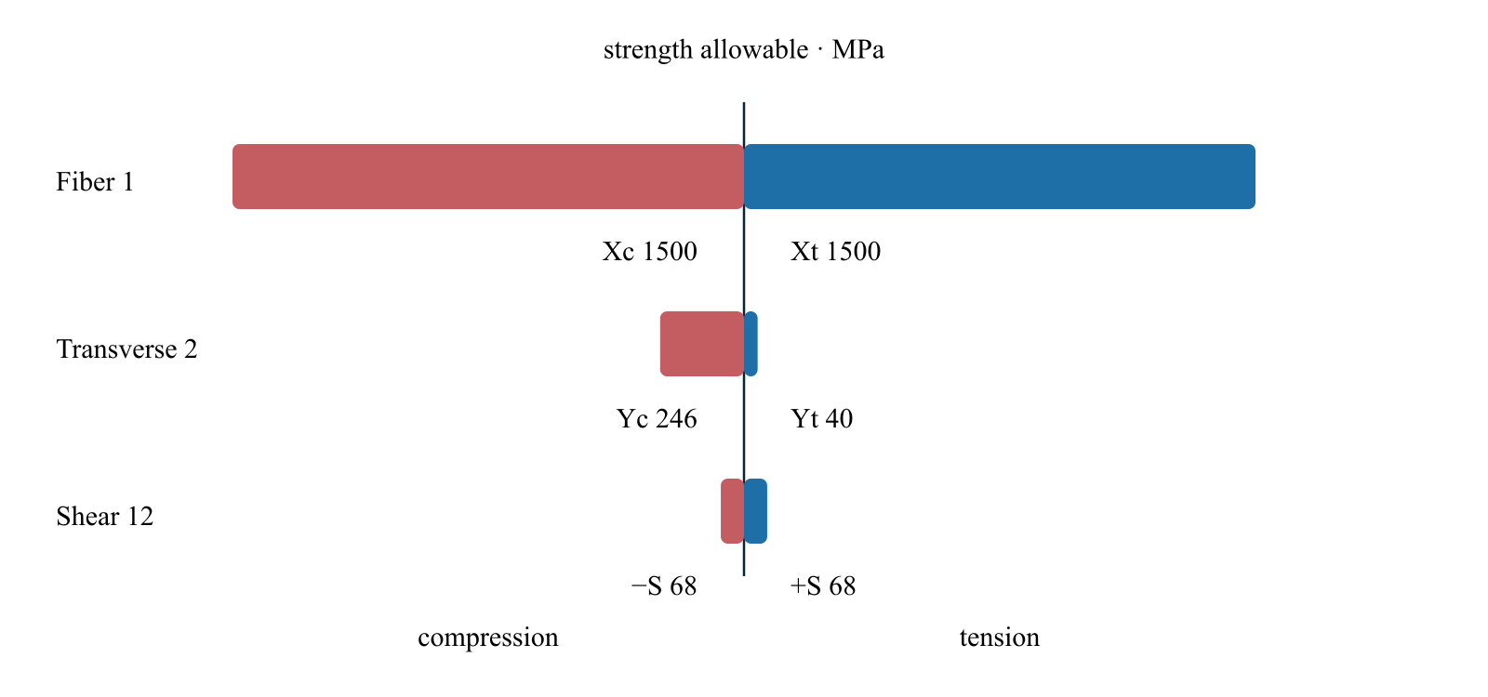
What the result shows
Transverse tensile strength is the controlling allowable at only 2.7% of Xt.
Result basis Published inputs · CDS comparison . Values and trends reproduce this page’s example; this is not a fresh solver result or an additional validation claim.
M03 Reported performance thresholds

Aligned discontinuous TuFF translation
Represent a highly aligned short-fiber material as a micromechanics case instead of treating discontinuous reinforcement as automatically low performance.
Sources and theory ( 2 )
TuFF aligned-fiber composite patent
Heider et al. (2019), TuFF microstructure
M03 Aligned discontinuous TuFF translation Illustrated example · not a live run
Materials
Micro
Properties

1 Inputs
01
IM7/PEI
02
3 mm fiber
03
≥50% fiber volume
04
controlled alignment
Keep these conditions unchanged when comparing with the answer.

2 Output visualization
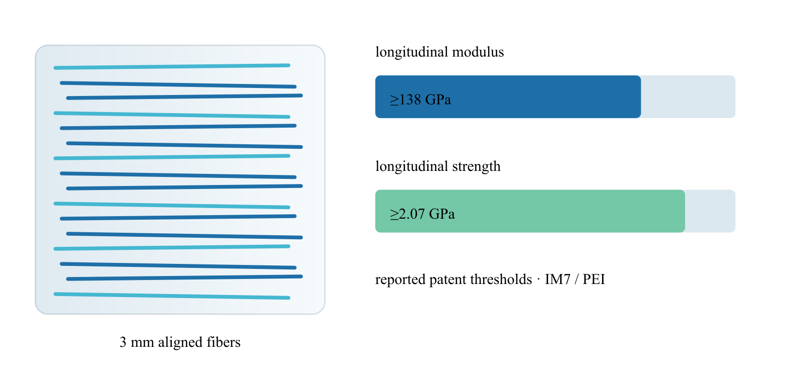
What the result shows
Reported thresholds exceed 138 GPa modulus and 2.07 GPa longitudinal strength.
Result basis Reported performance thresholds . Values and trends reproduce this page’s example; this is not a fresh solver result or an additional validation claim.
M04 CDS parametric reproduction

Fiber-length efficiency sweep
Use the Cox shear-lag relation to see how load-transfer efficiency changes when an aligned discontinuous architecture moves from sub-millimeter to multi-millimeter fibers.
Sources and theory ( 2 )
Cox (1952), shear-lag formulation
Yu et al. (2014), 3 mm HiPerDiF alignment data
M04 Fiber-length efficiency sweep Illustrated example · not a live run
Materials
Micro
Properties

1 Inputs
01
0.5–6 mm length sweep
02
β = 1.6 mm⁻¹
03
aligned-fiber case
Keep these conditions unchanged when comparing with the answer.

2 Output visualization
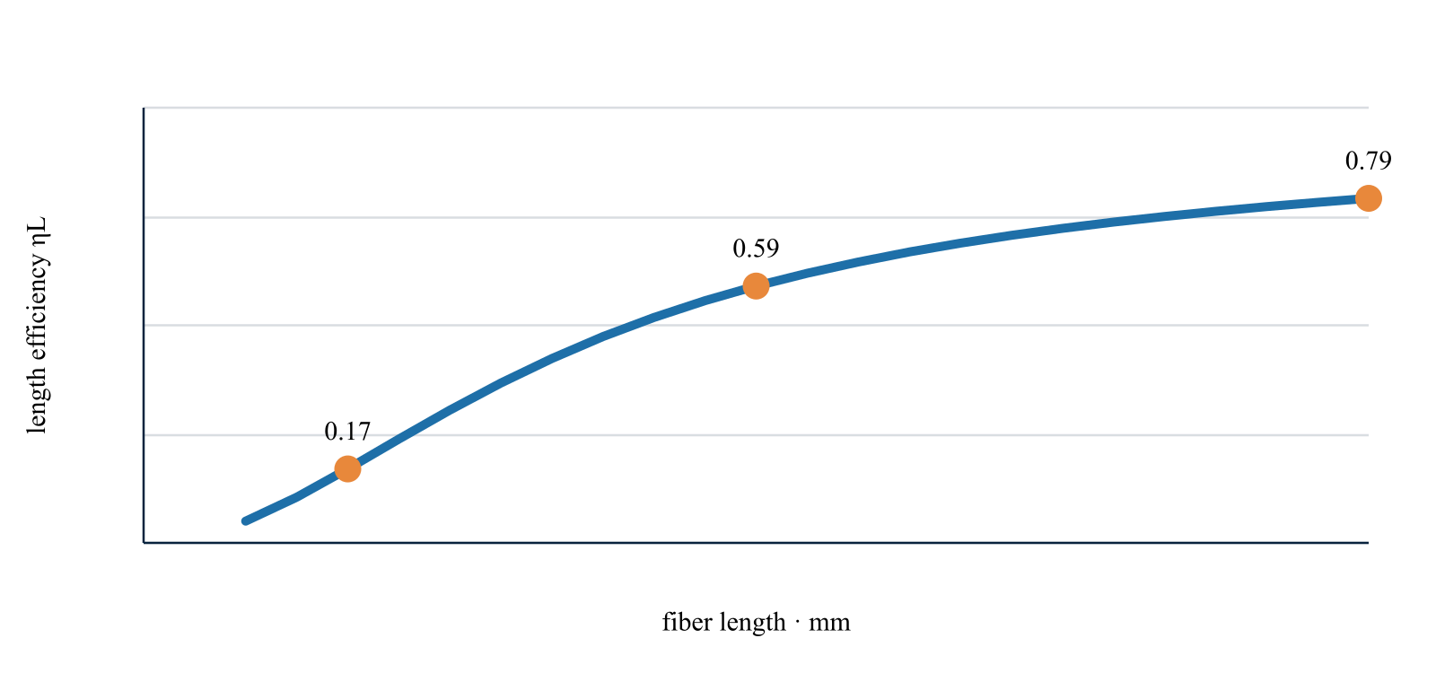
What the result shows
The CDS parametric curve increases from ηL 0.05 at 0.5 mm to 0.79 at 6 mm.
Result basis CDS parametric reproduction . Values and trends reproduce this page’s example; this is not a fresh solver result or an additional validation claim.
M05 CDS r15 micromechanics sweep

Fiber-volume stiffness sweep
Run the continuous-fiber property route while increasing fiber volume fraction and retaining the same carbon-fiber and epoxy records.
Sources and theory ( 1 )
CDS elastic micromechanics implementation
M05 Fiber-volume stiffness sweep Illustrated example · not a live run
Materials
Micro
Properties

1 Inputs
01
Ef1 230 GPa
02
Em 3.5 GPa
03
Vf 0.35–0.65
04
longitudinal ROM route
Keep these conditions unchanged when comparing with the answer.

2 Output visualization
What the result shows
The solver increases E1 from 82.8 to 150.7 GPa across the selected fiber-volume range.
Result basis CDS r15 micromechanics sweep . Values and trends reproduce this page’s example; this is not a fresh solver result or an additional validation claim.
M06 CDS r15 constituent-compliance solve

Transverse modulus sensitivity
Compare the weaker transverse load path as reinforcement content rises, using the solver's constituent compliance route.
Sources and theory ( 1 )
CDS homogenization models
M06 Transverse modulus sensitivity Illustrated example · not a live run
Materials
Micro
Properties

1 Inputs
01
Ef2 15 GPa
02
Em 3.5 GPa
03
Vf 0.35–0.65
Keep these conditions unchanged when comparing with the answer.

2 Output visualization
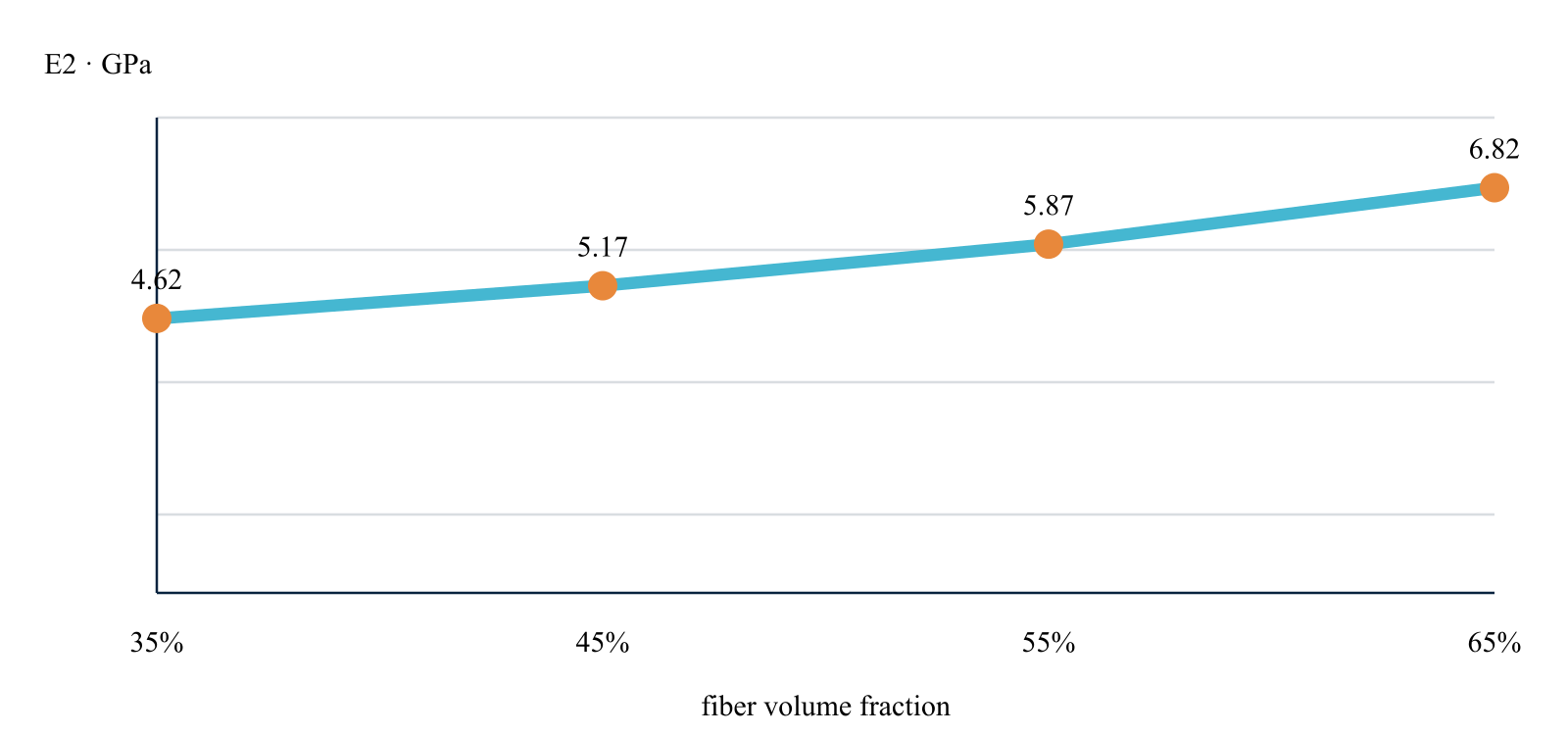
What the result shows
E2 increases from 4.62 to 6.82 GPa, far more slowly than E1 because matrix compliance remains dominant.
Result basis CDS r15 constituent-compliance solve . Values and trends reproduce this page’s example; this is not a fresh solver result or an additional validation claim.
M07 CDS r15 architecture modifier

Void-content stiffness knockdown
Activate the void correction and quantify how manufacturing porosity reduces the resolved longitudinal ply modulus.
Sources and theory ( 1 )
CDS void and defect corrections
M07 Void-content stiffness knockdown Illustrated example · not a live run
Materials
Micro
Properties

1 Inputs
01
Baseline E1 128.1 GPa
02
void fraction 0–5%
03
CDS void modifier
Keep these conditions unchanged when comparing with the answer.

2 Output visualization
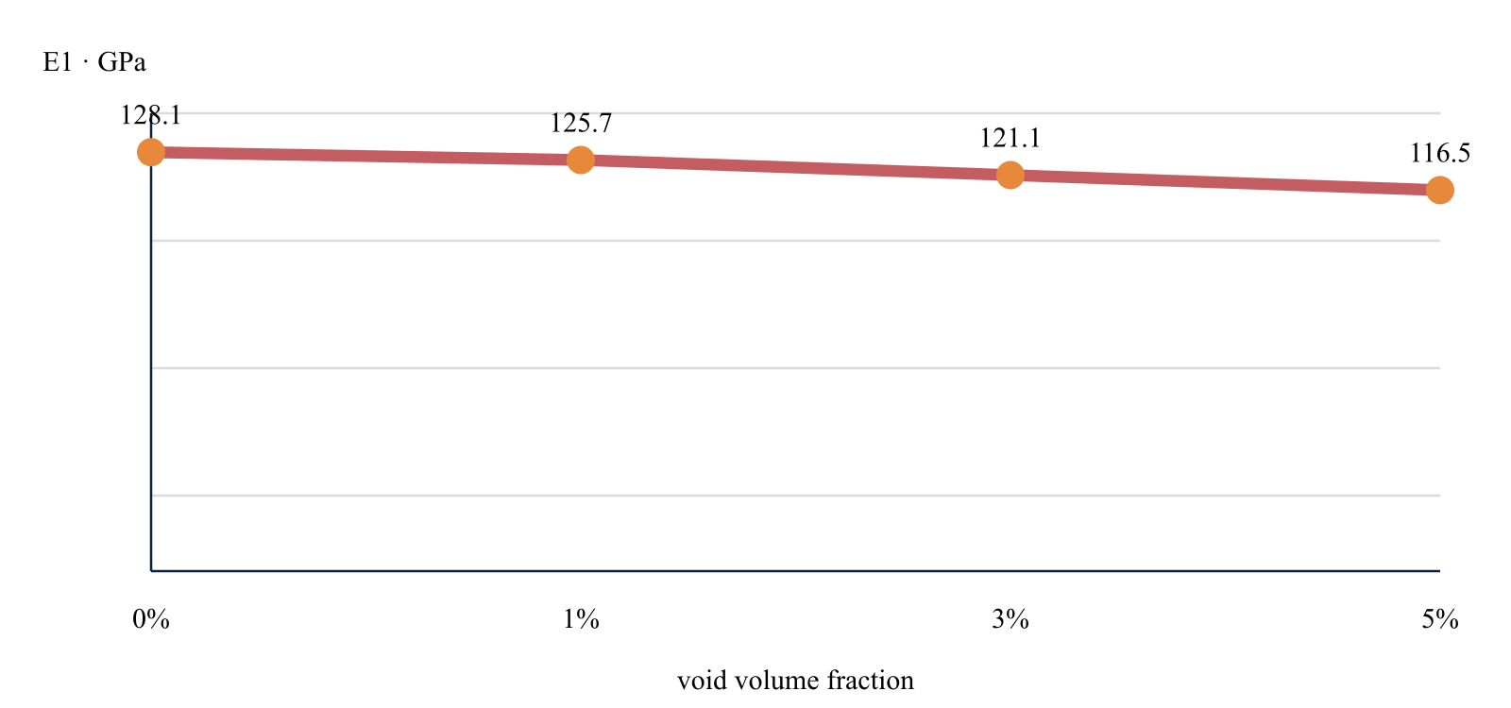
What the result shows
The example correction reduces E1 to 116.5 GPa at 5% void content.
Result basis CDS r15 architecture modifier . Values and trends reproduce this page’s example; this is not a fresh solver result or an additional validation claim.
M08 CDS r15 orientation-tensor route

Fiber-alignment efficiency
Exercise the orientation correction with a controlled misalignment sweep for an otherwise identical aligned-fiber material.
Sources and theory ( 1 )
CDS orientation and architecture theory
M08 Fiber-alignment efficiency Illustrated example · not a live run
Materials
Micro
Properties

1 Inputs
01
Mean misalignment 0–15°
02
fourth-order longitudinal orientation factor
Keep these conditions unchanged when comparing with the answer.

2 Output visualization
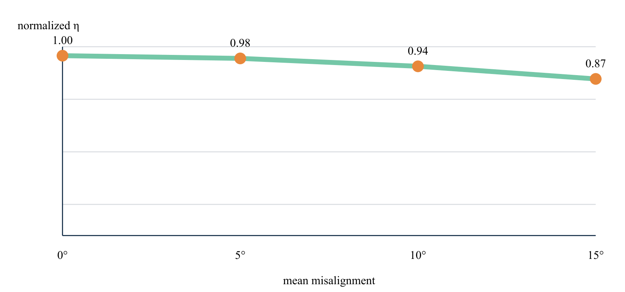
What the result shows
The normalized longitudinal efficiency falls from 1.00 to 0.87 at 15° misalignment.
Result basis CDS r15 orientation-tensor route . Values and trends reproduce this page’s example; this is not a fresh solver result or an additional validation claim.
M09 CDS r15 textile architecture route

Woven crimp correction
Route a balanced woven reinforcement through the crimp modifier to separate ideal tow stiffness from the manufactured fabric response.
Sources and theory ( 1 )
CDS woven and textile models
M09 Woven crimp correction Illustrated example · not a live run
Materials
Micro
Properties

1 Inputs
01
Balanced 0/90 fabric
02
crimp angle 0–15°
03
equal tow fractions
Keep these conditions unchanged when comparing with the answer.

2 Output visualization
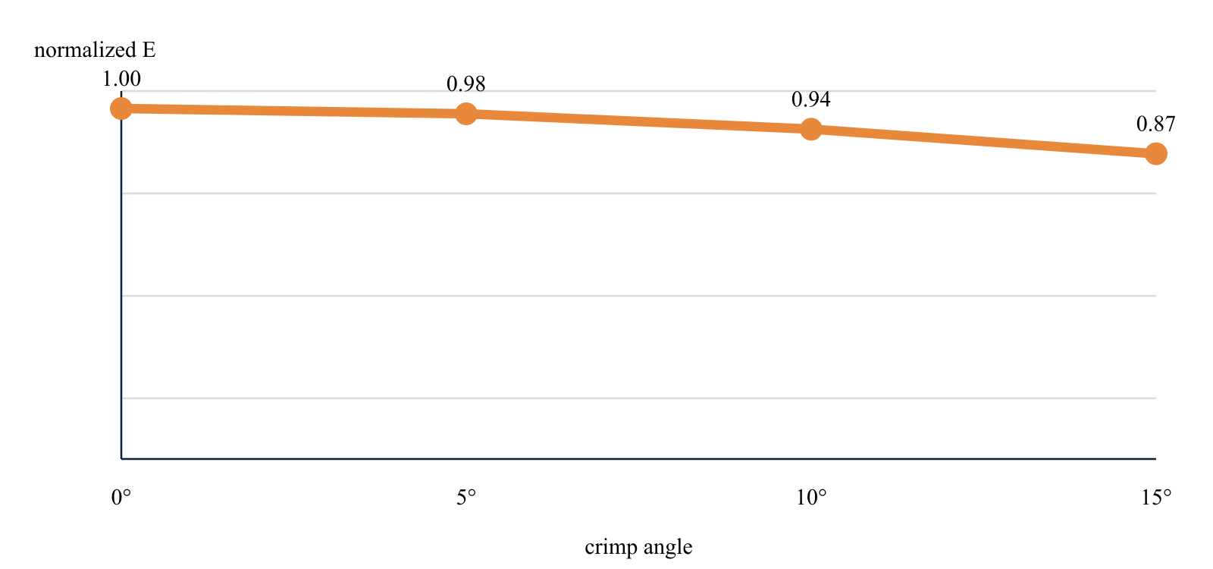
What the result shows
Increasing crimp progressively lowers the normalized in-plane stiffness to 0.87.
Result basis CDS r15 textile architecture route . Values and trends reproduce this page’s example; this is not a fresh solver result or an additional validation claim.
M10 CDS r15 thermophysical property solve

Directional thermal conductivity
Resolve the longitudinal transport property set passed from micromechanics into the transient process solver.
Sources and theory ( 1 )
CDS thermal-property assembly
M10 Directional thermal conductivity Illustrated example · not a live run
Materials
Micro
Properties

1 Inputs
01
kf1 10 W/m·K
02
km 0.2 W/m·K
03
Vf 0.40–0.70
Keep these conditions unchanged when comparing with the answer.

2 Output visualization
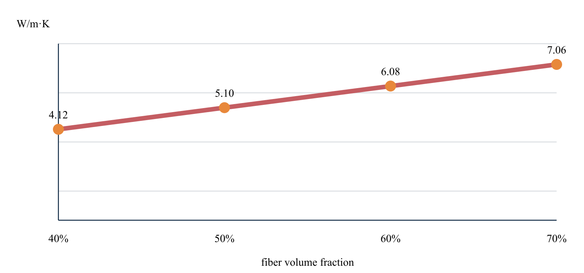
What the result shows
The longitudinal conductivity rises from 4.12 to 7.06 W/m·K as fiber content increases.
Result basis CDS r15 thermophysical property solve . Values and trends reproduce this page’s example; this is not a fresh solver result or an additional validation claim.
Workbench availability: released models, inputs and compatible study paths . The wider theory library includes reference formulations not available in every Workbench solve.

10 Open Inspect Run and adapt
Online chapter
Download compact input datasets and executable solver examples for micromechanics, laminates, plates, cylinders, and beam sections.
Constituent-to-ply · inputs File contents · not solved results
Field | Stored value
Fiber / matrix | Carbon fiber / Epoxy
Fiber volume fraction | 0.58
Void volume fraction | 0.02
Model | Continuous unidirectional

Input preview from cds-lamina-starter.csv . No modulus result is stored in this file.
Symmetric plate · ply stack File contents · not solved results
Ply | Angle | Thickness
1 | 0 ° | 0.125 mm
2 | 45 ° | 0.125 mm
3 | -45 ° | 0.125 mm
4 | 90 ° | 0.125 mm
5 | 90 ° | 0.125 mm
6 | -45 ° | 0.125 mm
7 | 45 ° | 0.125 mm
8 | 0 ° | 0.125 mm

Eight-ply CSV · 1.0 mm total thickness. Thermal and moisture increments start at zero.
Cylinder · geometry and load File contents · not solved results
Field | Stored value
Radius / length | 250 / 1000 mm
Internal pressure | 2.5 MPa
Axial force / torque | 0 N / 0 N·m
Temperature | 23 °C
End condition | Closed

Input preview from cds-cylinder-load-case.csv . Run a compatible solver to obtain the response.
Starter files
6 direct downloads
01 Lamina / CSV

Constituent-to-ply starter
A compact carbon-fiber and epoxy definition for beginning a continuous unidirectional micromechanics study.
- Fiber and matrix assignment
- Volume fractions
- Model selection
cds-lamina-starter.csv ↓
02 Laminate / CSV

Symmetric plate layup
An eight-ply quasi-isotropic stacking sequence with orientation, thickness, and environmental fields.
- Eight-ply stack
- Symmetric layup
- Thermal and moisture fields
cds-laminate-plate.csv ↓
03 Structural / CSV

Cylinder pressure case
A starter pressure-vessel case with geometry, pressure, loading, temperature, and end-condition inputs.
- Cylinder geometry
- Pressure and load inputs
- Closed-end condition
cds-cylinder-load-case.csv ↓
04 Script / M

Plate web-request example
A Web r18 simply supported composite plate with center point load, pressure, stability, and vibration outputs.
- Structured request
- Point + distributed load
- Named structural results
example_plate_web_r18.m ↓
05 Script / M

Cylinder web-request example
The same pressure-cylinder Recipe evaluated with constant-section shell and Hyer thick-wall formulations.
- Structured request
- Shell / Hyer toggle
- Named cylinder results
example_cylinder_web_r18.m ↓
06 Script / M

Beam web-request example
A fixed-fixed laminated I-beam with section, response, energy, buckling, and frequency calculations.
- Structured request
- Five section families
- A/I/J + EI outputs
example_beam_web_r18.m ↓
Engineering use: Verify units, material provenance, boundary conditions, release compatibility, and governing allowables before using any example in a design decision.

11 CDS Training Manual learn by completing a study
Online chapter
One curriculum shared with Workbench. Choose an exercise, follow its tasks, check the expected behavior, and keep evidence of your results. The User Guide explains the controls; the Theory Manual explains the mathematics.
Current Workbench, reference editions and downloads
Use the online User Guide for current controls, the released model directory for selectable models and compatibility, and the Training Manual for connected exercises. Wider theory references do not mean every formulation is enabled in Workbench.
Dated GUI captures and compiled Web r18 PDF manuals retain their stated scope; they are not a substitute for current hosted Workbench instructions. Find the overview PDF, guides and exercise databases in Your CDS library .

Exercise curriculum
Shared CDS database
CREATE Design a starting point
DISCOVER Explore the live laminate
SIMULATE Launch Workbench
Search exercises
Application
Model
Geometry
Resource type
Group / sort by
104 of 104 resources
Exercises
Click to preview · double-click or Enter to open in Workbench.
Two-row simulation workflow · Open full-size map
Linked-input preview, not solved results. Gray blocks are not configured.
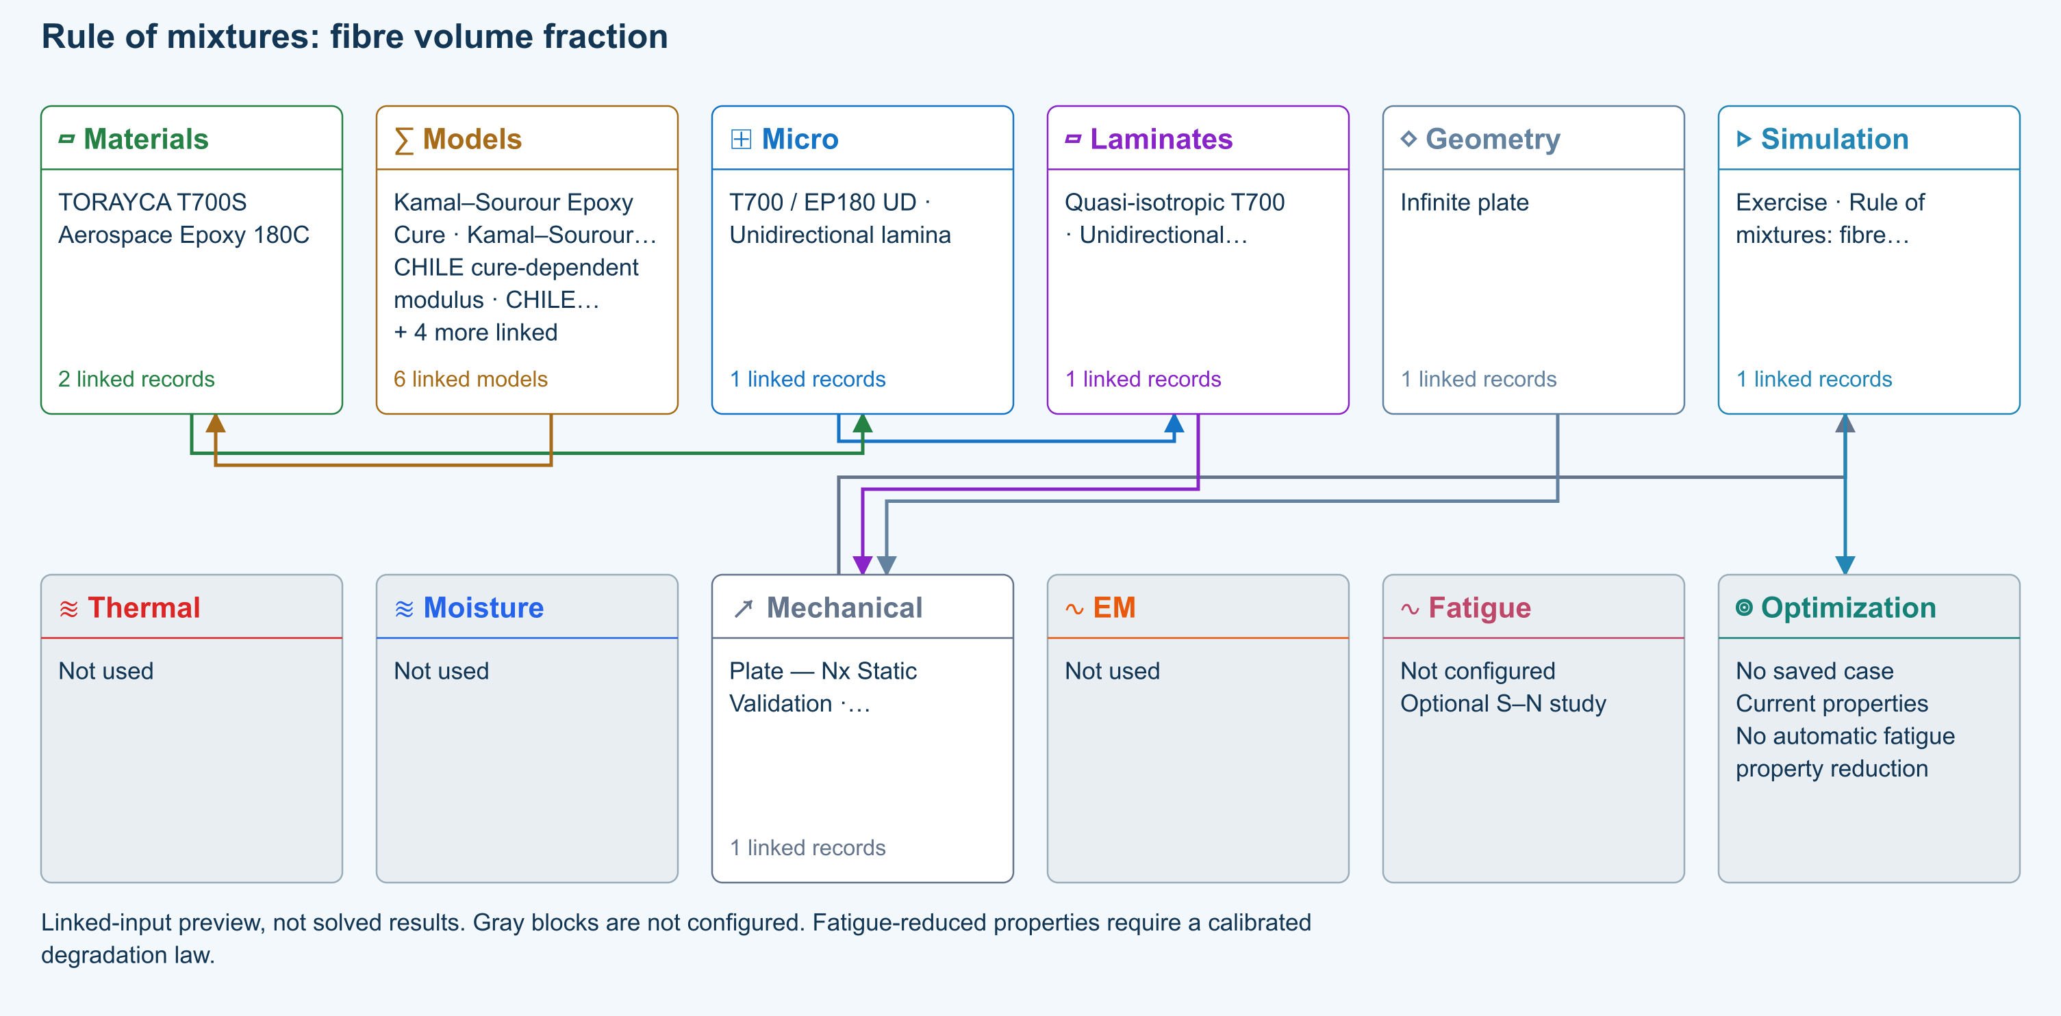
∑ Selected models & submodels
These are the exercise’s linked choices, not solved results. Open a first-layer model to see its submodels and scope.
Kamal–Sourour autocatalytic · Kamal–Sourour Epoxy Cure
Reusable material model. It contributes only when assigned to a material used by this simulation; separate model records can supply independent properties.
Calibration & applicability
Illustrative model defaults — replace with characterized resin kinetics
∑ Theory & assumptions
CHILE (degree of cure) · CHILE cure-dependent modulus
Reusable material model. It contributes only when assigned to a material used by this simulation; separate model records can supply independent properties. Cure-dependent modulus does not automatically scale strength allowables.
Calibration & applicability
CHILE(α), section 2.4 of Materials 2019, 12, 259. Example parameters, not measured EP180 data. Fixed Poisson ratio; no viscoelastic relaxation or Tg softening. Incremental elastic stress integration at saved process intervals: check time-step convergence. Strength allowables are independent measured inputs, not scaled with modulus.
∑ Theory & assumptions
Temperature-dependent tabular · Temperature-dependent Thermal
Reusable material model. It contributes only when assigned to a material used by this simulation; separate model records can supply independent properties. Micro uses the 23 °C reference; Process evaluates the same table at local temperature, without extrapolation.
Calibration & applicability
Check source data, applicable environment and validity limits in the model record; saved defaults are not experimental validation.
∑ Theory & assumptions
1D Fickian diffusion · Layered Fickian Diffusion
Reusable material model. It contributes only when assigned to a material used by this simulation; separate model records can supply independent properties.
Calibration & applicability
Check source data, applicable environment and validity limits in the model record; saved defaults are not experimental validation.
∑ Theory & assumptions
Rule of mixtures · T700 / EP180 UD · Unidirectional lamina
One compatible homogenization model per Micro recipe. Separate recipes compare models; their predictions are not blended.
∑ Theory & assumptions
CLT · Linear static with failure indices · Plate — Nx Static Validation · Unidirectional lamina
Shared laminate stiffness drives this membrane/CLT path. Failure criteria are independent comparisons, not blended models. Fatigue is a separate assessment.
Failure criterion · Maximum stress
Primary criterion. Additional envelope comparisons are chosen in Response → Failure; they run independently.
∑ Theory & assumptions
Data travelling between blocks
Micro → Laminates
Predicted ply stiffness, strength, density and expansion properties.
Materials → Micro
Constituent stiffness, strength, density and thermal / moisture properties.
Models → Materials
Model choices and calibrated parameters.
Mechanical → Simulation
SIMULATION selects this case and its analysis model; the case owns its applicable cycle and input references.
Laminates → Mechanical
Ply angles and thicknesses, stiffness, mass and ply properties.
Geometry → Mechanical
Shape and dimensions for the selected structural analysis.
Simulation → Optimization
Linked inputs and current-property response for candidate evaluation.
Exercise
20
min

Rule of mixtures fibre volume fraction
1. Getting started · 01-rom
Application
Unidirectional lamina
Models
Rule of mixtures · Voigt · Reuss
Geometry
Infinite plate
Open in Workbench Database downloads in user portal →

Reference validation 2026-09-18
Benchmark validated — analytical scope
Listed reference-elastic extensional constants only; free curvature, ply stresses, strength and every user variation are outside this badge.
Recorded baseline only—not a certification of the current database, edited inputs, or every output. Analytical agreement is not experimental material or failure validation.
Source validation, comparisons and tested inputs
Execution: Completed (not validation)
Quantity | CDS | Reference | Error % | Tolerance (relative + absolute) | Result
Ex ( GPa ) | 51.01956 | 51.01956 | 0.000001713727 | 0.01 % + 0.00002 GPa | Pass
Ey ( GPa ) | 51.01956 | 51.01956 | 0.000001713727 | 0.01 % + 0.00002 GPa | Pass
Gxy ( GPa ) | 19.35659 | 19.35659 | -0.000002845679 | 0.01 % + 0.00002 GPa | Pass
νxy ( — ) | 0.31789 | 0.317886 | 0.001260455 | 0.01 % + 0.00002 — | Pass
Micro E1 ( GPa ) | 139.38 | 139.38 | 0 | 0.01 % + 0.00002 GPa | Pass
Micro E2 ( GPa ) | 6.41264 | 6.412639 | 0.000009275362 | 0.01 % + 0.00002 GPa | Pass
Micro G12 ( GPa ) | 2.98755 | 2.987552 | -0.0000625 | 0.01 % + 0.00002 GPa | Pass
Micro ν12 ( — ) | 0.26 | 0.26 | 0 | 0.01 % + 0.00002 — | Pass

- MIT / David Roylance — Laminated Composite Plates Transformed plane-stress constitutive law and laminate extensional stiffness, equations 10–11 and 20–25 . Independent strain/stress transformation and thickness integration; prescribed input elasticity is not validated.
- MIT / David Roylance — Introduction to Composites Equations 1–3, printed pages 3–4 . Published analytical equations; not experimental material validation.

Tested inputs
Reference ply list (GPa, mm, degrees)
[{"e1":139.38,"e2":6.4126394052044615,"g":2.987551867219917,"nu":0.26,"angle":45,"t":0.125},{"e1":139.38,"e2":6.4126394052044615,"g":2.987551867219917,"nu":0.26,"angle":0,"t":0.125},{"e1":139.38,"e2":6.4126394052044615,"g":2.987551867219917,"nu":0.26,"angle":-45,"t":0.125},{"e1":139.38,"e2":6.4126394052044615,"g":2.987551867219917,"nu":0.26,"angle":90,"t":0.125},{"e1":139.38,"e2":6.4126394052044615,"g":2.987551867219917,"nu":0.26,"angle":45,"t":0.125},{"e1":139.38,"e2":6.4126394052044615,"g":2.987551867219917,"nu":0.26,"angle":0,"t":0.125},{"e1":139.38,"e2":6.4126394052044615,"g":2.987551867219917,"nu":0.26,"angle":-45,"t":0.125},{"e1":139.38,"e2":6.4126394052044615,"g":2.987551867219917,"nu":0.26,"angle":90,"t":0.125},{"e1":139.38,"e2":6.4126394052044615,"g":2.987551867219917,"nu":0.26,"angle":90,"t":0.125},{"e1":139.38,"e2":6.4126394052044615,"g":2.987551867219917,"nu":0.26,"angle":-45,"t":0.125},{"e1":139.38,"e2":6.4126394052044615,"g":2.987551867219917,"nu":0.26,"angle":0,"t":0.125},{"e1":139.38,"e2":6.4126394052044615,"g":2.987551867219917,"nu":0.26,"angle":45,"t":0.125},{"e1":139.38,"e2":6.4126394052044615,"g":2.987551867219917,"nu":0.26,"angle":90,"t":0.125},{"e1":139.38,"e2":6.4126394052044615,"g":2.987551867219917,"nu":0.26,"angle":-45,"t":0.125},{"e1":139.38,"e2":6.4126394052044615,"g":2.987551867219917,"nu":0.26,"angle":0,"t":0.125},{"e1":139.38,"e2":6.4126394052044615,"g":2.987551867219917,"nu":0.26,"angle":45,"t":0.125}]
Input SHA-256: 33568bf12395e4ef96259f641b50c3640ee6c9b360aa0ef5e4d14898130dbb28
Solver source SHA-256: 30c8a614b6cb004a26da8adaf8ab7c534c37c4d534836921939f35a549e1bcc5
- Ideal continuous, aligned reinforcement with zero voids. This is a teaching comparison, not a measured material allowable.
Download source-validation evidence (JSON) · Full 104 -exercise study

Prepare the study
- Open this exercise in Workbench. Confirm the selected simulation and follow the workflow arrows to its linked records.
- Review the setup note, units, material sources and model limits below. Preserve shared reference records: duplicate a record before making an independent variation.
- Check the connected input summary and any validation notices before running. A preview diagram is not a solved result.

Complete the exercise
- Open the copied Micro record and identify its fibre and matrix materials.
- Set fibre volume fraction to 0.3, 0.5 and 0.7; use Run after each change and record E1, E2 and density from Micro outputs.
- Calculate E1 = Vf Ef + (1 − Vf) Em using the linked constituent moduli and compare with CDS.

Review checkpoints
- At zero void fraction, constituent fractions sum to one.
- Longitudinal modulus follows the linear mixture calculation; distinguish it from the transverse compliance estimate.

Record your conclusion
Save the study with its inputs and capture the relevant output plot or table, units, solver notices and the comparison requested above. State whether each checkpoint was met and explain discrepancies. Claim benchmark validation only where the source-validation panel explicitly supports it.
User Guide · operating the Workbench → · ∑ Theory Manual · equations and assumptions →

Model limits
Ideal continuous, aligned reinforcement with zero voids. This is a teaching comparison, not a measured material allowable.

Reference material
- Create and connect a lamina
- Edit material properties and units
- Run and review a model
- Review effective properties
- Related case study: NASA lamina analysis
How the shared curriculum works
- Read the reference
- Select an exercise from the shared CDS database
- Trace inputs in Simulation
- Run and inspect fields
- Compare checkpoints and record limits
SIMULATION selects the Thermal, Moisture, Mechanical and EM cases to run, with None available in each slot. Geometry owns shared specimen dimensions; Laminate owns plies and thickness. Each case owns one analysis model, its applied conditions and its applicable cycle; there is no separate Process block. Surrounding blocks manage available records. Run updates results; completed does not mean validated or passed.
All 104 exercises select connected records from one shared default database. Opening an exercise does not add duplicate materials. Changes to shared records affect studies using them; duplicate a record for an independent variation. Downloads provide self-contained subsets of that database and require sign-in and an active CDS license. Exercise links open the matching guide; they do not run a solver or replace your database. Historical files remain in a separate portal archive.
Catalogue revision 2026-09-09 . Source-data case studies require the setup and calibration described in their guides.
All exercises, case studies and simulation examples → · Your CDS library: overview, manuals and database downloads →

Choose the run in the SIMULATION block
SIMULATION is the control point for the run. Select a Thermal case, Moisture case, Mechanical case and EM case, or None in any slot. Each selected case shows its analysis model, laminate and applicable geometry.
- Keep candidate records in the surrounding blocks. Adding a candidate does not select it for execution.
- Select the required cases in SIMULATION and review their inputs before Run. At least one case is required.
- Use the same laminate for a supported combined run. Run standalone studies separately with the other selectors set to None.
- Run executes the selected combination. A connection or Used marker is not evidence of a successful solve.
Good practice
Selecting several cases does not add unsupported physics coupling. EM screening studies do not automatically heat the thermal case.

Review every downstream geometry dependency
A geometry record can be shared by several cases and simulations. Editing its dimensions or type affects all linked consumers, including studies that are not currently open. Unrelated records are unchanged.
- After editing geometry, open Solver messages and expand Review affected cases and simulations. Select a linked name to inspect that record.
- Check the selected model, load basis, dimensions and boundary conditions. Loads are not automatically replaced when the geometry changes.
- Resolve incompatible geometry and model combinations before running. An I-section does not turn a plate theory into a beam theory.
- Rerun affected simulations before relying on previous results. Inputs changed warnings indicate that stored results no longer match their connected inputs.
Good practice
Geometry affects only dimensions consumed by the selected model. One-dimensional transport retains its through-thickness assumptions; standalone studies may own their dimensions. Under fixed total edge loads, changing plate width changes force per unit width. Under prescribed resultants, it does not.

Rule of mixtures fibre volume fraction
Online chapter
Unidirectional lamina. Infinite plate. Models: Rule of mixtures, Voigt, Reuss.
Open this exercise in Workbench

Tasks
Open the copied Micro record and identify its fibre and matrix materials.
Set fibre volume fraction to 0.3, 0.5 and 0.7; use Run after each change and record E1, E2 and density from Micro outputs.
Calculate E1 = Vf Ef + (1 − Vf) Em using the linked constituent moduli and compare with CDS.

Checkpoints
At zero void fraction, constituent fractions sum to one.
Longitudinal modulus follows the linear mixture calculation; distinguish it from the transverse compliance estimate.

Model limits
Ideal continuous, aligned reinforcement with zero voids. This is a teaching comparison, not a measured material allowable.

Recorded validation
2026-09-18 — Benchmark validated — analytical scope: Listed reference-elastic extensional constants only; free curvature, ply stresses, strength and every user variation are outside this badge.
Ideal continuous, aligned reinforcement with zero voids. This is a teaching comparison, not a measured material allowable.
Validation evidence and tested inputs

Connected models and submodels
Kamal–Sourour autocatalytic. Reusable material model. It contributes only when assigned to a material used by this simulation; separate model records can supply independent properties.
Theory and assumptions
Calibration & applicability. Illustrative model defaults — replace with characterized resin kinetics
CHILE (degree of cure). Reusable material model. It contributes only when assigned to a material used by this simulation; separate model records can supply independent properties. Cure-dependent modulus does not automatically scale strength allowables.
Theory and assumptions
Calibration & applicability. CHILE(α), section 2.4 of Materials 2019, 12, 259. Example parameters, not measured EP180 data. Fixed Poisson ratio; no viscoelastic relaxation or Tg softening. Incremental elastic stress integration at saved process intervals: check time-step convergence. Strength allowables are independent measured inputs, not scaled with modulus.
Temperature-dependent tabular. Reusable material model. It contributes only when assigned to a material used by this simulation; separate model records can supply independent properties. Micro uses the 23 °C reference; Process evaluates the same table at local temperature, without extrapolation.
Theory and assumptions
Calibration & applicability. Check source data, applicable environment and validity limits in the model record; saved defaults are not experimental validation.
1D Fickian diffusion. Reusable material model. It contributes only when assigned to a material used by this simulation; separate model records can supply independent properties.
Theory and assumptions
Calibration & applicability. Check source data, applicable environment and validity limits in the model record; saved defaults are not experimental validation.
Rule of mixtures. One compatible homogenization model per Micro recipe. Separate recipes compare models; their predictions are not blended.
Theory and assumptions
CLT · Linear static with failure indices. Shared laminate stiffness drives this membrane/CLT path. Failure criteria are independent comparisons, not blended models. Fatigue is a separate assessment.
Theory and assumptions
Failure criterion · Maximum stress. Primary criterion. Additional envelope comparisons are chosen in Response → Failure; they run independently.

Data between modules
Micro to Laminates: Predicted ply stiffness, strength, density and expansion properties.
Materials to Micro: Constituent stiffness, strength, density and thermal / moisture properties.
Models to Materials: Model choices and calibrated parameters.
Mechanical to Simulation: SIMULATION selects this case and its analysis model; the case owns its applicable cycle and input references.
Laminates to Mechanical: Ply angles and thicknesses, stiffness, mass and ply properties.
Geometry to Mechanical: Shape and dimensions for the selected structural analysis.
Simulation to Optimization: Linked inputs and current-property response for candidate evaluation.

References
Create and connect a lamina
Edit material properties and units
Run and review a model
Review effective properties
Related case study: NASA lamina analysis
Record the inputs, units, solver notices and checkpoint results before drawing a conclusion. When exploring a variation, change one factor at a time and compare it with the original case.

Compare transverse micromechanics models
Online chapter
Unidirectional lamina. Infinite plate. Models: Halpin–Tsai, Rule of mixtures.
Open this exercise in Workbench
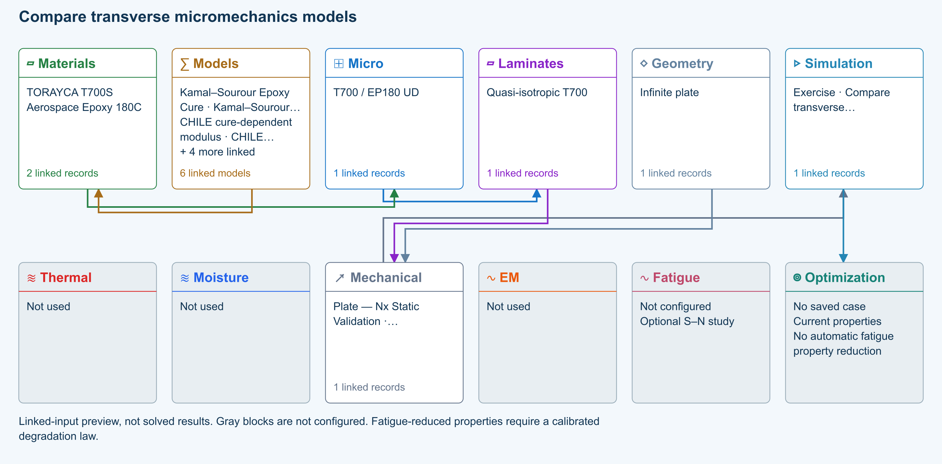

Tasks
Run the supplied Halpin–Tsai Micro recipe and record E1, E2 and G12.
Change only the micromechanics model to Rule of mixtures and rerun.
Restore Halpin–Tsai; vary fibre volume fraction while holding the constituent data fixed.

Checkpoints
Compare transverse and shear predictions at identical fractions.
Explain why different homogenization assumptions give different transverse properties.

Model limits
Use the editable model inputs and their documented assumptions; matching a trend does not validate a strength prediction.

Recorded validation
2026-09-18 — Not benchmark validated: No matched quantitative reference comparison completed for the full exercise.
Use the editable model inputs and their documented assumptions; matching a trend does not validate a strength prediction.
Validation evidence and tested inputs

Connected models and submodels
Kamal–Sourour autocatalytic. Reusable material model. It contributes only when assigned to a material used by this simulation; separate model records can supply independent properties.
Theory and assumptions
Calibration & applicability. Illustrative model defaults — replace with characterized resin kinetics
CHILE (degree of cure). Reusable material model. It contributes only when assigned to a material used by this simulation; separate model records can supply independent properties. Cure-dependent modulus does not automatically scale strength allowables.
Theory and assumptions
Calibration & applicability. CHILE(α), section 2.4 of Materials 2019, 12, 259. Example parameters, not measured EP180 data. Fixed Poisson ratio; no viscoelastic relaxation or Tg softening. Incremental elastic stress integration at saved process intervals: check time-step convergence. Strength allowables are independent measured inputs, not scaled with modulus.
Temperature-dependent tabular. Reusable material model. It contributes only when assigned to a material used by this simulation; separate model records can supply independent properties. Micro uses the 23 °C reference; Process evaluates the same table at local temperature, without extrapolation.
Theory and assumptions
Calibration & applicability. Check source data, applicable environment and validity limits in the model record; saved defaults are not experimental validation.
1D Fickian diffusion. Reusable material model. It contributes only when assigned to a material used by this simulation; separate model records can supply independent properties.
Theory and assumptions
Calibration & applicability. Check source data, applicable environment and validity limits in the model record; saved defaults are not experimental validation.
Halpin–Tsai. One compatible homogenization model per Micro recipe. Separate recipes compare models; their predictions are not blended.
Theory and assumptions
CLT · Linear static with failure indices. Shared laminate stiffness drives this membrane/CLT path. Failure criteria are independent comparisons, not blended models. Fatigue is a separate assessment.
Theory and assumptions
Failure criterion · Maximum stress. Primary criterion. Additional envelope comparisons are chosen in Response → Failure; they run independently.

Data between modules
Micro to Laminates: Predicted ply stiffness, strength, density and expansion properties.
Materials to Micro: Constituent stiffness, strength, density and thermal / moisture properties.
Models to Materials: Model choices and calibrated parameters.
Mechanical to Simulation: SIMULATION selects this case and its analysis model; the case owns its applicable cycle and input references.
Laminates to Mechanical: Ply angles and thicknesses, stiffness, mass and ply properties.
Geometry to Mechanical: Shape and dimensions for the selected structural analysis.
Simulation to Optimization: Linked inputs and current-property response for candidate evaluation.

References
Create and connect a lamina
Review effective properties
Run and review a model
Related case study: NASA lamina analysis
Record the inputs, units, solver notices and checkpoint results before drawing a conclusion. When exploring a variation, change one factor at a time and compare it with the original case.

Short fibers aspect ratio and shear-lag transfer
Online chapter
Aligned short-fiber lamina. Infinite plate. Models: Cox shear-lag elastic, Classical laminate theory, Maximum stress.
Open this exercise in Workbench
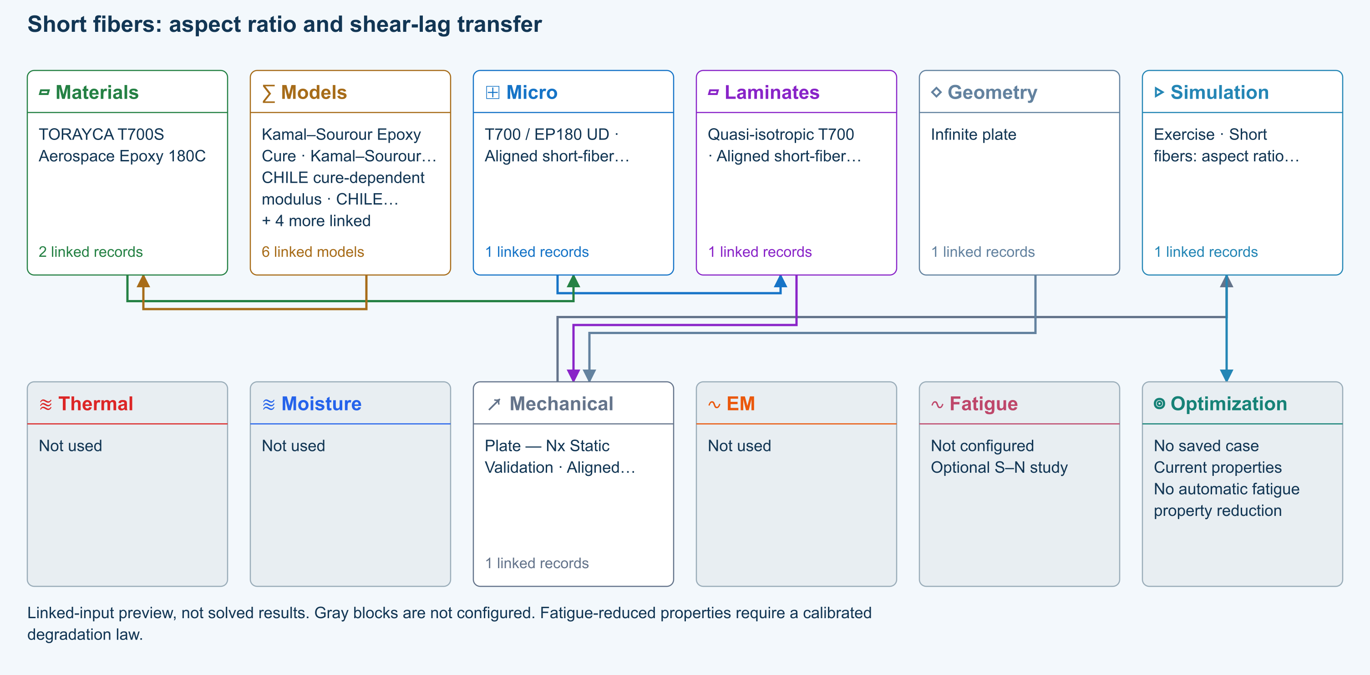

Tasks
Open Micro: identify length 0.35 mm, diameter 7 µm and derived L/d = 50. Inspect the linked constituent moduli.
Run at lengths 0.07, 0.35 and 3.5 mm, keeping diameter fixed. Compare E1, shear-lag efficiency and elastic transfer length in Micro outputs.
Double both length and diameter. Rerun and explain why aspect ratio and elastic stiffness are unchanged.
Open Response → Failure. Compare the available classical criteria using the independent teaching allowables in Micro → Strength & failure; do not interpret them as measured T700 short-fiber strengths.

Checkpoints
Efficiency increases toward one as aspect ratio increases; E1 approaches the aligned continuous-fiber mixture limit.
RVE progressive failure remains disabled. Cox predicts elastic transfer, not critical break length or damage evolution.
Strength values in this exercise are illustrative assumptions, not predictions or qualified allowables.

Model limits
Aligned monodisperse elastic fibers, perfect interface and concentric-cell shear lag. Halpin–Tsai transverse/shear screening closure. Existing constituent data are reused; the short-fiber composite and its strength allowables are a hypothetical teaching system.

Recorded validation
2026-09-18 — Not benchmark validated: No matched quantitative reference comparison completed for the full exercise.
Aligned monodisperse elastic fibers, perfect interface and concentric-cell shear lag. Halpin–Tsai transverse/shear screening closure. Existing constituent data are reused; the short-fiber composite and its strength allowables are a hypothetical teaching system.
Validation evidence and tested inputs

Connected models and submodels
Kamal–Sourour autocatalytic. Reusable material model. It contributes only when assigned to a material used by this simulation; separate model records can supply independent properties.
Theory and assumptions
Calibration & applicability. Illustrative model defaults — replace with characterized resin kinetics
CHILE (degree of cure). Reusable material model. It contributes only when assigned to a material used by this simulation; separate model records can supply independent properties. Cure-dependent modulus does not automatically scale strength allowables.
Theory and assumptions
Calibration & applicability. CHILE(α), section 2.4 of Materials 2019, 12, 259. Example parameters, not measured EP180 data. Fixed Poisson ratio; no viscoelastic relaxation or Tg softening. Incremental elastic stress integration at saved process intervals: check time-step convergence. Strength allowables are independent measured inputs, not scaled with modulus.
Temperature-dependent tabular. Reusable material model. It contributes only when assigned to a material used by this simulation; separate model records can supply independent properties. Micro uses the 23 °C reference; Process evaluates the same table at local temperature, without extrapolation.
Theory and assumptions
Calibration & applicability. Check source data, applicable environment and validity limits in the model record; saved defaults are not experimental validation.
1D Fickian diffusion. Reusable material model. It contributes only when assigned to a material used by this simulation; separate model records can supply independent properties.
Theory and assumptions
Calibration & applicability. Check source data, applicable environment and validity limits in the model record; saved defaults are not experimental validation.
Cox shear-lag elastic. One compatible homogenization model per Micro recipe. Separate recipes compare models; their predictions are not blended.
Theory and assumptions
CLT · Linear static with failure indices. Shared laminate stiffness drives this membrane/CLT path. Failure criteria are independent comparisons, not blended models. Fatigue is a separate assessment.
Theory and assumptions
Failure criterion · Maximum stress. Primary criterion. Additional envelope comparisons are chosen in Response → Failure; they run independently.

Data between modules
Micro to Laminates: Predicted ply stiffness, strength, density and expansion properties.
Materials to Micro: Constituent stiffness, strength, density and thermal / moisture properties.
Models to Materials: Model choices and calibrated parameters.
Mechanical to Simulation: SIMULATION selects this case and its analysis model; the case owns its applicable cycle and input references.
Laminates to Mechanical: Ply angles and thicknesses, stiffness, mass and ply properties.
Geometry to Mechanical: Shape and dimensions for the selected structural analysis.
Simulation to Optimization: Linked inputs and current-property response for candidate evaluation.

References
Create and connect a lamina
Edit material properties and units
Run and review a model
Review effective properties
Connected inputs and result freshness
Edit laminate materials, angles and thicknesses
Related case study: NASA lamina analysis
Record the inputs, units, solver notices and checkpoint results before drawing a conclusion. When exploring a variation, change one factor at a time and compare it with the original case.

01 Rule of mixtures continuous fibers
Online chapter
Unidirectional lamina. Infinite plate. Models: Rule of mixtures, Voigt, Reuss.
Open this exercise in Workbench
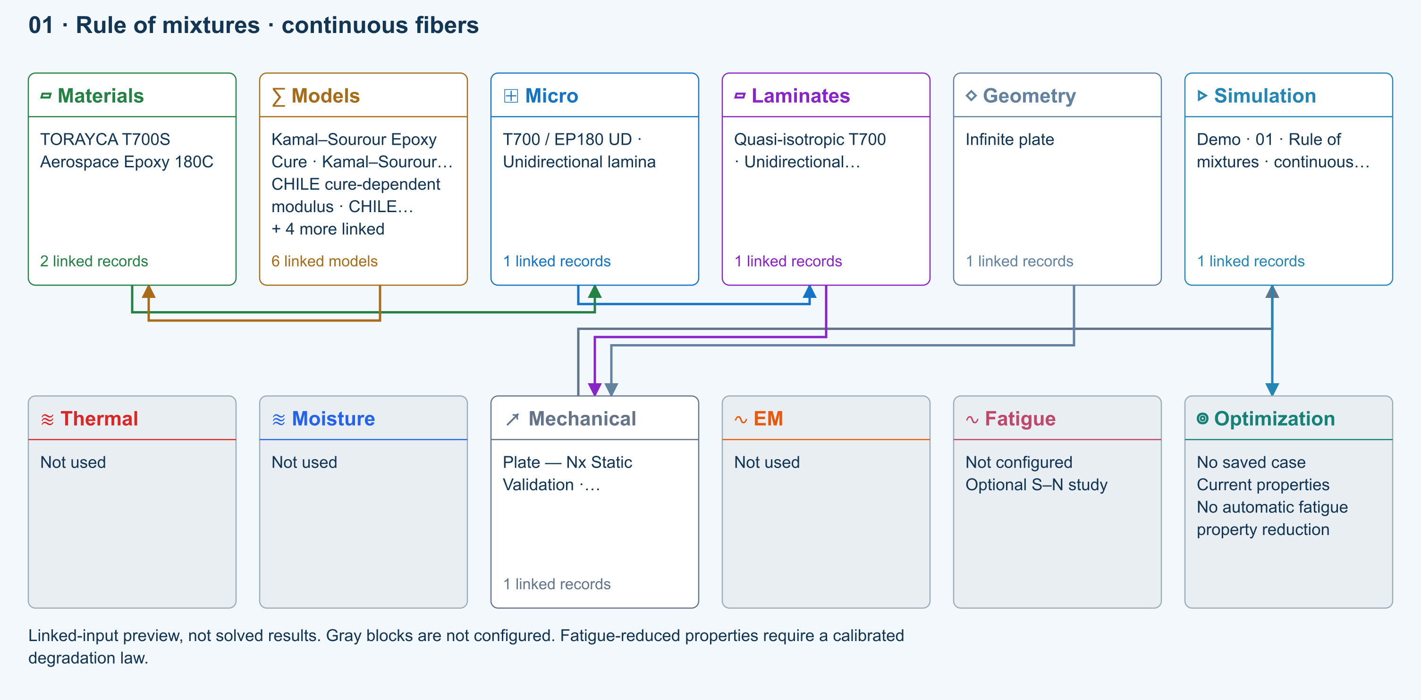

Tasks
Open the copied Micro record and identify its fibre and matrix materials.
Set fibre volume fraction to 0.3, 0.5 and 0.7; use Run after each change and record E1, E2 and density from Micro outputs.
Calculate E1 = Vf Ef + (1 − Vf) Em using the linked constituent moduli and compare with CDS.

Checkpoints
At zero void fraction, constituent fractions sum to one.
Longitudinal modulus follows the linear mixture calculation; distinguish it from the transverse compliance estimate.

Model limits
Ideal continuous, aligned reinforcement with zero voids. This is a teaching comparison, not a measured material allowable.

Recorded validation
2026-09-18 — Benchmark validated — analytical scope: Listed reference-elastic extensional constants only; free curvature, ply stresses, strength and every user variation are outside this badge.
Ideal continuous, aligned reinforcement with zero voids. This is a teaching comparison, not a measured material allowable.
Validation evidence and tested inputs

Connected models and submodels
Kamal–Sourour autocatalytic. Reusable material model. It contributes only when assigned to a material used by this simulation; separate model records can supply independent properties.
Theory and assumptions
Calibration & applicability. Illustrative model defaults — replace with characterized resin kinetics
CHILE (degree of cure). Reusable material model. It contributes only when assigned to a material used by this simulation; separate model records can supply independent properties. Cure-dependent modulus does not automatically scale strength allowables.
Theory and assumptions
Calibration & applicability. CHILE(α), section 2.4 of Materials 2019, 12, 259. Example parameters, not measured EP180 data. Fixed Poisson ratio; no viscoelastic relaxation or Tg softening. Incremental elastic stress integration at saved process intervals: check time-step convergence. Strength allowables are independent measured inputs, not scaled with modulus.
Temperature-dependent tabular. Reusable material model. It contributes only when assigned to a material used by this simulation; separate model records can supply independent properties. Micro uses the 23 °C reference; Process evaluates the same table at local temperature, without extrapolation.
Theory and assumptions
Calibration & applicability. Check source data, applicable environment and validity limits in the model record; saved defaults are not experimental validation.
1D Fickian diffusion. Reusable material model. It contributes only when assigned to a material used by this simulation; separate model records can supply independent properties.
Theory and assumptions
Calibration & applicability. Check source data, applicable environment and validity limits in the model record; saved defaults are not experimental validation.
Rule of mixtures. One compatible homogenization model per Micro recipe. Separate recipes compare models; their predictions are not blended.
Theory and assumptions
CLT · Linear static with failure indices. Shared laminate stiffness drives this membrane/CLT path. Failure criteria are independent comparisons, not blended models. Fatigue is a separate assessment.
Theory and assumptions
Failure criterion · Maximum stress. Primary criterion. Additional envelope comparisons are chosen in Response → Failure; they run independently.

Data between modules
Micro to Laminates: Predicted ply stiffness, strength, density and expansion properties.
Materials to Micro: Constituent stiffness, strength, density and thermal / moisture properties.
Models to Materials: Model choices and calibrated parameters.
Mechanical to Simulation: SIMULATION selects this case and its analysis model; the case owns its applicable cycle and input references.
Laminates to Mechanical: Ply angles and thicknesses, stiffness, mass and ply properties.
Geometry to Mechanical: Shape and dimensions for the selected structural analysis.
Simulation to Optimization: Linked inputs and current-property response for candidate evaluation.

References
Create and connect a lamina
Edit material properties and units
Run and review a model
Review effective properties
Related case study: NASA lamina analysis
Record the inputs, units, solver notices and checkpoint results before drawing a conclusion. When exploring a variation, change one factor at a time and compare it with the original case.

FSDT plate bending thin-to-thick comparison
Online chapter
Plate transverse bending. Finite rectangular plate. Models: FSDT, Classical laminate theory, Transverse shear, Static bending.
Open this exercise in Workbench
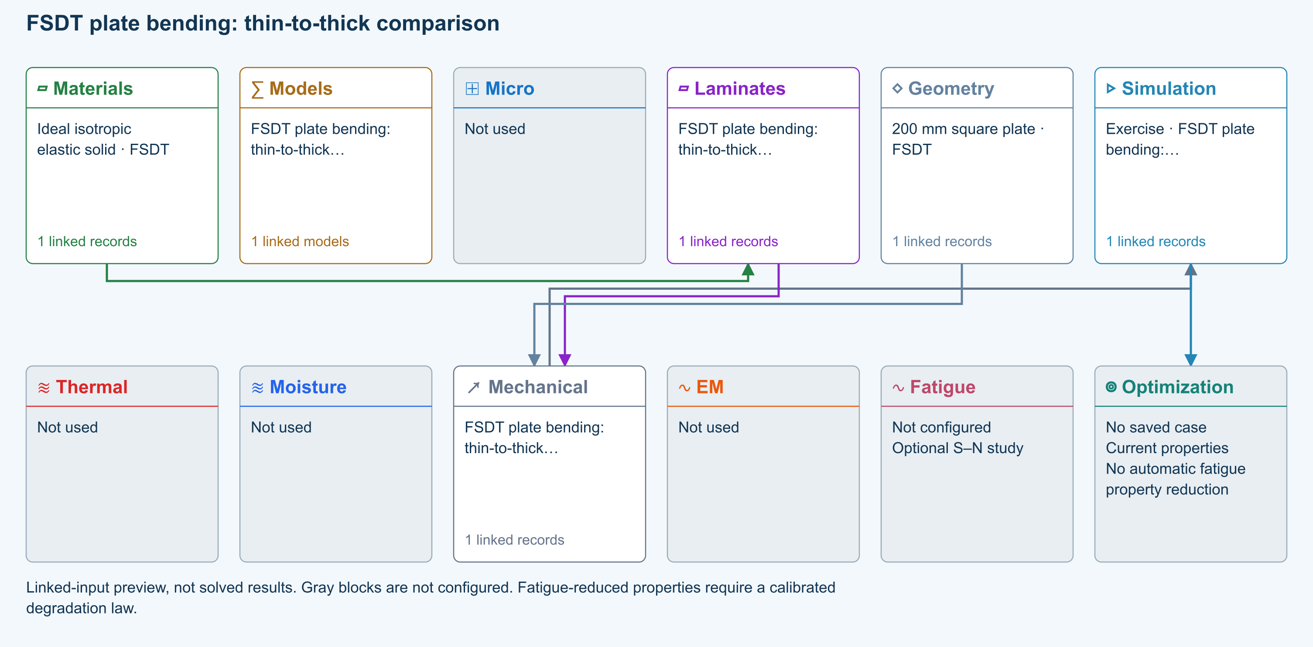

Tasks
Open Simulation and trace stored material → shared laminate → finite Plate Geometry → FSDT Loading. Confirm G13 and G23 are supplied.
Run Static bending; inspect physical w, section rotations and Qx/Qy, including both cursor sections.
Change thickness and rerun. For modal comparison set Plate pressure to zero and Nx/Ny/Nxy to zero before selecting Modal.
Increase Ritz order from 6 to 8 and compare displacement or the lowest retained eigenvalues.

Checkpoints
Geometry owns length/width; Laminate owns all ply thicknesses.
CLT and FSDT share A/B/D. As and rotary inertia extend the structural formulation.
Completed is not a material, strength, interface or delamination validation pass.

Model limits
Reference-elastic symmetric rectangular FSDT plate. Idealized teaching data, no calibrated material/strength claim. No thermal/moisture preload, thickness stretch, contact, debonding, damage or postbuckling. Directional energy-equivalent shear correction is an approximation; refine numerical order and compare published solutions.

Recorded validation
2026-09-18 — Not benchmark validated: No matched quantitative reference comparison completed for the full exercise.
Reference-elastic symmetric rectangular FSDT plate. Idealized teaching data, no calibrated material/strength claim. No thermal/moisture preload, thickness stretch, contact, debonding, damage or postbuckling. Directional energy-equivalent shear correction is an approximation; refine numerical order and compare published solutions.
Validation evidence and tested inputs

Connected models and submodels
FSDT · Finite plate. Automatic selects FSDT for sandwich architecture and CLT otherwise. Static bending requires FSDT. Finite-plate studies do not consume process links or run progressive failure/fatigue.
Theory and assumptions
Study · Static bending. Reference-elastic plate study; progressive failure and fatigue are not evaluated here.
Numerical settings. Ritz order: 6. Shear correction (FSDT only): Energy equivalent. Increase resolution to check convergence.

Data between modules
Materials to Laminates: Stored ply stiffness, strength, density and expansion properties.
Mechanical to Simulation: SIMULATION selects this case and its analysis model; the case owns its applicable cycle and input references.
Laminates to Mechanical: Ply angles and thicknesses, stiffness, mass and ply properties.
Geometry to Mechanical: Shape and dimensions for the selected structural analysis.
Simulation to Optimization: Linked inputs and current-property response for candidate evaluation.

References
FSDT: shared laminate stiffness, shear and plate response
Edit laminate materials, angles and thicknesses
Run and review a model
Geometry, loading and virtual tests
Record the inputs, units, solver notices and checkpoint results before drawing a conclusion. When exploring a variation, change one factor at a time and compare it with the original case.

Micro optimization stiffness voids and density
Online chapter
Micro optimization. Infinite plate. Models: Rule of mixtures, Micro optimization.
Open this exercise in Workbench
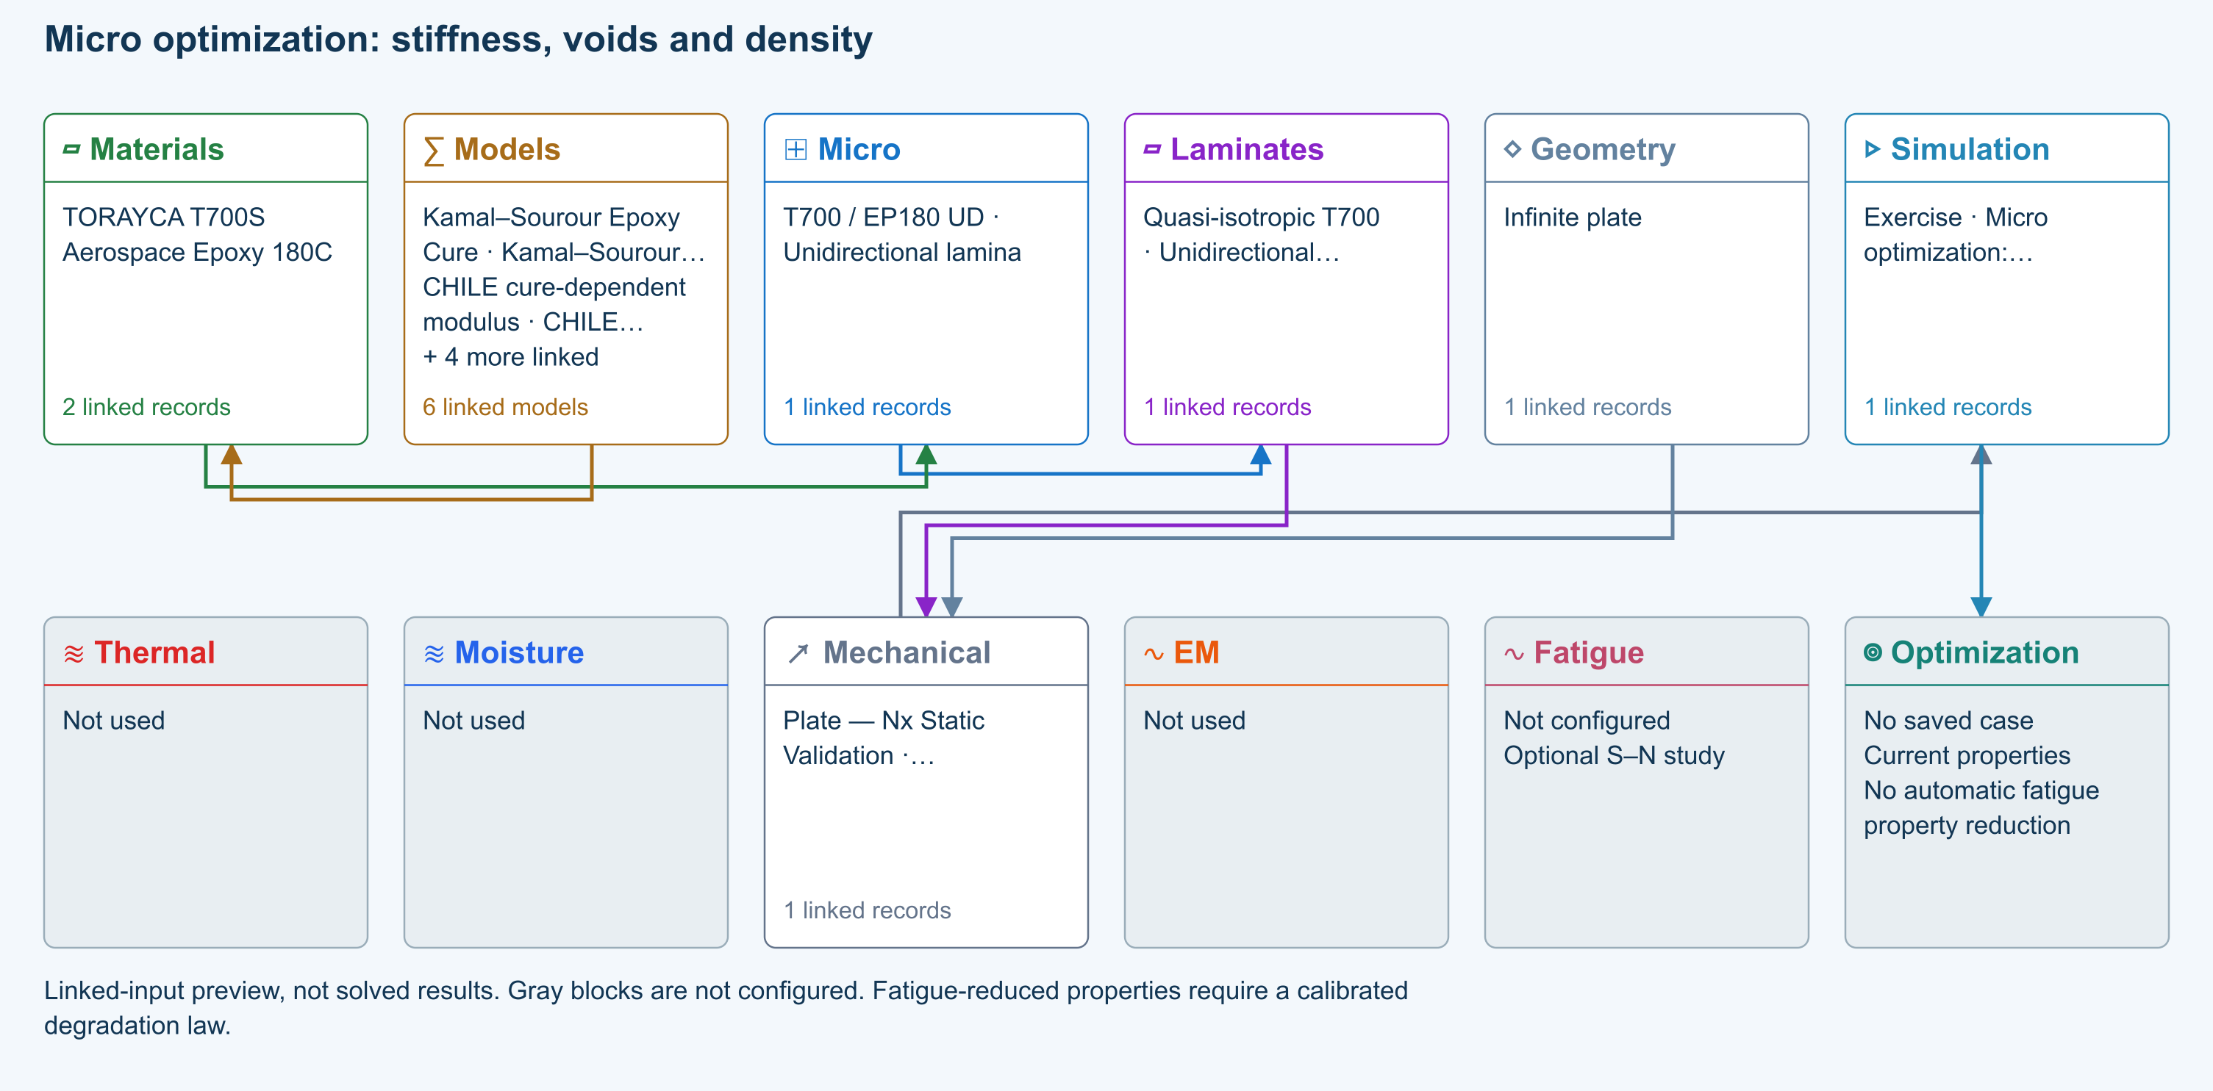

Tasks
Open Simulation and identify the linked Micro recipe and constituent materials. Open Optimize → Lamina / Micro and select that recipe.
Set fiber volume fraction to Sweep, minimum 0.30 and maximum 0.70; set void volume fraction to Sweep, minimum 0 and maximum 0.05. Keep every other variable at its source value. Use 11 samples per axis.
Choose maximum E1 / density. Set minimum E2 = 0, minimum G12 = 0 and maximum density = 2000 kg/m³. Run the map and compare the best feasible point with neighboring samples.
Save as Micro stiffness-density study. Reopen Optimizations → Micro and inspect All saved optimization inputs. Change a source material and verify the saved effective inputs and result remain unchanged.

Checkpoints
The maximum is best among the sampled designs, not a proof of a global continuous optimum.
Void and fiber fractions must leave a positive resin fraction. No strength pass is inferred from this elastic study.

Model limits
Guided optimization case study using shared database records. Configure the documented search in Optimize, then save its results and inputs. No precomputed optimum or benchmark-validation claim. Ideal continuous, aligned reinforcement with zero voids. This is a teaching comparison, not a measured material allowable.

Recorded validation
2026-09-18 — Benchmark validated — analytical scope: Listed reference-elastic extensional constants only; free curvature, ply stresses, strength and every user variation are outside this badge.
Guided optimization case study using shared database records. Configure the documented search in Optimize, then save its results and inputs. No precomputed optimum or benchmark-validation claim. Ideal continuous, aligned reinforcement with zero voids. This is a teaching comparison, not a measured material allowable.
Validation evidence and tested inputs

Connected models and submodels
Kamal–Sourour autocatalytic. Reusable material model. It contributes only when assigned to a material used by this simulation; separate model records can supply independent properties.
Theory and assumptions
Calibration & applicability. Illustrative model defaults — replace with characterized resin kinetics
CHILE (degree of cure). Reusable material model. It contributes only when assigned to a material used by this simulation; separate model records can supply independent properties. Cure-dependent modulus does not automatically scale strength allowables.
Theory and assumptions
Calibration & applicability. CHILE(α), section 2.4 of Materials 2019, 12, 259. Example parameters, not measured EP180 data. Fixed Poisson ratio; no viscoelastic relaxation or Tg softening. Incremental elastic stress integration at saved process intervals: check time-step convergence. Strength allowables are independent measured inputs, not scaled with modulus.
Temperature-dependent tabular. Reusable material model. It contributes only when assigned to a material used by this simulation; separate model records can supply independent properties. Micro uses the 23 °C reference; Process evaluates the same table at local temperature, without extrapolation.
Theory and assumptions
Calibration & applicability. Check source data, applicable environment and validity limits in the model record; saved defaults are not experimental validation.
1D Fickian diffusion. Reusable material model. It contributes only when assigned to a material used by this simulation; separate model records can supply independent properties.
Theory and assumptions
Calibration & applicability. Check source data, applicable environment and validity limits in the model record; saved defaults are not experimental validation.
Rule of mixtures. One compatible homogenization model per Micro recipe. Separate recipes compare models; their predictions are not blended.
Theory and assumptions
CLT · Linear static with failure indices. Shared laminate stiffness drives this membrane/CLT path. Failure criteria are independent comparisons, not blended models. Fatigue is a separate assessment.
Theory and assumptions
Failure criterion · Maximum stress. Primary criterion. Additional envelope comparisons are chosen in Response → Failure; they run independently.

Data between modules
Micro to Laminates: Predicted ply stiffness, strength, density and expansion properties.
Materials to Micro: Constituent stiffness, strength, density and thermal / moisture properties.
Models to Materials: Model choices and calibrated parameters.
Mechanical to Simulation: SIMULATION selects this case and its analysis model; the case owns its applicable cycle and input references.
Laminates to Mechanical: Ply angles and thicknesses, stiffness, mass and ply properties.
Geometry to Mechanical: Shape and dimensions for the selected structural analysis.
Simulation to Optimization: Linked inputs and current-property response for candidate evaluation.

References
Optimization cases: complete inputs and guided studies
Create and connect a lamina
Connected inputs and result freshness
Record the inputs, units, solver notices and checkpoint results before drawing a conclusion. When exploring a variation, change one factor at a time and compare it with the original case.

02 Halpin Tsai transverse stiffness
Online chapter
Unidirectional lamina. Infinite plate. Models: Halpin–Tsai, Rule of mixtures.
Open this exercise in Workbench
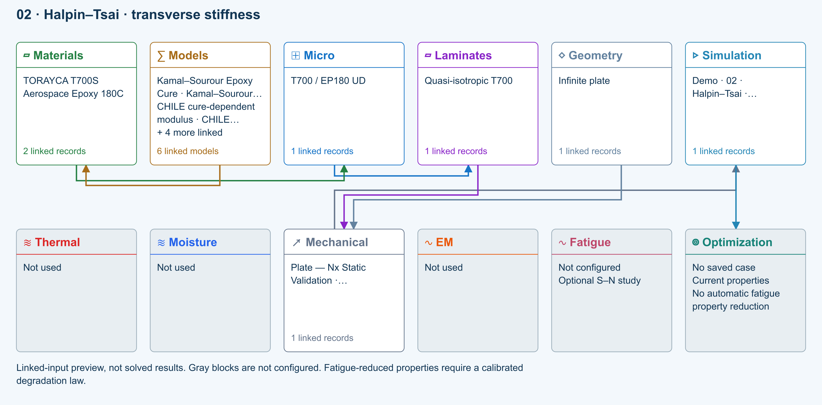

Tasks
Run the supplied Halpin–Tsai Micro recipe and record E1, E2 and G12.
Change only the micromechanics model to Rule of mixtures and rerun.
Restore Halpin–Tsai; vary fibre volume fraction while holding the constituent data fixed.

Checkpoints
Compare transverse and shear predictions at identical fractions.
Explain why different homogenization assumptions give different transverse properties.

Model limits
Use the editable model inputs and their documented assumptions; matching a trend does not validate a strength prediction.

Recorded validation
2026-09-18 — Not benchmark validated: No matched quantitative reference comparison completed for the full exercise.
Use the editable model inputs and their documented assumptions; matching a trend does not validate a strength prediction.
Validation evidence and tested inputs

Connected models and submodels
Kamal–Sourour autocatalytic. Reusable material model. It contributes only when assigned to a material used by this simulation; separate model records can supply independent properties.
Theory and assumptions
Calibration & applicability. Illustrative model defaults — replace with characterized resin kinetics
CHILE (degree of cure). Reusable material model. It contributes only when assigned to a material used by this simulation; separate model records can supply independent properties. Cure-dependent modulus does not automatically scale strength allowables.
Theory and assumptions
Calibration & applicability. CHILE(α), section 2.4 of Materials 2019, 12, 259. Example parameters, not measured EP180 data. Fixed Poisson ratio; no viscoelastic relaxation or Tg softening. Incremental elastic stress integration at saved process intervals: check time-step convergence. Strength allowables are independent measured inputs, not scaled with modulus.
Temperature-dependent tabular. Reusable material model. It contributes only when assigned to a material used by this simulation; separate model records can supply independent properties. Micro uses the 23 °C reference; Process evaluates the same table at local temperature, without extrapolation.
Theory and assumptions
Calibration & applicability. Check source data, applicable environment and validity limits in the model record; saved defaults are not experimental validation.
1D Fickian diffusion. Reusable material model. It contributes only when assigned to a material used by this simulation; separate model records can supply independent properties.
Theory and assumptions
Calibration & applicability. Check source data, applicable environment and validity limits in the model record; saved defaults are not experimental validation.
Halpin–Tsai. One compatible homogenization model per Micro recipe. Separate recipes compare models; their predictions are not blended.
Theory and assumptions
CLT · Linear static with failure indices. Shared laminate stiffness drives this membrane/CLT path. Failure criteria are independent comparisons, not blended models. Fatigue is a separate assessment.
Theory and assumptions
Failure criterion · Maximum stress. Primary criterion. Additional envelope comparisons are chosen in Response → Failure; they run independently.

Data between modules
Micro to Laminates: Predicted ply stiffness, strength, density and expansion properties.
Materials to Micro: Constituent stiffness, strength, density and thermal / moisture properties.
Models to Materials: Model choices and calibrated parameters.
Mechanical to Simulation: SIMULATION selects this case and its analysis model; the case owns its applicable cycle and input references.
Laminates to Mechanical: Ply angles and thicknesses, stiffness, mass and ply properties.
Geometry to Mechanical: Shape and dimensions for the selected structural analysis.
Simulation to Optimization: Linked inputs and current-property response for candidate evaluation.

References
Create and connect a lamina
Review effective properties
Run and review a model
Related case study: NASA lamina analysis
Record the inputs, units, solver notices and checkpoint results before drawing a conclusion. When exploring a variation, change one factor at a time and compare it with the original case.

FSDT cross-ply plate buckling and natural frequencies
Online chapter
Plate stability and vibration. Finite rectangular plate. Models: FSDT, Classical laminate theory, Transverse shear, Rotary inertia, Linear buckling.
Open this exercise in Workbench
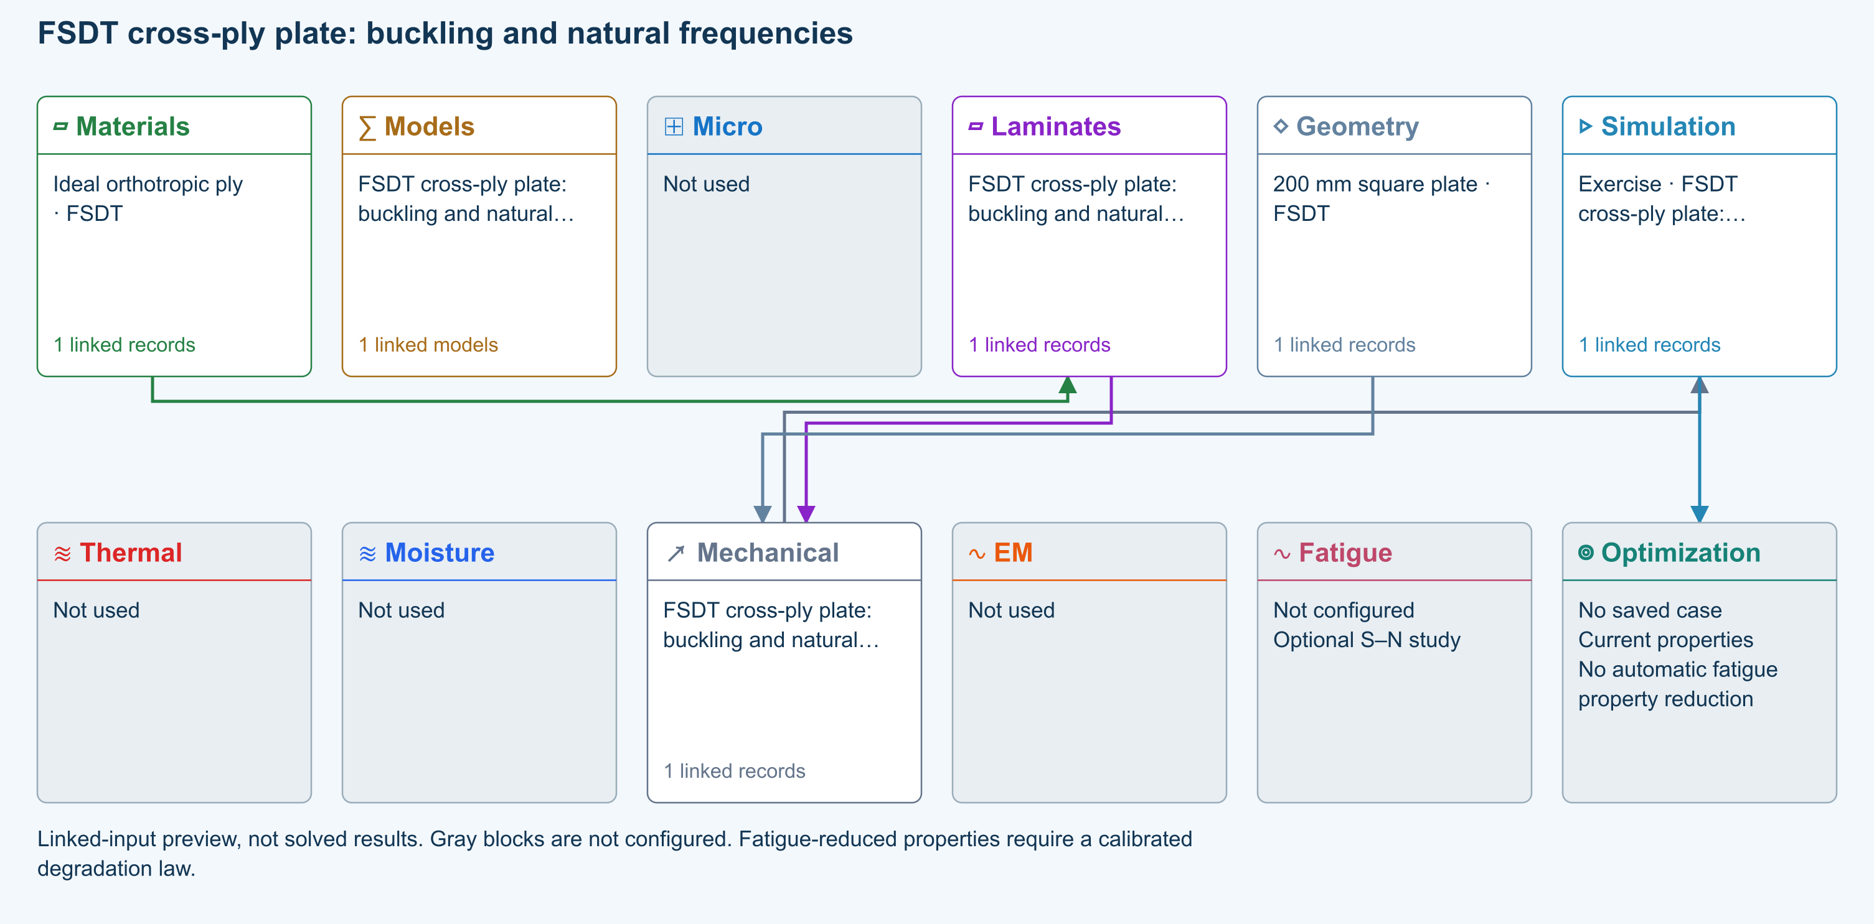

Tasks
Open Simulation and trace stored material → shared laminate → finite Plate Geometry → FSDT Loading. Confirm G13 and G23 are supplied.
Run buckling and modes; compare CLT with FSDT on the same laminate. Frequencies are unprestressed.
Change thickness and rerun. For modal comparison set Plate pressure to zero and Nx/Ny/Nxy to zero before selecting Modal.
Increase Ritz order from 6 to 8 and compare displacement or the lowest retained eigenvalues.

Checkpoints
Geometry owns length/width; Laminate owns all ply thicknesses.
CLT and FSDT share A/B/D. As and rotary inertia extend the structural formulation.
Completed is not a material, strength, interface or delamination validation pass.

Model limits
Reference-elastic symmetric rectangular FSDT plate. Idealized teaching data, no calibrated material/strength claim. No thermal/moisture preload, thickness stretch, contact, debonding, damage or postbuckling. Directional energy-equivalent shear correction is an approximation; refine numerical order and compare published solutions.

Recorded validation
2026-09-18 — Not benchmark validated: No matched quantitative reference comparison completed for the full exercise.
Reference-elastic symmetric rectangular FSDT plate. Idealized teaching data, no calibrated material/strength claim. No thermal/moisture preload, thickness stretch, contact, debonding, damage or postbuckling. Directional energy-equivalent shear correction is an approximation; refine numerical order and compare published solutions.
Validation evidence and tested inputs

Connected models and submodels
FSDT · Finite plate. Automatic selects FSDT for sandwich architecture and CLT otherwise. Static bending requires FSDT. Finite-plate studies do not consume process links or run progressive failure/fatigue.
Theory and assumptions
Study · Buckling and modal. Reference-elastic plate study; progressive failure and fatigue are not evaluated here.
Numerical settings. Ritz order: 6. Shear correction (FSDT only): Energy equivalent. Increase resolution to check convergence.

Data between modules
Materials to Laminates: Stored ply stiffness, strength, density and expansion properties.
Mechanical to Simulation: SIMULATION selects this case and its analysis model; the case owns its applicable cycle and input references.
Laminates to Mechanical: Ply angles and thicknesses, stiffness, mass and ply properties.
Geometry to Mechanical: Shape and dimensions for the selected structural analysis.
Simulation to Optimization: Linked inputs and current-property response for candidate evaluation.

References
FSDT: shared laminate stiffness, shear and plate response
Edit laminate materials, angles and thicknesses
Run and review a model
Geometry, loading and virtual tests
Record the inputs, units, solver notices and checkpoint results before drawing a conclusion. When exploring a variation, change one factor at a time and compare it with the original case.

Laminate optimization minimum mass under axial loading
Online chapter
Laminate optimization. Finite plate. Models: Classical laminate theory, Maximum stress, Laminate optimization.
Open this exercise in Workbench
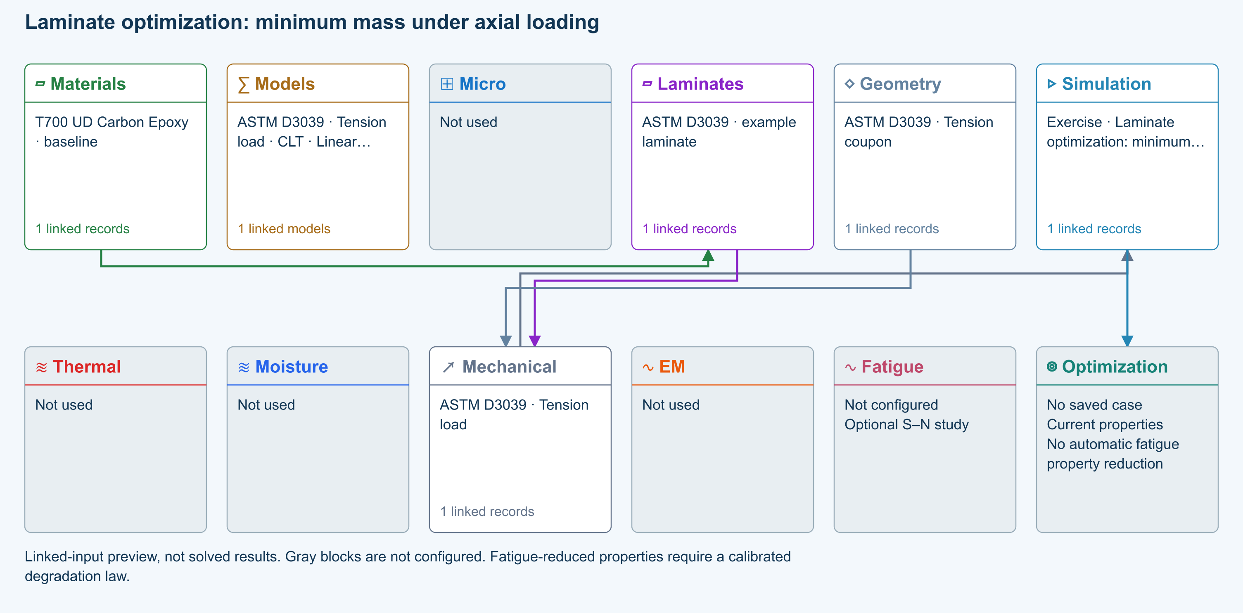

Tasks
Open the structural load linked by Simulation. Set Nx = 100 N/mm and Ny, Nxy, Mx, My and Mxy to zero. Confirm the linked laminate has usable strengths and densities.
Open Optimize → Laminate and select that structural case. Select minimum mass, Maximum stress, required load factor 1, allowed angles −45, 0, 45, 90°, minimum 4 and maximum 16 plies; enable symmetry and balance, with minimum angle content 0%.
Use search budget 400 and seed 42. Run optimization, inspect convergence and compare mass against the baseline. If the search is budget-limited, report best found, not global optimum.
Save as Axial minimum-mass study. Reopen Optimizations → Laminate and review the complete search settings, selected mechanical loads and frozen ply inputs. Create a candidate laminate separately and rerun structural analysis before accepting it.

Checkpoints
This is mechanical first-ply screening; it does not certify buckling, delamination, fatigue or manufacturing suitability.
An infeasible best candidate is not a pass. Source loads and ramped optimization loads are distinct saved inputs.

Model limits
Guided optimization case study using shared database records. Configure the documented search in Optimize, then save its results and inputs. No precomputed optimum or benchmark-validation claim. ASTM-based teaching geometry, not certification. Grips, tabs, alignment and physical test validity are not simulated.

Recorded validation
2026-09-18 — Benchmark validated — analytical scope: Listed reference-elastic extensional constants only; free curvature, ply stresses, strength and every user variation are outside this badge.
Guided optimization case study using shared database records. Configure the documented search in Optimize, then save its results and inputs. No precomputed optimum or benchmark-validation claim. ASTM-based teaching geometry, not certification. Grips, tabs, alignment and physical test validity are not simulated.
Validation evidence and tested inputs

Connected models and submodels
CLT · Linear static. Shared laminate stiffness drives this membrane/CLT path. Failure criteria are independent comparisons, not blended models. Fatigue is a separate assessment.
Theory and assumptions

Data between modules
Materials to Laminates: Stored ply stiffness, strength, density and expansion properties.
Mechanical to Simulation: SIMULATION selects this case and its analysis model; the case owns its applicable cycle and input references.
Laminates to Mechanical: Ply angles and thicknesses, stiffness, mass and ply properties.
Geometry to Mechanical: Shape and dimensions for the selected structural analysis.
Simulation to Optimization: Linked inputs and current-property response for candidate evaluation.

References
Optimization cases: complete inputs and guided studies
Edit laminate materials, angles and thicknesses
Run and review a model
Record the inputs, units, solver notices and checkpoint results before drawing a conclusion. When exploring a variation, change one factor at a time and compare it with the original case.

03 Short fibers shear-lag transfer
Online chapter
Aligned short-fiber lamina. Infinite plate. Models: Cox shear-lag elastic, Classical laminate theory, Maximum stress.
Open this exercise in Workbench
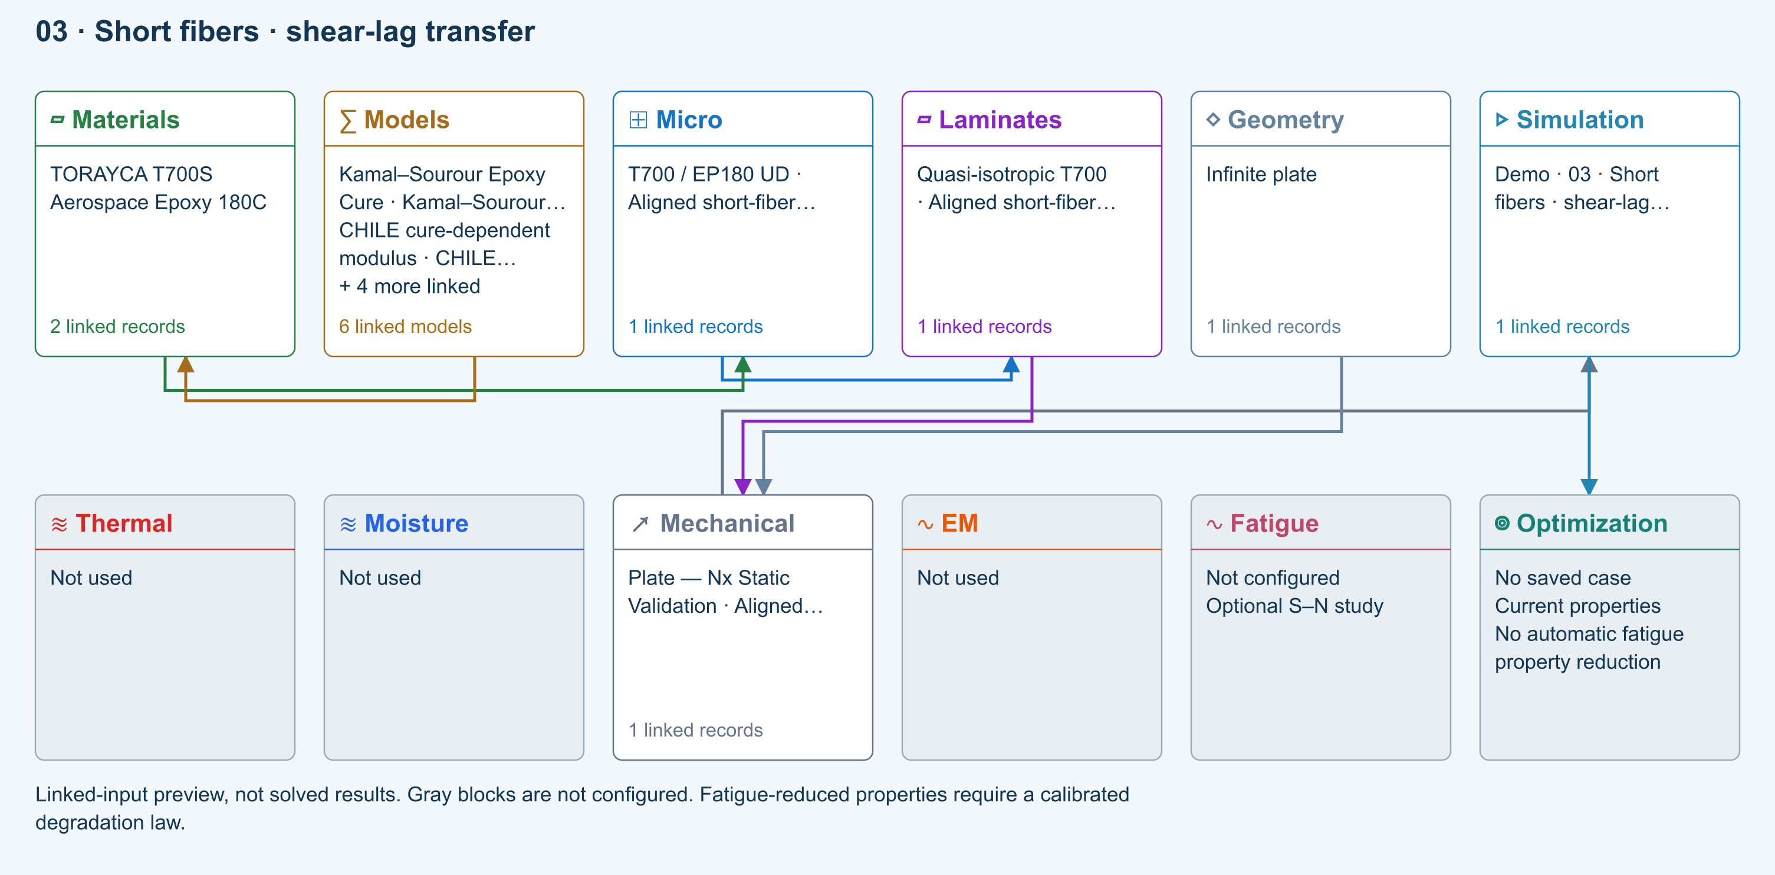

Tasks
Open Micro: identify length 0.35 mm, diameter 7 µm and derived L/d = 50. Inspect the linked constituent moduli.
Run at lengths 0.07, 0.35 and 3.5 mm, keeping diameter fixed. Compare E1, shear-lag efficiency and elastic transfer length in Micro outputs.
Double both length and diameter. Rerun and explain why aspect ratio and elastic stiffness are unchanged.
Open Response → Failure. Compare the available classical criteria using the independent teaching allowables in Micro → Strength & failure; do not interpret them as measured T700 short-fiber strengths.

Checkpoints
Efficiency increases toward one as aspect ratio increases; E1 approaches the aligned continuous-fiber mixture limit.
RVE progressive failure remains disabled. Cox predicts elastic transfer, not critical break length or damage evolution.
Strength values in this exercise are illustrative assumptions, not predictions or qualified allowables.

Model limits
Aligned monodisperse elastic fibers, perfect interface and concentric-cell shear lag. Halpin–Tsai transverse/shear screening closure. Existing constituent data are reused; the short-fiber composite and its strength allowables are a hypothetical teaching system.

Recorded validation
2026-09-18 — Not benchmark validated: No matched quantitative reference comparison completed for the full exercise.
Aligned monodisperse elastic fibers, perfect interface and concentric-cell shear lag. Halpin–Tsai transverse/shear screening closure. Existing constituent data are reused; the short-fiber composite and its strength allowables are a hypothetical teaching system.
Validation evidence and tested inputs

Connected models and submodels
Kamal–Sourour autocatalytic. Reusable material model. It contributes only when assigned to a material used by this simulation; separate model records can supply independent properties.
Theory and assumptions
Calibration & applicability. Illustrative model defaults — replace with characterized resin kinetics
CHILE (degree of cure). Reusable material model. It contributes only when assigned to a material used by this simulation; separate model records can supply independent properties. Cure-dependent modulus does not automatically scale strength allowables.
Theory and assumptions
Calibration & applicability. CHILE(α), section 2.4 of Materials 2019, 12, 259. Example parameters, not measured EP180 data. Fixed Poisson ratio; no viscoelastic relaxation or Tg softening. Incremental elastic stress integration at saved process intervals: check time-step convergence. Strength allowables are independent measured inputs, not scaled with modulus.
Temperature-dependent tabular. Reusable material model. It contributes only when assigned to a material used by this simulation; separate model records can supply independent properties. Micro uses the 23 °C reference; Process evaluates the same table at local temperature, without extrapolation.
Theory and assumptions
Calibration & applicability. Check source data, applicable environment and validity limits in the model record; saved defaults are not experimental validation.
1D Fickian diffusion. Reusable material model. It contributes only when assigned to a material used by this simulation; separate model records can supply independent properties.
Theory and assumptions
Calibration & applicability. Check source data, applicable environment and validity limits in the model record; saved defaults are not experimental validation.
Cox shear-lag elastic. One compatible homogenization model per Micro recipe. Separate recipes compare models; their predictions are not blended.
Theory and assumptions
CLT · Linear static with failure indices. Shared laminate stiffness drives this membrane/CLT path. Failure criteria are independent comparisons, not blended models. Fatigue is a separate assessment.
Theory and assumptions
Failure criterion · Maximum stress. Primary criterion. Additional envelope comparisons are chosen in Response → Failure; they run independently.

Data between modules
Micro to Laminates: Predicted ply stiffness, strength, density and expansion properties.
Materials to Micro: Constituent stiffness, strength, density and thermal / moisture properties.
Models to Materials: Model choices and calibrated parameters.
Mechanical to Simulation: SIMULATION selects this case and its analysis model; the case owns its applicable cycle and input references.
Laminates to Mechanical: Ply angles and thicknesses, stiffness, mass and ply properties.
Geometry to Mechanical: Shape and dimensions for the selected structural analysis.
Simulation to Optimization: Linked inputs and current-property response for candidate evaluation.

References
Create and connect a lamina
Edit material properties and units
Run and review a model
Review effective properties
Connected inputs and result freshness
Edit laminate materials, angles and thicknesses
Related case study: NASA lamina analysis
Record the inputs, units, solver notices and checkpoint results before drawing a conclusion. When exploring a variation, change one factor at a time and compare it with the original case.

FSDT soft-core plate shear-dominated bending
Online chapter
Soft-core plate bending. Finite rectangular plate. Models: FSDT, Classical laminate theory, Transverse shear, Static bending.
Open this exercise in Workbench
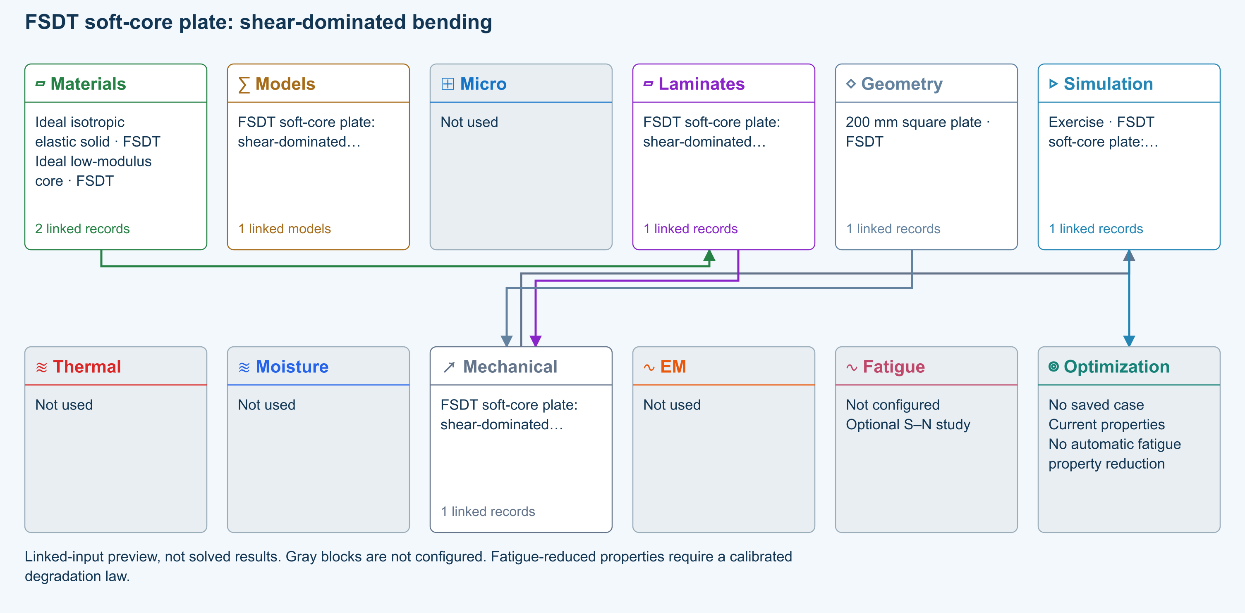

Tasks
Open Simulation and trace stored material → shared laminate → finite Plate Geometry → FSDT Loading. Confirm G13 and G23 are supplied.
Run Static bending; inspect physical w, section rotations and Qx/Qy, including both cursor sections.
Confirm Automatic resolves to FSDT for Sandwich Structures. Compare Energy equivalent and Uniform 5/6 shear corrections. Explain why a soft core makes a single homogeneous correction inappropriate.
Increase Ritz order from 6 to 8 and compare displacement or the lowest retained eigenvalues.

Checkpoints
Geometry owns length/width; Laminate owns all ply thicknesses.
CLT and FSDT share A/B/D. As and rotary inertia extend the structural formulation.
Completed is not a material, strength, interface or delamination validation pass.

Model limits
Reference-elastic symmetric rectangular FSDT plate. Idealized teaching data, no calibrated material/strength claim. No thermal/moisture preload, thickness stretch, contact, debonding, damage or postbuckling. Directional energy-equivalent shear correction is an approximation; refine numerical order and compare published solutions.

Recorded validation
2026-09-18 — Not benchmark validated: No matched quantitative reference comparison completed for the full exercise.
Reference-elastic symmetric rectangular FSDT plate. Idealized teaching data, no calibrated material/strength claim. No thermal/moisture preload, thickness stretch, contact, debonding, damage or postbuckling. Directional energy-equivalent shear correction is an approximation; refine numerical order and compare published solutions.
Validation evidence and tested inputs

Connected models and submodels
Automatic · Finite plate. Automatic selects FSDT for sandwich architecture and CLT otherwise. Static bending requires FSDT. Finite-plate studies do not consume process links or run progressive failure/fatigue.
Theory and assumptions
Study · Static bending. Reference-elastic plate study; progressive failure and fatigue are not evaluated here.
Numerical settings. Ritz order: 6. Shear correction (FSDT only): Energy equivalent. Increase resolution to check convergence.

Data between modules
Materials to Laminates: Stored ply stiffness, strength, density and expansion properties.
Mechanical to Simulation: SIMULATION selects this case and its analysis model; the case owns its applicable cycle and input references.
Laminates to Mechanical: Ply angles and thicknesses, stiffness, mass and ply properties.
Geometry to Mechanical: Shape and dimensions for the selected structural analysis.
Simulation to Optimization: Linked inputs and current-property response for candidate evaluation.

References
FSDT: shared laminate stiffness, shear and plate response
Edit laminate materials, angles and thicknesses
Run and review a model
Geometry, loading and virtual tests
Record the inputs, units, solver notices and checkpoint results before drawing a conclusion. When exploring a variation, change one factor at a time and compare it with the original case.

Process optimization cycle time and thermal uniformity
Online chapter
Process optimization. Laminate through-thickness slab. Models: Transient heat transfer, Process optimization.
Open this exercise in Workbench
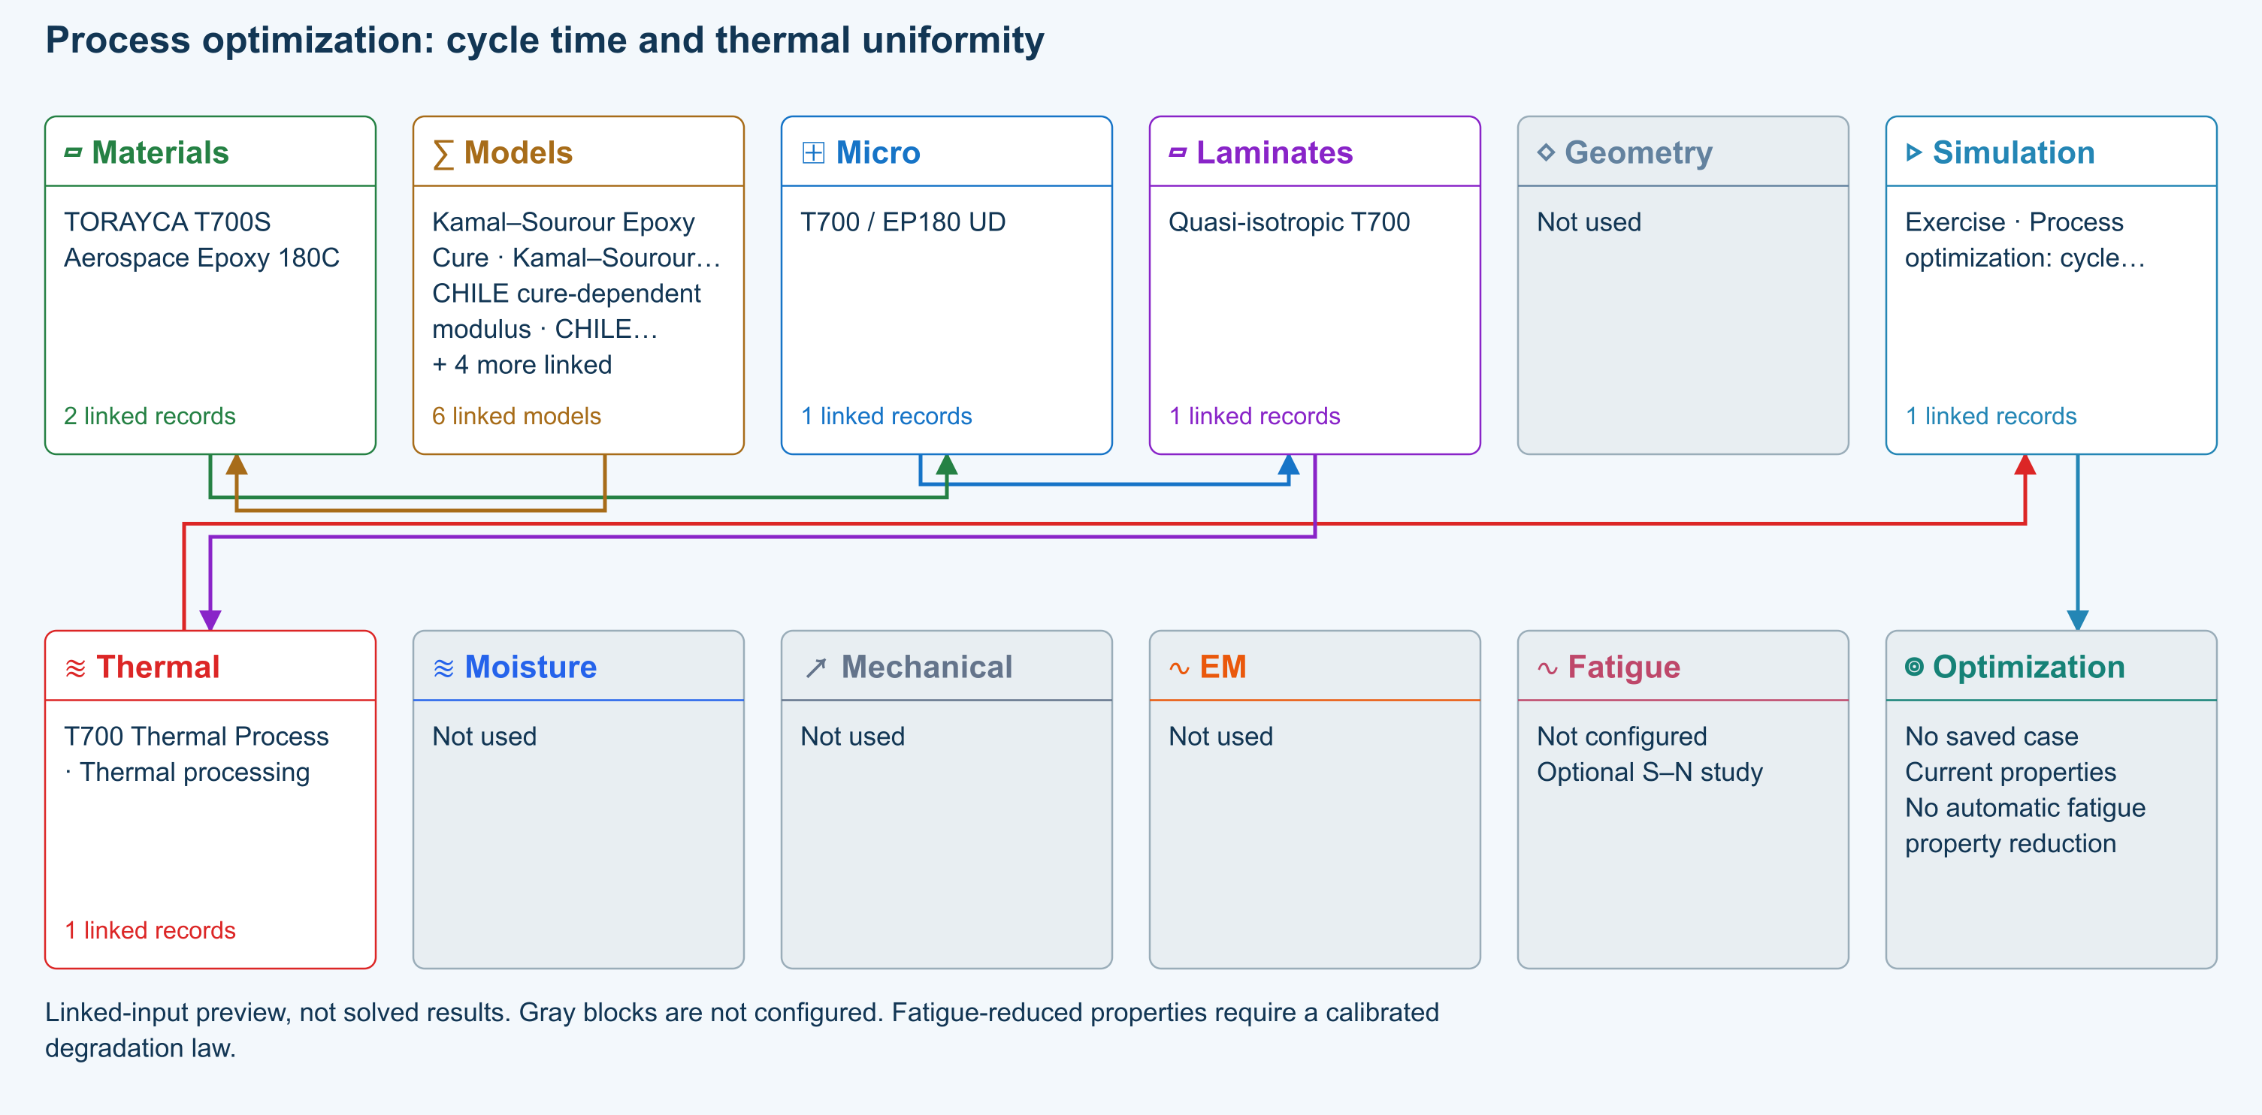

Tasks
Open Simulation and identify its thermal load, laminate and Process schedule. In Optimize → Process select that thermal case; inspect source temperatures, layer conductivity/capacity and film coefficients.
Use duration objective, target core temperature 120 °C, required hold 10 min, maximum part temperature 200 °C and maximum through-thickness difference 30 °C. Sweep time scale 0.75–1.25 and temperature scale 0.90–1.10 with 5 samples per axis and 21 through-thickness nodes.
Keep cure exotherm off for this thermal-only exercise and acknowledge the displayed assumptions. Run; inspect feasible candidates, temperature histories and the best sampled duration. If none are feasible, report that outcome and adjust a constraint deliberately.
Save as Thermal cycle-time study. Reopen Optimizations → Process and inspect saved boundaries, layers, constraints and source cycle. Create a candidate cycle separately, then rerun the coupled simulation; thermal feasibility alone does not establish cure or strength.

Checkpoints
The schedule is prescribed boundary temperature, not oven dynamics. This example is not UV or pultrusion optimization.
Compare a refined grid before accepting the best sampled candidate. Thermal-only feasibility is not cure completion or a strength pass.

Model limits
Guided optimization case study using shared database records. Configure the documented search in Optimize, then save its results and inputs. No precomputed optimum or benchmark-validation claim. One-dimensional through-thickness transport; lateral heat loss and oven airflow are not resolved. Inspect linked cure settings before interpreting reaction heating.

Recorded validation
2026-09-18 — Not benchmark validated: No matched quantitative reference comparison completed for the full exercise.
Guided optimization case study using shared database records. Configure the documented search in Optimize, then save its results and inputs. No precomputed optimum or benchmark-validation claim. One-dimensional through-thickness transport; lateral heat loss and oven airflow are not resolved. Inspect linked cure settings before interpreting reaction heating.
Validation evidence and tested inputs

Connected models and submodels
Kamal–Sourour autocatalytic. Reusable material model. It contributes only when assigned to a material used by this simulation; separate model records can supply independent properties.
Theory and assumptions
Calibration & applicability. Illustrative model defaults — replace with characterized resin kinetics
CHILE (degree of cure). Reusable material model. It contributes only when assigned to a material used by this simulation; separate model records can supply independent properties. Cure-dependent modulus does not automatically scale strength allowables.
Theory and assumptions
Calibration & applicability. CHILE(α), section 2.4 of Materials 2019, 12, 259. Example parameters, not measured EP180 data. Fixed Poisson ratio; no viscoelastic relaxation or Tg softening. Incremental elastic stress integration at saved process intervals: check time-step convergence. Strength allowables are independent measured inputs, not scaled with modulus.
Temperature-dependent tabular. Reusable material model. It contributes only when assigned to a material used by this simulation; separate model records can supply independent properties. Micro uses the 23 °C reference; Process evaluates the same table at local temperature, without extrapolation.
Theory and assumptions
Calibration & applicability. Check source data, applicable environment and validity limits in the model record; saved defaults are not experimental validation.
1D Fickian diffusion. Reusable material model. It contributes only when assigned to a material used by this simulation; separate model records can supply independent properties.
Theory and assumptions
Calibration & applicability. Check source data, applicable environment and validity limits in the model record; saved defaults are not experimental validation.
Halpin–Tsai. One compatible homogenization model per Micro recipe. Separate recipes compare models; their predictions are not blended.
Theory and assumptions
1D transient heat transfer. Needs linked laminate properties and a compatible process schedule. A linked cycle is not a solved temperature history.
Theory and assumptions

Data between modules
Micro to Laminates: Predicted ply stiffness, strength, density and expansion properties.
Materials to Micro: Constituent stiffness, strength, density and thermal / moisture properties.
Models to Materials: Model choices and calibrated parameters.
Thermal to Simulation: SIMULATION selects this case and its analysis model; the case owns its applicable cycle and input references.
Laminates to Thermal: Ply angles and thicknesses, stiffness, mass and ply properties.
Simulation to Optimization: Linked inputs and current-property response for candidate evaluation.

References
Optimization cases: complete inputs and guided studies
Enter a process cycle and boundary conditions
Cure exotherm and evolving modulus
Record the inputs, units, solver notices and checkpoint results before drawing a conclusion. When exploring a variation, change one factor at a time and compare it with the original case.

04 Hybrid fibers orientation distribution
Online chapter
Hybrid short-fiber lamina. Infinite plate. Models: Cox shear-lag elastic, Orientation averaging, Classical laminate theory.
Open this exercise in Workbench
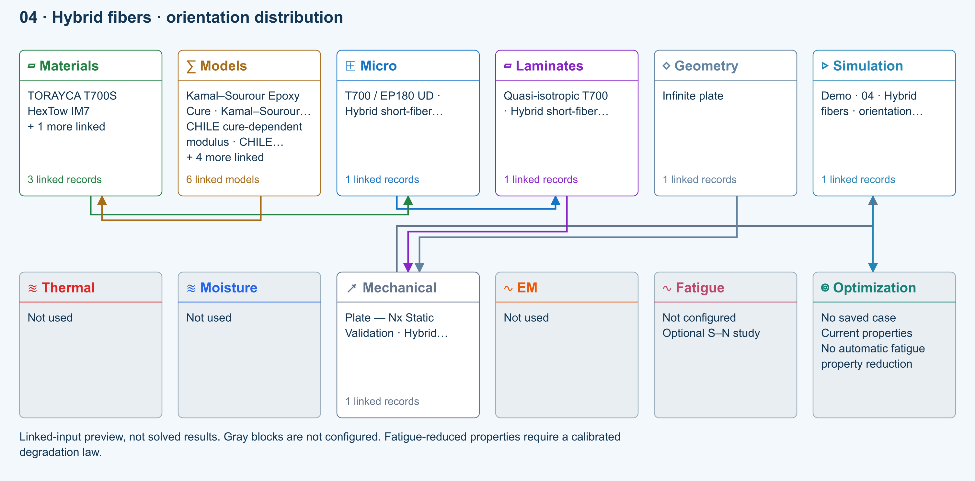

Tasks
Inspect both linked fibers: 20% T700 plus 10% IM7, 2% voids and 68% resin. Rotate the live 3D view; normalized fiber lengths are illustrative only.
Run with Fa=1, then Fa=0/Fp=1, then Fa=0/Fp=0. Compare E1, E2, E3 and shear moduli.
Hold total fiber at 30% and move volume between fiber 1 and fiber 2. Rerun and compare stiffness and density.
Review classical failure inputs. The supplied zero allowables mean strength is not assessed; do not claim a pass from elasticity alone.

Checkpoints
In-plane random orientation gives E1 = E2; spatial random orientation gives E1 = E2 = E3.
Fa=.5 and Fp=.5 represent 50% axial, 25% planar-random and 25% spatial-random fibers.
Cox transfer is evaluated per fiber modulus. Hybrid transverse closure is an averaged-constituent screening approximation; it does not model phase interaction or debonding.

Model limits
Prescribed orientation, common filament dimensions and resin. Voigt stiffness averaging; not a manufacturing orientation prediction or progressive failure model. Thermal transport retains aligned closure assumptions.

Recorded validation
2026-09-18 — Not benchmark validated: No matched quantitative reference comparison completed for the full exercise.
Prescribed orientation, common filament dimensions and resin. Voigt stiffness averaging; not a manufacturing orientation prediction or progressive failure model. Thermal transport retains aligned closure assumptions.
Validation evidence and tested inputs

Connected models and submodels
Kamal–Sourour autocatalytic. Reusable material model. It contributes only when assigned to a material used by this simulation; separate model records can supply independent properties.
Theory and assumptions
Calibration & applicability. Illustrative model defaults — replace with characterized resin kinetics
CHILE (degree of cure). Reusable material model. It contributes only when assigned to a material used by this simulation; separate model records can supply independent properties. Cure-dependent modulus does not automatically scale strength allowables.
Theory and assumptions
Calibration & applicability. CHILE(α), section 2.4 of Materials 2019, 12, 259. Example parameters, not measured EP180 data. Fixed Poisson ratio; no viscoelastic relaxation or Tg softening. Incremental elastic stress integration at saved process intervals: check time-step convergence. Strength allowables are independent measured inputs, not scaled with modulus.
Temperature-dependent tabular. Reusable material model. It contributes only when assigned to a material used by this simulation; separate model records can supply independent properties. Micro uses the 23 °C reference; Process evaluates the same table at local temperature, without extrapolation.
Theory and assumptions
Calibration & applicability. Check source data, applicable environment and validity limits in the model record; saved defaults are not experimental validation.
1D Fickian diffusion. Reusable material model. It contributes only when assigned to a material used by this simulation; separate model records can supply independent properties.
Theory and assumptions
Calibration & applicability. Check source data, applicable environment and validity limits in the model record; saved defaults are not experimental validation.
Cox shear-lag elastic. One compatible homogenization model per Micro recipe. Separate recipes compare models; their predictions are not blended.
Theory and assumptions
CLT · Linear static with failure indices. Shared laminate stiffness drives this membrane/CLT path. Failure criteria are independent comparisons, not blended models. Fatigue is a separate assessment.
Theory and assumptions
Failure criterion · Maximum stress. Primary criterion. Additional envelope comparisons are chosen in Response → Failure; they run independently.

Data between modules
Micro to Laminates: Predicted ply stiffness, strength, density and expansion properties.
Materials to Micro: Constituent stiffness, strength, density and thermal / moisture properties.
Models to Materials: Model choices and calibrated parameters.
Mechanical to Simulation: SIMULATION selects this case and its analysis model; the case owns its applicable cycle and input references.
Laminates to Mechanical: Ply angles and thicknesses, stiffness, mass and ply properties.
Geometry to Mechanical: Shape and dimensions for the selected structural analysis.
Simulation to Optimization: Linked inputs and current-property response for candidate evaluation.

References
Create and connect a lamina
Edit material properties and units
Run and review a model
Review effective properties
Connected inputs and result freshness
Edit laminate materials, angles and thicknesses
Related case study: NASA lamina analysis
Record the inputs, units, solver notices and checkpoint results before drawing a conclusion. When exploring a variation, change one factor at a time and compare it with the original case.

Sandwich FSDT clamped panel bending
Online chapter
Sandwich panel bending. Finite rectangular plate. Models: FSDT, Classical laminate theory, Transverse shear, Static bending.
Open this exercise in Workbench
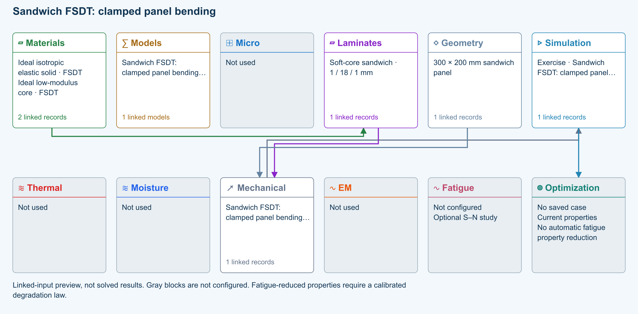

Tasks
Open Simulation: check the shared skins/core, 1 / 18 / 1 mm stack, 300 × 200 mm Geometry, and paired Loading. Architecture must be Sandwich Structures; Automatic resolves to FSDT with Energy equivalent shear correction.
Run uniform-pressure bending with all edges clamped. Compare peak deflection and Qx/Qy with the same panel set to Simply supported; record the restraint effect.
Increase Ritz order from 6 to 8; compare the quantity of interest before interpreting the result.
Double Plate pressure and verify that linear deflection doubles. Save an independent copy before changing shared records.

Checkpoints
Geometry owns length and width; Laminate owns skin/core thicknesses.
Static pressure and membrane loads are never combined in these examples. Modal loads are all zero.
w is a physical displacement in mm; Qx/Qy are shear resultants, not interface stresses.
Completion does not assess wrinkling, core crushing, debonding or delamination.

Model limits
Reference-elastic symmetric rectangular FSDT plate. Idealized teaching data, no calibrated material/strength claim. No thermal/moisture preload, thickness stretch, contact, debonding, damage or postbuckling. Directional energy-equivalent shear correction is an approximation; refine numerical order and compare published solutions.

Recorded validation
2026-09-18 — Not benchmark validated: No matched quantitative reference comparison completed for the full exercise.
Reference-elastic symmetric rectangular FSDT plate. Idealized teaching data, no calibrated material/strength claim. No thermal/moisture preload, thickness stretch, contact, debonding, damage or postbuckling. Directional energy-equivalent shear correction is an approximation; refine numerical order and compare published solutions.
Validation evidence and tested inputs

Connected models and submodels
Automatic · Finite plate. Automatic selects FSDT for sandwich architecture and CLT otherwise. Static bending requires FSDT. Finite-plate studies do not consume process links or run progressive failure/fatigue.
Theory and assumptions
Study · Static bending. Reference-elastic plate study; progressive failure and fatigue are not evaluated here.
Numerical settings. Ritz order: 6. Shear correction (FSDT only): Energy equivalent. Increase resolution to check convergence.

Data between modules
Materials to Laminates: Stored ply stiffness, strength, density and expansion properties.
Mechanical to Simulation: SIMULATION selects this case and its analysis model; the case owns its applicable cycle and input references.
Laminates to Mechanical: Ply angles and thicknesses, stiffness, mass and ply properties.
Geometry to Mechanical: Shape and dimensions for the selected structural analysis.
Simulation to Optimization: Linked inputs and current-property response for candidate evaluation.

References
FSDT: shared laminate stiffness, shear and plate response
Edit laminate materials, angles and thicknesses
Run and review a model
Geometry, loading and virtual tests
Record the inputs, units, solver notices and checkpoint results before drawing a conclusion. When exploring a variation, change one factor at a time and compare it with the original case.

NASA T700/PR520 lamina analysis
Online chapter
Constituent-to-lamina comparison. Unidirectional lamina. Models: Halpin–Tsai, Rule of mixtures, MAC/GMC comparison.
Open this exercise in Workbench

Setup
The copied T700/EP180 database is a connected starter, not T700/PR520. Complete the constituent setup below before comparing with NASA.

Tasks
Open the linked web walkthrough and NASA/TM–2015-218814. Rename the copied constituents for this study; enter T700 E1/E2/G12 = 230/15/27 GPa, ν12 = 0.20 and density 1.80 g/cm³. Enter PR520 E/ν/G = 4.0 GPa/0.38/1.44 GPa and density 1.25 g/cm³. Preserve the research citation; do not substitute the starter resin properties.
Use continuous unidirectional micromechanics with zero voids. Evaluate Vf = 0.375, 0.733 and 0.800, holding every other input fixed. Save three copies or an optimization comparison.
Compare E1/E2/G12 against 88.5/6.22/2.60, 169.5/9.90/7.00 and 184.7/10.9/6.00 GPa respectively. Report 100 × (CDS − reference) / reference; compare another supported homogenization model.
Save the chosen predicted lamina and source links. Leave unsupported strength and transport data unavailable; do not carry over unrelated starter allowables.

Checkpoints
Published MAC/GMC values are external comparison data, not exact acceptance targets for Halpin–Tsai.
Keep the three local fiber-volume regions separate; averaging braid subcells needs justification.

Model limits
Constituent-to-lamina screening only. The NASA braid subcells, calibrated LS-DYNA damage and coupon validation are not reproduced.

Recorded validation
2026-09-18 — Not benchmark validated: No matched quantitative reference comparison completed for the full exercise.
Constituent-to-lamina screening only. The NASA braid subcells, calibrated LS-DYNA damage and coupon validation are not reproduced.
Validation evidence and tested inputs

Connected models and submodels
Kamal–Sourour autocatalytic. Reusable material model. It contributes only when assigned to a material used by this simulation; separate model records can supply independent properties.
Theory and assumptions
Calibration & applicability. Illustrative model defaults — replace with characterized resin kinetics
CHILE (degree of cure). Reusable material model. It contributes only when assigned to a material used by this simulation; separate model records can supply independent properties. Cure-dependent modulus does not automatically scale strength allowables.
Theory and assumptions
Calibration & applicability. CHILE(α), section 2.4 of Materials 2019, 12, 259. Example parameters, not measured EP180 data. Fixed Poisson ratio; no viscoelastic relaxation or Tg softening. Incremental elastic stress integration at saved process intervals: check time-step convergence. Strength allowables are independent measured inputs, not scaled with modulus.
Temperature-dependent tabular. Reusable material model. It contributes only when assigned to a material used by this simulation; separate model records can supply independent properties. Micro uses the 23 °C reference; Process evaluates the same table at local temperature, without extrapolation.
Theory and assumptions
Calibration & applicability. Check source data, applicable environment and validity limits in the model record; saved defaults are not experimental validation.
1D Fickian diffusion. Reusable material model. It contributes only when assigned to a material used by this simulation; separate model records can supply independent properties.
Theory and assumptions
Calibration & applicability. Check source data, applicable environment and validity limits in the model record; saved defaults are not experimental validation.
Halpin–Tsai. One compatible homogenization model per Micro recipe. Separate recipes compare models; their predictions are not blended.
Theory and assumptions
CLT · Linear static with failure indices. Shared laminate stiffness drives this membrane/CLT path. Failure criteria are independent comparisons, not blended models. Fatigue is a separate assessment.
Theory and assumptions
Failure criterion · Maximum stress. Primary criterion. Additional envelope comparisons are chosen in Response → Failure; they run independently.

Data between modules
Micro to Laminates: Predicted ply stiffness, strength, density and expansion properties.
Materials to Micro: Constituent stiffness, strength, density and thermal / moisture properties.
Models to Materials: Model choices and calibrated parameters.
Mechanical to Simulation: SIMULATION selects this case and its analysis model; the case owns its applicable cycle and input references.
Laminates to Mechanical: Ply angles and thicknesses, stiffness, mass and ply properties.
Geometry to Mechanical: Shape and dimensions for the selected structural analysis.
Simulation to Optimization: Linked inputs and current-property response for candidate evaluation.

References
Related case study: NASA lamina analysis
Edit material properties and units
Create and connect a lamina
Review effective properties
Connected inputs and result freshness
Run and review a model
Record the inputs, units, solver notices and checkpoint results before drawing a conclusion. When exploring a variation, change one factor at a time and compare it with the original case.

T700S / 180C Epoxy UD stored-ply elasticity
Online chapter
Stored ply properties. Infinite plate. Models: Stored lamina elasticity, Classical laminate theory, Maximum stress.
Open this exercise in Workbench
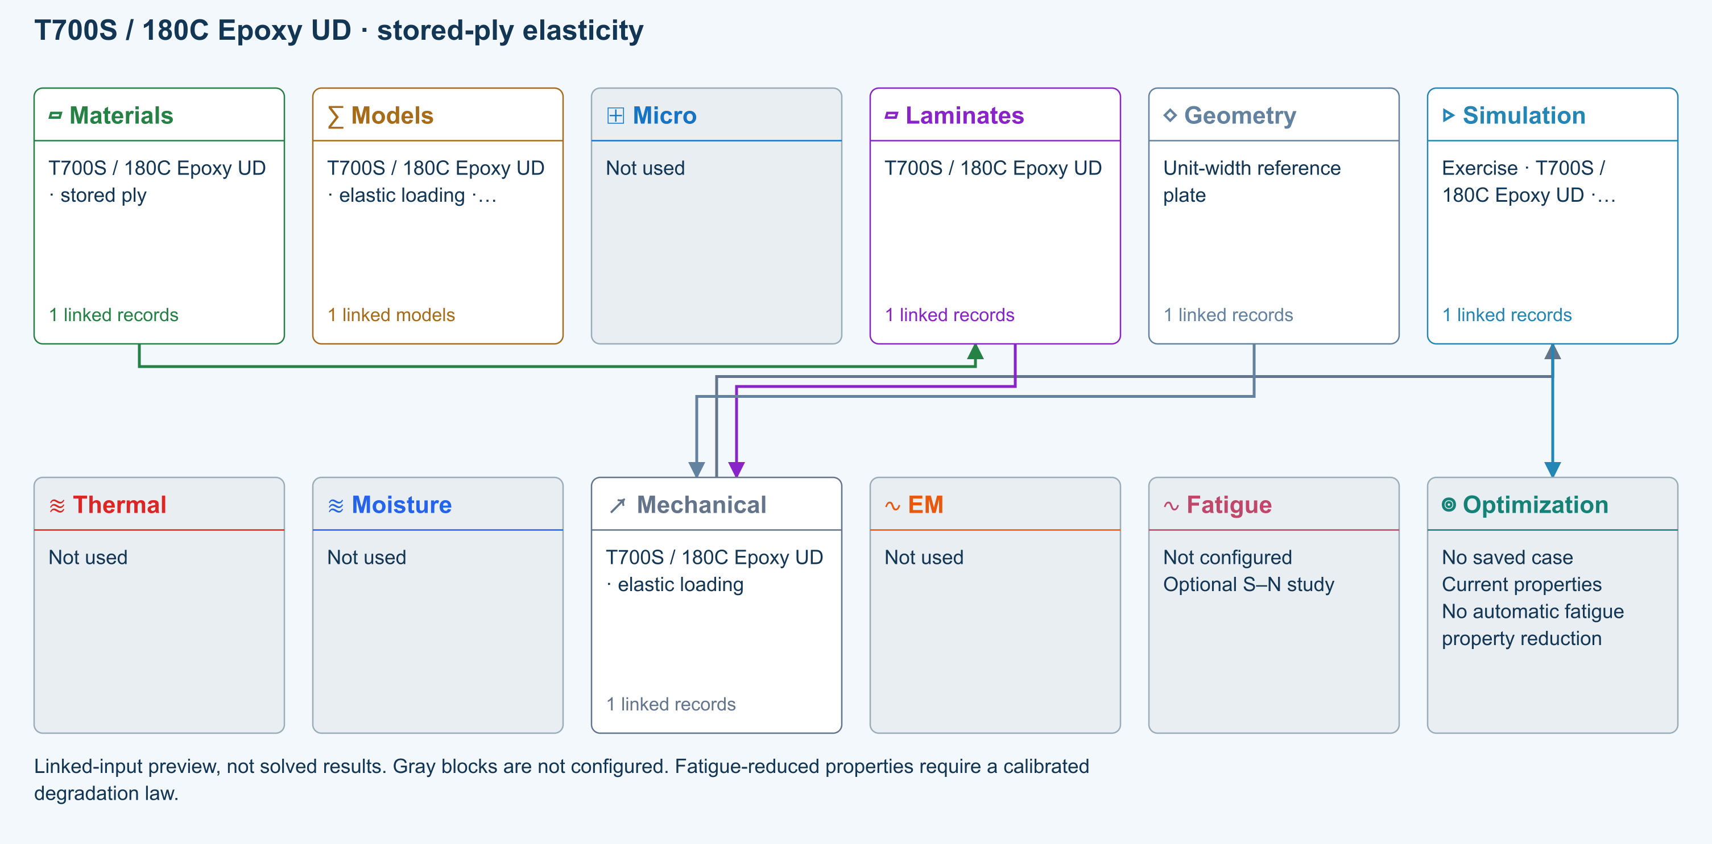

Tasks
Trace the stored material-to-laminate path. Inspect original file, record ID, property status and units; Micro is intentionally not used.
Run the added teaching load Nx = 1 N/mm. Inspect stiffness, strain and ply stresses; this load was not stored in the original library.
Double one applied resultant, rerun, and compare the corresponding linear response. Record the model limits before interpreting strength.

Checkpoints
Stored moduli and strengths retain their original SI values after display-unit conversion.
Each original ply angle and thickness is retained; no constituent mixing or cure model is substituted.
These are executable teaching studies, not independently validated physical benchmarks.

Model limits
Stored original ply properties; original homogenization and failure-model selections are not rerun. Maximum-stress screening uses original teaching strengths, not qualified allowables. Linear CLT resultants only: no grip/edge boundary layers, buckling, delamination, progressive growth or process coupling. Completion is not validation or a physical pass.

Source data
L-T700-EP180-UD | CDS2026_Beam_Analysis_Examples.cdsdb | 74780b9bf0abab55f0d6a0ff2e885a322196bea12ee6af9b4a08b0ebb7ce0db3 | Original stored data with a new explicit unit-resultant teaching load

Recorded validation
2026-09-18 — Benchmark validated — analytical scope: Listed reference-elastic extensional constants only; free curvature, ply stresses, strength and every user variation are outside this badge.
Stored original ply properties; original homogenization and failure-model selections are not rerun. Maximum-stress screening uses original teaching strengths, not qualified allowables. Linear CLT resultants only: no grip/edge boundary layers, buckling, delamination, progressive growth or process coupling. Completion is not validation or a physical pass.
Validation evidence and tested inputs

Connected models and submodels
CLT · Linear static with failure indices. Shared laminate stiffness drives this membrane/CLT path. Failure criteria are independent comparisons, not blended models. Fatigue is a separate assessment.
Theory and assumptions
Failure criterion · Maximum stress. Primary criterion. Additional envelope comparisons are chosen in Response → Failure; they run independently.

Data between modules
Materials to Laminates: Stored ply stiffness, strength, density and expansion properties.
Mechanical to Simulation: SIMULATION selects this case and its analysis model; the case owns its applicable cycle and input references.
Laminates to Mechanical: Ply angles and thicknesses, stiffness, mass and ply properties.
Geometry to Mechanical: Shape and dimensions for the selected structural analysis.
Simulation to Optimization: Linked inputs and current-property response for candidate evaluation.

References
Edit material properties and units
Edit laminate materials, angles and thicknesses
Run and review a model
Review effective properties
Connected inputs and result freshness
Geometry, loading and virtual tests
Record the inputs, units, solver notices and checkpoint results before drawing a conclusion. When exploring a variation, change one factor at a time and compare it with the original case.

IM7 / Toughened Epoxy UD stored-ply elasticity
Online chapter
Stored ply properties. Infinite plate. Models: Stored lamina elasticity, Classical laminate theory, Maximum stress.
Open this exercise in Workbench
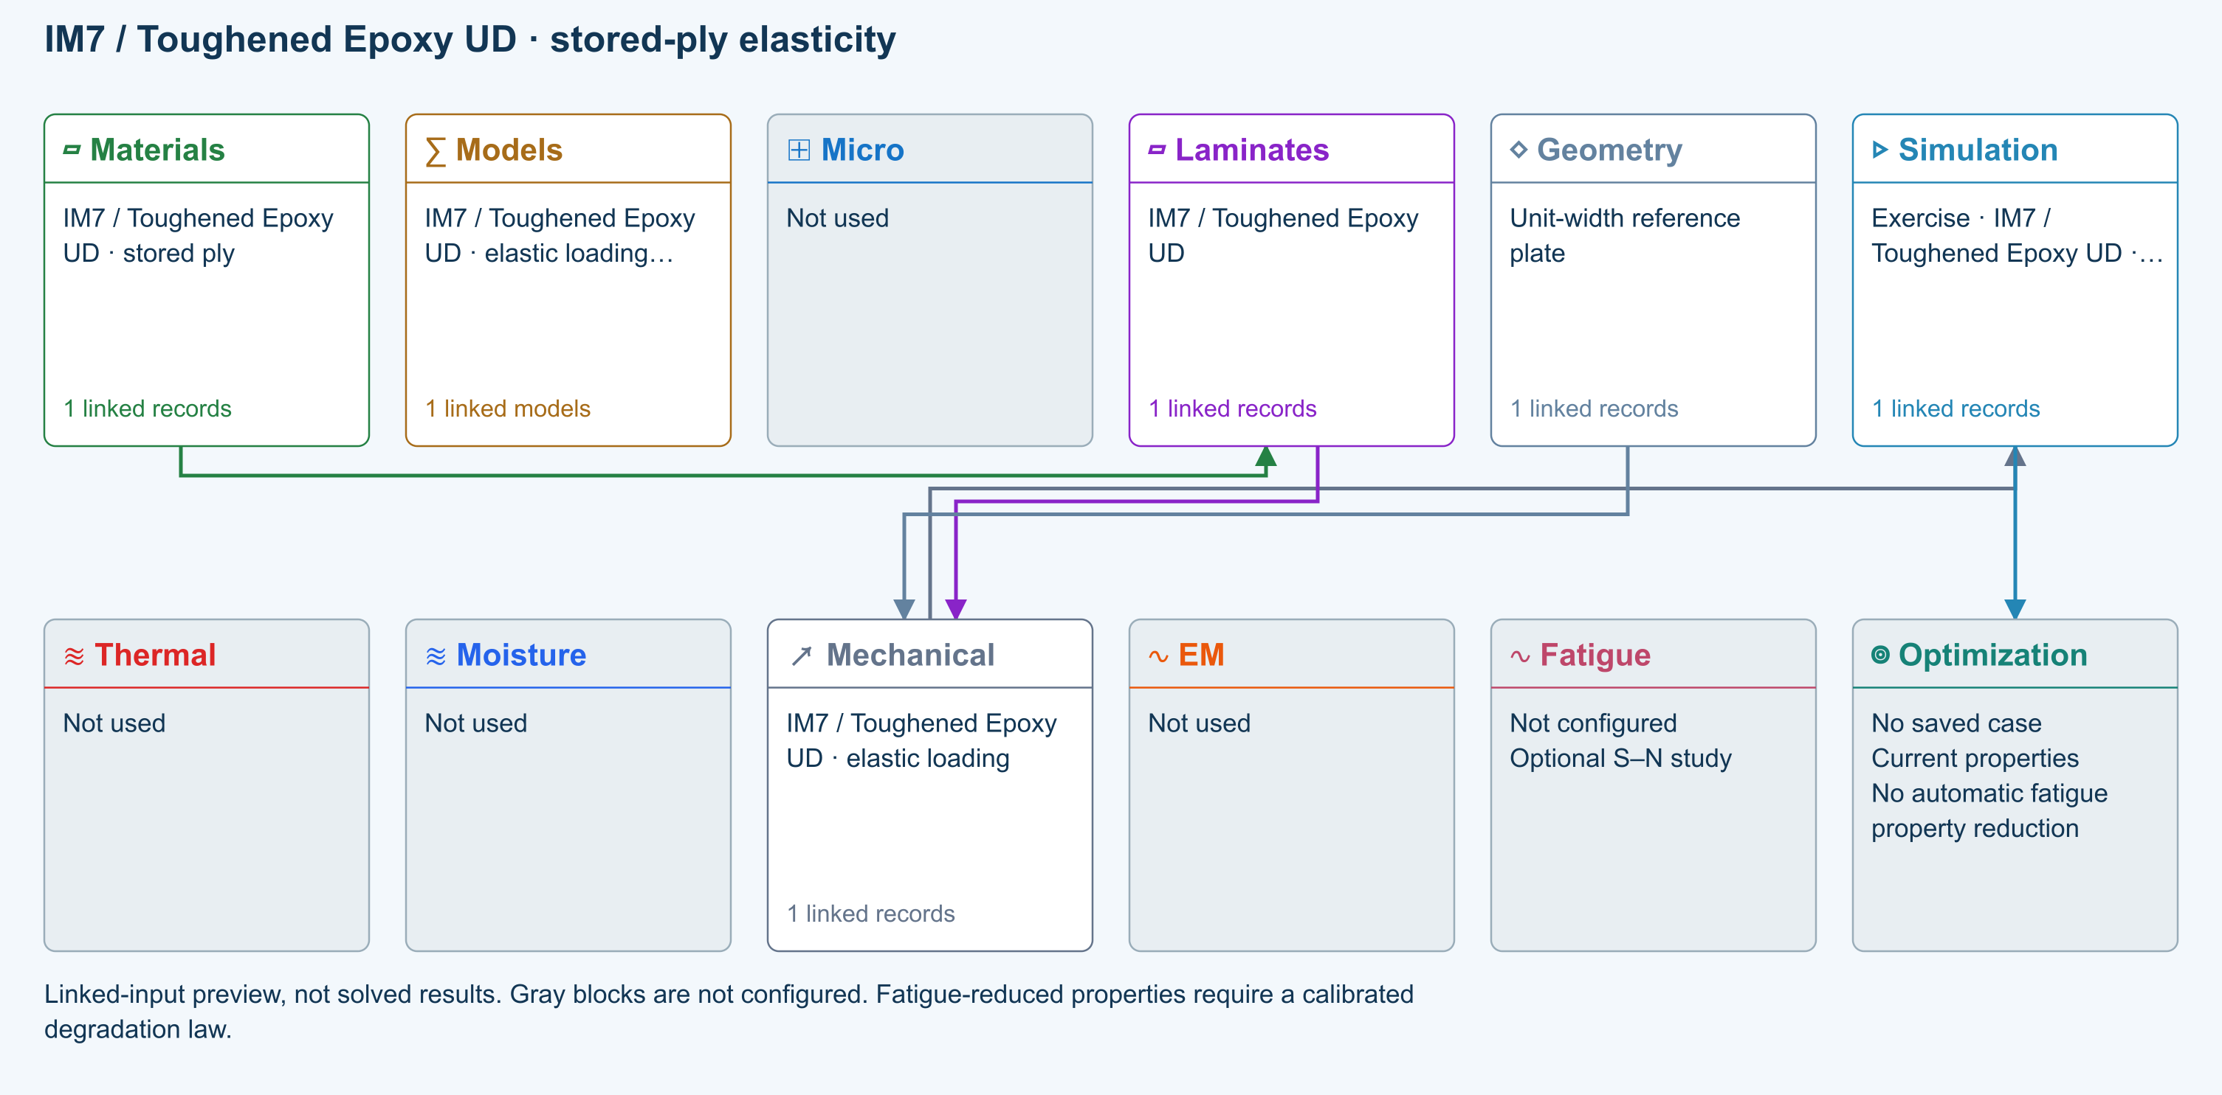

Tasks
Trace the stored material-to-laminate path. Inspect original file, record ID, property status and units; Micro is intentionally not used.
Run the added teaching load Nx = 1 N/mm. Inspect stiffness, strain and ply stresses; this load was not stored in the original library.
Double one applied resultant, rerun, and compare the corresponding linear response. Record the model limits before interpreting strength.

Checkpoints
Stored moduli and strengths retain their original SI values after display-unit conversion.
Each original ply angle and thickness is retained; no constituent mixing or cure model is substituted.
These are executable teaching studies, not independently validated physical benchmarks.

Model limits
Stored original ply properties; original homogenization and failure-model selections are not rerun. Maximum-stress screening uses original teaching strengths, not qualified allowables. Linear CLT resultants only: no grip/edge boundary layers, buckling, delamination, progressive growth or process coupling. Completion is not validation or a physical pass.

Source data
L-IM7-8552-UD | CDS2026_Beam_Analysis_Examples.cdsdb | 74780b9bf0abab55f0d6a0ff2e885a322196bea12ee6af9b4a08b0ebb7ce0db3 | Original stored data with a new explicit unit-resultant teaching load

Recorded validation
2026-09-18 — Benchmark validated — analytical scope: Listed reference-elastic extensional constants only; free curvature, ply stresses, strength and every user variation are outside this badge.
Stored original ply properties; original homogenization and failure-model selections are not rerun. Maximum-stress screening uses original teaching strengths, not qualified allowables. Linear CLT resultants only: no grip/edge boundary layers, buckling, delamination, progressive growth or process coupling. Completion is not validation or a physical pass.
Validation evidence and tested inputs

Connected models and submodels
CLT · Linear static with failure indices. Shared laminate stiffness drives this membrane/CLT path. Failure criteria are independent comparisons, not blended models. Fatigue is a separate assessment.
Theory and assumptions
Failure criterion · Maximum stress. Primary criterion. Additional envelope comparisons are chosen in Response → Failure; they run independently.

Data between modules
Materials to Laminates: Stored ply stiffness, strength, density and expansion properties.
Mechanical to Simulation: SIMULATION selects this case and its analysis model; the case owns its applicable cycle and input references.
Laminates to Mechanical: Ply angles and thicknesses, stiffness, mass and ply properties.
Geometry to Mechanical: Shape and dimensions for the selected structural analysis.
Simulation to Optimization: Linked inputs and current-property response for candidate evaluation.

References
Edit material properties and units
Edit laminate materials, angles and thicknesses
Run and review a model
Review effective properties
Connected inputs and result freshness
Geometry, loading and virtual tests
Record the inputs, units, solver notices and checkpoint results before drawing a conclusion. When exploring a variation, change one factor at a time and compare it with the original case.

T800S / BMI UD stored-ply elasticity
Online chapter
Stored ply properties. Infinite plate. Models: Stored lamina elasticity, Classical laminate theory, Maximum stress.
Open this exercise in Workbench
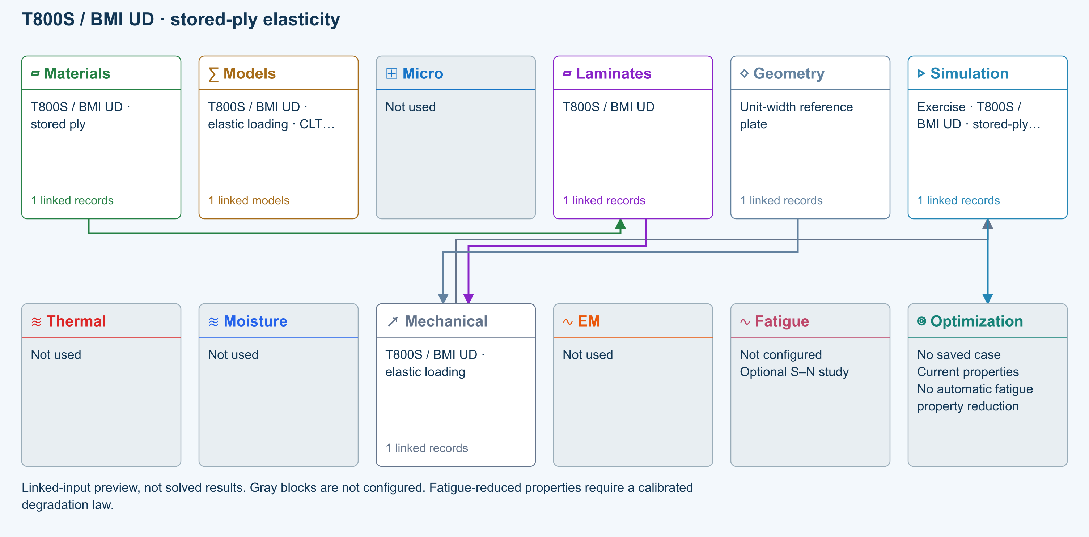

Tasks
Trace the stored material-to-laminate path. Inspect original file, record ID, property status and units; Micro is intentionally not used.
Run the added teaching load Nx = 1 N/mm. Inspect stiffness, strain and ply stresses; this load was not stored in the original library.
Double one applied resultant, rerun, and compare the corresponding linear response. Record the model limits before interpreting strength.

Checkpoints
Stored moduli and strengths retain their original SI values after display-unit conversion.
Each original ply angle and thickness is retained; no constituent mixing or cure model is substituted.
These are executable teaching studies, not independently validated physical benchmarks.

Model limits
Stored original ply properties; original homogenization and failure-model selections are not rerun. Maximum-stress screening uses original teaching strengths, not qualified allowables. Linear CLT resultants only: no grip/edge boundary layers, buckling, delamination, progressive growth or process coupling. Completion is not validation or a physical pass.

Source data
L-T800-BMI-UD | CDS2026_Beam_Analysis_Examples.cdsdb | 74780b9bf0abab55f0d6a0ff2e885a322196bea12ee6af9b4a08b0ebb7ce0db3 | Original stored data with a new explicit unit-resultant teaching load

Recorded validation
2026-09-18 — Benchmark validated — analytical scope: Listed reference-elastic extensional constants only; free curvature, ply stresses, strength and every user variation are outside this badge.
Stored original ply properties; original homogenization and failure-model selections are not rerun. Maximum-stress screening uses original teaching strengths, not qualified allowables. Linear CLT resultants only: no grip/edge boundary layers, buckling, delamination, progressive growth or process coupling. Completion is not validation or a physical pass.
Validation evidence and tested inputs

Connected models and submodels
CLT · Linear static with failure indices. Shared laminate stiffness drives this membrane/CLT path. Failure criteria are independent comparisons, not blended models. Fatigue is a separate assessment.
Theory and assumptions
Failure criterion · Maximum stress. Primary criterion. Additional envelope comparisons are chosen in Response → Failure; they run independently.

Data between modules
Materials to Laminates: Stored ply stiffness, strength, density and expansion properties.
Mechanical to Simulation: SIMULATION selects this case and its analysis model; the case owns its applicable cycle and input references.
Laminates to Mechanical: Ply angles and thicknesses, stiffness, mass and ply properties.
Geometry to Mechanical: Shape and dimensions for the selected structural analysis.
Simulation to Optimization: Linked inputs and current-property response for candidate evaluation.

References
Edit material properties and units
Edit laminate materials, angles and thicknesses
Run and review a model
Review effective properties
Connected inputs and result freshness
Geometry, loading and virtual tests
Record the inputs, units, solver notices and checkpoint results before drawing a conclusion. When exploring a variation, change one factor at a time and compare it with the original case.

AS4 / PEEK UD stored-ply elasticity
Online chapter
Stored ply properties. Infinite plate. Models: Stored lamina elasticity, Classical laminate theory, Maximum stress.
Open this exercise in Workbench
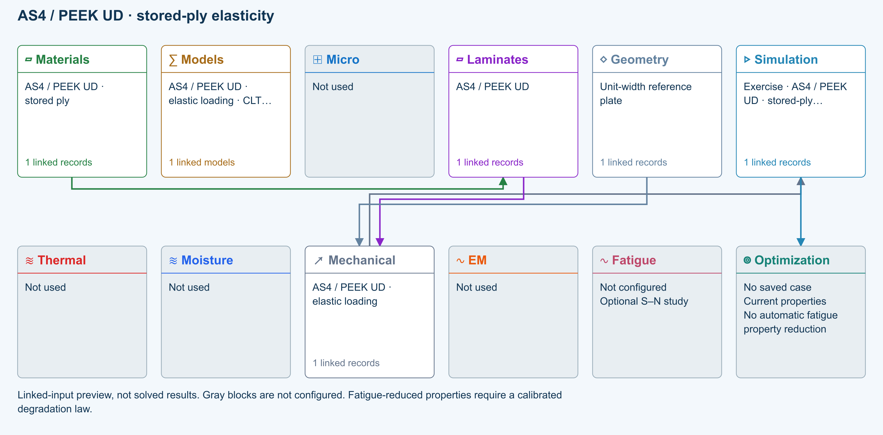

Tasks
Trace the stored material-to-laminate path. Inspect original file, record ID, property status and units; Micro is intentionally not used.
Run the added teaching load Nx = 1 N/mm. Inspect stiffness, strain and ply stresses; this load was not stored in the original library.
Double one applied resultant, rerun, and compare the corresponding linear response. Record the model limits before interpreting strength.

Checkpoints
Stored moduli and strengths retain their original SI values after display-unit conversion.
Each original ply angle and thickness is retained; no constituent mixing or cure model is substituted.
These are executable teaching studies, not independently validated physical benchmarks.

Model limits
Stored original ply properties; original homogenization and failure-model selections are not rerun. Maximum-stress screening uses original teaching strengths, not qualified allowables. Linear CLT resultants only: no grip/edge boundary layers, buckling, delamination, progressive growth or process coupling. Completion is not validation or a physical pass.

Source data
L-AS4-PEEK-UD | CDS2026_Beam_Analysis_Examples.cdsdb | 74780b9bf0abab55f0d6a0ff2e885a322196bea12ee6af9b4a08b0ebb7ce0db3 | Original stored data with a new explicit unit-resultant teaching load

Recorded validation
2026-09-18 — Benchmark validated — analytical scope: Listed reference-elastic extensional constants only; free curvature, ply stresses, strength and every user variation are outside this badge.
Stored original ply properties; original homogenization and failure-model selections are not rerun. Maximum-stress screening uses original teaching strengths, not qualified allowables. Linear CLT resultants only: no grip/edge boundary layers, buckling, delamination, progressive growth or process coupling. Completion is not validation or a physical pass.
Validation evidence and tested inputs

Connected models and submodels
CLT · Linear static with failure indices. Shared laminate stiffness drives this membrane/CLT path. Failure criteria are independent comparisons, not blended models. Fatigue is a separate assessment.
Theory and assumptions
Failure criterion · Maximum stress. Primary criterion. Additional envelope comparisons are chosen in Response → Failure; they run independently.

Data between modules
Materials to Laminates: Stored ply stiffness, strength, density and expansion properties.
Mechanical to Simulation: SIMULATION selects this case and its analysis model; the case owns its applicable cycle and input references.
Laminates to Mechanical: Ply angles and thicknesses, stiffness, mass and ply properties.
Geometry to Mechanical: Shape and dimensions for the selected structural analysis.
Simulation to Optimization: Linked inputs and current-property response for candidate evaluation.

References
Edit material properties and units
Edit laminate materials, angles and thicknesses
Run and review a model
Review effective properties
Connected inputs and result freshness
Geometry, loading and virtual tests
Record the inputs, units, solver notices and checkpoint results before drawing a conclusion. When exploring a variation, change one factor at a time and compare it with the original case.

T300 / EPON 862 Epoxy UD Prepreg stored-ply elasticity
Online chapter
Stored ply properties. Infinite plate. Models: Stored lamina elasticity, Classical laminate theory, Maximum stress.
Open this exercise in Workbench
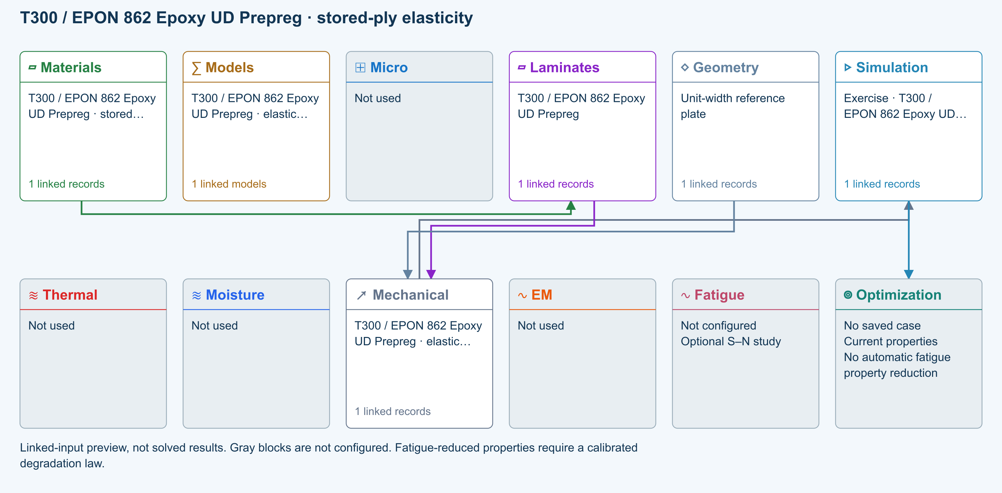

Tasks
Trace the stored material-to-laminate path. Inspect original file, record ID, property status and units; Micro is intentionally not used.
Run the added teaching load Nx = 1 N/mm. Inspect stiffness, strain and ply stresses; this load was not stored in the original library.
Double one applied resultant, rerun, and compare the corresponding linear response. Record the model limits before interpreting strength.

Checkpoints
Stored moduli and strengths retain their original SI values after display-unit conversion.
Each original ply angle and thickness is retained; no constituent mixing or cure model is substituted.
These are executable teaching studies, not independently validated physical benchmarks.

Model limits
Stored original ply properties; original homogenization and failure-model selections are not rerun. Maximum-stress screening uses original teaching strengths, not qualified allowables. Linear CLT resultants only: no grip/edge boundary layers, buckling, delamination, progressive growth or process coupling. Completion is not validation or a physical pass.

Source data
L-T300-EPON862-UD | CDS2026_Epoxy_Prepregs_5.cdsdb | a577fdadc042d0d4b167acf5698c139b290a27ed0a0c1fbe4708f61f6a9f5313 | Original stored data with a new explicit unit-resultant teaching load

Recorded validation
2026-09-18 — Benchmark validated — analytical scope: Listed reference-elastic extensional constants only; free curvature, ply stresses, strength and every user variation are outside this badge.
Stored original ply properties; original homogenization and failure-model selections are not rerun. Maximum-stress screening uses original teaching strengths, not qualified allowables. Linear CLT resultants only: no grip/edge boundary layers, buckling, delamination, progressive growth or process coupling. Completion is not validation or a physical pass.
Validation evidence and tested inputs

Connected models and submodels
CLT · Linear static with failure indices. Shared laminate stiffness drives this membrane/CLT path. Failure criteria are independent comparisons, not blended models. Fatigue is a separate assessment.
Theory and assumptions
Failure criterion · Maximum stress. Primary criterion. Additional envelope comparisons are chosen in Response → Failure; they run independently.

Data between modules
Materials to Laminates: Stored ply stiffness, strength, density and expansion properties.
Mechanical to Simulation: SIMULATION selects this case and its analysis model; the case owns its applicable cycle and input references.
Laminates to Mechanical: Ply angles and thicknesses, stiffness, mass and ply properties.
Geometry to Mechanical: Shape and dimensions for the selected structural analysis.
Simulation to Optimization: Linked inputs and current-property response for candidate evaluation.

References
Edit material properties and units
Edit laminate materials, angles and thicknesses
Run and review a model
Review effective properties
Connected inputs and result freshness
Geometry, loading and virtual tests
Record the inputs, units, solver notices and checkpoint results before drawing a conclusion. When exploring a variation, change one factor at a time and compare it with the original case.

T800S / 977-3-Type Epoxy UD Prepreg stored-ply elasticity
Online chapter
Stored ply properties. Infinite plate. Models: Stored lamina elasticity, Classical laminate theory, Maximum stress.
Open this exercise in Workbench
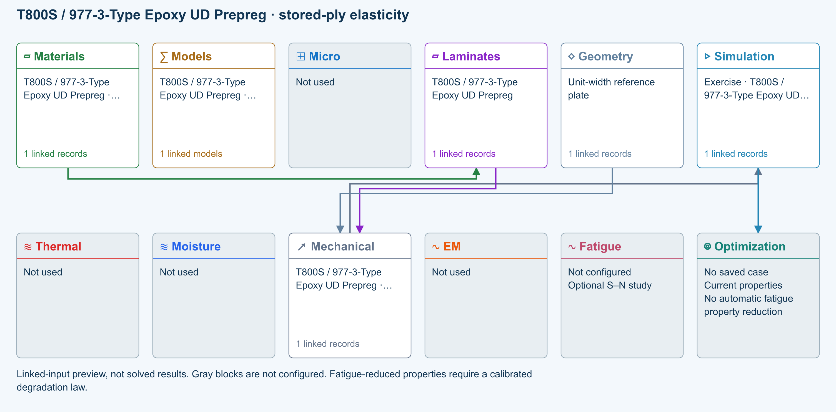

Tasks
Trace the stored material-to-laminate path. Inspect original file, record ID, property status and units; Micro is intentionally not used.
Run the added teaching load Nx = 1 N/mm. Inspect stiffness, strain and ply stresses; this load was not stored in the original library.
Double one applied resultant, rerun, and compare the corresponding linear response. Record the model limits before interpreting strength.

Checkpoints
Stored moduli and strengths retain their original SI values after display-unit conversion.
Each original ply angle and thickness is retained; no constituent mixing or cure model is substituted.
These are executable teaching studies, not independently validated physical benchmarks.

Model limits
Stored original ply properties; original homogenization and failure-model selections are not rerun. Maximum-stress screening uses original teaching strengths, not qualified allowables. Linear CLT resultants only: no grip/edge boundary layers, buckling, delamination, progressive growth or process coupling. Completion is not validation or a physical pass.

Source data
L-T800-9773-UD | CDS2026_Epoxy_Prepregs_5.cdsdb | a577fdadc042d0d4b167acf5698c139b290a27ed0a0c1fbe4708f61f6a9f5313 | Original stored data with a new explicit unit-resultant teaching load

Recorded validation
2026-09-18 — Benchmark validated — analytical scope: Listed reference-elastic extensional constants only; free curvature, ply stresses, strength and every user variation are outside this badge.
Stored original ply properties; original homogenization and failure-model selections are not rerun. Maximum-stress screening uses original teaching strengths, not qualified allowables. Linear CLT resultants only: no grip/edge boundary layers, buckling, delamination, progressive growth or process coupling. Completion is not validation or a physical pass.
Validation evidence and tested inputs

Connected models and submodels
CLT · Linear static with failure indices. Shared laminate stiffness drives this membrane/CLT path. Failure criteria are independent comparisons, not blended models. Fatigue is a separate assessment.
Theory and assumptions
Failure criterion · Maximum stress. Primary criterion. Additional envelope comparisons are chosen in Response → Failure; they run independently.

Data between modules
Materials to Laminates: Stored ply stiffness, strength, density and expansion properties.
Mechanical to Simulation: SIMULATION selects this case and its analysis model; the case owns its applicable cycle and input references.
Laminates to Mechanical: Ply angles and thicknesses, stiffness, mass and ply properties.
Geometry to Mechanical: Shape and dimensions for the selected structural analysis.
Simulation to Optimization: Linked inputs and current-property response for candidate evaluation.

References
Edit material properties and units
Edit laminate materials, angles and thicknesses
Run and review a model
Review effective properties
Connected inputs and result freshness
Geometry, loading and virtual tests
Record the inputs, units, solver notices and checkpoint results before drawing a conclusion. When exploring a variation, change one factor at a time and compare it with the original case.

AS4 / LY 1564-Type Epoxy UD Prepreg stored-ply elasticity
Online chapter
Stored ply properties. Infinite plate. Models: Stored lamina elasticity, Classical laminate theory, Maximum stress.
Open this exercise in Workbench
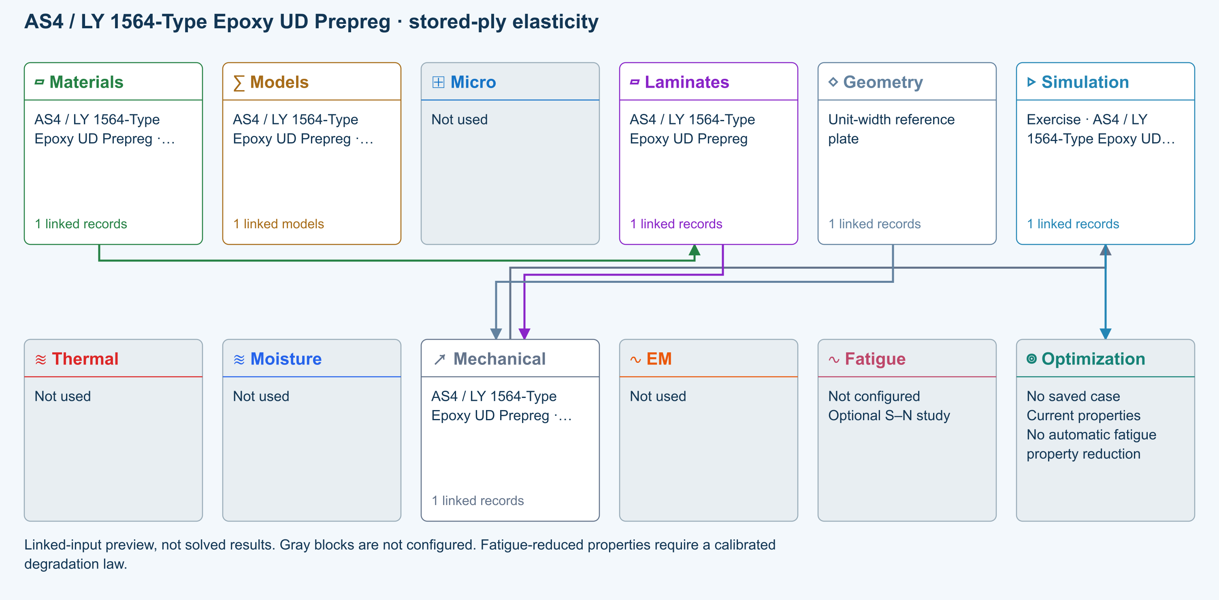

Tasks
Trace the stored material-to-laminate path. Inspect original file, record ID, property status and units; Micro is intentionally not used.
Run the added teaching load Nx = 1 N/mm. Inspect stiffness, strain and ply stresses; this load was not stored in the original library.
Double one applied resultant, rerun, and compare the corresponding linear response. Record the model limits before interpreting strength.

Checkpoints
Stored moduli and strengths retain their original SI values after display-unit conversion.
Each original ply angle and thickness is retained; no constituent mixing or cure model is substituted.
These are executable teaching studies, not independently validated physical benchmarks.

Model limits
Stored original ply properties; original homogenization and failure-model selections are not rerun. Maximum-stress screening uses original teaching strengths, not qualified allowables. Linear CLT resultants only: no grip/edge boundary layers, buckling, delamination, progressive growth or process coupling. Completion is not validation or a physical pass.

Source data
L-AS4-LY1564-UD | CDS2026_Epoxy_Prepregs_5.cdsdb | a577fdadc042d0d4b167acf5698c139b290a27ed0a0c1fbe4708f61f6a9f5313 | Original stored data with a new explicit unit-resultant teaching load

Recorded validation
2026-09-18 — Benchmark validated — analytical scope: Listed reference-elastic extensional constants only; free curvature, ply stresses, strength and every user variation are outside this badge.
Stored original ply properties; original homogenization and failure-model selections are not rerun. Maximum-stress screening uses original teaching strengths, not qualified allowables. Linear CLT resultants only: no grip/edge boundary layers, buckling, delamination, progressive growth or process coupling. Completion is not validation or a physical pass.
Validation evidence and tested inputs

Connected models and submodels
CLT · Linear static with failure indices. Shared laminate stiffness drives this membrane/CLT path. Failure criteria are independent comparisons, not blended models. Fatigue is a separate assessment.
Theory and assumptions
Failure criterion · Maximum stress. Primary criterion. Additional envelope comparisons are chosen in Response → Failure; they run independently.

Data between modules
Materials to Laminates: Stored ply stiffness, strength, density and expansion properties.
Mechanical to Simulation: SIMULATION selects this case and its analysis model; the case owns its applicable cycle and input references.
Laminates to Mechanical: Ply angles and thicknesses, stiffness, mass and ply properties.
Geometry to Mechanical: Shape and dimensions for the selected structural analysis.
Simulation to Optimization: Linked inputs and current-property response for candidate evaluation.

References
Edit material properties and units
Edit laminate materials, angles and thicknesses
Run and review a model
Review effective properties
Connected inputs and result freshness
Geometry, loading and virtual tests
Record the inputs, units, solver notices and checkpoint results before drawing a conclusion. When exploring a variation, change one factor at a time and compare it with the original case.

T300 / Phenolic Plain Weave stored-ply elasticity
Online chapter
Stored ply properties. Infinite plate. Models: Stored lamina elasticity, Classical laminate theory, Maximum stress.
Open this exercise in Workbench
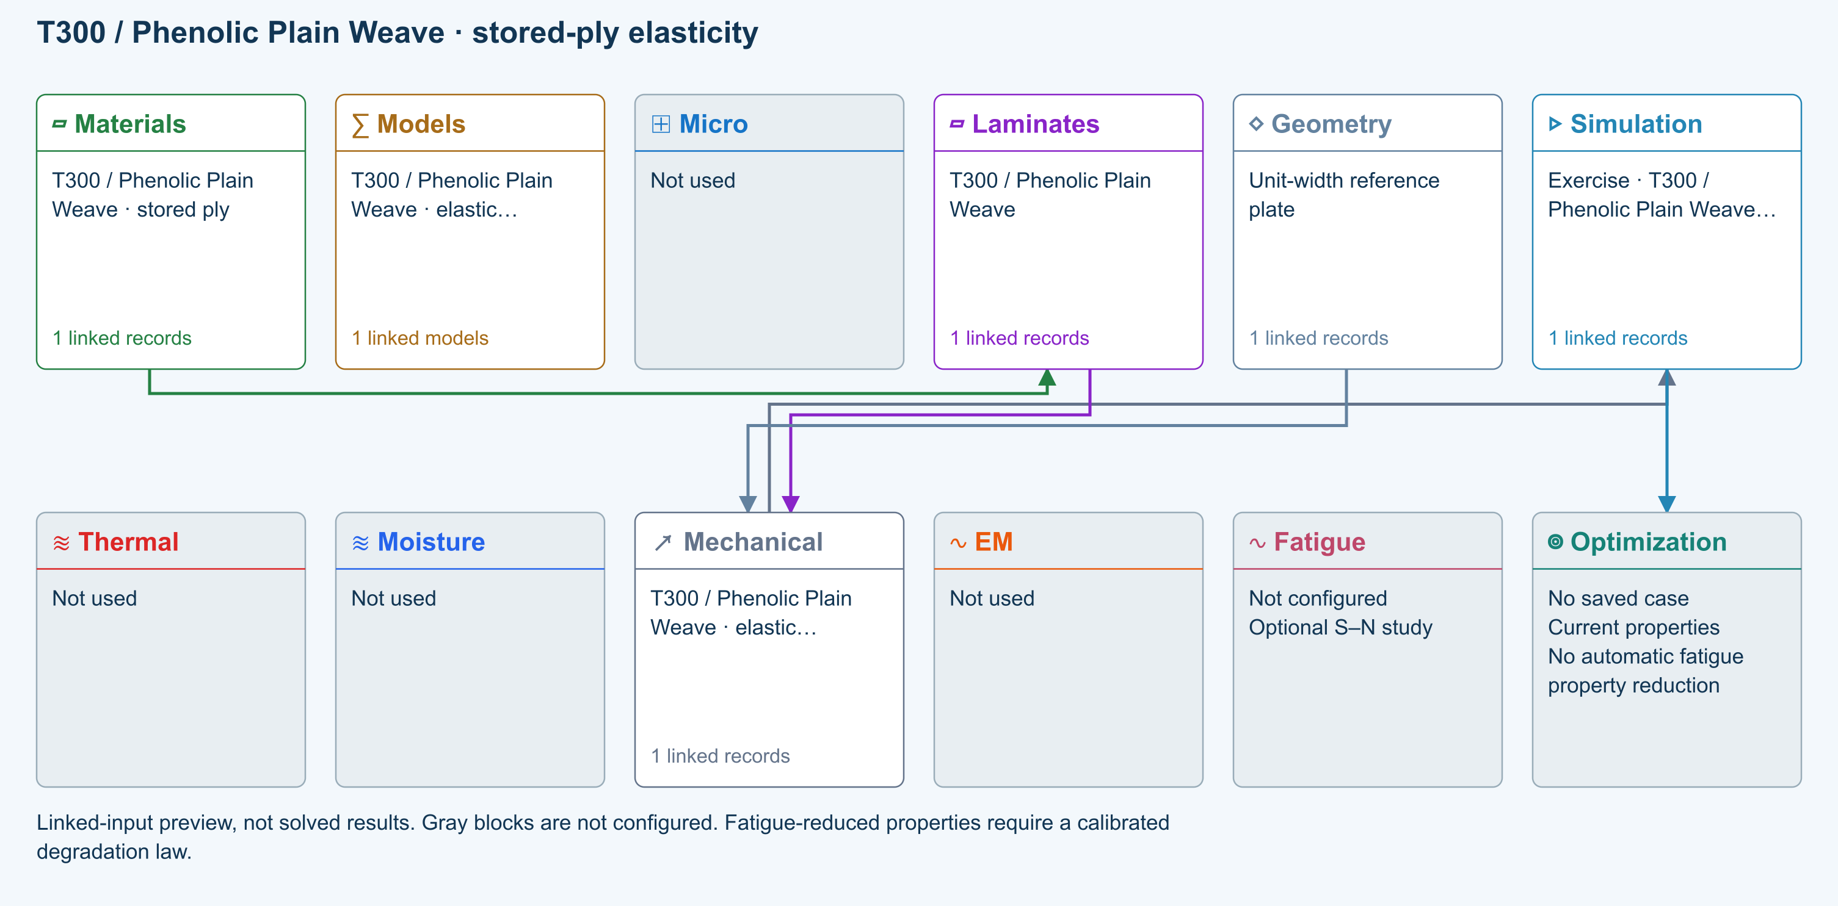

Tasks
Trace the stored material-to-laminate path. Inspect original file, record ID, property status and units; Micro is intentionally not used.
Run the added teaching load Nx = 1 N/mm. Inspect stiffness, strain and ply stresses; this load was not stored in the original library.
Double one applied resultant, rerun, and compare the corresponding linear response. Record the model limits before interpreting strength.

Checkpoints
Stored moduli and strengths retain their original SI values after display-unit conversion.
Each original ply angle and thickness is retained; no constituent mixing or cure model is substituted.
These are executable teaching studies, not independently validated physical benchmarks.

Model limits
Stored original ply properties; original homogenization and failure-model selections are not rerun. Maximum-stress screening uses original teaching strengths, not qualified allowables. Linear CLT resultants only: no grip/edge boundary layers, buckling, delamination, progressive growth or process coupling. Completion is not validation or a physical pass.

Source data
L-T300-PHEN-WOVEN | CDS2026_Expanded_Sample_Source.cdsdb | 10821a0fdf842b7ee4040a70b6141838bebee06c14fd2824a9da1d3edc2d3d1d | Original stored data with a new explicit unit-resultant teaching load

Recorded validation
2026-09-18 — Benchmark validated — analytical scope: Listed reference-elastic extensional constants only; free curvature, ply stresses, strength and every user variation are outside this badge.
Stored original ply properties; original homogenization and failure-model selections are not rerun. Maximum-stress screening uses original teaching strengths, not qualified allowables. Linear CLT resultants only: no grip/edge boundary layers, buckling, delamination, progressive growth or process coupling. Completion is not validation or a physical pass.
Validation evidence and tested inputs

Connected models and submodels
CLT · Linear static with failure indices. Shared laminate stiffness drives this membrane/CLT path. Failure criteria are independent comparisons, not blended models. Fatigue is a separate assessment.
Theory and assumptions
Failure criterion · Maximum stress. Primary criterion. Additional envelope comparisons are chosen in Response → Failure; they run independently.

Data between modules
Materials to Laminates: Stored ply stiffness, strength, density and expansion properties.
Mechanical to Simulation: SIMULATION selects this case and its analysis model; the case owns its applicable cycle and input references.
Laminates to Mechanical: Ply angles and thicknesses, stiffness, mass and ply properties.
Geometry to Mechanical: Shape and dimensions for the selected structural analysis.
Simulation to Optimization: Linked inputs and current-property response for candidate evaluation.

References
Edit material properties and units
Edit laminate materials, angles and thicknesses
Run and review a model
Review effective properties
Connected inputs and result freshness
Geometry, loading and virtual tests
Record the inputs, units, solver notices and checkpoint results before drawing a conclusion. When exploring a variation, change one factor at a time and compare it with the original case.

Laminate orientation and tensile response
Online chapter
Flat tensile coupon. Finite plate. Models: Classical laminate theory, Linear static, ASTM D3039-based.
Open this exercise in Workbench
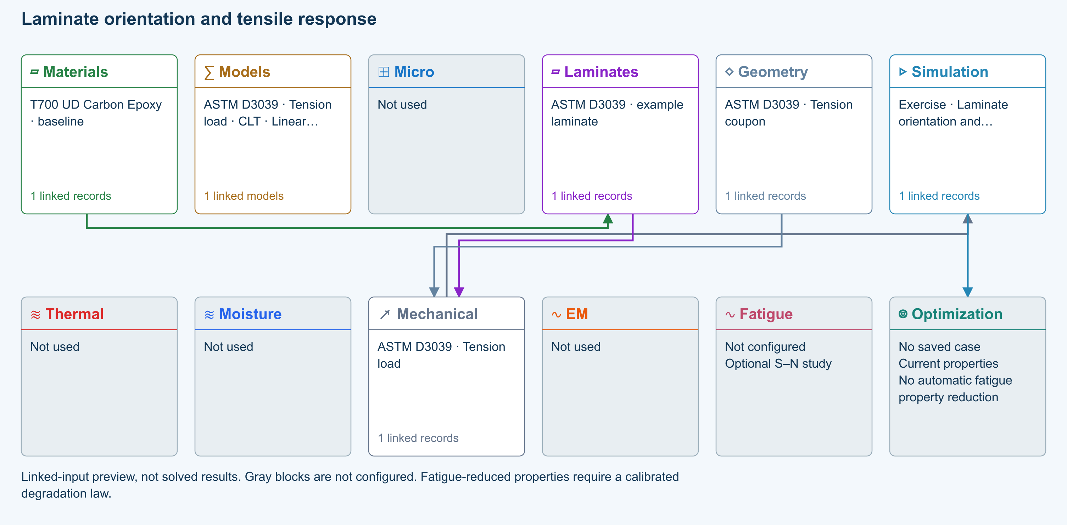

Tasks
Open the copied laminate and record the initial stacking sequence and total thickness.
Run the tensile example, then compare symmetric cross-ply and balanced ±45° stacks at the same thickness.
Review laminate stiffness and ply stresses; keep force and specimen width unchanged.

Checkpoints
Geometry supplies the finite coupon width; the load is a total force.
A symmetric layup should have negligible extension–bending coupling.

Model limits
ASTM-based teaching geometry, not certification. Grips, tabs, alignment and physical test validity are not simulated.

Recorded validation
2026-09-18 — Benchmark validated — analytical scope: Listed reference-elastic extensional constants only; free curvature, ply stresses, strength and every user variation are outside this badge.
ASTM-based teaching geometry, not certification. Grips, tabs, alignment and physical test validity are not simulated.
Validation evidence and tested inputs

Connected models and submodels
CLT · Linear static. Shared laminate stiffness drives this membrane/CLT path. Failure criteria are independent comparisons, not blended models. Fatigue is a separate assessment.
Theory and assumptions

Data between modules
Materials to Laminates: Stored ply stiffness, strength, density and expansion properties.
Mechanical to Simulation: SIMULATION selects this case and its analysis model; the case owns its applicable cycle and input references.
Laminates to Mechanical: Ply angles and thicknesses, stiffness, mass and ply properties.
Geometry to Mechanical: Shape and dimensions for the selected structural analysis.
Simulation to Optimization: Linked inputs and current-property response for candidate evaluation.

References
Edit laminate materials, angles and thicknesses
Apply symmetry and balance
Run and review a model
Review effective properties
Geometry, loading and virtual tests
Related case study: NASA laminate design
Record the inputs, units, solver notices and checkpoint results before drawing a conclusion. When exploring a variation, change one factor at a time and compare it with the original case.

±45° coupon in-plane shear
Online chapter
Shear characterization. Finite plate. Models: Classical laminate theory, ASTM D3518-based.
Open this exercise in Workbench
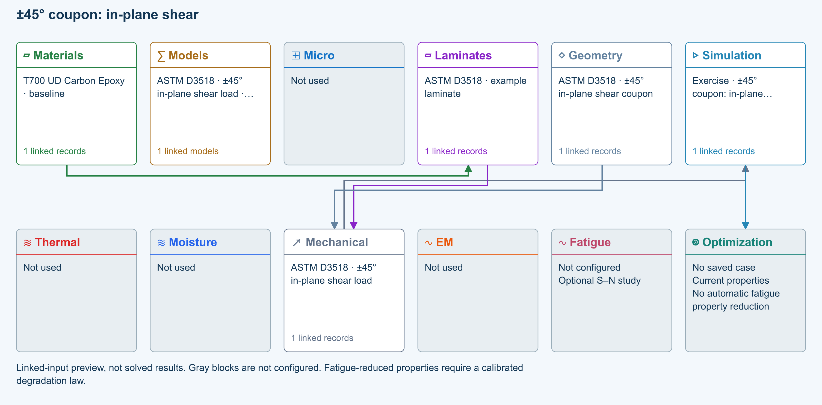

Tasks
Inspect the balanced ±45° laminate and its axial tensile load.
Run and inspect material-axis shear stresses and global strains.
Compare nominal shear stress P/(2bt) with the applicable output and explain the coordinate transformation.

Checkpoints
The applied load is axial tension, not a directly applied global shear force.
Keep the distinction between global strains and material-axis shear strain.

Model limits
Small-strain elastic teaching model; fibre rotation and nonlinear termination rules are not represented.

Recorded validation
2026-09-18 — Benchmark validated — analytical scope: Listed reference-elastic extensional constants only; free curvature, ply stresses, strength and every user variation are outside this badge.
Small-strain elastic teaching model; fibre rotation and nonlinear termination rules are not represented.
Validation evidence and tested inputs

Connected models and submodels
CLT · Linear static. Shared laminate stiffness drives this membrane/CLT path. Failure criteria are independent comparisons, not blended models. Fatigue is a separate assessment.
Theory and assumptions

Data between modules
Materials to Laminates: Stored ply stiffness, strength, density and expansion properties.
Mechanical to Simulation: SIMULATION selects this case and its analysis model; the case owns its applicable cycle and input references.
Laminates to Mechanical: Ply angles and thicknesses, stiffness, mass and ply properties.
Geometry to Mechanical: Shape and dimensions for the selected structural analysis.
Simulation to Optimization: Linked inputs and current-property response for candidate evaluation.

References
Edit laminate materials, angles and thicknesses
Geometry, loading and virtual tests
Run and review a model
Review effective properties
Related case study: NASA laminate design
Record the inputs, units, solver notices and checkpoint results before drawing a conclusion. When exploring a variation, change one factor at a time and compare it with the original case.

Three-point bending span and stiffness
Online chapter
Flexural coupon. Plate in three-point bend. Models: Euler–Bernoulli beam, ASTM D7264-based.
Open this exercise in Workbench
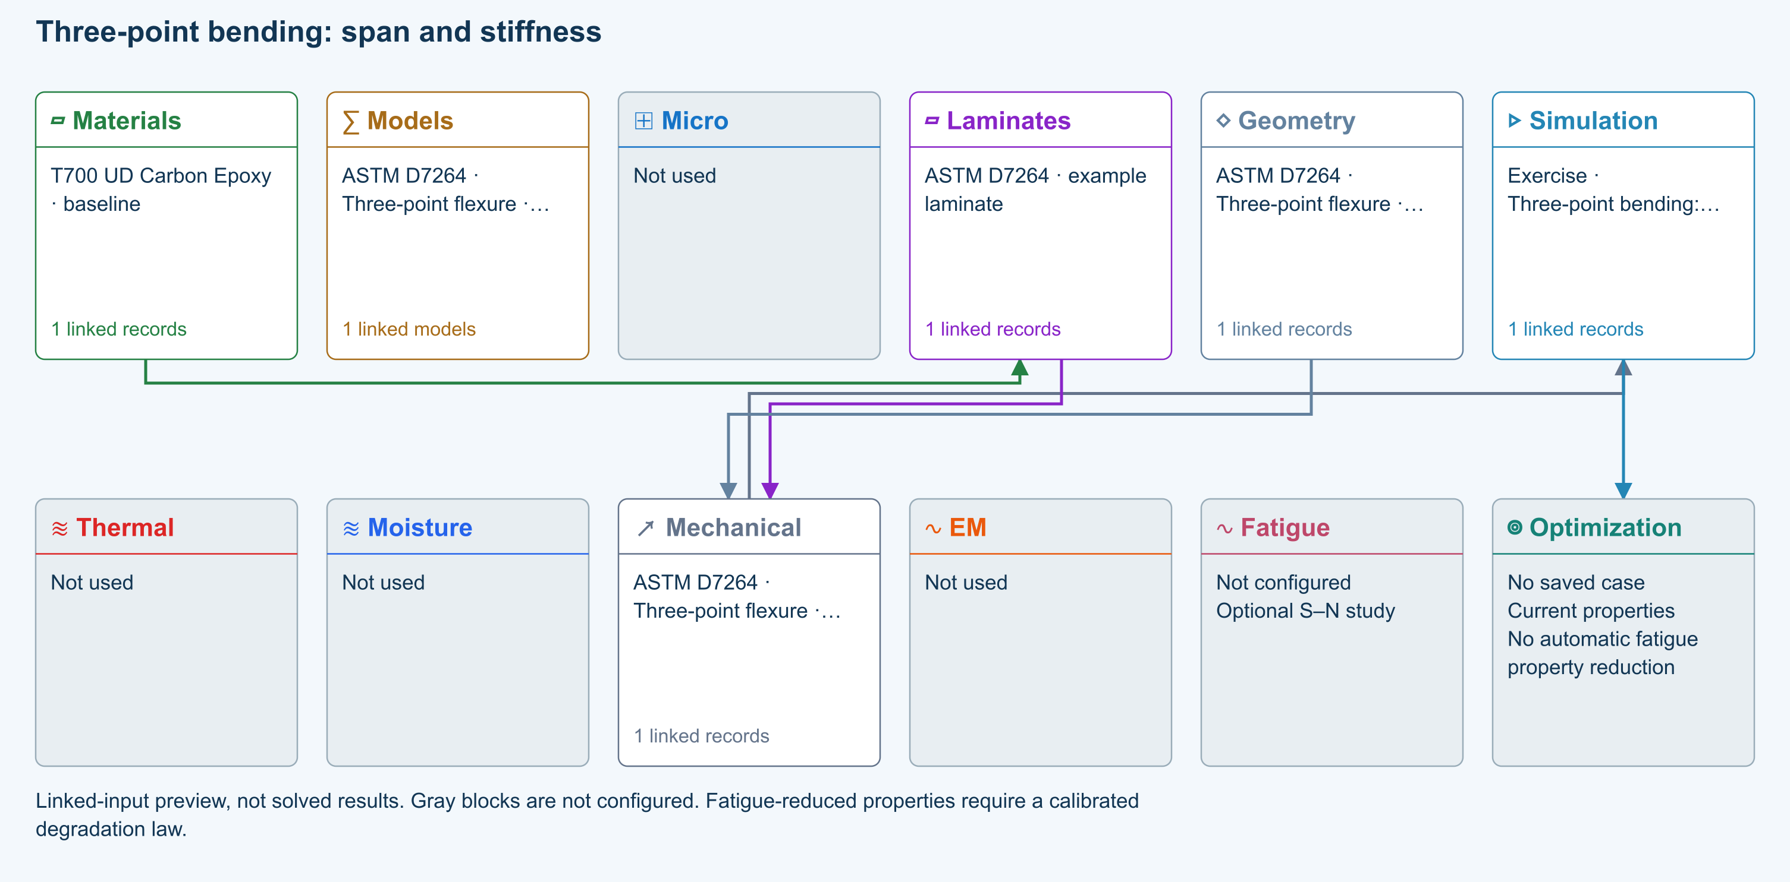

Tasks
Inspect specimen width, laminate thickness, support span and central force.
Run and inspect the deflection plot and ply stresses.
Change support span by 20% while maintaining sufficient specimen length, rerun, and compare peak deflection.

Checkpoints
Check the support and loading graphic against the setup.
For unchanged effective EI and load, beam deflection scales with span cubed.

Model limits
Procedure A teaching setup. Transverse shear deformation, roller contact and indentation are excluded.

Recorded validation
2026-09-18 — Benchmark validated — analytical scope: Central-load beam deflection and shear, conditional on the reported effective Ex. Material elasticity, ply stress and failure not validated.
Procedure A teaching setup. Transverse shear deformation, roller contact and indentation are excluded.
Validation evidence and tested inputs

Connected models and submodels
Euler–Bernoulli beam · Linear static. Beam bending uses effective laminate axial stiffness, the linked section geometry, support span and applied loading. Euler–Bernoulli deflection excludes transverse shear deformation, roller contact and indentation. Ply stress recovery for rectangular laminate coupons is separate from section-level beam stress recovery.
Theory and assumptions

Data between modules
Materials to Laminates: Stored ply stiffness, strength, density and expansion properties.
Mechanical to Simulation: SIMULATION selects this case and its analysis model; the case owns its applicable cycle and input references.
Laminates to Mechanical: Ply angles and thicknesses, stiffness, mass and ply properties.
Geometry to Mechanical: Shape and dimensions for the selected structural analysis.
Simulation to Optimization: Linked inputs and current-property response for candidate evaluation.

References
Geometry, loading and virtual tests
Edit laminate materials, angles and thicknesses
Run and review a model
Connected inputs and result freshness
Record the inputs, units, solver notices and checkpoint results before drawing a conclusion. When exploring a variation, change one factor at a time and compare it with the original case.

Thin-wall pressure vessel
Online chapter
Pressure vessel. Circular tube. Models: Thin-wall membrane, Classical laminate theory.
Open this exercise in Workbench
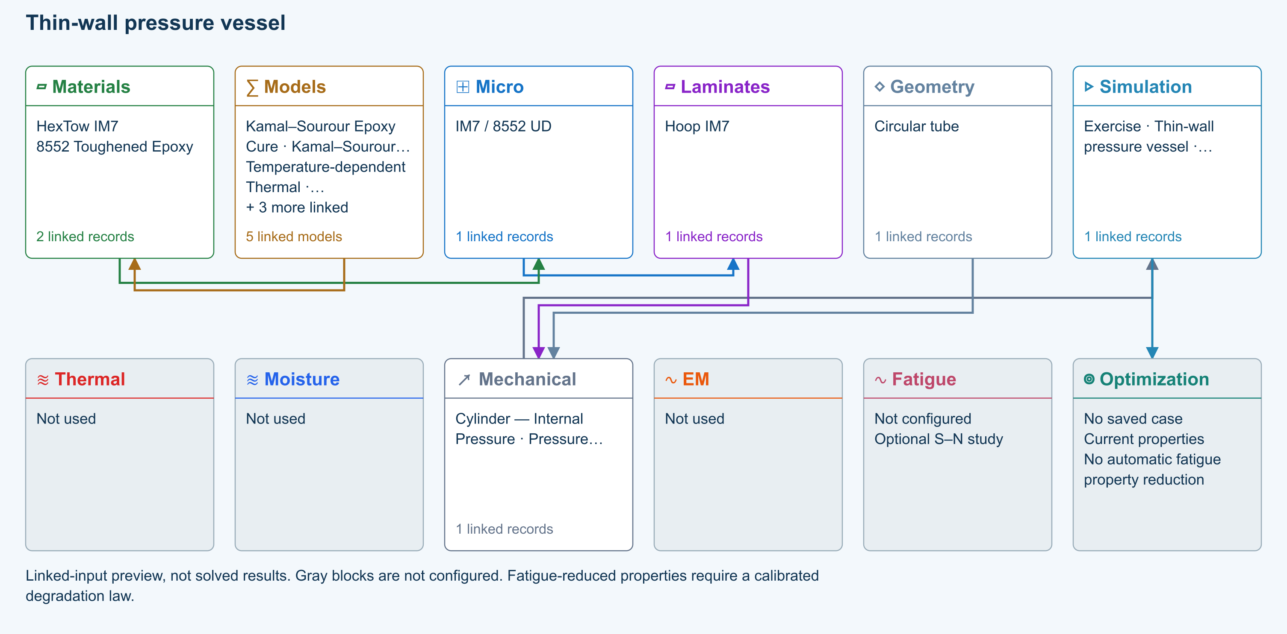

Tasks
Inspect the tube dimensions in Geometry and pressure/end conditions in CASES.
Run the closed-end vessel; compare hoop and axial membrane resultants.
Vary the hoop/axial ply balance and rerun without changing the geometry or pressure.

Checkpoints
For zero external pressure, closed ends and no additional axial load, hoop resultant is twice the pressure-induced axial resultant.
Verify the wall is sufficiently thin for the selected theory.

Model limits
Thin-wall membrane theory: no through-wall radial stress profile or local end effects.

Recorded validation
2026-09-18 — Benchmark validated — analytical scope: Thin-wall pressure equilibrium and orthotropic biaxial strain comparison; stiffness inputs are conditional where Micro closure has not been verified.
Thin-wall membrane theory: no through-wall radial stress profile or local end effects.
Validation evidence and tested inputs

Connected models and submodels
Kamal–Sourour autocatalytic. Reusable material model. It contributes only when assigned to a material used by this simulation; separate model records can supply independent properties.
Theory and assumptions
Calibration & applicability. Illustrative model defaults — replace with characterized resin kinetics
Temperature-dependent tabular. Reusable material model. It contributes only when assigned to a material used by this simulation; separate model records can supply independent properties. Micro uses the 23 °C reference; Process evaluates the same table at local temperature, without extrapolation.
Theory and assumptions
Calibration & applicability. Check source data, applicable environment and validity limits in the model record; saved defaults are not experimental validation.
1D Fickian diffusion. Reusable material model. It contributes only when assigned to a material used by this simulation; separate model records can supply independent properties.
Theory and assumptions
Calibration & applicability. Check source data, applicable environment and validity limits in the model record; saved defaults are not experimental validation.
Halpin–Tsai. One compatible homogenization model per Micro recipe. Separate recipes compare models; their predictions are not blended.
Theory and assumptions
CLT · Linear thin-wall membrane. Shared laminate stiffness drives this membrane/CLT path. Failure criteria are independent comparisons, not blended models. Fatigue is a separate assessment.
Theory and assumptions

Data between modules
Micro to Laminates: Predicted ply stiffness, strength, density and expansion properties.
Materials to Micro: Constituent stiffness, strength, density and thermal / moisture properties.
Models to Materials: Model choices and calibrated parameters.
Mechanical to Simulation: SIMULATION selects this case and its analysis model; the case owns its applicable cycle and input references.
Laminates to Mechanical: Ply angles and thicknesses, stiffness, mass and ply properties.
Geometry to Mechanical: Shape and dimensions for the selected structural analysis.
Simulation to Optimization: Linked inputs and current-property response for candidate evaluation.

References
Geometry, loading and virtual tests
Related case study: NASA pressure cylinder
Run and review a model
Edit laminate materials, angles and thicknesses
Apply symmetry and balance
Record the inputs, units, solver notices and checkpoint results before drawing a conclusion. When exploring a variation, change one factor at a time and compare it with the original case.

05 Tensile coupon laminate orientation
Online chapter
Flat tensile coupon. Finite plate. Models: Classical laminate theory, Linear static, ASTM D3039-based.
Open this exercise in Workbench
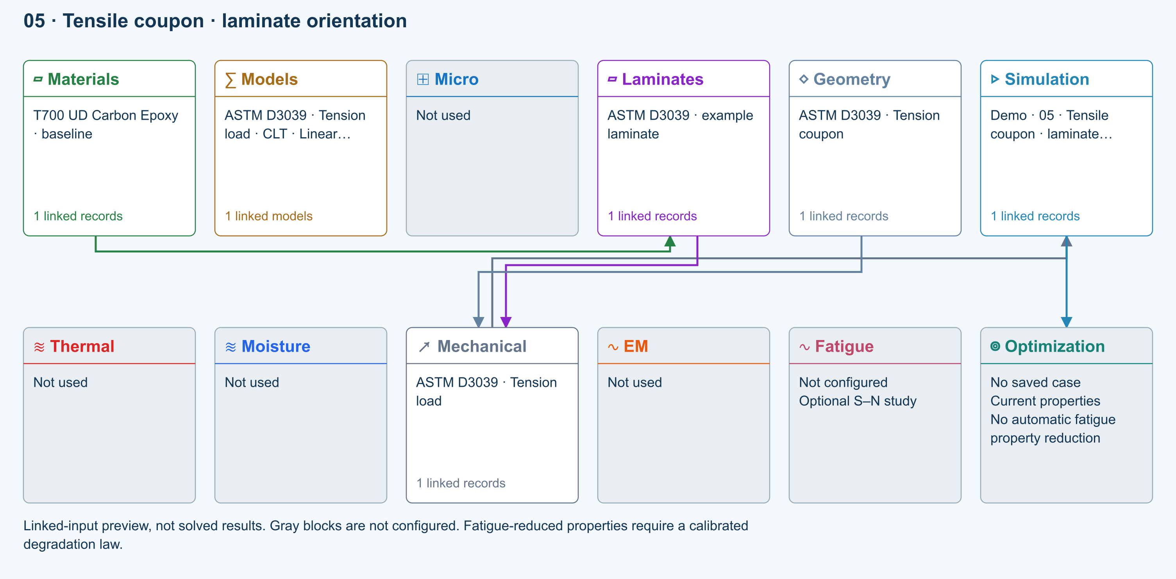

Tasks
Open the copied laminate and record the initial stacking sequence and total thickness.
Run the tensile example, then compare symmetric cross-ply and balanced ±45° stacks at the same thickness.
Review laminate stiffness and ply stresses; keep force and specimen width unchanged.

Checkpoints
Geometry supplies the finite coupon width; the load is a total force.
A symmetric layup should have negligible extension–bending coupling.

Model limits
ASTM-based teaching geometry, not certification. Grips, tabs, alignment and physical test validity are not simulated.

Recorded validation
2026-09-18 — Benchmark validated — analytical scope: Listed reference-elastic extensional constants only; free curvature, ply stresses, strength and every user variation are outside this badge.
ASTM-based teaching geometry, not certification. Grips, tabs, alignment and physical test validity are not simulated.
Validation evidence and tested inputs

Connected models and submodels
CLT · Linear static. Shared laminate stiffness drives this membrane/CLT path. Failure criteria are independent comparisons, not blended models. Fatigue is a separate assessment.
Theory and assumptions

Data between modules
Materials to Laminates: Stored ply stiffness, strength, density and expansion properties.
Mechanical to Simulation: SIMULATION selects this case and its analysis model; the case owns its applicable cycle and input references.
Laminates to Mechanical: Ply angles and thicknesses, stiffness, mass and ply properties.
Geometry to Mechanical: Shape and dimensions for the selected structural analysis.
Simulation to Optimization: Linked inputs and current-property response for candidate evaluation.

References
Edit laminate materials, angles and thicknesses
Apply symmetry and balance
Run and review a model
Review effective properties
Geometry, loading and virtual tests
Related case study: NASA laminate design
Record the inputs, units, solver notices and checkpoint results before drawing a conclusion. When exploring a variation, change one factor at a time and compare it with the original case.

Sandwich FSDT biaxial compression buckling
Online chapter
Sandwich panel stability. Finite rectangular plate. Models: FSDT, Classical laminate theory, Transverse shear, Linear buckling.
Open this exercise in Workbench
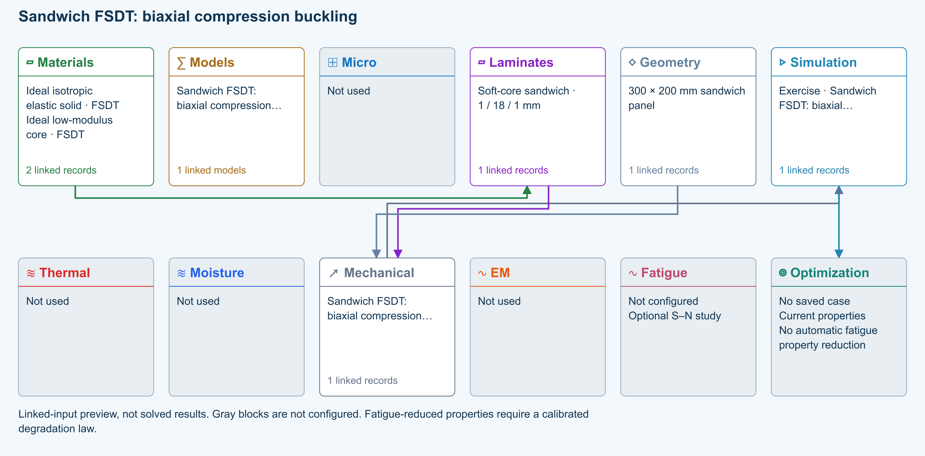

Tasks
Open Simulation: check the shared skins/core, 1 / 18 / 1 mm stack, 300 × 200 mm Geometry, and paired Loading. Architecture must be Sandwich Structures; Automatic resolves to FSDT with Energy equivalent shear correction.
Run biaxial buckling with Nx = −1000 N/m and Ny = −500 N/m. Multiply both reference loads by the first positive factor to obtain the proportional critical load pair. Repeat with Ny = 0.
Increase Ritz order from 6 to 8; compare the quantity of interest before interpreting the result.
Select explicit CLT as a comparison, keeping all other inputs unchanged. Explain the difference due to transverse shear flexibility.

Checkpoints
Geometry owns length and width; Laminate owns skin/core thicknesses.
Static pressure and membrane loads are never combined in these examples. Modal loads are all zero.
Buckling factor is not a skin, core, bond or postbuckling strength limit.
Completion does not assess wrinkling, core crushing, debonding or delamination.

Model limits
Reference-elastic symmetric rectangular FSDT plate. Idealized teaching data, no calibrated material/strength claim. No thermal/moisture preload, thickness stretch, contact, debonding, damage or postbuckling. Directional energy-equivalent shear correction is an approximation; refine numerical order and compare published solutions.

Recorded validation
2026-09-18 — Not benchmark validated: No matched quantitative reference comparison completed for the full exercise.
Reference-elastic symmetric rectangular FSDT plate. Idealized teaching data, no calibrated material/strength claim. No thermal/moisture preload, thickness stretch, contact, debonding, damage or postbuckling. Directional energy-equivalent shear correction is an approximation; refine numerical order and compare published solutions.
Validation evidence and tested inputs

Connected models and submodels
Automatic · Finite plate. Automatic selects FSDT for sandwich architecture and CLT otherwise. Static bending requires FSDT. Finite-plate studies do not consume process links or run progressive failure/fatigue.
Theory and assumptions
Study · Buckling. Reference-elastic plate study; progressive failure and fatigue are not evaluated here.
Numerical settings. Ritz order: 6. Shear correction (FSDT only): Energy equivalent. Increase resolution to check convergence.

Data between modules
Materials to Laminates: Stored ply stiffness, strength, density and expansion properties.
Mechanical to Simulation: SIMULATION selects this case and its analysis model; the case owns its applicable cycle and input references.
Laminates to Mechanical: Ply angles and thicknesses, stiffness, mass and ply properties.
Geometry to Mechanical: Shape and dimensions for the selected structural analysis.
Simulation to Optimization: Linked inputs and current-property response for candidate evaluation.

References
FSDT: shared laminate stiffness, shear and plate response
Edit laminate materials, angles and thicknesses
Run and review a model
Geometry, loading and virtual tests
Record the inputs, units, solver notices and checkpoint results before drawing a conclusion. When exploring a variation, change one factor at a time and compare it with the original case.

06 ±45° laminate in-plane shear
Online chapter
Shear characterization. Finite plate. Models: Classical laminate theory, ASTM D3518-based.
Open this exercise in Workbench
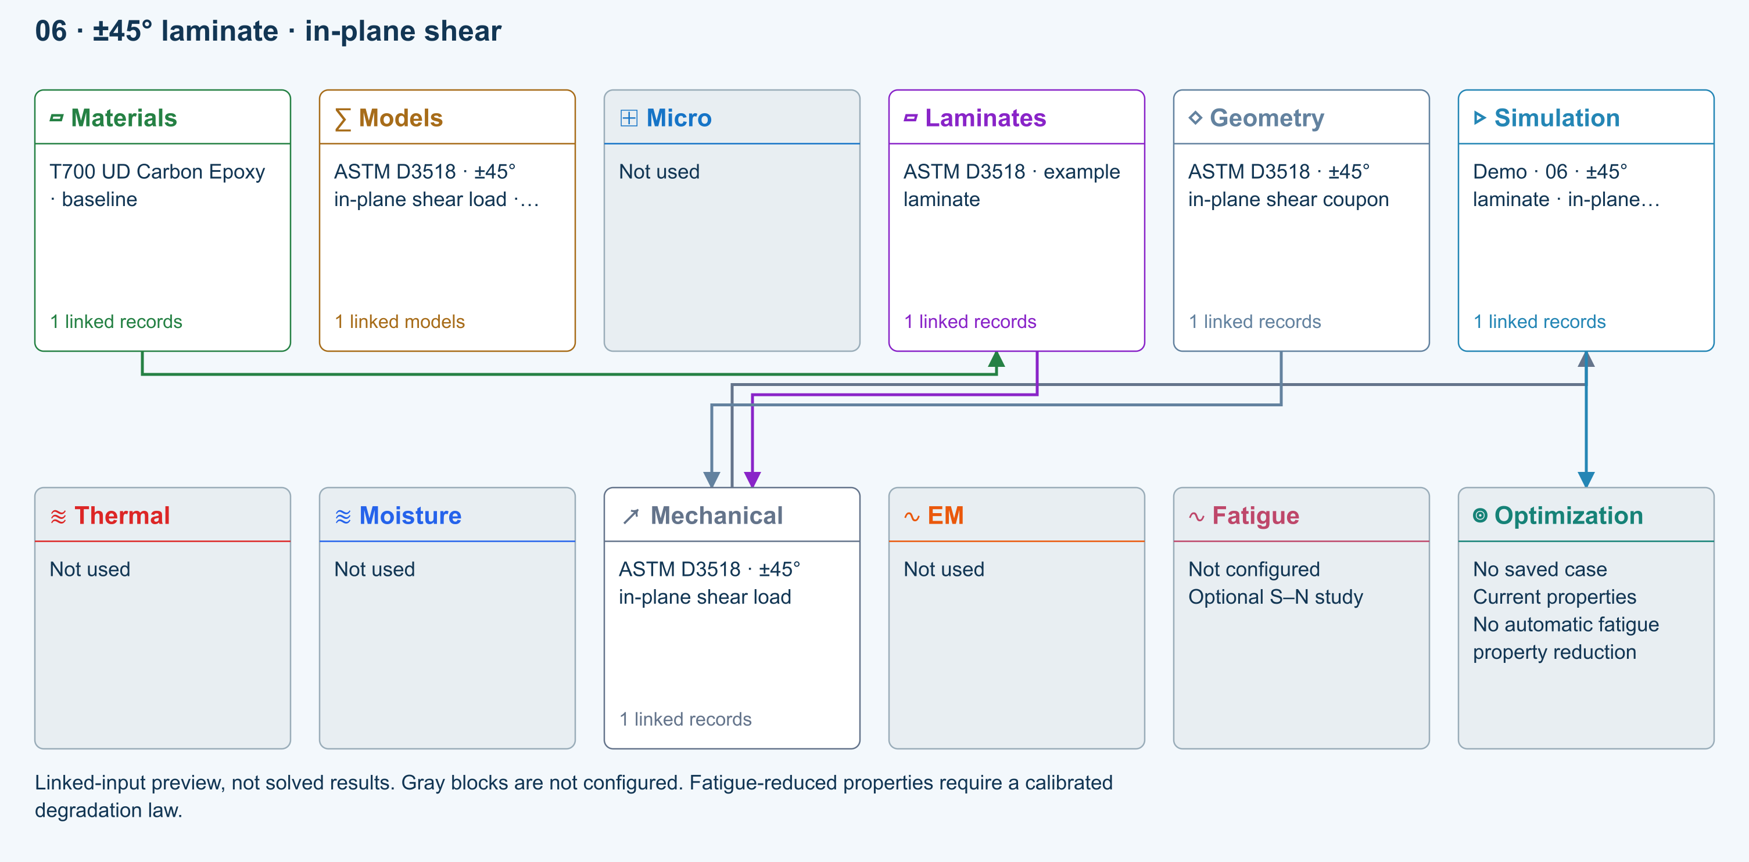

Tasks
Inspect the balanced ±45° laminate and its axial tensile load.
Run and inspect material-axis shear stresses and global strains.
Compare nominal shear stress P/(2bt) with the applicable output and explain the coordinate transformation.

Checkpoints
The applied load is axial tension, not a directly applied global shear force.
Keep the distinction between global strains and material-axis shear strain.

Model limits
Small-strain elastic teaching model; fibre rotation and nonlinear termination rules are not represented.

Recorded validation
2026-09-18 — Benchmark validated — analytical scope: Listed reference-elastic extensional constants only; free curvature, ply stresses, strength and every user variation are outside this badge.
Small-strain elastic teaching model; fibre rotation and nonlinear termination rules are not represented.
Validation evidence and tested inputs

Connected models and submodels
CLT · Linear static. Shared laminate stiffness drives this membrane/CLT path. Failure criteria are independent comparisons, not blended models. Fatigue is a separate assessment.
Theory and assumptions

Data between modules
Materials to Laminates: Stored ply stiffness, strength, density and expansion properties.
Mechanical to Simulation: SIMULATION selects this case and its analysis model; the case owns its applicable cycle and input references.
Laminates to Mechanical: Ply angles and thicknesses, stiffness, mass and ply properties.
Geometry to Mechanical: Shape and dimensions for the selected structural analysis.
Simulation to Optimization: Linked inputs and current-property response for candidate evaluation.

References
Edit laminate materials, angles and thicknesses
Geometry, loading and virtual tests
Run and review a model
Review effective properties
Related case study: NASA laminate design
Record the inputs, units, solver notices and checkpoint results before drawing a conclusion. When exploring a variation, change one factor at a time and compare it with the original case.

Sandwich FSDT directional-core natural frequencies
Online chapter
Sandwich panel vibration. Finite rectangular plate. Models: FSDT, Classical laminate theory, Transverse shear, Rotary inertia.
Open this exercise in Workbench
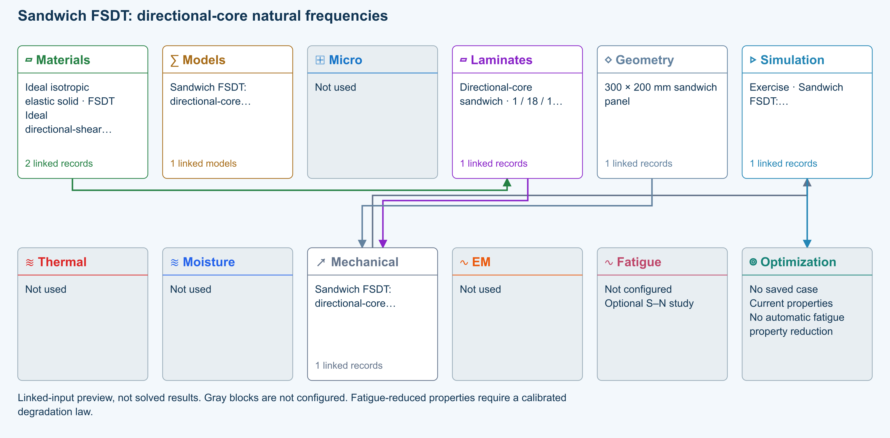

Tasks
Open Simulation: check the shared skins/core, 1 / 18 / 1 mm stack, 300 × 200 mm Geometry, and paired Loading. Architecture must be Sandwich Structures; Automatic resolves to FSDT with Energy equivalent shear correction.
Run unprestressed modes with rotary inertia and compare the first three frequencies. Exchange core G13 and G23 and rerun to explore directional shear flexibility; compare shapes as well as sorted frequency order.
Increase Ritz order from 6 to 8; compare the quantity of interest before interpreting the result.
Select explicit CLT as a comparison, keeping all other inputs unchanged. Explain the difference due to transverse shear flexibility and rotary inertia.

Checkpoints
Geometry owns length and width; Laminate owns skin/core thicknesses.
Static pressure and membrane loads are never combined in these examples. Modal loads are all zero.
Mode amplitudes are normalized, not physical vibration displacements. Density is explicit in skins and core.
Completion does not assess wrinkling, core crushing, debonding or delamination.

Model limits
Reference-elastic symmetric rectangular FSDT plate. Idealized teaching data, no calibrated material/strength claim. No thermal/moisture preload, thickness stretch, contact, debonding, damage or postbuckling. Directional energy-equivalent shear correction is an approximation; refine numerical order and compare published solutions.

Recorded validation
2026-09-18 — Not benchmark validated: No matched quantitative reference comparison completed for the full exercise.
Reference-elastic symmetric rectangular FSDT plate. Idealized teaching data, no calibrated material/strength claim. No thermal/moisture preload, thickness stretch, contact, debonding, damage or postbuckling. Directional energy-equivalent shear correction is an approximation; refine numerical order and compare published solutions.
Validation evidence and tested inputs

Connected models and submodels
Automatic · Finite plate. Automatic selects FSDT for sandwich architecture and CLT otherwise. Static bending requires FSDT. Finite-plate studies do not consume process links or run progressive failure/fatigue.
Theory and assumptions
Study · Modal. Reference-elastic plate study; progressive failure and fatigue are not evaluated here.
Numerical settings. Ritz order: 6. Shear correction (FSDT only): Energy equivalent. Increase resolution to check convergence.

Data between modules
Materials to Laminates: Stored ply stiffness, strength, density and expansion properties.
Mechanical to Simulation: SIMULATION selects this case and its analysis model; the case owns its applicable cycle and input references.
Laminates to Mechanical: Ply angles and thicknesses, stiffness, mass and ply properties.
Geometry to Mechanical: Shape and dimensions for the selected structural analysis.
Simulation to Optimization: Linked inputs and current-property response for candidate evaluation.

References
FSDT: shared laminate stiffness, shear and plate response
Edit laminate materials, angles and thicknesses
Run and review a model
Geometry, loading and virtual tests
Record the inputs, units, solver notices and checkpoint results before drawing a conclusion. When exploring a variation, change one factor at a time and compare it with the original case.

07 Stored lamina material bypass Micro
Online chapter
Stored-material laminate. Infinite plate. Models: Stored lamina elasticity, Classical laminate theory.
Open this exercise in Workbench
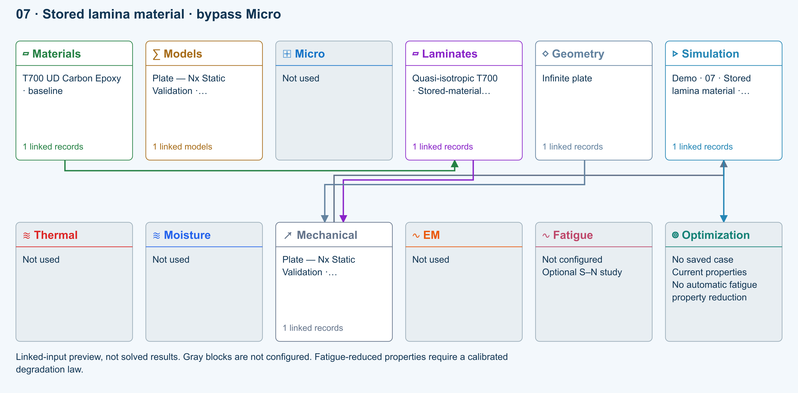

Tasks
Trace the material directly to the laminate; Micro is not used.
Run the stored-material laminate, then compare with example 01.

Checkpoints
The material-to-laminate path bypasses Micro.
Changing a stored modulus changes the next Run, not another example.

Model limits
Stored representative lamina properties, not a solved Micro recipe or qualified design allowables.

Recorded validation
2026-09-18 — Benchmark validated — analytical scope: Listed reference-elastic extensional constants only; free curvature, ply stresses, strength and every user variation are outside this badge.
Stored representative lamina properties, not a solved Micro recipe or qualified design allowables.
Validation evidence and tested inputs

Connected models and submodels
CLT · Linear static with failure indices. Shared laminate stiffness drives this membrane/CLT path. Failure criteria are independent comparisons, not blended models. Fatigue is a separate assessment.
Theory and assumptions
Failure criterion · Maximum stress. Primary criterion. Additional envelope comparisons are chosen in Response → Failure; they run independently.

Data between modules
Materials to Laminates: Stored ply stiffness, strength, density and expansion properties.
Mechanical to Simulation: SIMULATION selects this case and its analysis model; the case owns its applicable cycle and input references.
Laminates to Mechanical: Ply angles and thicknesses, stiffness, mass and ply properties.
Geometry to Mechanical: Shape and dimensions for the selected structural analysis.
Simulation to Optimization: Linked inputs and current-property response for candidate evaluation.

References
Connect a simulation
Edit laminate materials, angles and thicknesses
Run and review a model
Connected inputs and result freshness
Related case study: NASA laminate design
Record the inputs, units, solver notices and checkpoint results before drawing a conclusion. When exploring a variation, change one factor at a time and compare it with the original case.

08 Mixed stored/solved plies unequal thickness
Online chapter
Mixed-source laminate. Infinite plate. Models: Stored lamina elasticity, Rule of mixtures, Classical laminate theory, Unequal ply thickness.
Open this exercise in Workbench
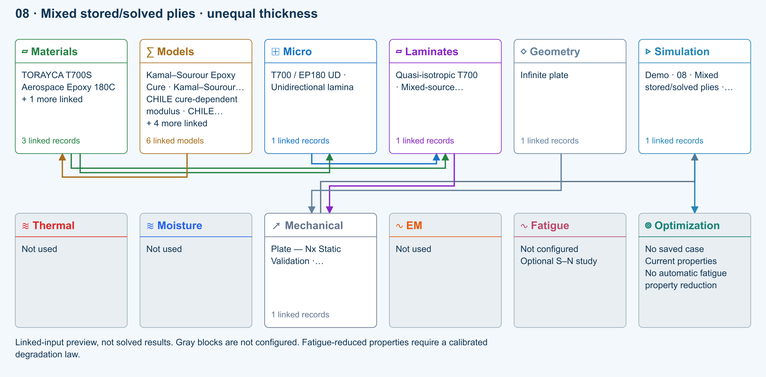

Tasks
Inspect alternating stored-material and solved-Micro plies and their 0.15/0.10 mm thicknesses.
Run and compare with the uniform stored and solved examples.

Checkpoints
The sixteen plies total 2 mm.
Both direct material and solved Micro paths feed the laminate.

Model limits
Reference-state elastic laminate comparison; different ply sources and thicknesses are intentional. Representative properties are not qualified allowables.

Recorded validation
2026-09-18 — Benchmark validated — analytical scope: Listed reference-elastic extensional constants only; free curvature, ply stresses, strength and every user variation are outside this badge.
Reference-state elastic laminate comparison; different ply sources and thicknesses are intentional. Representative properties are not qualified allowables.
Validation evidence and tested inputs

Connected models and submodels
Kamal–Sourour autocatalytic. Reusable material model. It contributes only when assigned to a material used by this simulation; separate model records can supply independent properties.
Theory and assumptions
Calibration & applicability. Illustrative model defaults — replace with characterized resin kinetics
CHILE (degree of cure). Reusable material model. It contributes only when assigned to a material used by this simulation; separate model records can supply independent properties. Cure-dependent modulus does not automatically scale strength allowables.
Theory and assumptions
Calibration & applicability. CHILE(α), section 2.4 of Materials 2019, 12, 259. Example parameters, not measured EP180 data. Fixed Poisson ratio; no viscoelastic relaxation or Tg softening. Incremental elastic stress integration at saved process intervals: check time-step convergence. Strength allowables are independent measured inputs, not scaled with modulus.
Temperature-dependent tabular. Reusable material model. It contributes only when assigned to a material used by this simulation; separate model records can supply independent properties. Micro uses the 23 °C reference; Process evaluates the same table at local temperature, without extrapolation.
Theory and assumptions
Calibration & applicability. Check source data, applicable environment and validity limits in the model record; saved defaults are not experimental validation.
1D Fickian diffusion. Reusable material model. It contributes only when assigned to a material used by this simulation; separate model records can supply independent properties.
Theory and assumptions
Calibration & applicability. Check source data, applicable environment and validity limits in the model record; saved defaults are not experimental validation.
Rule of mixtures. One compatible homogenization model per Micro recipe. Separate recipes compare models; their predictions are not blended.
Theory and assumptions
CLT · Linear static with failure indices. Shared laminate stiffness drives this membrane/CLT path. Failure criteria are independent comparisons, not blended models. Fatigue is a separate assessment.
Theory and assumptions
Failure criterion · Maximum stress. Primary criterion. Additional envelope comparisons are chosen in Response → Failure; they run independently.

Data between modules
Micro to Laminates: Predicted ply stiffness, strength, density and expansion properties.
Materials to Laminates: Stored ply stiffness, strength, density and expansion properties.
Materials to Micro: Constituent stiffness, strength, density and thermal / moisture properties.
Models to Materials: Model choices and calibrated parameters.
Mechanical to Simulation: SIMULATION selects this case and its analysis model; the case owns its applicable cycle and input references.
Laminates to Mechanical: Ply angles and thicknesses, stiffness, mass and ply properties.
Geometry to Mechanical: Shape and dimensions for the selected structural analysis.
Simulation to Optimization: Linked inputs and current-property response for candidate evaluation.

References
Connect a simulation
Edit laminate materials, angles and thicknesses
Run and review a model
Connected inputs and result freshness
Related case study: NASA laminate design
Record the inputs, units, solver notices and checkpoint results before drawing a conclusion. When exploring a variation, change one factor at a time and compare it with the original case.

09 Three-point bend deflection
Online chapter
Flexural coupon. Plate in three-point bend. Models: Euler–Bernoulli beam, ASTM D7264-based.
Open this exercise in Workbench
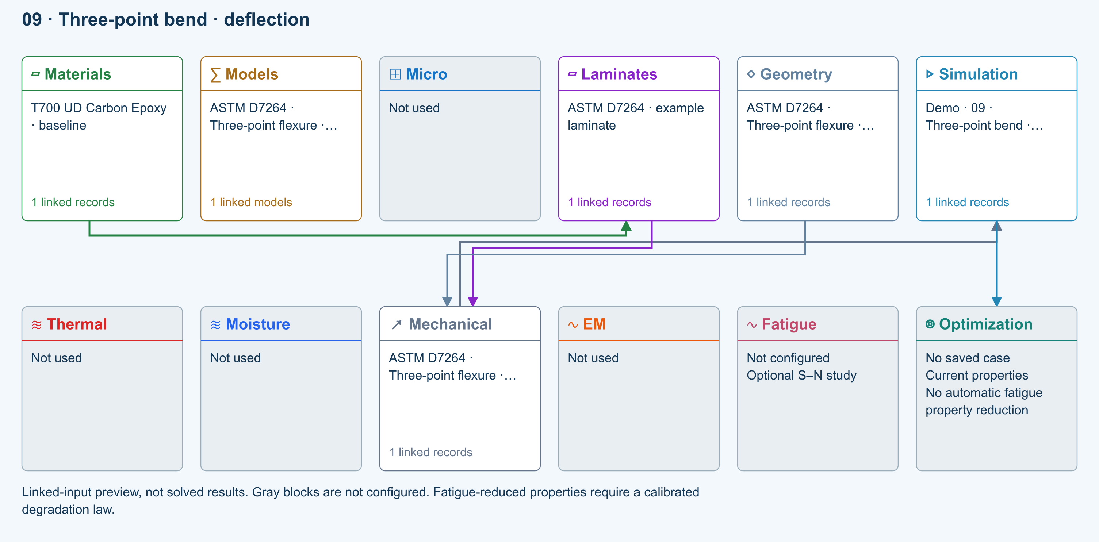

Tasks
Inspect specimen width, laminate thickness, support span and central force.
Run and inspect the deflection plot and ply stresses.
Change support span by 20% while maintaining sufficient specimen length, rerun, and compare peak deflection.

Checkpoints
Check the support and loading graphic against the setup.
For unchanged effective EI and load, beam deflection scales with span cubed.

Model limits
Procedure A teaching setup. Transverse shear deformation, roller contact and indentation are excluded.

Recorded validation
2026-09-18 — Benchmark validated — analytical scope: Central-load beam deflection and shear, conditional on the reported effective Ex. Material elasticity, ply stress and failure not validated.
Procedure A teaching setup. Transverse shear deformation, roller contact and indentation are excluded.
Validation evidence and tested inputs

Connected models and submodels
Euler–Bernoulli beam · Linear static. Beam bending uses effective laminate axial stiffness, the linked section geometry, support span and applied loading. Euler–Bernoulli deflection excludes transverse shear deformation, roller contact and indentation. Ply stress recovery for rectangular laminate coupons is separate from section-level beam stress recovery.
Theory and assumptions

Data between modules
Materials to Laminates: Stored ply stiffness, strength, density and expansion properties.
Mechanical to Simulation: SIMULATION selects this case and its analysis model; the case owns its applicable cycle and input references.
Laminates to Mechanical: Ply angles and thicknesses, stiffness, mass and ply properties.
Geometry to Mechanical: Shape and dimensions for the selected structural analysis.
Simulation to Optimization: Linked inputs and current-property response for candidate evaluation.

References
Geometry, loading and virtual tests
Edit laminate materials, angles and thicknesses
Run and review a model
Connected inputs and result freshness
Record the inputs, units, solver notices and checkpoint results before drawing a conclusion. When exploring a variation, change one factor at a time and compare it with the original case.

10 Cylinder internal pressure
Online chapter
Pressure vessel. Circular tube. Models: Thin-wall membrane, Classical laminate theory.
Open this exercise in Workbench
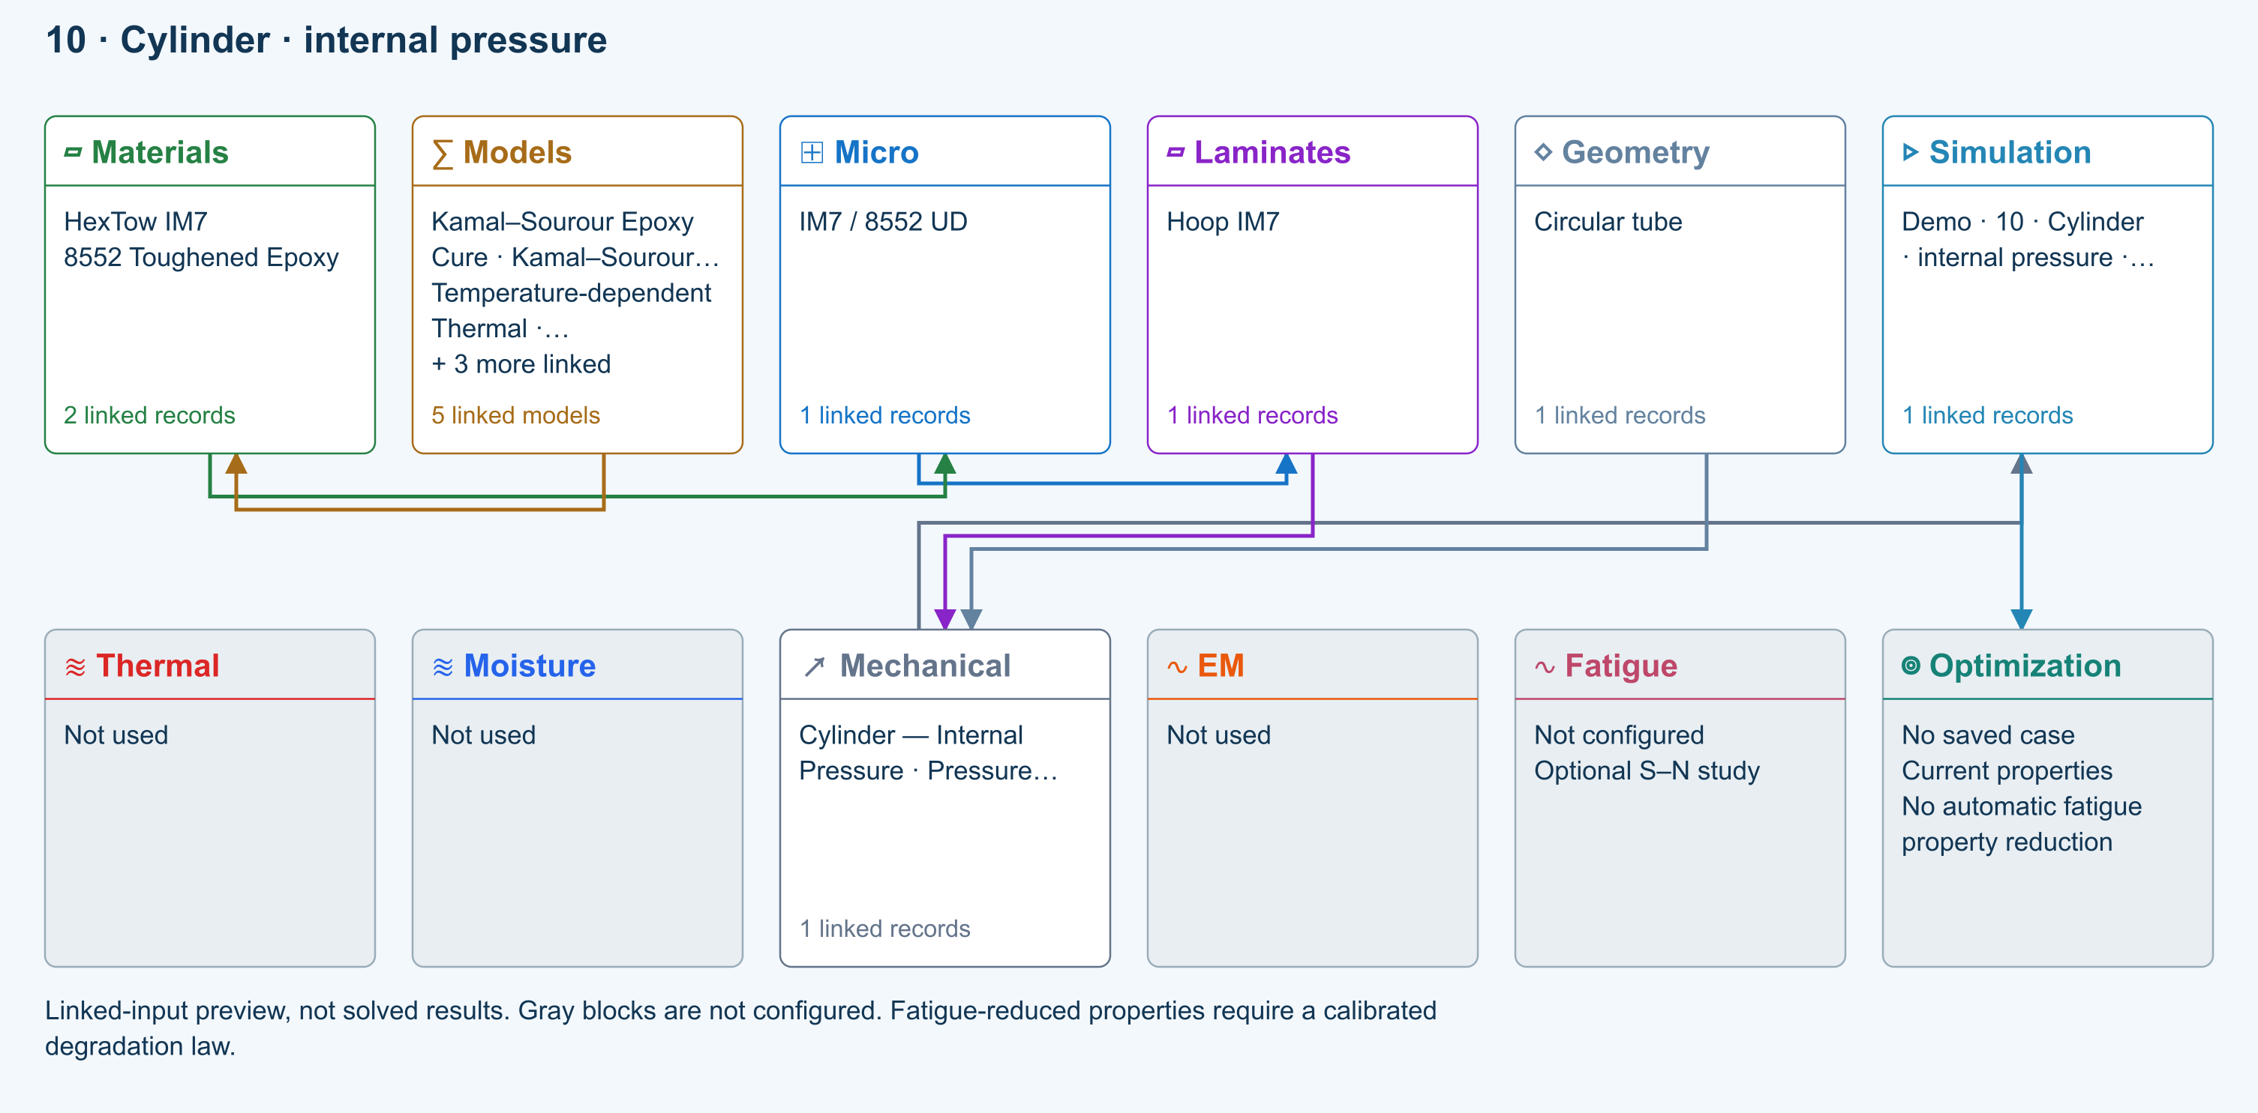

Tasks
Inspect the tube dimensions in Geometry and pressure/end conditions in CASES.
Run the closed-end vessel; compare hoop and axial membrane resultants.
Vary the hoop/axial ply balance and rerun without changing the geometry or pressure.

Checkpoints
For zero external pressure, closed ends and no additional axial load, hoop resultant is twice the pressure-induced axial resultant.
Verify the wall is sufficiently thin for the selected theory.

Model limits
Thin-wall membrane theory: no through-wall radial stress profile or local end effects.

Recorded validation
2026-09-18 — Benchmark validated — analytical scope: Thin-wall pressure equilibrium and orthotropic biaxial strain comparison; stiffness inputs are conditional where Micro closure has not been verified.
Thin-wall membrane theory: no through-wall radial stress profile or local end effects.
Validation evidence and tested inputs

Connected models and submodels
Kamal–Sourour autocatalytic. Reusable material model. It contributes only when assigned to a material used by this simulation; separate model records can supply independent properties.
Theory and assumptions
Calibration & applicability. Illustrative model defaults — replace with characterized resin kinetics
Temperature-dependent tabular. Reusable material model. It contributes only when assigned to a material used by this simulation; separate model records can supply independent properties. Micro uses the 23 °C reference; Process evaluates the same table at local temperature, without extrapolation.
Theory and assumptions
Calibration & applicability. Check source data, applicable environment and validity limits in the model record; saved defaults are not experimental validation.
1D Fickian diffusion. Reusable material model. It contributes only when assigned to a material used by this simulation; separate model records can supply independent properties.
Theory and assumptions
Calibration & applicability. Check source data, applicable environment and validity limits in the model record; saved defaults are not experimental validation.
Halpin–Tsai. One compatible homogenization model per Micro recipe. Separate recipes compare models; their predictions are not blended.
Theory and assumptions
CLT · Linear thin-wall membrane. Shared laminate stiffness drives this membrane/CLT path. Failure criteria are independent comparisons, not blended models. Fatigue is a separate assessment.
Theory and assumptions

Data between modules
Micro to Laminates: Predicted ply stiffness, strength, density and expansion properties.
Materials to Micro: Constituent stiffness, strength, density and thermal / moisture properties.
Models to Materials: Model choices and calibrated parameters.
Mechanical to Simulation: SIMULATION selects this case and its analysis model; the case owns its applicable cycle and input references.
Laminates to Mechanical: Ply angles and thicknesses, stiffness, mass and ply properties.
Geometry to Mechanical: Shape and dimensions for the selected structural analysis.
Simulation to Optimization: Linked inputs and current-property response for candidate evaluation.

References
Geometry, loading and virtual tests
Related case study: NASA pressure cylinder
Run and review a model
Edit laminate materials, angles and thicknesses
Apply symmetry and balance
Record the inputs, units, solver notices and checkpoint results before drawing a conclusion. When exploring a variation, change one factor at a time and compare it with the original case.

11 Lap joint two adherends and adhesive
Online chapter
Adhesive lap joint. Single-lap joint. Models: 2D x-z plane strain, Linear elasticity.
Open this exercise in Workbench
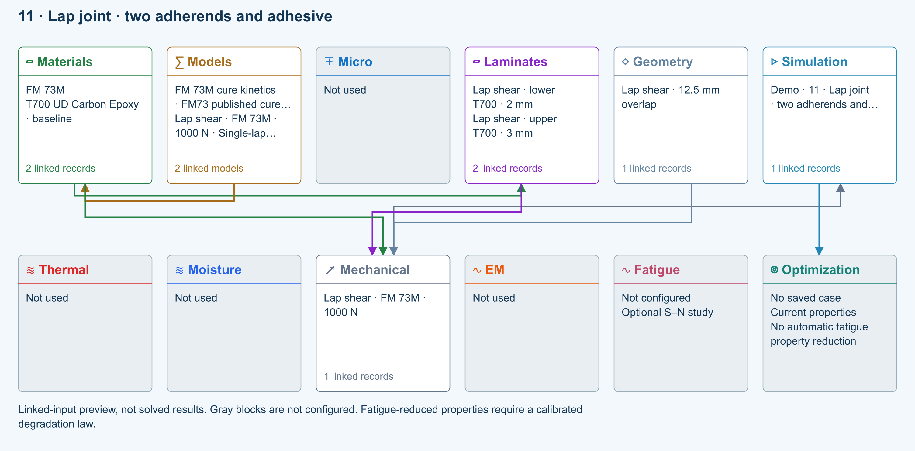

Tasks
Trace lower laminate, upper laminate and adhesive selections from Simulation to Geometry.
Run and inspect the adherend and adhesive stress/strain fields.
Vary overlap or bondline thickness, then refine the available mesh controls to assess peak-stress sensitivity.

Checkpoints
Check adhesive stiffness inputs and their material assumptions.
Compare field shape and displacement as well as a single peak value.

Model limits
Perfectly bonded linear-elastic interfaces. Mesh-sensitive edge peaks are not joint strength, debonding or damage predictions.

Recorded validation
2026-09-18 — Not benchmark validated: No matched quantitative reference comparison completed for the full exercise.
Perfectly bonded linear-elastic interfaces. Mesh-sensitive edge peaks are not joint strength, debonding or damage predictions.
Validation evidence and tested inputs

Connected models and submodels
FM73 published cure kinetics (reference only). Reusable material model. It contributes only when assigned to a material used by this simulation; separate model records can supply independent properties.
Theory and assumptions
Calibration & applicability. Reference located; coefficients require verification. No generic epoxy defaults are substituted.
Single-lap x-z plane strain. Selected formulation for this source record. Changing it requires rerunning affected simulations.
Theory and assumptions
Perfectly bonded elastic joint. This formulation does not use cohesive crack growth.

Data between modules
Materials to Laminates: Stored ply stiffness, strength, density and expansion properties.
Models to Materials: Model choices and calibrated parameters.
Mechanical to Simulation: SIMULATION selects this case and its analysis model; the case owns its applicable cycle and input references.
Laminates to Mechanical: Ply angles and thicknesses, stiffness, mass and ply properties.
Materials to Mechanical: Constituent stiffness, strength, density and thermal / moisture properties.
Geometry to Mechanical: Shape and dimensions for the selected structural analysis.
Simulation to Optimization: Linked inputs and current-property response for candidate evaluation.

References
Connect a simulation
Geometry, loading and virtual tests
Through-thickness section analysis and assumptions
Run and review a model
Connected inputs and result freshness
Record the inputs, units, solver notices and checkpoint results before drawing a conclusion. When exploring a variation, change one factor at a time and compare it with the original case.

12 Sandwich bend skins core and bond screening
Online chapter
Sandwich beam. Sandwich plate in three-point bend. Models: Sandwich beam screening, Core shear, Face wrinkling, Bond shear screening.
Open this exercise in Workbench
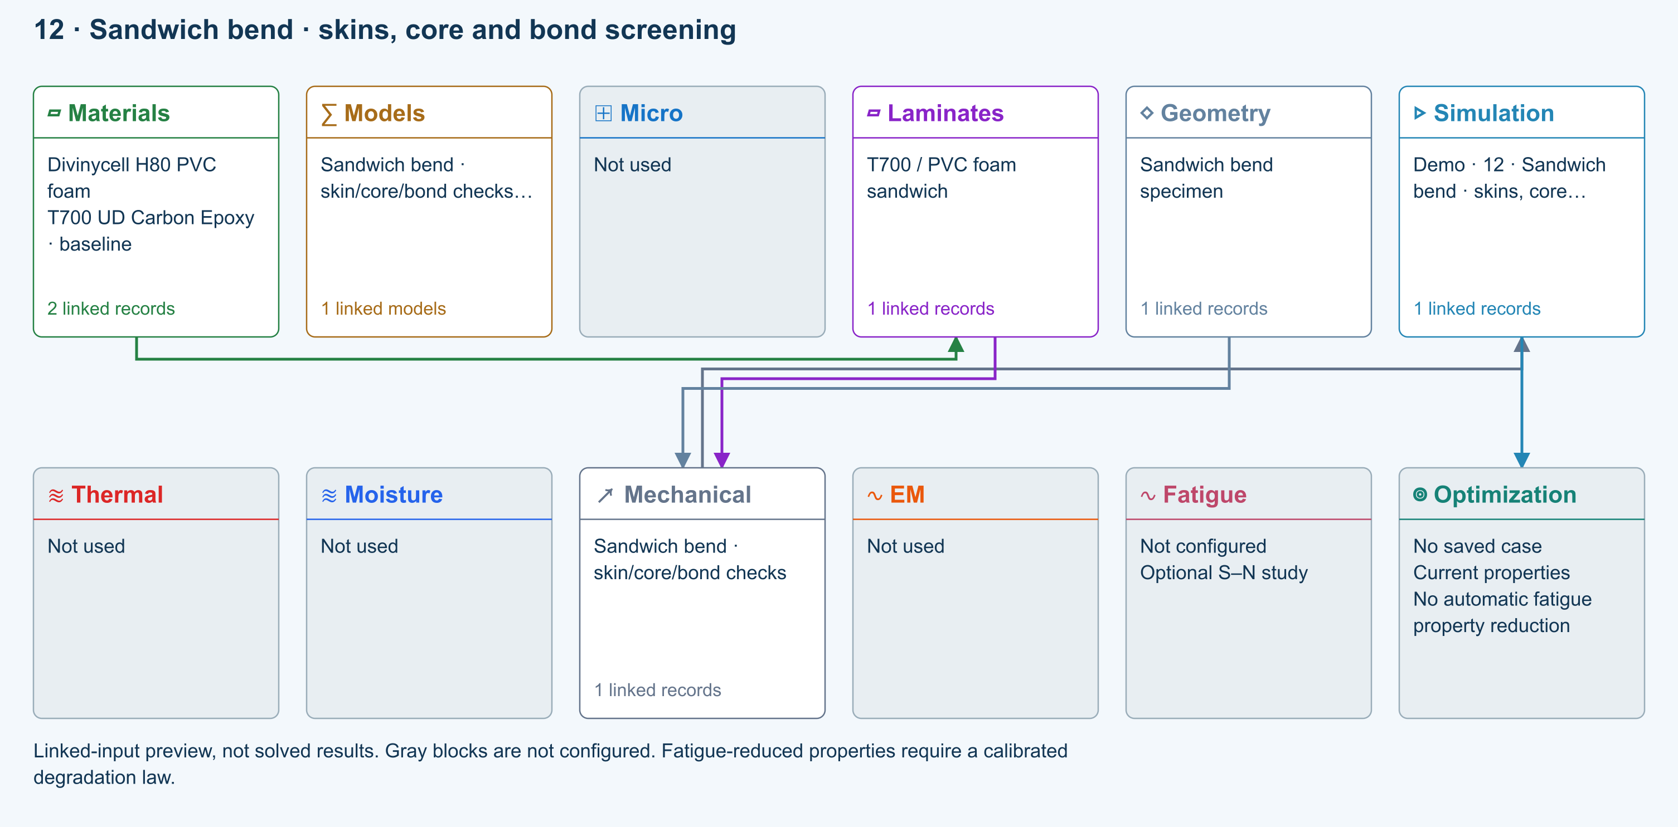

Tasks
Inspect the two skins, core and bond allowables.
Run and inspect deflection, core shear, face wrinkling and bond shear checks.

Checkpoints
Nonzero teaching strengths permit screening checks but are not measured allowables.
Unassessed peel and mixed-mode bonding prevent an overall pass.

Model limits
Illustrative strengths only. Local peel and mixed-mode bond growth are not assessed. Completion is not an overall sandwich pass.

Recorded validation
2026-09-18 — Not benchmark validated: No matched quantitative reference comparison completed for the full exercise.
Illustrative strengths only. Local peel and mixed-mode bond growth are not assessed. Completion is not an overall sandwich pass.
Validation evidence and tested inputs

Connected models and submodels
Sandwich three-point bend. Selected formulation for this source record. Changing it requires rerunning affected simulations.
Theory and assumptions

Data between modules
Materials to Laminates: Stored ply stiffness, strength, density and expansion properties.
Mechanical to Simulation: SIMULATION selects this case and its analysis model; the case owns its applicable cycle and input references.
Laminates to Mechanical: Ply angles and thicknesses, stiffness, mass and ply properties.
Geometry to Mechanical: Shape and dimensions for the selected structural analysis.
Simulation to Optimization: Linked inputs and current-property response for candidate evaluation.

References
Connect a simulation
Edit laminate materials, angles and thicknesses
Run and review a model
Connected inputs and result freshness
Record the inputs, units, solver notices and checkpoint results before drawing a conclusion. When exploring a variation, change one factor at a time and compare it with the original case.

Hybrid short fibers orientation and volume balance
Online chapter
Hybrid short-fiber lamina. Infinite plate. Models: Cox shear-lag elastic, Orientation averaging, Classical laminate theory.
Open this exercise in Workbench
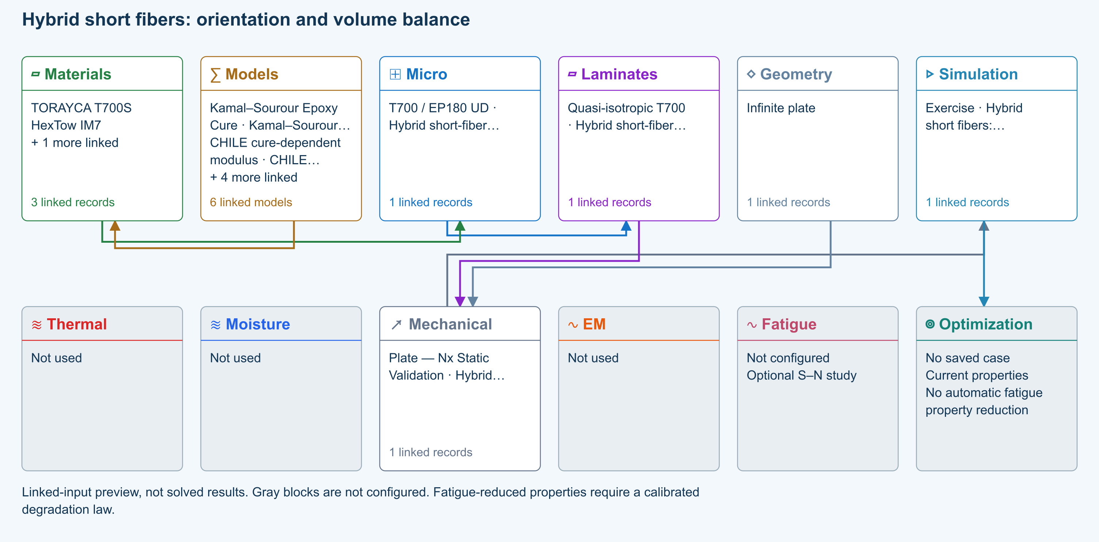

Tasks
Inspect both linked fibers: 20% T700 plus 10% IM7, 2% voids and 68% resin. Rotate the live 3D view; normalized fiber lengths are illustrative only.
Run with Fa=1, then Fa=0/Fp=1, then Fa=0/Fp=0. Compare E1, E2, E3 and shear moduli.
Hold total fiber at 30% and move volume between fiber 1 and fiber 2. Rerun and compare stiffness and density.
Review classical failure inputs. The supplied zero allowables mean strength is not assessed; do not claim a pass from elasticity alone.

Checkpoints
In-plane random orientation gives E1 = E2; spatial random orientation gives E1 = E2 = E3.
Fa=.5 and Fp=.5 represent 50% axial, 25% planar-random and 25% spatial-random fibers.
Cox transfer is evaluated per fiber modulus. Hybrid transverse closure is an averaged-constituent screening approximation; it does not model phase interaction or debonding.

Model limits
Prescribed orientation, common filament dimensions and resin. Voigt stiffness averaging; not a manufacturing orientation prediction or progressive failure model. Thermal transport retains aligned closure assumptions.

Recorded validation
2026-09-18 — Not benchmark validated: No matched quantitative reference comparison completed for the full exercise.
Prescribed orientation, common filament dimensions and resin. Voigt stiffness averaging; not a manufacturing orientation prediction or progressive failure model. Thermal transport retains aligned closure assumptions.
Validation evidence and tested inputs

Connected models and submodels
Kamal–Sourour autocatalytic. Reusable material model. It contributes only when assigned to a material used by this simulation; separate model records can supply independent properties.
Theory and assumptions
Calibration & applicability. Illustrative model defaults — replace with characterized resin kinetics
CHILE (degree of cure). Reusable material model. It contributes only when assigned to a material used by this simulation; separate model records can supply independent properties. Cure-dependent modulus does not automatically scale strength allowables.
Theory and assumptions
Calibration & applicability. CHILE(α), section 2.4 of Materials 2019, 12, 259. Example parameters, not measured EP180 data. Fixed Poisson ratio; no viscoelastic relaxation or Tg softening. Incremental elastic stress integration at saved process intervals: check time-step convergence. Strength allowables are independent measured inputs, not scaled with modulus.
Temperature-dependent tabular. Reusable material model. It contributes only when assigned to a material used by this simulation; separate model records can supply independent properties. Micro uses the 23 °C reference; Process evaluates the same table at local temperature, without extrapolation.
Theory and assumptions
Calibration & applicability. Check source data, applicable environment and validity limits in the model record; saved defaults are not experimental validation.
1D Fickian diffusion. Reusable material model. It contributes only when assigned to a material used by this simulation; separate model records can supply independent properties.
Theory and assumptions
Calibration & applicability. Check source data, applicable environment and validity limits in the model record; saved defaults are not experimental validation.
Cox shear-lag elastic. One compatible homogenization model per Micro recipe. Separate recipes compare models; their predictions are not blended.
Theory and assumptions
CLT · Linear static with failure indices. Shared laminate stiffness drives this membrane/CLT path. Failure criteria are independent comparisons, not blended models. Fatigue is a separate assessment.
Theory and assumptions
Failure criterion · Maximum stress. Primary criterion. Additional envelope comparisons are chosen in Response → Failure; they run independently.

Data between modules
Micro to Laminates: Predicted ply stiffness, strength, density and expansion properties.
Materials to Micro: Constituent stiffness, strength, density and thermal / moisture properties.
Models to Materials: Model choices and calibrated parameters.
Mechanical to Simulation: SIMULATION selects this case and its analysis model; the case owns its applicable cycle and input references.
Laminates to Mechanical: Ply angles and thicknesses, stiffness, mass and ply properties.
Geometry to Mechanical: Shape and dimensions for the selected structural analysis.
Simulation to Optimization: Linked inputs and current-property response for candidate evaluation.

References
Create and connect a lamina
Edit material properties and units
Run and review a model
Review effective properties
Connected inputs and result freshness
Edit laminate materials, angles and thicknesses
Related case study: NASA lamina analysis
Record the inputs, units, solver notices and checkpoint results before drawing a conclusion. When exploring a variation, change one factor at a time and compare it with the original case.

T700/Epoxy Quasi-Isotropic stored-data layup
Online chapter
Stored-material laminate. Infinite plate. Models: Stored lamina elasticity, Classical laminate theory, Maximum stress.
Open this exercise in Workbench
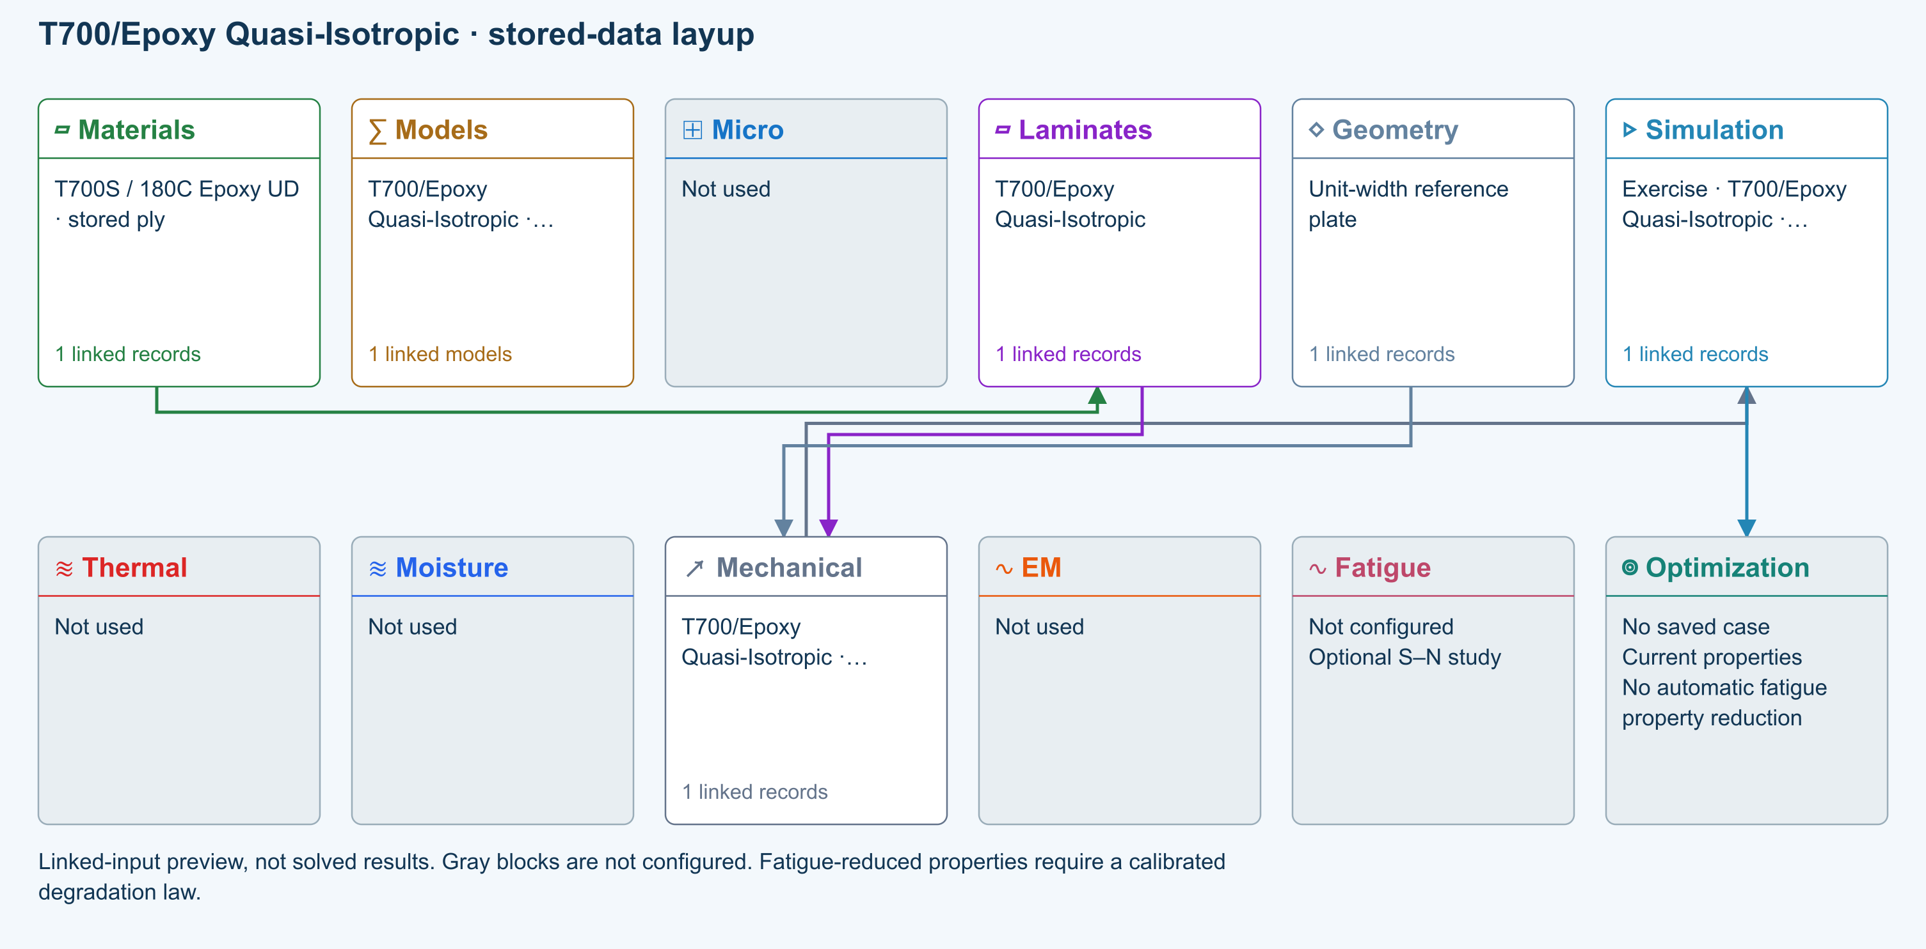

Tasks
Trace the stored material-to-laminate path. Inspect original file, record ID, property status and units; Micro is intentionally not used.
Run the added teaching load Nx = 1 N/mm. Inspect stiffness, strain and ply stresses; this load was not stored in the original library.
Double one applied resultant, rerun, and compare the corresponding linear response. Record the model limits before interpreting strength.

Checkpoints
Stored moduli and strengths retain their original SI values after display-unit conversion.
Each original ply angle and thickness is retained; no constituent mixing or cure model is substituted.
These are executable teaching studies, not independently validated physical benchmarks.

Model limits
Stored original ply properties; original homogenization and failure-model selections are not rerun. Maximum-stress screening uses original teaching strengths, not qualified allowables. Linear CLT resultants only: no grip/edge boundary layers, buckling, delamination, progressive growth or process coupling. Completion is not validation or a physical pass.

Source data
LAM-QI-T700 | CDS2026_Beam_Analysis_Examples.cdsdb | 74780b9bf0abab55f0d6a0ff2e885a322196bea12ee6af9b4a08b0ebb7ce0db3 | Original stored data with a new explicit unit-resultant teaching load

Recorded validation
2026-09-18 — Benchmark validated — analytical scope: Listed reference-elastic extensional constants only; free curvature, ply stresses, strength and every user variation are outside this badge.
Stored original ply properties; original homogenization and failure-model selections are not rerun. Maximum-stress screening uses original teaching strengths, not qualified allowables. Linear CLT resultants only: no grip/edge boundary layers, buckling, delamination, progressive growth or process coupling. Completion is not validation or a physical pass.
Validation evidence and tested inputs

Connected models and submodels
CLT · Linear static with failure indices. Shared laminate stiffness drives this membrane/CLT path. Failure criteria are independent comparisons, not blended models. Fatigue is a separate assessment.
Theory and assumptions
Failure criterion · Maximum stress. Primary criterion. Additional envelope comparisons are chosen in Response → Failure; they run independently.

Data between modules
Materials to Laminates: Stored ply stiffness, strength, density and expansion properties.
Mechanical to Simulation: SIMULATION selects this case and its analysis model; the case owns its applicable cycle and input references.
Laminates to Mechanical: Ply angles and thicknesses, stiffness, mass and ply properties.
Geometry to Mechanical: Shape and dimensions for the selected structural analysis.
Simulation to Optimization: Linked inputs and current-property response for candidate evaluation.

References
Edit material properties and units
Edit laminate materials, angles and thicknesses
Run and review a model
Review effective properties
Connected inputs and result freshness
Geometry, loading and virtual tests
Record the inputs, units, solver notices and checkpoint results before drawing a conclusion. When exploring a variation, change one factor at a time and compare it with the original case.

IM7/Toughened Epoxy Bending-Optimized stored-data layup
Online chapter
Stored-material laminate. Infinite plate. Models: Stored lamina elasticity, Classical laminate theory, Maximum stress.
Open this exercise in Workbench

Tasks
Trace the stored material-to-laminate path. Inspect original file, record ID, property status and units; Micro is intentionally not used.
Run the added teaching load Nx = 1 N/mm. Inspect stiffness, strain and ply stresses; this load was not stored in the original library.
Double one applied resultant, rerun, and compare the corresponding linear response. Record the model limits before interpreting strength.

Checkpoints
Stored moduli and strengths retain their original SI values after display-unit conversion.
Each original ply angle and thickness is retained; no constituent mixing or cure model is substituted.
These are executable teaching studies, not independently validated physical benchmarks.

Model limits
Stored original ply properties; original homogenization and failure-model selections are not rerun. Maximum-stress screening uses original teaching strengths, not qualified allowables. Linear CLT resultants only: no grip/edge boundary layers, buckling, delamination, progressive growth or process coupling. Completion is not validation or a physical pass.

Source data
LAM-BEND-IM7 | CDS2026_Beam_Analysis_Examples.cdsdb | 74780b9bf0abab55f0d6a0ff2e885a322196bea12ee6af9b4a08b0ebb7ce0db3 | Original stored data with a new explicit unit-resultant teaching load

Recorded validation
2026-09-18 — Benchmark validated — analytical scope: Listed reference-elastic extensional constants only; free curvature, ply stresses, strength and every user variation are outside this badge.
Stored original ply properties; original homogenization and failure-model selections are not rerun. Maximum-stress screening uses original teaching strengths, not qualified allowables. Linear CLT resultants only: no grip/edge boundary layers, buckling, delamination, progressive growth or process coupling. Completion is not validation or a physical pass.
Validation evidence and tested inputs

Connected models and submodels
CLT · Linear static with failure indices. Shared laminate stiffness drives this membrane/CLT path. Failure criteria are independent comparisons, not blended models. Fatigue is a separate assessment.
Theory and assumptions
Failure criterion · Maximum stress. Primary criterion. Additional envelope comparisons are chosen in Response → Failure; they run independently.

Data between modules
Materials to Laminates: Stored ply stiffness, strength, density and expansion properties.
Mechanical to Simulation: SIMULATION selects this case and its analysis model; the case owns its applicable cycle and input references.
Laminates to Mechanical: Ply angles and thicknesses, stiffness, mass and ply properties.
Geometry to Mechanical: Shape and dimensions for the selected structural analysis.
Simulation to Optimization: Linked inputs and current-property response for candidate evaluation.

References
Edit material properties and units
Edit laminate materials, angles and thicknesses
Run and review a model
Review effective properties
Connected inputs and result freshness
Geometry, loading and virtual tests
Record the inputs, units, solver notices and checkpoint results before drawing a conclusion. When exploring a variation, change one factor at a time and compare it with the original case.

T800/BMI Balanced Cylinder stored-data layup
Online chapter
Stored-material laminate. Infinite plate. Models: Stored lamina elasticity, Classical laminate theory, Maximum stress.
Open this exercise in Workbench

Tasks
Trace the stored material-to-laminate path. Inspect original file, record ID, property status and units; Micro is intentionally not used.
Run the added teaching load Nx = 1 N/mm. Inspect stiffness, strain and ply stresses; this load was not stored in the original library.
Double one applied resultant, rerun, and compare the corresponding linear response. Record the model limits before interpreting strength.

Checkpoints
Stored moduli and strengths retain their original SI values after display-unit conversion.
Each original ply angle and thickness is retained; no constituent mixing or cure model is substituted.
These are executable teaching studies, not independently validated physical benchmarks.

Model limits
Stored original ply properties; original homogenization and failure-model selections are not rerun. Maximum-stress screening uses original teaching strengths, not qualified allowables. Linear CLT resultants only: no grip/edge boundary layers, buckling, delamination, progressive growth or process coupling. Completion is not validation or a physical pass.

Source data
LAM-CYL-BAL | CDS2026_Beam_Analysis_Examples.cdsdb | 74780b9bf0abab55f0d6a0ff2e885a322196bea12ee6af9b4a08b0ebb7ce0db3 | Original stored data with a new explicit unit-resultant teaching load

Recorded validation
2026-09-18 — Benchmark validated — analytical scope: Listed reference-elastic extensional constants only; free curvature, ply stresses, strength and every user variation are outside this badge.
Stored original ply properties; original homogenization and failure-model selections are not rerun. Maximum-stress screening uses original teaching strengths, not qualified allowables. Linear CLT resultants only: no grip/edge boundary layers, buckling, delamination, progressive growth or process coupling. Completion is not validation or a physical pass.
Validation evidence and tested inputs

Connected models and submodels
CLT · Linear static with failure indices. Shared laminate stiffness drives this membrane/CLT path. Failure criteria are independent comparisons, not blended models. Fatigue is a separate assessment.
Theory and assumptions
Failure criterion · Maximum stress. Primary criterion. Additional envelope comparisons are chosen in Response → Failure; they run independently.

Data between modules
Materials to Laminates: Stored ply stiffness, strength, density and expansion properties.
Mechanical to Simulation: SIMULATION selects this case and its analysis model; the case owns its applicable cycle and input references.
Laminates to Mechanical: Ply angles and thicknesses, stiffness, mass and ply properties.
Geometry to Mechanical: Shape and dimensions for the selected structural analysis.
Simulation to Optimization: Linked inputs and current-property response for candidate evaluation.

References
Edit material properties and units
Edit laminate materials, angles and thicknesses
Run and review a model
Review effective properties
Connected inputs and result freshness
Geometry, loading and virtual tests
Record the inputs, units, solver notices and checkpoint results before drawing a conclusion. When exploring a variation, change one factor at a time and compare it with the original case.

AS4/PEEK Quasi-Isotropic stored-data layup
Online chapter
Stored-material laminate. Infinite plate. Models: Stored lamina elasticity, Classical laminate theory, Maximum stress.
Open this exercise in Workbench

Tasks
Trace the stored material-to-laminate path. Inspect original file, record ID, property status and units; Micro is intentionally not used.
Run the added teaching load Nx = 1 N/mm. Inspect stiffness, strain and ply stresses; this load was not stored in the original library.
Double one applied resultant, rerun, and compare the corresponding linear response. Record the model limits before interpreting strength.

Checkpoints
Stored moduli and strengths retain their original SI values after display-unit conversion.
Each original ply angle and thickness is retained; no constituent mixing or cure model is substituted.
These are executable teaching studies, not independently validated physical benchmarks.

Model limits
Stored original ply properties; original homogenization and failure-model selections are not rerun. Maximum-stress screening uses original teaching strengths, not qualified allowables. Linear CLT resultants only: no grip/edge boundary layers, buckling, delamination, progressive growth or process coupling. Completion is not validation or a physical pass.

Source data
LAM-QI-PEEK | CDS2026_Beam_Analysis_Examples.cdsdb | 74780b9bf0abab55f0d6a0ff2e885a322196bea12ee6af9b4a08b0ebb7ce0db3 | Original stored data with a new explicit unit-resultant teaching load

Recorded validation
2026-09-18 — Benchmark validated — analytical scope: Listed reference-elastic extensional constants only; free curvature, ply stresses, strength and every user variation are outside this badge.
Stored original ply properties; original homogenization and failure-model selections are not rerun. Maximum-stress screening uses original teaching strengths, not qualified allowables. Linear CLT resultants only: no grip/edge boundary layers, buckling, delamination, progressive growth or process coupling. Completion is not validation or a physical pass.
Validation evidence and tested inputs

Connected models and submodels
CLT · Linear static with failure indices. Shared laminate stiffness drives this membrane/CLT path. Failure criteria are independent comparisons, not blended models. Fatigue is a separate assessment.
Theory and assumptions
Failure criterion · Maximum stress. Primary criterion. Additional envelope comparisons are chosen in Response → Failure; they run independently.

Data between modules
Materials to Laminates: Stored ply stiffness, strength, density and expansion properties.
Mechanical to Simulation: SIMULATION selects this case and its analysis model; the case owns its applicable cycle and input references.
Laminates to Mechanical: Ply angles and thicknesses, stiffness, mass and ply properties.
Geometry to Mechanical: Shape and dimensions for the selected structural analysis.
Simulation to Optimization: Linked inputs and current-property response for candidate evaluation.

References
Edit material properties and units
Edit laminate materials, angles and thicknesses
Run and review a model
Review effective properties
Connected inputs and result freshness
Geometry, loading and virtual tests
Record the inputs, units, solver notices and checkpoint results before drawing a conclusion. When exploring a variation, change one factor at a time and compare it with the original case.

T800/BMI Hoop-Dominant Cylinder stored-data layup
Online chapter
Stored-material laminate. Infinite plate. Models: Stored lamina elasticity, Classical laminate theory, Maximum stress.
Open this exercise in Workbench

Tasks
Trace the stored material-to-laminate path. Inspect original file, record ID, property status and units; Micro is intentionally not used.
Run the added teaching load Nx = 1 N/mm. Inspect stiffness, strain and ply stresses; this load was not stored in the original library.
Double one applied resultant, rerun, and compare the corresponding linear response. Record the model limits before interpreting strength.

Checkpoints
Stored moduli and strengths retain their original SI values after display-unit conversion.
Each original ply angle and thickness is retained; no constituent mixing or cure model is substituted.
These are executable teaching studies, not independently validated physical benchmarks.

Model limits
Stored original ply properties; original homogenization and failure-model selections are not rerun. Maximum-stress screening uses original teaching strengths, not qualified allowables. Linear CLT resultants only: no grip/edge boundary layers, buckling, delamination, progressive growth or process coupling. Completion is not validation or a physical pass.

Source data
LAM-CYL-HOOP | CDS2026_Cylinder_Analysis_Examples.cdsdb | a904c85c45a10843a7db0ccec4ba7a9de1f7d0b91b793ff7c63d6b31b2dae48a | Original stored data with a new explicit unit-resultant teaching load

Recorded validation
2026-09-18 — Benchmark validated — analytical scope: Listed reference-elastic extensional constants only; free curvature, ply stresses, strength and every user variation are outside this badge.
Stored original ply properties; original homogenization and failure-model selections are not rerun. Maximum-stress screening uses original teaching strengths, not qualified allowables. Linear CLT resultants only: no grip/edge boundary layers, buckling, delamination, progressive growth or process coupling. Completion is not validation or a physical pass.
Validation evidence and tested inputs

Connected models and submodels
CLT · Linear static with failure indices. Shared laminate stiffness drives this membrane/CLT path. Failure criteria are independent comparisons, not blended models. Fatigue is a separate assessment.
Theory and assumptions
Failure criterion · Maximum stress. Primary criterion. Additional envelope comparisons are chosen in Response → Failure; they run independently.

Data between modules
Materials to Laminates: Stored ply stiffness, strength, density and expansion properties.
Mechanical to Simulation: SIMULATION selects this case and its analysis model; the case owns its applicable cycle and input references.
Laminates to Mechanical: Ply angles and thicknesses, stiffness, mass and ply properties.
Geometry to Mechanical: Shape and dimensions for the selected structural analysis.
Simulation to Optimization: Linked inputs and current-property response for candidate evaluation.

References
Edit material properties and units
Edit laminate materials, angles and thicknesses
Run and review a model
Review effective properties
Connected inputs and result freshness
Geometry, loading and virtual tests
Record the inputs, units, solver notices and checkpoint results before drawing a conclusion. When exploring a variation, change one factor at a time and compare it with the original case.

T700/Epoxy Cross-Ply stored-data layup
Online chapter
Stored-material laminate. Infinite plate. Models: Stored lamina elasticity, Classical laminate theory, Maximum stress.
Open this exercise in Workbench

Tasks
Trace the stored material-to-laminate path. Inspect original file, record ID, property status and units; Micro is intentionally not used.
Run the added teaching load Nx = 1 N/mm. Inspect stiffness, strain and ply stresses; this load was not stored in the original library.
Double one applied resultant, rerun, and compare the corresponding linear response. Record the model limits before interpreting strength.

Checkpoints
Stored moduli and strengths retain their original SI values after display-unit conversion.
Each original ply angle and thickness is retained; no constituent mixing or cure model is substituted.
These are executable teaching studies, not independently validated physical benchmarks.

Model limits
Stored original ply properties; original homogenization and failure-model selections are not rerun. Maximum-stress screening uses original teaching strengths, not qualified allowables. Linear CLT resultants only: no grip/edge boundary layers, buckling, delamination, progressive growth or process coupling. Completion is not validation or a physical pass.

Source data
LAM-XPLY-T700 | CDS2026_Expanded_Sample_Source.cdsdb | 10821a0fdf842b7ee4040a70b6141838bebee06c14fd2824a9da1d3edc2d3d1d | Original stored data with a new explicit unit-resultant teaching load

Recorded validation
2026-09-18 — Benchmark validated — analytical scope: Listed reference-elastic extensional constants only; free curvature, ply stresses, strength and every user variation are outside this badge.
Stored original ply properties; original homogenization and failure-model selections are not rerun. Maximum-stress screening uses original teaching strengths, not qualified allowables. Linear CLT resultants only: no grip/edge boundary layers, buckling, delamination, progressive growth or process coupling. Completion is not validation or a physical pass.
Validation evidence and tested inputs

Connected models and submodels
CLT · Linear static with failure indices. Shared laminate stiffness drives this membrane/CLT path. Failure criteria are independent comparisons, not blended models. Fatigue is a separate assessment.
Theory and assumptions
Failure criterion · Maximum stress. Primary criterion. Additional envelope comparisons are chosen in Response → Failure; they run independently.

Data between modules
Materials to Laminates: Stored ply stiffness, strength, density and expansion properties.
Mechanical to Simulation: SIMULATION selects this case and its analysis model; the case owns its applicable cycle and input references.
Laminates to Mechanical: Ply angles and thicknesses, stiffness, mass and ply properties.
Geometry to Mechanical: Shape and dimensions for the selected structural analysis.
Simulation to Optimization: Linked inputs and current-property response for candidate evaluation.

References
Edit material properties and units
Edit laminate materials, angles and thicknesses
Run and review a model
Review effective properties
Connected inputs and result freshness
Geometry, loading and virtual tests
Record the inputs, units, solver notices and checkpoint results before drawing a conclusion. When exploring a variation, change one factor at a time and compare it with the original case.

T700/Epoxy Balanced Angle-Ply stored-data layup
Online chapter
Stored-material laminate. Infinite plate. Models: Stored lamina elasticity, Classical laminate theory, Maximum stress.
Open this exercise in Workbench

Tasks
Trace the stored material-to-laminate path. Inspect original file, record ID, property status and units; Micro is intentionally not used.
Run the added teaching load Nx = 1 N/mm. Inspect stiffness, strain and ply stresses; this load was not stored in the original library.
Double one applied resultant, rerun, and compare the corresponding linear response. Record the model limits before interpreting strength.

Checkpoints
Stored moduli and strengths retain their original SI values after display-unit conversion.
Each original ply angle and thickness is retained; no constituent mixing or cure model is substituted.
These are executable teaching studies, not independently validated physical benchmarks.

Model limits
Stored original ply properties; original homogenization and failure-model selections are not rerun. Maximum-stress screening uses original teaching strengths, not qualified allowables. Linear CLT resultants only: no grip/edge boundary layers, buckling, delamination, progressive growth or process coupling. Completion is not validation or a physical pass.

Source data
LAM-ANGLE-T700 | CDS2026_Expanded_Sample_Source.cdsdb | 10821a0fdf842b7ee4040a70b6141838bebee06c14fd2824a9da1d3edc2d3d1d | Original stored data with a new explicit unit-resultant teaching load

Recorded validation
2026-09-18 — Benchmark validated — analytical scope: Listed reference-elastic extensional constants only; free curvature, ply stresses, strength and every user variation are outside this badge.
Stored original ply properties; original homogenization and failure-model selections are not rerun. Maximum-stress screening uses original teaching strengths, not qualified allowables. Linear CLT resultants only: no grip/edge boundary layers, buckling, delamination, progressive growth or process coupling. Completion is not validation or a physical pass.
Validation evidence and tested inputs

Connected models and submodels
CLT · Linear static with failure indices. Shared laminate stiffness drives this membrane/CLT path. Failure criteria are independent comparisons, not blended models. Fatigue is a separate assessment.
Theory and assumptions
Failure criterion · Maximum stress. Primary criterion. Additional envelope comparisons are chosen in Response → Failure; they run independently.

Data between modules
Materials to Laminates: Stored ply stiffness, strength, density and expansion properties.
Mechanical to Simulation: SIMULATION selects this case and its analysis model; the case owns its applicable cycle and input references.
Laminates to Mechanical: Ply angles and thicknesses, stiffness, mass and ply properties.
Geometry to Mechanical: Shape and dimensions for the selected structural analysis.
Simulation to Optimization: Linked inputs and current-property response for candidate evaluation.

References
Edit material properties and units
Edit laminate materials, angles and thicknesses
Run and review a model
Review effective properties
Connected inputs and result freshness
Geometry, loading and virtual tests
Record the inputs, units, solver notices and checkpoint results before drawing a conclusion. When exploring a variation, change one factor at a time and compare it with the original case.

IM7/Toughened Epoxy Unidirectional stored-data layup
Online chapter
Stored-material laminate. Infinite plate. Models: Stored lamina elasticity, Classical laminate theory, Maximum stress.
Open this exercise in Workbench

Tasks
Trace the stored material-to-laminate path. Inspect original file, record ID, property status and units; Micro is intentionally not used.
Run the added teaching load Nx = 1 N/mm. Inspect stiffness, strain and ply stresses; this load was not stored in the original library.
Double one applied resultant, rerun, and compare the corresponding linear response. Record the model limits before interpreting strength.

Checkpoints
Stored moduli and strengths retain their original SI values after display-unit conversion.
Each original ply angle and thickness is retained; no constituent mixing or cure model is substituted.
These are executable teaching studies, not independently validated physical benchmarks.

Model limits
Stored original ply properties; original homogenization and failure-model selections are not rerun. Maximum-stress screening uses original teaching strengths, not qualified allowables. Linear CLT resultants only: no grip/edge boundary layers, buckling, delamination, progressive growth or process coupling. Completion is not validation or a physical pass.

Source data
LAM-UD-IM7 | CDS2026_Expanded_Sample_Source.cdsdb | 10821a0fdf842b7ee4040a70b6141838bebee06c14fd2824a9da1d3edc2d3d1d | Original stored data with a new explicit unit-resultant teaching load

Recorded validation
2026-09-18 — Benchmark validated — analytical scope: Listed reference-elastic extensional constants only; free curvature, ply stresses, strength and every user variation are outside this badge.
Stored original ply properties; original homogenization and failure-model selections are not rerun. Maximum-stress screening uses original teaching strengths, not qualified allowables. Linear CLT resultants only: no grip/edge boundary layers, buckling, delamination, progressive growth or process coupling. Completion is not validation or a physical pass.
Validation evidence and tested inputs

Connected models and submodels
CLT · Linear static with failure indices. Shared laminate stiffness drives this membrane/CLT path. Failure criteria are independent comparisons, not blended models. Fatigue is a separate assessment.
Theory and assumptions
Failure criterion · Maximum stress. Primary criterion. Additional envelope comparisons are chosen in Response → Failure; they run independently.

Data between modules
Materials to Laminates: Stored ply stiffness, strength, density and expansion properties.
Mechanical to Simulation: SIMULATION selects this case and its analysis model; the case owns its applicable cycle and input references.
Laminates to Mechanical: Ply angles and thicknesses, stiffness, mass and ply properties.
Geometry to Mechanical: Shape and dimensions for the selected structural analysis.
Simulation to Optimization: Linked inputs and current-property response for candidate evaluation.

References
Edit material properties and units
Edit laminate materials, angles and thicknesses
Run and review a model
Review effective properties
Connected inputs and result freshness
Geometry, loading and virtual tests
Record the inputs, units, solver notices and checkpoint results before drawing a conclusion. When exploring a variation, change one factor at a time and compare it with the original case.

AS4/PEEK Cross-Ply stored-data layup
Online chapter
Stored-material laminate. Infinite plate. Models: Stored lamina elasticity, Classical laminate theory, Maximum stress.
Open this exercise in Workbench

Tasks
Trace the stored material-to-laminate path. Inspect original file, record ID, property status and units; Micro is intentionally not used.
Run the added teaching load Nx = 1 N/mm. Inspect stiffness, strain and ply stresses; this load was not stored in the original library.
Double one applied resultant, rerun, and compare the corresponding linear response. Record the model limits before interpreting strength.

Checkpoints
Stored moduli and strengths retain their original SI values after display-unit conversion.
Each original ply angle and thickness is retained; no constituent mixing or cure model is substituted.
These are executable teaching studies, not independently validated physical benchmarks.

Model limits
Stored original ply properties; original homogenization and failure-model selections are not rerun. Maximum-stress screening uses original teaching strengths, not qualified allowables. Linear CLT resultants only: no grip/edge boundary layers, buckling, delamination, progressive growth or process coupling. Completion is not validation or a physical pass.

Source data
LAM-XPLY-PEEK | CDS2026_Expanded_Sample_Source.cdsdb | 10821a0fdf842b7ee4040a70b6141838bebee06c14fd2824a9da1d3edc2d3d1d | Original stored data with a new explicit unit-resultant teaching load

Recorded validation
2026-09-18 — Benchmark validated — analytical scope: Listed reference-elastic extensional constants only; free curvature, ply stresses, strength and every user variation are outside this badge.
Stored original ply properties; original homogenization and failure-model selections are not rerun. Maximum-stress screening uses original teaching strengths, not qualified allowables. Linear CLT resultants only: no grip/edge boundary layers, buckling, delamination, progressive growth or process coupling. Completion is not validation or a physical pass.
Validation evidence and tested inputs

Connected models and submodels
CLT · Linear static with failure indices. Shared laminate stiffness drives this membrane/CLT path. Failure criteria are independent comparisons, not blended models. Fatigue is a separate assessment.
Theory and assumptions
Failure criterion · Maximum stress. Primary criterion. Additional envelope comparisons are chosen in Response → Failure; they run independently.

Data between modules
Materials to Laminates: Stored ply stiffness, strength, density and expansion properties.
Mechanical to Simulation: SIMULATION selects this case and its analysis model; the case owns its applicable cycle and input references.
Laminates to Mechanical: Ply angles and thicknesses, stiffness, mass and ply properties.
Geometry to Mechanical: Shape and dimensions for the selected structural analysis.
Simulation to Optimization: Linked inputs and current-property response for candidate evaluation.

References
Edit material properties and units
Edit laminate materials, angles and thicknesses
Run and review a model
Review effective properties
Connected inputs and result freshness
Geometry, loading and virtual tests
Record the inputs, units, solver notices and checkpoint results before drawing a conclusion. When exploring a variation, change one factor at a time and compare it with the original case.

T300/Phenolic Woven Symmetric stored-data layup
Online chapter
Stored-material laminate. Infinite plate. Models: Stored lamina elasticity, Classical laminate theory, Maximum stress.
Open this exercise in Workbench

Tasks
Trace the stored material-to-laminate path. Inspect original file, record ID, property status and units; Micro is intentionally not used.
Run the added teaching load Nx = 1 N/mm. Inspect stiffness, strain and ply stresses; this load was not stored in the original library.
Double one applied resultant, rerun, and compare the corresponding linear response. Record the model limits before interpreting strength.

Checkpoints
Stored moduli and strengths retain their original SI values after display-unit conversion.
Each original ply angle and thickness is retained; no constituent mixing or cure model is substituted.
These are executable teaching studies, not independently validated physical benchmarks.

Model limits
Stored original ply properties; original homogenization and failure-model selections are not rerun. Maximum-stress screening uses original teaching strengths, not qualified allowables. Linear CLT resultants only: no grip/edge boundary layers, buckling, delamination, progressive growth or process coupling. Completion is not validation or a physical pass.

Source data
LAM-WOVEN-PHEN | CDS2026_Expanded_Sample_Source.cdsdb | 10821a0fdf842b7ee4040a70b6141838bebee06c14fd2824a9da1d3edc2d3d1d | Original stored data with a new explicit unit-resultant teaching load

Recorded validation
2026-09-18 — Benchmark validated — analytical scope: Listed reference-elastic extensional constants only; free curvature, ply stresses, strength and every user variation are outside this badge.
Stored original ply properties; original homogenization and failure-model selections are not rerun. Maximum-stress screening uses original teaching strengths, not qualified allowables. Linear CLT resultants only: no grip/edge boundary layers, buckling, delamination, progressive growth or process coupling. Completion is not validation or a physical pass.
Validation evidence and tested inputs

Connected models and submodels
CLT · Linear static with failure indices. Shared laminate stiffness drives this membrane/CLT path. Failure criteria are independent comparisons, not blended models. Fatigue is a separate assessment.
Theory and assumptions
Failure criterion · Maximum stress. Primary criterion. Additional envelope comparisons are chosen in Response → Failure; they run independently.

Data between modules
Materials to Laminates: Stored ply stiffness, strength, density and expansion properties.
Mechanical to Simulation: SIMULATION selects this case and its analysis model; the case owns its applicable cycle and input references.
Laminates to Mechanical: Ply angles and thicknesses, stiffness, mass and ply properties.
Geometry to Mechanical: Shape and dimensions for the selected structural analysis.
Simulation to Optimization: Linked inputs and current-property response for candidate evaluation.

References
Edit material properties and units
Edit laminate materials, angles and thicknesses
Run and review a model
Review effective properties
Connected inputs and result freshness
Geometry, loading and virtual tests
Record the inputs, units, solver notices and checkpoint results before drawing a conclusion. When exploring a variation, change one factor at a time and compare it with the original case.

T300/EPON 862 Quasi-Isotropic stored-data layup
Online chapter
Stored-material laminate. Infinite plate. Models: Stored lamina elasticity, Classical laminate theory, Maximum stress.
Open this exercise in Workbench

Tasks
Trace the stored material-to-laminate path. Inspect original file, record ID, property status and units; Micro is intentionally not used.
Run the added teaching load Nx = 1 N/mm. Inspect stiffness, strain and ply stresses; this load was not stored in the original library.
Double one applied resultant, rerun, and compare the corresponding linear response. Record the model limits before interpreting strength.

Checkpoints
Stored moduli and strengths retain their original SI values after display-unit conversion.
Each original ply angle and thickness is retained; no constituent mixing or cure model is substituted.
These are executable teaching studies, not independently validated physical benchmarks.

Model limits
Stored original ply properties; original homogenization and failure-model selections are not rerun. Maximum-stress screening uses original teaching strengths, not qualified allowables. Linear CLT resultants only: no grip/edge boundary layers, buckling, delamination, progressive growth or process coupling. Completion is not validation or a physical pass.

Source data
LAM-QI-T300-EPON862 | CDS2026_Expanded_Sample_Source.cdsdb | 10821a0fdf842b7ee4040a70b6141838bebee06c14fd2824a9da1d3edc2d3d1d | Original stored data with a new explicit unit-resultant teaching load

Recorded validation
2026-09-18 — Benchmark validated — analytical scope: Listed reference-elastic extensional constants only; free curvature, ply stresses, strength and every user variation are outside this badge.
Stored original ply properties; original homogenization and failure-model selections are not rerun. Maximum-stress screening uses original teaching strengths, not qualified allowables. Linear CLT resultants only: no grip/edge boundary layers, buckling, delamination, progressive growth or process coupling. Completion is not validation or a physical pass.
Validation evidence and tested inputs

Connected models and submodels
CLT · Linear static with failure indices. Shared laminate stiffness drives this membrane/CLT path. Failure criteria are independent comparisons, not blended models. Fatigue is a separate assessment.
Theory and assumptions
Failure criterion · Maximum stress. Primary criterion. Additional envelope comparisons are chosen in Response → Failure; they run independently.

Data between modules
Materials to Laminates: Stored ply stiffness, strength, density and expansion properties.
Mechanical to Simulation: SIMULATION selects this case and its analysis model; the case owns its applicable cycle and input references.
Laminates to Mechanical: Ply angles and thicknesses, stiffness, mass and ply properties.
Geometry to Mechanical: Shape and dimensions for the selected structural analysis.
Simulation to Optimization: Linked inputs and current-property response for candidate evaluation.

References
Edit material properties and units
Edit laminate materials, angles and thicknesses
Run and review a model
Review effective properties
Connected inputs and result freshness
Geometry, loading and virtual tests
Record the inputs, units, solver notices and checkpoint results before drawing a conclusion. When exploring a variation, change one factor at a time and compare it with the original case.

T800/977-3 Quasi-Isotropic stored-data layup
Online chapter
Stored-material laminate. Infinite plate. Models: Stored lamina elasticity, Classical laminate theory, Maximum stress.
Open this exercise in Workbench

Tasks
Trace the stored material-to-laminate path. Inspect original file, record ID, property status and units; Micro is intentionally not used.
Run the added teaching load Nx = 1 N/mm. Inspect stiffness, strain and ply stresses; this load was not stored in the original library.
Double one applied resultant, rerun, and compare the corresponding linear response. Record the model limits before interpreting strength.

Checkpoints
Stored moduli and strengths retain their original SI values after display-unit conversion.
Each original ply angle and thickness is retained; no constituent mixing or cure model is substituted.
These are executable teaching studies, not independently validated physical benchmarks.

Model limits
Stored original ply properties; original homogenization and failure-model selections are not rerun. Maximum-stress screening uses original teaching strengths, not qualified allowables. Linear CLT resultants only: no grip/edge boundary layers, buckling, delamination, progressive growth or process coupling. Completion is not validation or a physical pass.

Source data
LAM-QI-T800-9773 | CDS2026_Expanded_Sample_Source.cdsdb | 10821a0fdf842b7ee4040a70b6141838bebee06c14fd2824a9da1d3edc2d3d1d | Original stored data with a new explicit unit-resultant teaching load

Recorded validation
2026-09-18 — Benchmark validated — analytical scope: Listed reference-elastic extensional constants only; free curvature, ply stresses, strength and every user variation are outside this badge.
Stored original ply properties; original homogenization and failure-model selections are not rerun. Maximum-stress screening uses original teaching strengths, not qualified allowables. Linear CLT resultants only: no grip/edge boundary layers, buckling, delamination, progressive growth or process coupling. Completion is not validation or a physical pass.
Validation evidence and tested inputs

Connected models and submodels
CLT · Linear static with failure indices. Shared laminate stiffness drives this membrane/CLT path. Failure criteria are independent comparisons, not blended models. Fatigue is a separate assessment.
Theory and assumptions
Failure criterion · Maximum stress. Primary criterion. Additional envelope comparisons are chosen in Response → Failure; they run independently.

Data between modules
Materials to Laminates: Stored ply stiffness, strength, density and expansion properties.
Mechanical to Simulation: SIMULATION selects this case and its analysis model; the case owns its applicable cycle and input references.
Laminates to Mechanical: Ply angles and thicknesses, stiffness, mass and ply properties.
Geometry to Mechanical: Shape and dimensions for the selected structural analysis.
Simulation to Optimization: Linked inputs and current-property response for candidate evaluation.

References
Edit material properties and units
Edit laminate materials, angles and thicknesses
Run and review a model
Review effective properties
Connected inputs and result freshness
Geometry, loading and virtual tests
Record the inputs, units, solver notices and checkpoint results before drawing a conclusion. When exploring a variation, change one factor at a time and compare it with the original case.

AS4/LY 1564 Quasi-Isotropic stored-data layup
Online chapter
Stored-material laminate. Infinite plate. Models: Stored lamina elasticity, Classical laminate theory, Maximum stress.
Open this exercise in Workbench

Tasks
Trace the stored material-to-laminate path. Inspect original file, record ID, property status and units; Micro is intentionally not used.
Run the added teaching load Nx = 1 N/mm. Inspect stiffness, strain and ply stresses; this load was not stored in the original library.
Double one applied resultant, rerun, and compare the corresponding linear response. Record the model limits before interpreting strength.

Checkpoints
Stored moduli and strengths retain their original SI values after display-unit conversion.
Each original ply angle and thickness is retained; no constituent mixing or cure model is substituted.
These are executable teaching studies, not independently validated physical benchmarks.

Model limits
Stored original ply properties; original homogenization and failure-model selections are not rerun. Maximum-stress screening uses original teaching strengths, not qualified allowables. Linear CLT resultants only: no grip/edge boundary layers, buckling, delamination, progressive growth or process coupling. Completion is not validation or a physical pass.

Source data
LAM-QI-AS4-LY1564 | CDS2026_Expanded_Sample_Source.cdsdb | 10821a0fdf842b7ee4040a70b6141838bebee06c14fd2824a9da1d3edc2d3d1d | Original stored data with a new explicit unit-resultant teaching load

Recorded validation
2026-09-18 — Benchmark validated — analytical scope: Listed reference-elastic extensional constants only; free curvature, ply stresses, strength and every user variation are outside this badge.
Stored original ply properties; original homogenization and failure-model selections are not rerun. Maximum-stress screening uses original teaching strengths, not qualified allowables. Linear CLT resultants only: no grip/edge boundary layers, buckling, delamination, progressive growth or process coupling. Completion is not validation or a physical pass.
Validation evidence and tested inputs

Connected models and submodels
CLT · Linear static with failure indices. Shared laminate stiffness drives this membrane/CLT path. Failure criteria are independent comparisons, not blended models. Fatigue is a separate assessment.
Theory and assumptions
Failure criterion · Maximum stress. Primary criterion. Additional envelope comparisons are chosen in Response → Failure; they run independently.

Data between modules
Materials to Laminates: Stored ply stiffness, strength, density and expansion properties.
Mechanical to Simulation: SIMULATION selects this case and its analysis model; the case owns its applicable cycle and input references.
Laminates to Mechanical: Ply angles and thicknesses, stiffness, mass and ply properties.
Geometry to Mechanical: Shape and dimensions for the selected structural analysis.
Simulation to Optimization: Linked inputs and current-property response for candidate evaluation.

References
Edit material properties and units
Edit laminate materials, angles and thicknesses
Run and review a model
Review effective properties
Connected inputs and result freshness
Geometry, loading and virtual tests
Record the inputs, units, solver notices and checkpoint results before drawing a conclusion. When exploring a variation, change one factor at a time and compare it with the original case.

IM7/8552-Type Quasi-Isotropic stored-data layup
Online chapter
Stored-material laminate. Infinite plate. Models: Stored lamina elasticity, Classical laminate theory, Maximum stress.
Open this exercise in Workbench

Tasks
Trace the stored material-to-laminate path. Inspect original file, record ID, property status and units; Micro is intentionally not used.
Run the added teaching load Nx = 1 N/mm. Inspect stiffness, strain and ply stresses; this load was not stored in the original library.
Double one applied resultant, rerun, and compare the corresponding linear response. Record the model limits before interpreting strength.

Checkpoints
Stored moduli and strengths retain their original SI values after display-unit conversion.
Each original ply angle and thickness is retained; no constituent mixing or cure model is substituted.
These are executable teaching studies, not independently validated physical benchmarks.

Model limits
Stored original ply properties; original homogenization and failure-model selections are not rerun. Maximum-stress screening uses original teaching strengths, not qualified allowables. Linear CLT resultants only: no grip/edge boundary layers, buckling, delamination, progressive growth or process coupling. Completion is not validation or a physical pass.

Source data
LAM-QI-IM7-8552 | CDS2026_Expanded_Sample_Source.cdsdb | 10821a0fdf842b7ee4040a70b6141838bebee06c14fd2824a9da1d3edc2d3d1d | Original stored data with a new explicit unit-resultant teaching load

Recorded validation
2026-09-18 — Benchmark validated — analytical scope: Listed reference-elastic extensional constants only; free curvature, ply stresses, strength and every user variation are outside this badge.
Stored original ply properties; original homogenization and failure-model selections are not rerun. Maximum-stress screening uses original teaching strengths, not qualified allowables. Linear CLT resultants only: no grip/edge boundary layers, buckling, delamination, progressive growth or process coupling. Completion is not validation or a physical pass.
Validation evidence and tested inputs

Connected models and submodels
CLT · Linear static with failure indices. Shared laminate stiffness drives this membrane/CLT path. Failure criteria are independent comparisons, not blended models. Fatigue is a separate assessment.
Theory and assumptions
Failure criterion · Maximum stress. Primary criterion. Additional envelope comparisons are chosen in Response → Failure; they run independently.

Data between modules
Materials to Laminates: Stored ply stiffness, strength, density and expansion properties.
Mechanical to Simulation: SIMULATION selects this case and its analysis model; the case owns its applicable cycle and input references.
Laminates to Mechanical: Ply angles and thicknesses, stiffness, mass and ply properties.
Geometry to Mechanical: Shape and dimensions for the selected structural analysis.
Simulation to Optimization: Linked inputs and current-property response for candidate evaluation.

References
Edit material properties and units
Edit laminate materials, angles and thicknesses
Run and review a model
Review effective properties
Connected inputs and result freshness
Geometry, loading and virtual tests
Record the inputs, units, solver notices and checkpoint results before drawing a conclusion. When exploring a variation, change one factor at a time and compare it with the original case.

Quasi-Isotropic Plate in Uniaxial Tension resultant response
Online chapter
Plate resultants. Finite plate. Models: Stored lamina elasticity, Classical laminate theory, Maximum stress.
Open this exercise in Workbench

Tasks
Trace the stored material-to-laminate path. Inspect original file, record ID, property status and units; Micro is intentionally not used.
Run the original prescribed resultants and inspect strains, curvature and ply stresses. Original progressive flags are documented but no progressive sweep is inferred.
Double one applied resultant, rerun, and compare the corresponding linear response. Record the model limits before interpreting strength.

Checkpoints
Stored moduli and strengths retain their original SI values after display-unit conversion.
Each original ply angle and thickness is retained; no constituent mixing or cure model is substituted.
These are executable teaching studies, not independently validated physical benchmarks.

Model limits
Stored original ply properties; original homogenization and failure-model selections are not rerun. Maximum-stress screening uses original teaching strengths, not qualified allowables. Linear CLT resultants only: no grip/edge boundary layers, buckling, delamination, progressive growth or process coupling. Completion is not validation or a physical pass.

Source data
STR-PL-001 | CDS2026_Expanded_Sample_Source.cdsdb | 10821a0fdf842b7ee4040a70b6141838bebee06c14fd2824a9da1d3edc2d3d1d | Original resultants, reference elastic CLT only

Recorded validation
2026-09-18 — Benchmark validated — analytical scope: Listed reference-elastic extensional constants only; free curvature, ply stresses, strength and every user variation are outside this badge.
Stored original ply properties; original homogenization and failure-model selections are not rerun. Maximum-stress screening uses original teaching strengths, not qualified allowables. Linear CLT resultants only: no grip/edge boundary layers, buckling, delamination, progressive growth or process coupling. Completion is not validation or a physical pass.
Validation evidence and tested inputs

Connected models and submodels
CLT · Linear static with failure indices. Shared laminate stiffness drives this membrane/CLT path. Failure criteria are independent comparisons, not blended models. Fatigue is a separate assessment.
Theory and assumptions
Failure criterion · Maximum stress. Primary criterion. Additional envelope comparisons are chosen in Response → Failure; they run independently.

Data between modules
Materials to Laminates: Stored ply stiffness, strength, density and expansion properties.
Mechanical to Simulation: SIMULATION selects this case and its analysis model; the case owns its applicable cycle and input references.
Laminates to Mechanical: Ply angles and thicknesses, stiffness, mass and ply properties.
Geometry to Mechanical: Shape and dimensions for the selected structural analysis.
Simulation to Optimization: Linked inputs and current-property response for candidate evaluation.

References
Edit material properties and units
Edit laminate materials, angles and thicknesses
Run and review a model
Review effective properties
Connected inputs and result freshness
Geometry, loading and virtual tests
Record the inputs, units, solver notices and checkpoint results before drawing a conclusion. When exploring a variation, change one factor at a time and compare it with the original case.

Cross-Ply Plate under Pure Bending resultant response
Online chapter
Plate resultants. Finite plate. Models: Stored lamina elasticity, Classical laminate theory, Maximum stress.
Open this exercise in Workbench

Tasks
Trace the stored material-to-laminate path. Inspect original file, record ID, property status and units; Micro is intentionally not used.
Run the original prescribed resultants and inspect strains, curvature and ply stresses. Original progressive flags are documented but no progressive sweep is inferred.
Double one applied resultant, rerun, and compare the corresponding linear response. Record the model limits before interpreting strength.

Checkpoints
Stored moduli and strengths retain their original SI values after display-unit conversion.
Each original ply angle and thickness is retained; no constituent mixing or cure model is substituted.
These are executable teaching studies, not independently validated physical benchmarks.

Model limits
Stored original ply properties; original homogenization and failure-model selections are not rerun. Maximum-stress screening uses original teaching strengths, not qualified allowables. Linear CLT resultants only: no grip/edge boundary layers, buckling, delamination, progressive growth or process coupling. Completion is not validation or a physical pass.

Source data
STR-PL-002 | CDS2026_Expanded_Sample_Source.cdsdb | 10821a0fdf842b7ee4040a70b6141838bebee06c14fd2824a9da1d3edc2d3d1d | Original resultants, reference elastic CLT only

Recorded validation
2026-09-18 — Benchmark validated — analytical scope: Listed reference-elastic extensional constants only; free curvature, ply stresses, strength and every user variation are outside this badge.
Stored original ply properties; original homogenization and failure-model selections are not rerun. Maximum-stress screening uses original teaching strengths, not qualified allowables. Linear CLT resultants only: no grip/edge boundary layers, buckling, delamination, progressive growth or process coupling. Completion is not validation or a physical pass.
Validation evidence and tested inputs

Connected models and submodels
CLT · Linear static with failure indices. Shared laminate stiffness drives this membrane/CLT path. Failure criteria are independent comparisons, not blended models. Fatigue is a separate assessment.
Theory and assumptions
Failure criterion · Maximum stress. Primary criterion. Additional envelope comparisons are chosen in Response → Failure; they run independently.

Data between modules
Materials to Laminates: Stored ply stiffness, strength, density and expansion properties.
Mechanical to Simulation: SIMULATION selects this case and its analysis model; the case owns its applicable cycle and input references.
Laminates to Mechanical: Ply angles and thicknesses, stiffness, mass and ply properties.
Geometry to Mechanical: Shape and dimensions for the selected structural analysis.
Simulation to Optimization: Linked inputs and current-property response for candidate evaluation.

References
Edit material properties and units
Edit laminate materials, angles and thicknesses
Run and review a model
Review effective properties
Connected inputs and result freshness
Geometry, loading and virtual tests
Record the inputs, units, solver notices and checkpoint results before drawing a conclusion. When exploring a variation, change one factor at a time and compare it with the original case.

Angle-Ply Plate under Biaxial Load and Shear resultant response
Online chapter
Plate resultants. Finite plate. Models: Stored lamina elasticity, Classical laminate theory, Maximum stress.
Open this exercise in Workbench

Tasks
Trace the stored material-to-laminate path. Inspect original file, record ID, property status and units; Micro is intentionally not used.
Run the original prescribed resultants and inspect strains, curvature and ply stresses. Original progressive flags are documented but no progressive sweep is inferred.
Double one applied resultant, rerun, and compare the corresponding linear response. Record the model limits before interpreting strength.

Checkpoints
Stored moduli and strengths retain their original SI values after display-unit conversion.
Each original ply angle and thickness is retained; no constituent mixing or cure model is substituted.
These are executable teaching studies, not independently validated physical benchmarks.

Model limits
Stored original ply properties; original homogenization and failure-model selections are not rerun. Maximum-stress screening uses original teaching strengths, not qualified allowables. Linear CLT resultants only: no grip/edge boundary layers, buckling, delamination, progressive growth or process coupling. Completion is not validation or a physical pass.

Source data
STR-PL-004 | CDS2026_Expanded_Sample_Source.cdsdb | 10821a0fdf842b7ee4040a70b6141838bebee06c14fd2824a9da1d3edc2d3d1d | Original resultants, reference elastic CLT only

Recorded validation
2026-09-18 — Benchmark validated — analytical scope: Listed reference-elastic extensional constants only; free curvature, ply stresses, strength and every user variation are outside this badge.
Stored original ply properties; original homogenization and failure-model selections are not rerun. Maximum-stress screening uses original teaching strengths, not qualified allowables. Linear CLT resultants only: no grip/edge boundary layers, buckling, delamination, progressive growth or process coupling. Completion is not validation or a physical pass.
Validation evidence and tested inputs

Connected models and submodels
CLT · Linear static with failure indices. Shared laminate stiffness drives this membrane/CLT path. Failure criteria are independent comparisons, not blended models. Fatigue is a separate assessment.
Theory and assumptions
Failure criterion · Maximum stress. Primary criterion. Additional envelope comparisons are chosen in Response → Failure; they run independently.

Data between modules
Materials to Laminates: Stored ply stiffness, strength, density and expansion properties.
Mechanical to Simulation: SIMULATION selects this case and its analysis model; the case owns its applicable cycle and input references.
Laminates to Mechanical: Ply angles and thicknesses, stiffness, mass and ply properties.
Geometry to Mechanical: Shape and dimensions for the selected structural analysis.
Simulation to Optimization: Linked inputs and current-property response for candidate evaluation.

References
Edit material properties and units
Edit laminate materials, angles and thicknesses
Run and review a model
Review effective properties
Connected inputs and result freshness
Geometry, loading and virtual tests
Record the inputs, units, solver notices and checkpoint results before drawing a conclusion. When exploring a variation, change one factor at a time and compare it with the original case.

NASA Balanced T700/epoxy tube laminate
Online chapter
Angle-ply laminate design. Circular tube. Models: Classical laminate theory, Carpet plots, Classical first-ply failure.
Open this exercise in Workbench

Setup
The copied IM7 pressure-vessel records are scaffolding. Replace the ply source and dimensions with the published T700/epoxy inputs; a pressure load is not an axial or torsional test.

Tasks
Read the web walkthrough and NASA/TM–2014-216635. Create a stored orthotropic ply with E1/E2/G12 = 153/10.5/8.27 GPa, ν12 = 0.30; Xt/Xc = 2760/781 MPa and Yt/Yc/S = 76.5/233/89.6 MPa. Mark these as published estimates, not qualified allowables.
Assign that stored ply to all eight plies in [45/−45]4. Set tube OD/ID = 52.95/48.26 mm and total laminate wall thickness 2.345 mm (0.293125 mm per ply). Verify Geometry and laminate thickness agree.
Compare Ex, Gxy and νxy with 27.7 GPa, 39.6 GPa and 0.68. Check A16 and A26 are near zero. Keep the baseline unchanged and use a copy for carpet plots or angle optimization.
Create separate compatible axial tension, compression and torsion cases. Review the supported classical failure criterion and the paper’s estimated 179/176/290 MPa laminate strengths; do not claim an exact strength match from a stiffness comparison.

Checkpoints
The stack is balanced; do not silently apply symmetry and change its sequence.
Material, dimensions, load basis and thickness convention must match before comparing results.

Model limits
Classical-laminate and first-ply screening. Manufacturing variation and qualification are excluded; the source describes estimated ply data.

Recorded validation
2026-09-18 — Not benchmark validated: No matched quantitative reference comparison completed for the full exercise.
Classical-laminate and first-ply screening. Manufacturing variation and qualification are excluded; the source describes estimated ply data.
Validation evidence and tested inputs

Connected models and submodels
Kamal–Sourour autocatalytic. Reusable material model. It contributes only when assigned to a material used by this simulation; separate model records can supply independent properties.
Theory and assumptions
Calibration & applicability. Illustrative model defaults — replace with characterized resin kinetics
Temperature-dependent tabular. Reusable material model. It contributes only when assigned to a material used by this simulation; separate model records can supply independent properties. Micro uses the 23 °C reference; Process evaluates the same table at local temperature, without extrapolation.
Theory and assumptions
Calibration & applicability. Check source data, applicable environment and validity limits in the model record; saved defaults are not experimental validation.
1D Fickian diffusion. Reusable material model. It contributes only when assigned to a material used by this simulation; separate model records can supply independent properties.
Theory and assumptions
Calibration & applicability. Check source data, applicable environment and validity limits in the model record; saved defaults are not experimental validation.
Halpin–Tsai. One compatible homogenization model per Micro recipe. Separate recipes compare models; their predictions are not blended.
Theory and assumptions
CLT · Linear thin-wall membrane. Shared laminate stiffness drives this membrane/CLT path. Failure criteria are independent comparisons, not blended models. Fatigue is a separate assessment.
Theory and assumptions

Data between modules
Micro to Laminates: Predicted ply stiffness, strength, density and expansion properties.
Materials to Micro: Constituent stiffness, strength, density and thermal / moisture properties.
Models to Materials: Model choices and calibrated parameters.
Mechanical to Simulation: SIMULATION selects this case and its analysis model; the case owns its applicable cycle and input references.
Laminates to Mechanical: Ply angles and thicknesses, stiffness, mass and ply properties.
Geometry to Mechanical: Shape and dimensions for the selected structural analysis.
Simulation to Optimization: Linked inputs and current-property response for candidate evaluation.

References
Related case study: NASA laminate design
Edit material properties and units
Edit laminate materials, angles and thicknesses
Review effective properties
Geometry, loading and virtual tests
Run and review a model
Record the inputs, units, solver notices and checkpoint results before drawing a conclusion. When exploring a variation, change one factor at a time and compare it with the original case.

Thermal cycle surface-to-core lag
Online chapter
Thermal processing. Laminate through-thickness slab. Models: 1D transient heat transfer, Film convection.
Open this exercise in Workbench

Tasks
Trace the thermal analysis to its laminate, Micro constituents and process cycle.
Run and inspect surface and core temperatures through the cycle.
Vary one film coefficient or dwell time, rerun, and compare the time required for the core to approach the target temperature.

Checkpoints
Film coefficients are explicit inputs, not automatically inferred from a boundary label.
Record thermal conductivity, heat capacity and units used in the linked material models.

Model limits
One-dimensional through-thickness transport; lateral heat loss and oven airflow are not resolved. Inspect linked cure settings before interpreting reaction heating.

Recorded validation
2026-09-18 — Not benchmark validated: No matched quantitative reference comparison completed for the full exercise.
One-dimensional through-thickness transport; lateral heat loss and oven airflow are not resolved. Inspect linked cure settings before interpreting reaction heating.
Validation evidence and tested inputs

Connected models and submodels
Kamal–Sourour autocatalytic. Reusable material model. It contributes only when assigned to a material used by this simulation; separate model records can supply independent properties.
Theory and assumptions
Calibration & applicability. Illustrative model defaults — replace with characterized resin kinetics
CHILE (degree of cure). Reusable material model. It contributes only when assigned to a material used by this simulation; separate model records can supply independent properties. Cure-dependent modulus does not automatically scale strength allowables.
Theory and assumptions
Calibration & applicability. CHILE(α), section 2.4 of Materials 2019, 12, 259. Example parameters, not measured EP180 data. Fixed Poisson ratio; no viscoelastic relaxation or Tg softening. Incremental elastic stress integration at saved process intervals: check time-step convergence. Strength allowables are independent measured inputs, not scaled with modulus.
Temperature-dependent tabular. Reusable material model. It contributes only when assigned to a material used by this simulation; separate model records can supply independent properties. Micro uses the 23 °C reference; Process evaluates the same table at local temperature, without extrapolation.
Theory and assumptions
Calibration & applicability. Check source data, applicable environment and validity limits in the model record; saved defaults are not experimental validation.
1D Fickian diffusion. Reusable material model. It contributes only when assigned to a material used by this simulation; separate model records can supply independent properties.
Theory and assumptions
Calibration & applicability. Check source data, applicable environment and validity limits in the model record; saved defaults are not experimental validation.
Halpin–Tsai. One compatible homogenization model per Micro recipe. Separate recipes compare models; their predictions are not blended.
Theory and assumptions
1D transient heat transfer. Needs linked laminate properties and a compatible process schedule. A linked cycle is not a solved temperature history.
Theory and assumptions

Data between modules
Micro to Laminates: Predicted ply stiffness, strength, density and expansion properties.
Materials to Micro: Constituent stiffness, strength, density and thermal / moisture properties.
Models to Materials: Model choices and calibrated parameters.
Thermal to Simulation: SIMULATION selects this case and its analysis model; the case owns its applicable cycle and input references.
Laminates to Thermal: Ply angles and thicknesses, stiffness, mass and ply properties.
Simulation to Optimization: Linked inputs and current-property response for candidate evaluation.

References
Connect a simulation
Edit material properties and units
Enter a process cycle and boundary conditions
Run and review a model
Connected inputs and result freshness
Related case study: NASA process cure
Record the inputs, units, solver notices and checkpoint results before drawing a conclusion. When exploring a variation, change one factor at a time and compare it with the original case.

Pultrusion heated die and residence time
Online chapter
Pultrusion. Laminate through-thickness slab. Models: 1D pultrusion thermal cure, Kamal–Sourour cure kinetics.
Open this exercise in Workbench

Tasks
In SIMULATION, select the thermal case and inspect its linked laminate. In the case Initial conditions, identify pulling velocity 0.1 m/min and inlet temperature 23°C; the calculated outlet is not a prescribed material temperature.
In the thermal case cycle, inspect the 1 m die with prescribed 150°C upper/lower boundaries. Switch Length to Time and back using this case’s velocity; the endpoint should be 10 min or 1 m.
Run and inspect surface/core temperature, cure, axial-position cursor, residence time and balanced inlet/outlet mass flux. Reaction heating uses the linked resin data.
Keep Length selected, double pulling velocity to 0.2 m/min and rerun. Residence time halves to 5 min; compare the outlet state rather than assuming complete cure.

Checkpoints
At 0.1 m/min, 1 m corresponds to 10 min.
Mass flux in equals mass flux out and is reported per unit cross-sectional area, not total mass flow. Increasing speed increases flux and reduces residence time.
Repeat with more thickness nodes and a shorter output interval to assess discretization sensitivity; do not infer a pass from the exercise completing.

Model limits
Hypothetical teaching process using existing T700/epoxy laminate properties and illustrative cure parameters, not a calibrated pultrusion recipe. Constant-speed moving section; no axial conduction, impregnation, leakage, die thermal mass or pulling-force prediction. Use Thermal Run, not batch-cycle optimization.

Recorded validation
2026-09-18 — Not benchmark validated: No matched quantitative reference comparison completed for the full exercise.
Hypothetical teaching process using existing T700/epoxy laminate properties and illustrative cure parameters, not a calibrated pultrusion recipe. Constant-speed moving section; no axial conduction, impregnation, leakage, die thermal mass or pulling-force prediction. Use Thermal Run, not batch-cycle optimization.
Validation evidence and tested inputs

Connected models and submodels
Kamal–Sourour autocatalytic. Reusable material model. It contributes only when assigned to a material used by this simulation; separate model records can supply independent properties.
Theory and assumptions
Calibration & applicability. Illustrative model defaults — replace with characterized resin kinetics
CHILE (degree of cure). Reusable material model. It contributes only when assigned to a material used by this simulation; separate model records can supply independent properties. Cure-dependent modulus does not automatically scale strength allowables.
Theory and assumptions
Calibration & applicability. CHILE(α), section 2.4 of Materials 2019, 12, 259. Example parameters, not measured EP180 data. Fixed Poisson ratio; no viscoelastic relaxation or Tg softening. Incremental elastic stress integration at saved process intervals: check time-step convergence. Strength allowables are independent measured inputs, not scaled with modulus.
Temperature-dependent tabular. Reusable material model. It contributes only when assigned to a material used by this simulation; separate model records can supply independent properties. Micro uses the 23 °C reference; Process evaluates the same table at local temperature, without extrapolation.
Theory and assumptions
Calibration & applicability. Check source data, applicable environment and validity limits in the model record; saved defaults are not experimental validation.
1D Fickian diffusion. Reusable material model. It contributes only when assigned to a material used by this simulation; separate model records can supply independent properties.
Theory and assumptions
Calibration & applicability. Check source data, applicable environment and validity limits in the model record; saved defaults are not experimental validation.
Halpin–Tsai. One compatible homogenization model per Micro recipe. Separate recipes compare models; their predictions are not blended.
Theory and assumptions
1D pultrusion thermal cure. Needs linked laminate properties and a compatible process schedule. A linked cycle is not a solved temperature history.
Theory and assumptions

Data between modules
Micro to Laminates: Predicted ply stiffness, strength, density and expansion properties.
Materials to Micro: Constituent stiffness, strength, density and thermal / moisture properties.
Models to Materials: Model choices and calibrated parameters.
Thermal to Simulation: SIMULATION selects this case and its analysis model; the case owns its applicable cycle and input references.
Laminates to Thermal: Ply angles and thicknesses, stiffness, mass and ply properties.
Simulation to Optimization: Linked inputs and current-property response for candidate evaluation.

References
Connect a simulation
Edit material properties and units
Enter a process cycle and boundary conditions
Run and review a model
Cure exotherm and evolving modulus
Connected inputs and result freshness
Related case study: NASA process cure
Record the inputs, units, solver notices and checkpoint results before drawing a conclusion. When exploring a variation, change one factor at a time and compare it with the original case.

Pultrusion multi-zone die and pulling speed
Online chapter
Pultrusion. Laminate through-thickness slab. Models: 1D pultrusion thermal cure, Kamal–Sourour cure kinetics.
Open this exercise in Workbench

Tasks
In SIMULATION, select the thermal case and inspect its linked laminate. In the case Initial conditions, identify pulling velocity 0.1 m/min and inlet temperature 23°C; the calculated outlet is not a prescribed material temperature.
In the thermal case cycle, inspect the 1.6 m preheat, cure and cooling stations. Boundary temperatures are interpolated between stations; they are not the material temperatures.
Run and inspect surface/core temperature, cure, axial-position cursor, residence time and balanced inlet/outlet mass flux. Reaction heating uses the linked resin data.
Keep Length selected and compare 0.05, 0.1 and 0.2 m/min. Record outlet core temperature and cure, and compare residence times 32, 16 and 8 min.

Checkpoints
At 0.1 m/min, 1.6 m corresponds to 16 min.
Mass flux in equals mass flux out and is reported per unit cross-sectional area, not total mass flow. Increasing speed increases flux and reduces residence time.
Repeat with more thickness nodes and a shorter output interval to assess discretization sensitivity; do not infer a pass from the exercise completing.

Model limits
Hypothetical teaching process using existing T700/epoxy laminate properties and illustrative cure parameters, not a calibrated pultrusion recipe. Constant-speed moving section; no axial conduction, impregnation, leakage, die thermal mass or pulling-force prediction. Use Thermal Run, not batch-cycle optimization.

Recorded validation
2026-09-18 — Not benchmark validated: No matched quantitative reference comparison completed for the full exercise.
Hypothetical teaching process using existing T700/epoxy laminate properties and illustrative cure parameters, not a calibrated pultrusion recipe. Constant-speed moving section; no axial conduction, impregnation, leakage, die thermal mass or pulling-force prediction. Use Thermal Run, not batch-cycle optimization.
Validation evidence and tested inputs

Connected models and submodels
Kamal–Sourour autocatalytic. Reusable material model. It contributes only when assigned to a material used by this simulation; separate model records can supply independent properties.
Theory and assumptions
Calibration & applicability. Illustrative model defaults — replace with characterized resin kinetics
CHILE (degree of cure). Reusable material model. It contributes only when assigned to a material used by this simulation; separate model records can supply independent properties. Cure-dependent modulus does not automatically scale strength allowables.
Theory and assumptions
Calibration & applicability. CHILE(α), section 2.4 of Materials 2019, 12, 259. Example parameters, not measured EP180 data. Fixed Poisson ratio; no viscoelastic relaxation or Tg softening. Incremental elastic stress integration at saved process intervals: check time-step convergence. Strength allowables are independent measured inputs, not scaled with modulus.
Temperature-dependent tabular. Reusable material model. It contributes only when assigned to a material used by this simulation; separate model records can supply independent properties. Micro uses the 23 °C reference; Process evaluates the same table at local temperature, without extrapolation.
Theory and assumptions
Calibration & applicability. Check source data, applicable environment and validity limits in the model record; saved defaults are not experimental validation.
1D Fickian diffusion. Reusable material model. It contributes only when assigned to a material used by this simulation; separate model records can supply independent properties.
Theory and assumptions
Calibration & applicability. Check source data, applicable environment and validity limits in the model record; saved defaults are not experimental validation.
Halpin–Tsai. One compatible homogenization model per Micro recipe. Separate recipes compare models; their predictions are not blended.
Theory and assumptions
1D pultrusion thermal cure. Needs linked laminate properties and a compatible process schedule. A linked cycle is not a solved temperature history.
Theory and assumptions

Data between modules
Micro to Laminates: Predicted ply stiffness, strength, density and expansion properties.
Materials to Micro: Constituent stiffness, strength, density and thermal / moisture properties.
Models to Materials: Model choices and calibrated parameters.
Thermal to Simulation: SIMULATION selects this case and its analysis model; the case owns its applicable cycle and input references.
Laminates to Thermal: Ply angles and thicknesses, stiffness, mass and ply properties.
Simulation to Optimization: Linked inputs and current-property response for candidate evaluation.

References
Connect a simulation
Edit material properties and units
Enter a process cycle and boundary conditions
Run and review a model
Cure exotherm and evolving modulus
Connected inputs and result freshness
Related case study: NASA process cure
Record the inputs, units, solver notices and checkpoint results before drawing a conclusion. When exploring a variation, change one factor at a time and compare it with the original case.

UV cure exposure penetration and exotherm
Online chapter
UV curing. Laminate through-thickness slab. Models: UV intensity-dependent cure, 1D transient heat transfer, Optical attenuation.
Open this exercise in Workbench

Tasks
Trace the hypothetical matrix to its UV cure model and open the thermal case containing the 365 nm UV exposure cycle. Review the illustrative optical, kinetic and reaction-enthalpy inputs before running.
Run the supplied 60 s upper-surface exposure followed by cooling to 120 s. Compare intensity, dose, degree of cure, absorbed UV heating and reaction heating through thickness.
Change upper intensity from 1000 to 500 W/m², rerun and compare surface/core cure. Restore 1000 W/m² and add 1000 W/m² lower illumination; compare two-sided penetration.
Halve UV maximum time step from 0.1 to 0.05 s and increase thickness nodes. Check convergence and note that this model does not advance cure in the dark.

Checkpoints
UV exposure timing is in seconds; the thermal boundary table is in minutes. Wavelength must match the linked UV model.
Low core conversion is an outcome to investigate, not a successful cure pass. Inspect depth profiles, not only surface cure.
Absorbed optical heating and resin reaction exotherm are separate heat sources; scattering loss is not converted to heat.

Model limits
Hypothetical UV-compatible teaching composite: inherited T700/epoxy elastic and transport values do not establish commercial resin UV compatibility or carbon-composite transparency. Effective optics, kinetics and enthalpy require calibration. No oxygen transport, shadowing, multiple scattering or radical dark cure. Use Run, not UV process optimization.

Recorded validation
2026-09-18 — Not benchmark validated: No matched quantitative reference comparison completed for the full exercise.
Hypothetical UV-compatible teaching composite: inherited T700/epoxy elastic and transport values do not establish commercial resin UV compatibility or carbon-composite transparency. Effective optics, kinetics and enthalpy require calibration. No oxygen transport, shadowing, multiple scattering or radical dark cure. Use Run, not UV process optimization.
Validation evidence and tested inputs

Connected models and submodels
UV intensity-dependent cure. Reusable material model. It contributes only when assigned to a material used by this simulation; separate model records can supply independent properties.
Theory and assumptions
Calibration & applicability. Illustrative coefficients only; not measured properties of any commercial resin. Calibrate kinetics and effective composite optics at the selected wavelength and fiber content.
CHILE (degree of cure). Reusable material model. It contributes only when assigned to a material used by this simulation; separate model records can supply independent properties. Cure-dependent modulus does not automatically scale strength allowables.
Theory and assumptions
Calibration & applicability. CHILE(α), section 2.4 of Materials 2019, 12, 259. Example parameters, not measured EP180 data. Fixed Poisson ratio; no viscoelastic relaxation or Tg softening. Incremental elastic stress integration at saved process intervals: check time-step convergence. Strength allowables are independent measured inputs, not scaled with modulus.
Temperature-dependent tabular. Reusable material model. It contributes only when assigned to a material used by this simulation; separate model records can supply independent properties. Micro uses the 23 °C reference; Process evaluates the same table at local temperature, without extrapolation.
Theory and assumptions
Calibration & applicability. Check source data, applicable environment and validity limits in the model record; saved defaults are not experimental validation.
1D Fickian diffusion. Reusable material model. It contributes only when assigned to a material used by this simulation; separate model records can supply independent properties.
Theory and assumptions
Calibration & applicability. Check source data, applicable environment and validity limits in the model record; saved defaults are not experimental validation.
Halpin–Tsai. One compatible homogenization model per Micro recipe. Separate recipes compare models; their predictions are not blended.
Theory and assumptions
1D transient heat transfer. Needs linked laminate properties and a compatible process schedule. A linked cycle is not a solved temperature history.
Theory and assumptions

Data between modules
Micro to Laminates: Predicted ply stiffness, strength, density and expansion properties.
Materials to Micro: Constituent stiffness, strength, density and thermal / moisture properties.
Models to Materials: Model choices and calibrated parameters.
Thermal to Simulation: SIMULATION selects this case and its analysis model; the case owns its applicable cycle and input references.
Laminates to Thermal: Ply angles and thicknesses, stiffness, mass and ply properties.
Simulation to Optimization: Linked inputs and current-property response for candidate evaluation.

References
Connect a simulation
Edit material properties and units
Cure exotherm and evolving modulus
Enter a process cycle and boundary conditions
Run and review a model
Connected inputs and result freshness
Related case study: NASA process cure
Record the inputs, units, solver notices and checkpoint results before drawing a conclusion. When exploring a variation, change one factor at a time and compare it with the original case.

Moisture conditioning and diffusion
Online chapter
Environmental conditioning. Laminate through-thickness slab. Models: 1D transient moisture diffusion.
Open this exercise in Workbench

Tasks
Inspect initial moisture, the conditioning cycle, saturation and diffusivity inputs.
Run and compare surface and core moisture histories.
Increase conditioning duration and rerun; explain why core uptake lags the boundary.

Checkpoints
Distinguish humidity boundary inputs from moisture concentration inside the material.
Check units and the linked diffusivity before comparing time scales.

Model limits
One-dimensional Fickian transport with the selected constitutive inputs, not a prediction of chemical degradation.

Recorded validation
2026-09-18 — Not benchmark validated: No matched quantitative reference comparison completed for the full exercise.
One-dimensional Fickian transport with the selected constitutive inputs, not a prediction of chemical degradation.
Validation evidence and tested inputs

Connected models and submodels
Kamal–Sourour autocatalytic. Reusable material model. It contributes only when assigned to a material used by this simulation; separate model records can supply independent properties.
Theory and assumptions
Calibration & applicability. Illustrative model defaults — replace with characterized resin kinetics
CHILE (degree of cure). Reusable material model. It contributes only when assigned to a material used by this simulation; separate model records can supply independent properties. Cure-dependent modulus does not automatically scale strength allowables.
Theory and assumptions
Calibration & applicability. CHILE(α), section 2.4 of Materials 2019, 12, 259. Example parameters, not measured EP180 data. Fixed Poisson ratio; no viscoelastic relaxation or Tg softening. Incremental elastic stress integration at saved process intervals: check time-step convergence. Strength allowables are independent measured inputs, not scaled with modulus.
Temperature-dependent tabular. Reusable material model. It contributes only when assigned to a material used by this simulation; separate model records can supply independent properties. Micro uses the 23 °C reference; Process evaluates the same table at local temperature, without extrapolation.
Theory and assumptions
Calibration & applicability. Check source data, applicable environment and validity limits in the model record; saved defaults are not experimental validation.
1D Fickian diffusion. Reusable material model. It contributes only when assigned to a material used by this simulation; separate model records can supply independent properties.
Theory and assumptions
Calibration & applicability. Check source data, applicable environment and validity limits in the model record; saved defaults are not experimental validation.
Halpin–Tsai. One compatible homogenization model per Micro recipe. Separate recipes compare models; their predictions are not blended.
Theory and assumptions
1D transient moisture diffusion. Needs its own moisture boundary conditions and linked laminate. A separate thermal analysis can share the simulation.
Theory and assumptions

Data between modules
Micro to Laminates: Predicted ply stiffness, strength, density and expansion properties.
Materials to Micro: Constituent stiffness, strength, density and thermal / moisture properties.
Models to Materials: Model choices and calibrated parameters.
Moisture to Simulation: SIMULATION selects this case and its analysis model; the case owns its applicable cycle and input references.
Laminates to Moisture: Ply angles and thicknesses, stiffness, mass and ply properties.
Simulation to Optimization: Linked inputs and current-property response for candidate evaluation.

References
Enter a process cycle and boundary conditions
Edit material properties and units
Run and review a model
Connected inputs and result freshness
Record the inputs, units, solver notices and checkpoint results before drawing a conclusion. When exploring a variation, change one factor at a time and compare it with the original case.

Bonded joint two adherends and adhesive
Online chapter
Adhesive lap joint. Single-lap joint. Models: 2D x-z plane strain, Linear elasticity.
Open this exercise in Workbench

Tasks
Trace lower laminate, upper laminate and adhesive selections from Simulation to Geometry.
Run and inspect the adherend and adhesive stress/strain fields.
Vary overlap or bondline thickness, then refine the available mesh controls to assess peak-stress sensitivity.

Checkpoints
Check adhesive stiffness inputs and their material assumptions.
Compare field shape and displacement as well as a single peak value.

Model limits
Perfectly bonded linear-elastic interfaces. Mesh-sensitive edge peaks are not joint strength, debonding or damage predictions.

Recorded validation
2026-09-18 — Not benchmark validated: No matched quantitative reference comparison completed for the full exercise.
Perfectly bonded linear-elastic interfaces. Mesh-sensitive edge peaks are not joint strength, debonding or damage predictions.
Validation evidence and tested inputs

Connected models and submodels
FM73 published cure kinetics (reference only). Reusable material model. It contributes only when assigned to a material used by this simulation; separate model records can supply independent properties.
Theory and assumptions
Calibration & applicability. Reference located; coefficients require verification. No generic epoxy defaults are substituted.
Single-lap x-z plane strain. Selected formulation for this source record. Changing it requires rerunning affected simulations.
Theory and assumptions
Perfectly bonded elastic joint. This formulation does not use cohesive crack growth.

Data between modules
Materials to Laminates: Stored ply stiffness, strength, density and expansion properties.
Models to Materials: Model choices and calibrated parameters.
Mechanical to Simulation: SIMULATION selects this case and its analysis model; the case owns its applicable cycle and input references.
Laminates to Mechanical: Ply angles and thicknesses, stiffness, mass and ply properties.
Materials to Mechanical: Constituent stiffness, strength, density and thermal / moisture properties.
Geometry to Mechanical: Shape and dimensions for the selected structural analysis.
Simulation to Optimization: Linked inputs and current-property response for candidate evaluation.

References
Connect a simulation
Geometry, loading and virtual tests
Through-thickness section analysis and assumptions
Run and review a model
Connected inputs and result freshness
Record the inputs, units, solver notices and checkpoint results before drawing a conclusion. When exploring a variation, change one factor at a time and compare it with the original case.

NASA AS4/3501-6 pressure-cylinder screening
Online chapter
Pressure-vessel damage-tolerance context. 305 mm circular cylinder. Models: Thin-wall membrane, Classical laminate theory, Classical first-ply failure.
Open this exercise in Workbench

Setup
The starter uses IM7/8552, not AS4/3501-6. Supply traceable AS4/3501-6 ply properties, thickness and the source diameter convention before comparison. Slits are intentionally outside this pristine-cylinder model.

Tasks
Read the web walkthrough and NASA-CR-195101 / NASA-CR-192618. Create a traceable AS4/3501-6 stored ply and replace the starter Micro source. Establish the source’s 305 mm cylinder diameter convention and corresponding Geometry inputs.
Build [90/0/45/−45]s and a separate [0/45/−45/90]s laminate at equal total thickness. Apply low internal pressure with closed ends and no unrelated axial load.
Run the pristine thin-wall membrane cases. Verify Nhoop = p r and Naxial = p r / 2; compare global strains, A-matrices and D16/D26. Use documented strength inputs for supported first-ply screening.
Document the excluded 12.7–50.8 mm axial slits and hand off loads/material state to a suitable local fracture model. Do not interpret a global first-ply result as slit failure pressure or delamination resistance.

Checkpoints
The pressure-induced hoop-to-axial membrane load ratio is two for the stated closed-end case.
Similar in-plane stiffness does not imply identical local damage or bending response.

Model limits
Pristine-cylinder screening only. Slit-tip fracture, splitting, delamination, nonlinear local response and the source’s subcritical damage are not solved here.

Recorded validation
2026-09-18 — Not benchmark validated: No matched quantitative reference comparison completed for the full exercise.
Pristine-cylinder screening only. Slit-tip fracture, splitting, delamination, nonlinear local response and the source’s subcritical damage are not solved here.
Validation evidence and tested inputs

Connected models and submodels
Kamal–Sourour autocatalytic. Reusable material model. It contributes only when assigned to a material used by this simulation; separate model records can supply independent properties.
Theory and assumptions
Calibration & applicability. Illustrative model defaults — replace with characterized resin kinetics
Temperature-dependent tabular. Reusable material model. It contributes only when assigned to a material used by this simulation; separate model records can supply independent properties. Micro uses the 23 °C reference; Process evaluates the same table at local temperature, without extrapolation.
Theory and assumptions
Calibration & applicability. Check source data, applicable environment and validity limits in the model record; saved defaults are not experimental validation.
1D Fickian diffusion. Reusable material model. It contributes only when assigned to a material used by this simulation; separate model records can supply independent properties.
Theory and assumptions
Calibration & applicability. Check source data, applicable environment and validity limits in the model record; saved defaults are not experimental validation.
Halpin–Tsai. One compatible homogenization model per Micro recipe. Separate recipes compare models; their predictions are not blended.
Theory and assumptions
CLT · Linear thin-wall membrane. Shared laminate stiffness drives this membrane/CLT path. Failure criteria are independent comparisons, not blended models. Fatigue is a separate assessment.
Theory and assumptions

Data between modules
Micro to Laminates: Predicted ply stiffness, strength, density and expansion properties.
Materials to Micro: Constituent stiffness, strength, density and thermal / moisture properties.
Models to Materials: Model choices and calibrated parameters.
Mechanical to Simulation: SIMULATION selects this case and its analysis model; the case owns its applicable cycle and input references.
Laminates to Mechanical: Ply angles and thicknesses, stiffness, mass and ply properties.
Geometry to Mechanical: Shape and dimensions for the selected structural analysis.
Simulation to Optimization: Linked inputs and current-property response for candidate evaluation.

References
Related case study: NASA pressure cylinder
Edit material properties and units
Edit laminate materials, angles and thicknesses
Geometry, loading and virtual tests
Connected inputs and result freshness
Run and review a model
Record the inputs, units, solver notices and checkpoint results before drawing a conclusion. When exploring a variation, change one factor at a time and compare it with the original case.

NASA Thick T700S/TC380 cure process
Online chapter
Thick-panel cure and exotherm. 40-ply through-thickness slab. Models: 1D transient heat transfer, Cure kinetics, CHILE, Process optimization.
Open this exercise in Workbench

Setup
The starter resin and cycle are not TC380 calibration. The source supplies the schedule and measured checkpoints, but not all kinetics, heat-of-reaction or transport inputs. Source those inputs before a quantitative comparison.

Tasks
Open the web case and NASA 20200000350. Build 40 plies totaling 25.4 mm; identify and document T700S/TC380 conductivity, density, specific heat, kinetics, reaction heat and cure-modulus data. Do not relabel the starter epoxy as TC380.
Enter the oven schedule: room temperature to 107°C at 1.1°C/min; hold 60 min; ramp to 180°C at 1.1°C/min; hold 120 min; cool at no more than 3°C/min to below 49°C. Treat the optional two-hour 180°C post-cure as a separate cycle.
Save a conduction baseline with reaction heating disabled, then use the calibrated cure model and compare core, surface and tool-side temperatures, cure state and exotherm. Check time and through-thickness mesh convergence.
Review the published approximate 10°C overshoot and maximum through-thickness variation, plus center/tool-side conversion context. Use a duplicate for cycle optimization with explicit peak-temperature and minimum-cure constraints; rerun the final candidate.

Checkpoints
Matching the oven schedule alone does not validate the cure model.
Keep measured temperature/conversion checkpoints separate from your chosen material calibration and boundary assumptions.

Model limits
One-dimensional through-thickness study, not oven airflow or a general 3D process model. Missing TC380 calibration remains a setup requirement, never a default validated result.

Recorded validation
2026-09-18 — Not benchmark validated: No matched quantitative reference comparison completed for the full exercise.
One-dimensional through-thickness study, not oven airflow or a general 3D process model. Missing TC380 calibration remains a setup requirement, never a default validated result.
Validation evidence and tested inputs

Connected models and submodels
Kamal–Sourour autocatalytic. Reusable material model. It contributes only when assigned to a material used by this simulation; separate model records can supply independent properties.
Theory and assumptions
Calibration & applicability. Illustrative model defaults — replace with characterized resin kinetics
CHILE (degree of cure). Reusable material model. It contributes only when assigned to a material used by this simulation; separate model records can supply independent properties. Cure-dependent modulus does not automatically scale strength allowables.
Theory and assumptions
Calibration & applicability. CHILE(α), section 2.4 of Materials 2019, 12, 259. Example parameters, not measured EP180 data. Fixed Poisson ratio; no viscoelastic relaxation or Tg softening. Incremental elastic stress integration at saved process intervals: check time-step convergence. Strength allowables are independent measured inputs, not scaled with modulus.
Temperature-dependent tabular. Reusable material model. It contributes only when assigned to a material used by this simulation; separate model records can supply independent properties. Micro uses the 23 °C reference; Process evaluates the same table at local temperature, without extrapolation.
Theory and assumptions
Calibration & applicability. Check source data, applicable environment and validity limits in the model record; saved defaults are not experimental validation.
1D Fickian diffusion. Reusable material model. It contributes only when assigned to a material used by this simulation; separate model records can supply independent properties.
Theory and assumptions
Calibration & applicability. Check source data, applicable environment and validity limits in the model record; saved defaults are not experimental validation.
Halpin–Tsai. One compatible homogenization model per Micro recipe. Separate recipes compare models; their predictions are not blended.
Theory and assumptions
1D transient heat transfer. Needs linked laminate properties and a compatible process schedule. A linked cycle is not a solved temperature history.
Theory and assumptions

Data between modules
Micro to Laminates: Predicted ply stiffness, strength, density and expansion properties.
Materials to Micro: Constituent stiffness, strength, density and thermal / moisture properties.
Models to Materials: Model choices and calibrated parameters.
Thermal to Simulation: SIMULATION selects this case and its analysis model; the case owns its applicable cycle and input references.
Laminates to Thermal: Ply angles and thicknesses, stiffness, mass and ply properties.
Simulation to Optimization: Linked inputs and current-property response for candidate evaluation.

References
Related case study: NASA process cure
Edit material properties and units
Enter a process cycle and boundary conditions
Cure exotherm and evolving modulus
Run and review a model
Connected inputs and result freshness
Record the inputs, units, solver notices and checkpoint results before drawing a conclusion. When exploring a variation, change one factor at a time and compare it with the original case.

Coupled cure thermal moisture and structural response
Online chapter
Environmental laminate response. Finite plate. Models: Heat transfer, Moisture diffusion, Classical laminate theory, Thermomechanical coupling, Kamal–Sourour cure kinetics, CHILE cure-dependent modulus.
Open this exercise in Workbench

Tasks
Trace all three linked analyses in Simulation, their shared laminate, separate process cycles, and the matrix cure-kinetics and cure-modulus models.
Run the connected example and inspect thermal, moisture and structural outputs together.
Compare with a mechanical-only copy by clearing the thermal and moisture analysis selections in Simulation; rerun and document the differences.

Checkpoints
Check reference temperature, reference moisture and the time/state used for structural coupling.
Separate applied mechanical loading from thermal and moisture expansion effects.

Model limits
Use the solver’s reported coupling state and limits. Do not assume this constitutes a general 3D coupled finite-element model or a calibrated cure-residual-stress prediction.

Recorded validation
2026-09-18 — Not benchmark validated: No matched quantitative reference comparison completed for the full exercise.
Use the solver’s reported coupling state and limits. Do not assume this constitutes a general 3D coupled finite-element model or a calibrated cure-residual-stress prediction.
Validation evidence and tested inputs

Connected models and submodels
Kamal–Sourour autocatalytic. Reusable material model. It contributes only when assigned to a material used by this simulation; separate model records can supply independent properties.
Theory and assumptions
Calibration & applicability. Illustrative model defaults — replace with characterized resin kinetics
CHILE (degree of cure). Reusable material model. It contributes only when assigned to a material used by this simulation; separate model records can supply independent properties. Cure-dependent modulus does not automatically scale strength allowables.
Theory and assumptions
Calibration & applicability. CHILE(α), section 2.4 of Materials 2019, 12, 259. Example parameters, not measured EP180 data. Fixed Poisson ratio; no viscoelastic relaxation or Tg softening. Incremental elastic stress integration at saved process intervals: check time-step convergence. Strength allowables are independent measured inputs, not scaled with modulus.
Temperature-dependent tabular. Reusable material model. It contributes only when assigned to a material used by this simulation; separate model records can supply independent properties. Micro uses the 23 °C reference; Process evaluates the same table at local temperature, without extrapolation.
Theory and assumptions
Calibration & applicability. Check source data, applicable environment and validity limits in the model record; saved defaults are not experimental validation.
1D Fickian diffusion. Reusable material model. It contributes only when assigned to a material used by this simulation; separate model records can supply independent properties.
Theory and assumptions
Calibration & applicability. Check source data, applicable environment and validity limits in the model record; saved defaults are not experimental validation.
Halpin–Tsai. One compatible homogenization model per Micro recipe. Separate recipes compare models; their predictions are not blended.
Theory and assumptions
1D transient heat transfer. Needs linked laminate properties and a compatible process schedule. A linked cycle is not a solved temperature history.
Theory and assumptions
1D transient moisture diffusion. Needs its own moisture boundary conditions and linked laminate. A separate thermal analysis can share the simulation.
Theory and assumptions
CLT · Linear static with failure indices. Shared laminate stiffness drives this membrane/CLT path. Failure criteria are independent comparisons, not blended models. Fatigue is a separate assessment.
Theory and assumptions
Failure criterion · Maximum stress. Primary criterion. Additional envelope comparisons are chosen in Response → Failure; they run independently.

Data between modules
Micro to Laminates: Predicted ply stiffness, strength, density and expansion properties.
Materials to Micro: Constituent stiffness, strength, density and thermal / moisture properties.
Models to Materials: Model choices and calibrated parameters.
Thermal to Simulation: SIMULATION selects this case and its analysis model; the case owns its applicable cycle and input references.
Laminates to Thermal: Ply angles and thicknesses, stiffness, mass and ply properties.
Moisture to Simulation: SIMULATION selects this case and its analysis model; the case owns its applicable cycle and input references.
Laminates to Moisture: Ply angles and thicknesses, stiffness, mass and ply properties.
Mechanical to Simulation: SIMULATION selects this case and its analysis model; the case owns its applicable cycle and input references.
Laminates to Mechanical: Ply angles and thicknesses, stiffness, mass and ply properties.
Geometry to Mechanical: Shape and dimensions for the selected structural analysis.
Simulation to Optimization: Linked inputs and current-property response for candidate evaluation.

References
Connect a simulation
Cure exotherm and evolving modulus
Run and review a model
Connected inputs and result freshness
Related case study: NASA process cure
Record the inputs, units, solver notices and checkpoint results before drawing a conclusion. When exploring a variation, change one factor at a time and compare it with the original case.

13 Thermal cycle surface/core lag
Online chapter
Thermal processing. Laminate through-thickness slab. Models: 1D transient heat transfer, Film convection.
Open this exercise in Workbench

Tasks
Trace the thermal analysis to its laminate, Micro constituents and process cycle.
Run and inspect surface and core temperatures through the cycle.
Vary one film coefficient or dwell time, rerun, and compare the time required for the core to approach the target temperature.

Checkpoints
Film coefficients are explicit inputs, not automatically inferred from a boundary label.
Record thermal conductivity, heat capacity and units used in the linked material models.

Model limits
One-dimensional through-thickness transport; lateral heat loss and oven airflow are not resolved. Inspect linked cure settings before interpreting reaction heating.

Recorded validation
2026-09-18 — Not benchmark validated: No matched quantitative reference comparison completed for the full exercise.
One-dimensional through-thickness transport; lateral heat loss and oven airflow are not resolved. Inspect linked cure settings before interpreting reaction heating.
Validation evidence and tested inputs

Connected models and submodels
Kamal–Sourour autocatalytic. Reusable material model. It contributes only when assigned to a material used by this simulation; separate model records can supply independent properties.
Theory and assumptions
Calibration & applicability. Illustrative model defaults — replace with characterized resin kinetics
CHILE (degree of cure). Reusable material model. It contributes only when assigned to a material used by this simulation; separate model records can supply independent properties. Cure-dependent modulus does not automatically scale strength allowables.
Theory and assumptions
Calibration & applicability. CHILE(α), section 2.4 of Materials 2019, 12, 259. Example parameters, not measured EP180 data. Fixed Poisson ratio; no viscoelastic relaxation or Tg softening. Incremental elastic stress integration at saved process intervals: check time-step convergence. Strength allowables are independent measured inputs, not scaled with modulus.
Temperature-dependent tabular. Reusable material model. It contributes only when assigned to a material used by this simulation; separate model records can supply independent properties. Micro uses the 23 °C reference; Process evaluates the same table at local temperature, without extrapolation.
Theory and assumptions
Calibration & applicability. Check source data, applicable environment and validity limits in the model record; saved defaults are not experimental validation.
1D Fickian diffusion. Reusable material model. It contributes only when assigned to a material used by this simulation; separate model records can supply independent properties.
Theory and assumptions
Calibration & applicability. Check source data, applicable environment and validity limits in the model record; saved defaults are not experimental validation.
Halpin–Tsai. One compatible homogenization model per Micro recipe. Separate recipes compare models; their predictions are not blended.
Theory and assumptions
1D transient heat transfer. Needs linked laminate properties and a compatible process schedule. A linked cycle is not a solved temperature history.
Theory and assumptions

Data between modules
Micro to Laminates: Predicted ply stiffness, strength, density and expansion properties.
Materials to Micro: Constituent stiffness, strength, density and thermal / moisture properties.
Models to Materials: Model choices and calibrated parameters.
Thermal to Simulation: SIMULATION selects this case and its analysis model; the case owns its applicable cycle and input references.
Laminates to Thermal: Ply angles and thicknesses, stiffness, mass and ply properties.
Simulation to Optimization: Linked inputs and current-property response for candidate evaluation.

References
Connect a simulation
Edit material properties and units
Enter a process cycle and boundary conditions
Run and review a model
Connected inputs and result freshness
Related case study: NASA process cure
Record the inputs, units, solver notices and checkpoint results before drawing a conclusion. When exploring a variation, change one factor at a time and compare it with the original case.

14 Moisture conditioning diffusion
Online chapter
Environmental conditioning. Laminate through-thickness slab. Models: 1D transient moisture diffusion.
Open this exercise in Workbench

Tasks
Inspect initial moisture, the conditioning cycle, saturation and diffusivity inputs.
Run and compare surface and core moisture histories.
Increase conditioning duration and rerun; explain why core uptake lags the boundary.

Checkpoints
Distinguish humidity boundary inputs from moisture concentration inside the material.
Check units and the linked diffusivity before comparing time scales.

Model limits
One-dimensional Fickian transport with the selected constitutive inputs, not a prediction of chemical degradation.

Recorded validation
2026-09-18 — Not benchmark validated: No matched quantitative reference comparison completed for the full exercise.
One-dimensional Fickian transport with the selected constitutive inputs, not a prediction of chemical degradation.
Validation evidence and tested inputs

Connected models and submodels
Kamal–Sourour autocatalytic. Reusable material model. It contributes only when assigned to a material used by this simulation; separate model records can supply independent properties.
Theory and assumptions
Calibration & applicability. Illustrative model defaults — replace with characterized resin kinetics
CHILE (degree of cure). Reusable material model. It contributes only when assigned to a material used by this simulation; separate model records can supply independent properties. Cure-dependent modulus does not automatically scale strength allowables.
Theory and assumptions
Calibration & applicability. CHILE(α), section 2.4 of Materials 2019, 12, 259. Example parameters, not measured EP180 data. Fixed Poisson ratio; no viscoelastic relaxation or Tg softening. Incremental elastic stress integration at saved process intervals: check time-step convergence. Strength allowables are independent measured inputs, not scaled with modulus.
Temperature-dependent tabular. Reusable material model. It contributes only when assigned to a material used by this simulation; separate model records can supply independent properties. Micro uses the 23 °C reference; Process evaluates the same table at local temperature, without extrapolation.
Theory and assumptions
Calibration & applicability. Check source data, applicable environment and validity limits in the model record; saved defaults are not experimental validation.
1D Fickian diffusion. Reusable material model. It contributes only when assigned to a material used by this simulation; separate model records can supply independent properties.
Theory and assumptions
Calibration & applicability. Check source data, applicable environment and validity limits in the model record; saved defaults are not experimental validation.
Halpin–Tsai. One compatible homogenization model per Micro recipe. Separate recipes compare models; their predictions are not blended.
Theory and assumptions
1D transient moisture diffusion. Needs its own moisture boundary conditions and linked laminate. A separate thermal analysis can share the simulation.
Theory and assumptions

Data between modules
Micro to Laminates: Predicted ply stiffness, strength, density and expansion properties.
Materials to Micro: Constituent stiffness, strength, density and thermal / moisture properties.
Models to Materials: Model choices and calibrated parameters.
Moisture to Simulation: SIMULATION selects this case and its analysis model; the case owns its applicable cycle and input references.
Laminates to Moisture: Ply angles and thicknesses, stiffness, mass and ply properties.
Simulation to Optimization: Linked inputs and current-property response for candidate evaluation.

References
Enter a process cycle and boundary conditions
Edit material properties and units
Run and review a model
Connected inputs and result freshness
Record the inputs, units, solver notices and checkpoint results before drawing a conclusion. When exploring a variation, change one factor at a time and compare it with the original case.

15 Pultrusion multi-zone die
Online chapter
Pultrusion. Laminate through-thickness slab. Models: 1D pultrusion thermal cure, Kamal–Sourour cure kinetics.
Open this exercise in Workbench

Tasks
In SIMULATION, select the thermal case and inspect its linked laminate. In the case Initial conditions, identify pulling velocity 0.1 m/min and inlet temperature 23°C; the calculated outlet is not a prescribed material temperature.
In the thermal case cycle, inspect the 1.6 m preheat, cure and cooling stations. Boundary temperatures are interpolated between stations; they are not the material temperatures.
Run and inspect surface/core temperature, cure, axial-position cursor, residence time and balanced inlet/outlet mass flux. Reaction heating uses the linked resin data.
Keep Length selected and compare 0.05, 0.1 and 0.2 m/min. Record outlet core temperature and cure, and compare residence times 32, 16 and 8 min.

Checkpoints
At 0.1 m/min, 1.6 m corresponds to 16 min.
Mass flux in equals mass flux out and is reported per unit cross-sectional area, not total mass flow. Increasing speed increases flux and reduces residence time.
Repeat with more thickness nodes and a shorter output interval to assess discretization sensitivity; do not infer a pass from the exercise completing.

Model limits
Hypothetical teaching process using existing T700/epoxy laminate properties and illustrative cure parameters, not a calibrated pultrusion recipe. Constant-speed moving section; no axial conduction, impregnation, leakage, die thermal mass or pulling-force prediction. Use Thermal Run, not batch-cycle optimization.

Recorded validation
2026-09-18 — Not benchmark validated: No matched quantitative reference comparison completed for the full exercise.
Hypothetical teaching process using existing T700/epoxy laminate properties and illustrative cure parameters, not a calibrated pultrusion recipe. Constant-speed moving section; no axial conduction, impregnation, leakage, die thermal mass or pulling-force prediction. Use Thermal Run, not batch-cycle optimization.
Validation evidence and tested inputs

Connected models and submodels
Kamal–Sourour autocatalytic. Reusable material model. It contributes only when assigned to a material used by this simulation; separate model records can supply independent properties.
Theory and assumptions
Calibration & applicability. Illustrative model defaults — replace with characterized resin kinetics
CHILE (degree of cure). Reusable material model. It contributes only when assigned to a material used by this simulation; separate model records can supply independent properties. Cure-dependent modulus does not automatically scale strength allowables.
Theory and assumptions
Calibration & applicability. CHILE(α), section 2.4 of Materials 2019, 12, 259. Example parameters, not measured EP180 data. Fixed Poisson ratio; no viscoelastic relaxation or Tg softening. Incremental elastic stress integration at saved process intervals: check time-step convergence. Strength allowables are independent measured inputs, not scaled with modulus.
Temperature-dependent tabular. Reusable material model. It contributes only when assigned to a material used by this simulation; separate model records can supply independent properties. Micro uses the 23 °C reference; Process evaluates the same table at local temperature, without extrapolation.
Theory and assumptions
Calibration & applicability. Check source data, applicable environment and validity limits in the model record; saved defaults are not experimental validation.
1D Fickian diffusion. Reusable material model. It contributes only when assigned to a material used by this simulation; separate model records can supply independent properties.
Theory and assumptions
Calibration & applicability. Check source data, applicable environment and validity limits in the model record; saved defaults are not experimental validation.
Halpin–Tsai. One compatible homogenization model per Micro recipe. Separate recipes compare models; their predictions are not blended.
Theory and assumptions
1D pultrusion thermal cure. Needs linked laminate properties and a compatible process schedule. A linked cycle is not a solved temperature history.
Theory and assumptions

Data between modules
Micro to Laminates: Predicted ply stiffness, strength, density and expansion properties.
Materials to Micro: Constituent stiffness, strength, density and thermal / moisture properties.
Models to Materials: Model choices and calibrated parameters.
Thermal to Simulation: SIMULATION selects this case and its analysis model; the case owns its applicable cycle and input references.
Laminates to Thermal: Ply angles and thicknesses, stiffness, mass and ply properties.
Simulation to Optimization: Linked inputs and current-property response for candidate evaluation.

References
Connect a simulation
Edit material properties and units
Enter a process cycle and boundary conditions
Run and review a model
Cure exotherm and evolving modulus
Connected inputs and result freshness
Related case study: NASA process cure
Record the inputs, units, solver notices and checkpoint results before drawing a conclusion. When exploring a variation, change one factor at a time and compare it with the original case.

16 UV cure penetration and exotherm
Online chapter
UV curing. Laminate through-thickness slab. Models: UV intensity-dependent cure, 1D transient heat transfer, Optical attenuation.
Open this exercise in Workbench

Tasks
Trace the hypothetical matrix to its UV cure model and open the thermal case containing the 365 nm UV exposure cycle. Review the illustrative optical, kinetic and reaction-enthalpy inputs before running.
Run the supplied 60 s upper-surface exposure followed by cooling to 120 s. Compare intensity, dose, degree of cure, absorbed UV heating and reaction heating through thickness.
Change upper intensity from 1000 to 500 W/m², rerun and compare surface/core cure. Restore 1000 W/m² and add 1000 W/m² lower illumination; compare two-sided penetration.
Halve UV maximum time step from 0.1 to 0.05 s and increase thickness nodes. Check convergence and note that this model does not advance cure in the dark.

Checkpoints
UV exposure timing is in seconds; the thermal boundary table is in minutes. Wavelength must match the linked UV model.
Low core conversion is an outcome to investigate, not a successful cure pass. Inspect depth profiles, not only surface cure.
Absorbed optical heating and resin reaction exotherm are separate heat sources; scattering loss is not converted to heat.

Model limits
Hypothetical UV-compatible teaching composite: inherited T700/epoxy elastic and transport values do not establish commercial resin UV compatibility or carbon-composite transparency. Effective optics, kinetics and enthalpy require calibration. No oxygen transport, shadowing, multiple scattering or radical dark cure. Use Run, not UV process optimization.

Recorded validation
2026-09-18 — Not benchmark validated: No matched quantitative reference comparison completed for the full exercise.
Hypothetical UV-compatible teaching composite: inherited T700/epoxy elastic and transport values do not establish commercial resin UV compatibility or carbon-composite transparency. Effective optics, kinetics and enthalpy require calibration. No oxygen transport, shadowing, multiple scattering or radical dark cure. Use Run, not UV process optimization.
Validation evidence and tested inputs

Connected models and submodels
UV intensity-dependent cure. Reusable material model. It contributes only when assigned to a material used by this simulation; separate model records can supply independent properties.
Theory and assumptions
Calibration & applicability. Illustrative coefficients only; not measured properties of any commercial resin. Calibrate kinetics and effective composite optics at the selected wavelength and fiber content.
CHILE (degree of cure). Reusable material model. It contributes only when assigned to a material used by this simulation; separate model records can supply independent properties. Cure-dependent modulus does not automatically scale strength allowables.
Theory and assumptions
Calibration & applicability. CHILE(α), section 2.4 of Materials 2019, 12, 259. Example parameters, not measured EP180 data. Fixed Poisson ratio; no viscoelastic relaxation or Tg softening. Incremental elastic stress integration at saved process intervals: check time-step convergence. Strength allowables are independent measured inputs, not scaled with modulus.
Temperature-dependent tabular. Reusable material model. It contributes only when assigned to a material used by this simulation; separate model records can supply independent properties. Micro uses the 23 °C reference; Process evaluates the same table at local temperature, without extrapolation.
Theory and assumptions
Calibration & applicability. Check source data, applicable environment and validity limits in the model record; saved defaults are not experimental validation.
1D Fickian diffusion. Reusable material model. It contributes only when assigned to a material used by this simulation; separate model records can supply independent properties.
Theory and assumptions
Calibration & applicability. Check source data, applicable environment and validity limits in the model record; saved defaults are not experimental validation.
Halpin–Tsai. One compatible homogenization model per Micro recipe. Separate recipes compare models; their predictions are not blended.
Theory and assumptions
1D transient heat transfer. Needs linked laminate properties and a compatible process schedule. A linked cycle is not a solved temperature history.
Theory and assumptions

Data between modules
Micro to Laminates: Predicted ply stiffness, strength, density and expansion properties.
Materials to Micro: Constituent stiffness, strength, density and thermal / moisture properties.
Models to Materials: Model choices and calibrated parameters.
Thermal to Simulation: SIMULATION selects this case and its analysis model; the case owns its applicable cycle and input references.
Laminates to Thermal: Ply angles and thicknesses, stiffness, mass and ply properties.
Simulation to Optimization: Linked inputs and current-property response for candidate evaluation.

References
Connect a simulation
Edit material properties and units
Cure exotherm and evolving modulus
Enter a process cycle and boundary conditions
Run and review a model
Connected inputs and result freshness
Related case study: NASA process cure
Record the inputs, units, solver notices and checkpoint results before drawing a conclusion. When exploring a variation, change one factor at a time and compare it with the original case.

17 Moisture expansion + structural load
Online chapter
Environmental laminate response. Finite plate. Models: Moisture diffusion, Classical laminate theory, Hygromechanical coupling.
Open this exercise in Workbench

Tasks
Trace moisture conditioning and the structural load to their shared laminate; Thermal is not included.
Run and compare the moisture history and moisture-expansion contribution with a dry mechanical-only copy.

Checkpoints
Thermal is deliberately disconnected.
Structural coupling uses the reported moisture state and reference moisture.

Model limits
Use the solver’s reported coupling state and limits. Do not assume this constitutes a general 3D coupled finite-element model or a calibrated cure-residual-stress prediction.

Recorded validation
2026-09-18 — Not benchmark validated: No matched quantitative reference comparison completed for the full exercise.
Use the solver’s reported coupling state and limits. Do not assume this constitutes a general 3D coupled finite-element model or a calibrated cure-residual-stress prediction.
Validation evidence and tested inputs

Connected models and submodels
Kamal–Sourour autocatalytic. Reusable material model. It contributes only when assigned to a material used by this simulation; separate model records can supply independent properties.
Theory and assumptions
Calibration & applicability. Illustrative model defaults — replace with characterized resin kinetics
CHILE (degree of cure). Reusable material model. It contributes only when assigned to a material used by this simulation; separate model records can supply independent properties. Cure-dependent modulus does not automatically scale strength allowables.
Theory and assumptions
Calibration & applicability. CHILE(α), section 2.4 of Materials 2019, 12, 259. Example parameters, not measured EP180 data. Fixed Poisson ratio; no viscoelastic relaxation or Tg softening. Incremental elastic stress integration at saved process intervals: check time-step convergence. Strength allowables are independent measured inputs, not scaled with modulus.
Temperature-dependent tabular. Reusable material model. It contributes only when assigned to a material used by this simulation; separate model records can supply independent properties. Micro uses the 23 °C reference; Process evaluates the same table at local temperature, without extrapolation.
Theory and assumptions
Calibration & applicability. Check source data, applicable environment and validity limits in the model record; saved defaults are not experimental validation.
1D Fickian diffusion. Reusable material model. It contributes only when assigned to a material used by this simulation; separate model records can supply independent properties.
Theory and assumptions
Calibration & applicability. Check source data, applicable environment and validity limits in the model record; saved defaults are not experimental validation.
Halpin–Tsai. One compatible homogenization model per Micro recipe. Separate recipes compare models; their predictions are not blended.
Theory and assumptions
1D transient moisture diffusion. Needs its own moisture boundary conditions and linked laminate. A separate thermal analysis can share the simulation.
Theory and assumptions
CLT · Linear static with failure indices. Shared laminate stiffness drives this membrane/CLT path. Failure criteria are independent comparisons, not blended models. Fatigue is a separate assessment.
Theory and assumptions
Failure criterion · Maximum stress. Primary criterion. Additional envelope comparisons are chosen in Response → Failure; they run independently.

Data between modules
Micro to Laminates: Predicted ply stiffness, strength, density and expansion properties.
Materials to Micro: Constituent stiffness, strength, density and thermal / moisture properties.
Models to Materials: Model choices and calibrated parameters.
Moisture to Simulation: SIMULATION selects this case and its analysis model; the case owns its applicable cycle and input references.
Laminates to Moisture: Ply angles and thicknesses, stiffness, mass and ply properties.
Mechanical to Simulation: SIMULATION selects this case and its analysis model; the case owns its applicable cycle and input references.
Laminates to Mechanical: Ply angles and thicknesses, stiffness, mass and ply properties.
Geometry to Mechanical: Shape and dimensions for the selected structural analysis.
Simulation to Optimization: Linked inputs and current-property response for candidate evaluation.

References
Connect a simulation
Edit laminate materials, angles and thicknesses
Run and review a model
Connected inputs and result freshness
Related case study: NASA process cure
Record the inputs, units, solver notices and checkpoint results before drawing a conclusion. When exploring a variation, change one factor at a time and compare it with the original case.

18 Mixed Micro recipes cure + structural response
Online chapter
Environmental laminate response. Finite plate. Models: Heat transfer, Kamal–Sourour cure kinetics, CHILE cure-dependent modulus, Thermomechanical coupling, Mixed Micro recipes.
Open this exercise in Workbench

Tasks
Trace alternating T700/epoxy and IM7/8552 Micro recipes and their 0.10/0.15 mm plies.
Run the shared thermal/structural simulation and inspect each resin cure history and the resulting structural state.

Checkpoints
Moisture is deliberately disconnected.
The total thickness is 2 mm; both constituent systems contribute to the coupled calculation.

Model limits
Use the solver’s reported coupling state and limits. Do not assume this constitutes a general 3D coupled finite-element model or a calibrated cure-residual-stress prediction.

Recorded validation
2026-09-18 — Not benchmark validated: No matched quantitative reference comparison completed for the full exercise.
Use the solver’s reported coupling state and limits. Do not assume this constitutes a general 3D coupled finite-element model or a calibrated cure-residual-stress prediction.
Validation evidence and tested inputs

Connected models and submodels
Kamal–Sourour autocatalytic. Reusable material model. It contributes only when assigned to a material used by this simulation; separate model records can supply independent properties.
Theory and assumptions
Calibration & applicability. Illustrative model defaults — replace with characterized resin kinetics
CHILE (degree of cure). Reusable material model. It contributes only when assigned to a material used by this simulation; separate model records can supply independent properties. Cure-dependent modulus does not automatically scale strength allowables.
Theory and assumptions
Calibration & applicability. CHILE(α), section 2.4 of Materials 2019, 12, 259. Example parameters, not measured EP180 data. Fixed Poisson ratio; no viscoelastic relaxation or Tg softening. Incremental elastic stress integration at saved process intervals: check time-step convergence. Strength allowables are independent measured inputs, not scaled with modulus.
Temperature-dependent tabular. Reusable material model. It contributes only when assigned to a material used by this simulation; separate model records can supply independent properties. Micro uses the 23 °C reference; Process evaluates the same table at local temperature, without extrapolation.
Theory and assumptions
Calibration & applicability. Check source data, applicable environment and validity limits in the model record; saved defaults are not experimental validation.
1D Fickian diffusion. Reusable material model. It contributes only when assigned to a material used by this simulation; separate model records can supply independent properties.
Theory and assumptions
Calibration & applicability. Check source data, applicable environment and validity limits in the model record; saved defaults are not experimental validation.
Halpin–Tsai. One compatible homogenization model per Micro recipe. Separate recipes compare models; their predictions are not blended.
Theory and assumptions
Halpin–Tsai. One compatible homogenization model per Micro recipe. Separate recipes compare models; their predictions are not blended.
Theory and assumptions
1D transient heat transfer. Needs linked laminate properties and a compatible process schedule. A linked cycle is not a solved temperature history.
Theory and assumptions
CLT · Linear static with failure indices. Shared laminate stiffness drives this membrane/CLT path. Failure criteria are independent comparisons, not blended models. Fatigue is a separate assessment.
Theory and assumptions
Failure criterion · Maximum stress. Primary criterion. Additional envelope comparisons are chosen in Response → Failure; they run independently.

Data between modules
Micro to Laminates: Predicted ply stiffness, strength, density and expansion properties.
Materials to Micro: Constituent stiffness, strength, density and thermal / moisture properties.
Models to Materials: Model choices and calibrated parameters.
Thermal to Simulation: SIMULATION selects this case and its analysis model; the case owns its applicable cycle and input references.
Laminates to Thermal: Ply angles and thicknesses, stiffness, mass and ply properties.
Mechanical to Simulation: SIMULATION selects this case and its analysis model; the case owns its applicable cycle and input references.
Laminates to Mechanical: Ply angles and thicknesses, stiffness, mass and ply properties.
Geometry to Mechanical: Shape and dimensions for the selected structural analysis.
Simulation to Optimization: Linked inputs and current-property response for candidate evaluation.

References
Connect a simulation
Edit laminate materials, angles and thicknesses
Run and review a model
Connected inputs and result freshness
Related case study: NASA process cure
Record the inputs, units, solver notices and checkpoint results before drawing a conclusion. When exploring a variation, change one factor at a time and compare it with the original case.

19 Cure + thermal + moisture + structural
Online chapter
Environmental laminate response. Finite plate. Models: Heat transfer, Moisture diffusion, Classical laminate theory, Thermomechanical coupling, Kamal–Sourour cure kinetics, CHILE cure-dependent modulus.
Open this exercise in Workbench

Tasks
Trace all three linked analyses in Simulation, their shared laminate, separate process cycles, and the matrix cure-kinetics and cure-modulus models.
Run the connected example and inspect thermal, moisture and structural outputs together.
Compare with a mechanical-only copy by clearing the thermal and moisture analysis selections in Simulation; rerun and document the differences.

Checkpoints
Check reference temperature, reference moisture and the time/state used for structural coupling.
Separate applied mechanical loading from thermal and moisture expansion effects.

Model limits
Use the solver’s reported coupling state and limits. Do not assume this constitutes a general 3D coupled finite-element model or a calibrated cure-residual-stress prediction.

Recorded validation
2026-09-18 — Not benchmark validated: No matched quantitative reference comparison completed for the full exercise.
Use the solver’s reported coupling state and limits. Do not assume this constitutes a general 3D coupled finite-element model or a calibrated cure-residual-stress prediction.
Validation evidence and tested inputs

Connected models and submodels
Kamal–Sourour autocatalytic. Reusable material model. It contributes only when assigned to a material used by this simulation; separate model records can supply independent properties.
Theory and assumptions
Calibration & applicability. Illustrative model defaults — replace with characterized resin kinetics
CHILE (degree of cure). Reusable material model. It contributes only when assigned to a material used by this simulation; separate model records can supply independent properties. Cure-dependent modulus does not automatically scale strength allowables.
Theory and assumptions
Calibration & applicability. CHILE(α), section 2.4 of Materials 2019, 12, 259. Example parameters, not measured EP180 data. Fixed Poisson ratio; no viscoelastic relaxation or Tg softening. Incremental elastic stress integration at saved process intervals: check time-step convergence. Strength allowables are independent measured inputs, not scaled with modulus.
Temperature-dependent tabular. Reusable material model. It contributes only when assigned to a material used by this simulation; separate model records can supply independent properties. Micro uses the 23 °C reference; Process evaluates the same table at local temperature, without extrapolation.
Theory and assumptions
Calibration & applicability. Check source data, applicable environment and validity limits in the model record; saved defaults are not experimental validation.
1D Fickian diffusion. Reusable material model. It contributes only when assigned to a material used by this simulation; separate model records can supply independent properties.
Theory and assumptions
Calibration & applicability. Check source data, applicable environment and validity limits in the model record; saved defaults are not experimental validation.
Halpin–Tsai. One compatible homogenization model per Micro recipe. Separate recipes compare models; their predictions are not blended.
Theory and assumptions
1D transient heat transfer. Needs linked laminate properties and a compatible process schedule. A linked cycle is not a solved temperature history.
Theory and assumptions
1D transient moisture diffusion. Needs its own moisture boundary conditions and linked laminate. A separate thermal analysis can share the simulation.
Theory and assumptions
CLT · Linear static with failure indices. Shared laminate stiffness drives this membrane/CLT path. Failure criteria are independent comparisons, not blended models. Fatigue is a separate assessment.
Theory and assumptions
Failure criterion · Maximum stress. Primary criterion. Additional envelope comparisons are chosen in Response → Failure; they run independently.

Data between modules
Micro to Laminates: Predicted ply stiffness, strength, density and expansion properties.
Materials to Micro: Constituent stiffness, strength, density and thermal / moisture properties.
Models to Materials: Model choices and calibrated parameters.
Thermal to Simulation: SIMULATION selects this case and its analysis model; the case owns its applicable cycle and input references.
Laminates to Thermal: Ply angles and thicknesses, stiffness, mass and ply properties.
Moisture to Simulation: SIMULATION selects this case and its analysis model; the case owns its applicable cycle and input references.
Laminates to Moisture: Ply angles and thicknesses, stiffness, mass and ply properties.
Mechanical to Simulation: SIMULATION selects this case and its analysis model; the case owns its applicable cycle and input references.
Laminates to Mechanical: Ply angles and thicknesses, stiffness, mass and ply properties.
Geometry to Mechanical: Shape and dimensions for the selected structural analysis.
Simulation to Optimization: Linked inputs and current-property response for candidate evaluation.

References
Connect a simulation
Cure exotherm and evolving modulus
Run and review a model
Connected inputs and result freshness
Related case study: NASA process cure
Record the inputs, units, solver notices and checkpoint results before drawing a conclusion. When exploring a variation, change one factor at a time and compare it with the original case.

20 Coupled ply damage + delamination growth
Online chapter
Interlaminar fracture and ply damage. Layerwise x-z plate section. Models: Cohesive delamination growth, Progressive ply damage, Maximum stress, 2D x-z plane strain.
Open this exercise in Workbench

Tasks
Review the explicitly hypothetical elastic, ply-strength and cohesive inputs. This is not a carbon material qualification.
Run; compare interface crack overlay, accepted-step timeline and ply damage.
Refine the mesh and load increments before interpreting crack-tip location or peak load.

Checkpoints
The section contains two 1 mm layers and a 0.5 mm initial interface crack.
Both interface damage and ply damage are updated within the same equilibrium solution; thermal and moisture coupling are not included.

Model limits
Mechanical-only x-z reference-state demonstration coupling cohesive interfaces and in-plane ply damage. No thermal/moisture residual loading, out-of-plane ply failure or full 3D validation. Assumed teaching strengths and fracture energies; never a design certification.

Recorded validation
2026-09-18 — Not benchmark validated: No matched quantitative reference comparison completed for the full exercise.
Mechanical-only x-z reference-state demonstration coupling cohesive interfaces and in-plane ply damage. No thermal/moisture residual loading, out-of-plane ply failure or full 3D validation. Assumed teaching strengths and fracture energies; never a design certification.
Validation evidence and tested inputs

Connected models and submodels
Layerwise x-z plane strain. Mechanical-only layerwise Plate section. Cohesive growth is active only when coupled growth is selected and calibrated.
Theory and assumptions
Coupled delamination growth. Mechanical-only layerwise section. Interface and ply damage re-equilibrate together.
Cohesive interfaces · bilinear mixed-mode. Calibrated interface stiffness, strengths and fracture energies.
Quadratic traction initiation.
Benzeggagh–Kenane mixed-mode evolution. Mode mix frozen at initiation; mode III energy equals mode II.
Ply damage · Maximum stress. In-plane ply criterion with calibrated stiffness retention.

Data between modules
Materials to Laminates: Stored ply stiffness, strength, density and expansion properties.
Mechanical to Simulation: SIMULATION selects this case and its analysis model; the case owns its applicable cycle and input references.
Laminates to Mechanical: Ply angles and thicknesses, stiffness, mass and ply properties.
Geometry to Mechanical: Shape and dimensions for the selected structural analysis.
Simulation to Optimization: Linked inputs and current-property response for candidate evaluation.

References
Edit material properties and units
Through-thickness section analysis and assumptions
Run and review a model
Connected inputs and result freshness
Edit laminate materials, angles and thicknesses
Record the inputs, units, solver notices and checkpoint results before drawing a conclusion. When exploring a variation, change one factor at a time and compare it with the original case.

D6641 Compression coupon
Online chapter
ASTM · Virtual Test Lab. Study-specific dimensions. Models: Virtual test · compression coupon.
Open this exercise in Workbench

Setup
Illustrative calibration only. Start with a 16-ply cross-ply reference laminate; this is a separate, reference-state study.

Tasks
Trace the laminate link and review the model scope before running.
Run the separate study and inspect the curves and parameter basis.
Change one study parameter, rerun, and explain the trend using the equations.

Checkpoints
Do not interpret example calibration values as material allowables.
Record the assumptions and distinguish analytical verification from experimental validation.

Model limits
Uniform small-strain compression using linked laminate Ex and thickness. Measured compressive strength supplies a screening ratio; fixture, tabs, buckling and failure evolution are not simulated.

Recorded validation
2026-09-18 — Not benchmark validated: No matched quantitative reference comparison completed for the full exercise.
Uniform small-strain compression using linked laminate Ex and thickness. Measured compressive strength supplies a screening ratio; fixture, tabs, buckling and failure evolution are not simulated.
Validation evidence and tested inputs

Connected models and submodels
Kamal–Sourour autocatalytic. Reusable material model. It contributes only when assigned to a material used by this simulation; separate model records can supply independent properties.
Theory and assumptions
Calibration & applicability. Illustrative model defaults — replace with characterized resin kinetics
CHILE (degree of cure). Reusable material model. It contributes only when assigned to a material used by this simulation; separate model records can supply independent properties. Cure-dependent modulus does not automatically scale strength allowables.
Theory and assumptions
Calibration & applicability. CHILE(α), section 2.4 of Materials 2019, 12, 259. Example parameters, not measured EP180 data. Fixed Poisson ratio; no viscoelastic relaxation or Tg softening. Incremental elastic stress integration at saved process intervals: check time-step convergence. Strength allowables are independent measured inputs, not scaled with modulus.
Temperature-dependent tabular. Reusable material model. It contributes only when assigned to a material used by this simulation; separate model records can supply independent properties. Micro uses the 23 °C reference; Process evaluates the same table at local temperature, without extrapolation.
Theory and assumptions
Calibration & applicability. Check source data, applicable environment and validity limits in the model record; saved defaults are not experimental validation.
1D Fickian diffusion. Reusable material model. It contributes only when assigned to a material used by this simulation; separate model records can supply independent properties.
Theory and assumptions
Calibration & applicability. Check source data, applicable environment and validity limits in the model record; saved defaults are not experimental validation.
Halpin–Tsai. One compatible homogenization model per Micro recipe. Separate recipes compare models; their predictions are not blended.
Theory and assumptions
Virtual test · compression coupon. Uniform small-strain compression using linked laminate Ex and thickness. Measured compressive strength supplies a screening ratio; fixture, tabs, buckling and failure evolution are not simulated.
Theory and assumptions
Linked laminate reference state. Ply stiffness, thickness and orientation come from the linked laminate. Other thermal or structural analyses must be run separately.
Calibration & study controls. Teaching example
Specimen width: 25 mm.
Gauge length: 25 mm.
Applied force: 1000 N. Positive magnitude. Compression is reported as a magnitude.
Measured compressive strength: 400 MPa.

Data between modules
Micro to Laminates: Predicted ply stiffness, strength, density and expansion properties.
Materials to Micro: Constituent stiffness, strength, density and thermal / moisture properties.
Models to Materials: Model choices and calibrated parameters.
Mechanical to Simulation: SIMULATION selects this case and its analysis model; the case owns its applicable cycle and input references.
Laminates to Mechanical: Ply angles and thicknesses, stiffness, mass and ply properties.
Simulation to Optimization: Linked inputs and current-property response for candidate evaluation.

References
ASTM Virtual Test Lab: equations and limits
Edit laminate materials, angles and thicknesses
Run and review a model
Connected inputs and result freshness
Record the inputs, units, solver notices and checkpoint results before drawing a conclusion. When exploring a variation, change one factor at a time and compare it with the original case.

D5379 / D7078 Shear coupon
Online chapter
ASTM · Virtual Test Lab. Study-specific dimensions. Models: Virtual test · nominal shear coupon.
Open this exercise in Workbench

Setup
Illustrative calibration only. Start with a 16-ply cross-ply reference laminate; this is a separate, reference-state study.

Tasks
Trace the laminate link and review the model scope before running.
Run the separate study and inspect the curves and parameter basis.
Change one study parameter, rerun, and explain the trend using the equations.

Checkpoints
Do not interpret example calibration values as material allowables.
Record the assumptions and distinguish analytical verification from experimental validation.

Model limits
Uniform nominal shear between notches using linked laminate Gxy and thickness. Not a notch/fixture stress field or nonlinear shear solution. Gauge length is the effective shear deformation length, not crosshead travel.

Recorded validation
2026-09-18 — Not benchmark validated: No matched quantitative reference comparison completed for the full exercise.
Uniform nominal shear between notches using linked laminate Gxy and thickness. Not a notch/fixture stress field or nonlinear shear solution. Gauge length is the effective shear deformation length, not crosshead travel.
Validation evidence and tested inputs

Connected models and submodels
Kamal–Sourour autocatalytic. Reusable material model. It contributes only when assigned to a material used by this simulation; separate model records can supply independent properties.
Theory and assumptions
Calibration & applicability. Illustrative model defaults — replace with characterized resin kinetics
CHILE (degree of cure). Reusable material model. It contributes only when assigned to a material used by this simulation; separate model records can supply independent properties. Cure-dependent modulus does not automatically scale strength allowables.
Theory and assumptions
Calibration & applicability. CHILE(α), section 2.4 of Materials 2019, 12, 259. Example parameters, not measured EP180 data. Fixed Poisson ratio; no viscoelastic relaxation or Tg softening. Incremental elastic stress integration at saved process intervals: check time-step convergence. Strength allowables are independent measured inputs, not scaled with modulus.
Temperature-dependent tabular. Reusable material model. It contributes only when assigned to a material used by this simulation; separate model records can supply independent properties. Micro uses the 23 °C reference; Process evaluates the same table at local temperature, without extrapolation.
Theory and assumptions
Calibration & applicability. Check source data, applicable environment and validity limits in the model record; saved defaults are not experimental validation.
1D Fickian diffusion. Reusable material model. It contributes only when assigned to a material used by this simulation; separate model records can supply independent properties.
Theory and assumptions
Calibration & applicability. Check source data, applicable environment and validity limits in the model record; saved defaults are not experimental validation.
Halpin–Tsai. One compatible homogenization model per Micro recipe. Separate recipes compare models; their predictions are not blended.
Theory and assumptions
Virtual test · nominal shear coupon. Uniform nominal shear between notches using linked laminate Gxy and thickness. Not a notch/fixture stress field or nonlinear shear solution. Gauge length is the effective shear deformation length, not crosshead travel.
Theory and assumptions
Linked laminate reference state. Ply stiffness, thickness and orientation come from the linked laminate. Other thermal or structural analyses must be run separately.
Calibration & study controls. Teaching example
Net section width: 12 mm.
Shear gauge length: 10 mm.
Applied force: 500 N.
Measured shear strength: 80 MPa.

Data between modules
Micro to Laminates: Predicted ply stiffness, strength, density and expansion properties.
Materials to Micro: Constituent stiffness, strength, density and thermal / moisture properties.
Models to Materials: Model choices and calibrated parameters.
Mechanical to Simulation: SIMULATION selects this case and its analysis model; the case owns its applicable cycle and input references.
Laminates to Mechanical: Ply angles and thicknesses, stiffness, mass and ply properties.
Simulation to Optimization: Linked inputs and current-property response for candidate evaluation.

References
ASTM Virtual Test Lab: equations and limits
Edit laminate materials, angles and thicknesses
Run and review a model
Connected inputs and result freshness
Record the inputs, units, solver notices and checkpoint results before drawing a conclusion. When exploring a variation, change one factor at a time and compare it with the original case.

D5528 DCB opening
Online chapter
ASTM · Virtual Test Lab. Study-specific dimensions. Models: Virtual test · DCB beam compliance.
Open this exercise in Workbench

Setup
Illustrative calibration only. Start with a 16-ply cross-ply reference laminate; this is a separate, reference-state study.

Tasks
Trace the laminate link and review the model scope before running.
Run the separate study and inspect the curves and parameter basis.
Change one study parameter, rerun, and explain the trend using the equations.

Checkpoints
Do not interpret example calibration values as material allowables.
Record the assumptions and distinguish analytical verification from experimental validation.

Model limits
Ideal Euler–Bernoulli DCB with equal homogeneous 0° arms, each half the linked laminate thickness. No root rotation, shear, large displacement or cohesive growth. Critical load is an initiation estimate from supplied GIc.

Recorded validation
2026-09-18 — Not benchmark validated: No matched quantitative reference comparison completed for the full exercise.
Ideal Euler–Bernoulli DCB with equal homogeneous 0° arms, each half the linked laminate thickness. No root rotation, shear, large displacement or cohesive growth. Critical load is an initiation estimate from supplied GIc.
Validation evidence and tested inputs

Connected models and submodels
Kamal–Sourour autocatalytic. Reusable material model. It contributes only when assigned to a material used by this simulation; separate model records can supply independent properties.
Theory and assumptions
Calibration & applicability. Illustrative model defaults — replace with characterized resin kinetics
CHILE (degree of cure). Reusable material model. It contributes only when assigned to a material used by this simulation; separate model records can supply independent properties. Cure-dependent modulus does not automatically scale strength allowables.
Theory and assumptions
Calibration & applicability. CHILE(α), section 2.4 of Materials 2019, 12, 259. Example parameters, not measured EP180 data. Fixed Poisson ratio; no viscoelastic relaxation or Tg softening. Incremental elastic stress integration at saved process intervals: check time-step convergence. Strength allowables are independent measured inputs, not scaled with modulus.
Temperature-dependent tabular. Reusable material model. It contributes only when assigned to a material used by this simulation; separate model records can supply independent properties. Micro uses the 23 °C reference; Process evaluates the same table at local temperature, without extrapolation.
Theory and assumptions
Calibration & applicability. Check source data, applicable environment and validity limits in the model record; saved defaults are not experimental validation.
1D Fickian diffusion. Reusable material model. It contributes only when assigned to a material used by this simulation; separate model records can supply independent properties.
Theory and assumptions
Calibration & applicability. Check source data, applicable environment and validity limits in the model record; saved defaults are not experimental validation.
Halpin–Tsai. One compatible homogenization model per Micro recipe. Separate recipes compare models; their predictions are not blended.
Theory and assumptions
Virtual test · DCB beam compliance. Ideal Euler–Bernoulli DCB with equal homogeneous 0° arms, each half the linked laminate thickness. No root rotation, shear, large displacement or cohesive growth. Critical load is an initiation estimate from supplied GIc.
Theory and assumptions
Linked laminate reference state. Ply stiffness, thickness and orientation come from the linked laminate. Other thermal or structural analyses must be run separately.
Calibration & study controls. Teaching example
Specimen width: 25 mm.
Crack length: 30 mm.
Applied force: 5 N.
Critical fracture energy: 0.3 N/mm. Measured fracture energy; default is hypothetical.

Data between modules
Micro to Laminates: Predicted ply stiffness, strength, density and expansion properties.
Materials to Micro: Constituent stiffness, strength, density and thermal / moisture properties.
Models to Materials: Model choices and calibrated parameters.
Mechanical to Simulation: SIMULATION selects this case and its analysis model; the case owns its applicable cycle and input references.
Laminates to Mechanical: Ply angles and thicknesses, stiffness, mass and ply properties.
Simulation to Optimization: Linked inputs and current-property response for candidate evaluation.

References
ASTM Virtual Test Lab: equations and limits
Edit laminate materials, angles and thicknesses
Run and review a model
Connected inputs and result freshness
Record the inputs, units, solver notices and checkpoint results before drawing a conclusion. When exploring a variation, change one factor at a time and compare it with the original case.

D7905 ENF sliding
Online chapter
ASTM · Virtual Test Lab. Study-specific dimensions. Models: Virtual test · ENF beam compliance.
Open this exercise in Workbench

Setup
Illustrative calibration only. Start with a 16-ply cross-ply reference laminate; this is a separate, reference-state study.

Tasks
Trace the laminate link and review the model scope before running.
Run the separate study and inspect the curves and parameter basis.
Change one study parameter, rerun, and explain the trend using the equations.

Checkpoints
Do not interpret example calibration values as material allowables.
Record the assumptions and distinguish analytical verification from experimental validation.

Model limits
Ideal equal-arm, homogeneous 0° ENF beam; support span is twice the half-span. Crack must be shorter than the half-span. No shear/root correction or unstable crack growth. GIIc is supplied, not fitted automatically.

Recorded validation
2026-09-18 — Not benchmark validated: No matched quantitative reference comparison completed for the full exercise.
Ideal equal-arm, homogeneous 0° ENF beam; support span is twice the half-span. Crack must be shorter than the half-span. No shear/root correction or unstable crack growth. GIIc is supplied, not fitted automatically.
Validation evidence and tested inputs

Connected models and submodels
Kamal–Sourour autocatalytic. Reusable material model. It contributes only when assigned to a material used by this simulation; separate model records can supply independent properties.
Theory and assumptions
Calibration & applicability. Illustrative model defaults — replace with characterized resin kinetics
CHILE (degree of cure). Reusable material model. It contributes only when assigned to a material used by this simulation; separate model records can supply independent properties. Cure-dependent modulus does not automatically scale strength allowables.
Theory and assumptions
Calibration & applicability. CHILE(α), section 2.4 of Materials 2019, 12, 259. Example parameters, not measured EP180 data. Fixed Poisson ratio; no viscoelastic relaxation or Tg softening. Incremental elastic stress integration at saved process intervals: check time-step convergence. Strength allowables are independent measured inputs, not scaled with modulus.
Temperature-dependent tabular. Reusable material model. It contributes only when assigned to a material used by this simulation; separate model records can supply independent properties. Micro uses the 23 °C reference; Process evaluates the same table at local temperature, without extrapolation.
Theory and assumptions
Calibration & applicability. Check source data, applicable environment and validity limits in the model record; saved defaults are not experimental validation.
1D Fickian diffusion. Reusable material model. It contributes only when assigned to a material used by this simulation; separate model records can supply independent properties.
Theory and assumptions
Calibration & applicability. Check source data, applicable environment and validity limits in the model record; saved defaults are not experimental validation.
Halpin–Tsai. One compatible homogenization model per Micro recipe. Separate recipes compare models; their predictions are not blended.
Theory and assumptions
Virtual test · ENF beam compliance. Ideal equal-arm, homogeneous 0° ENF beam; support span is twice the half-span. Crack must be shorter than the half-span. No shear/root correction or unstable crack growth. GIIc is supplied, not fitted automatically.
Theory and assumptions
Linked laminate reference state. Ply stiffness, thickness and orientation come from the linked laminate. Other thermal or structural analyses must be run separately.
Calibration & study controls. Teaching example
Specimen width: 25 mm.
Crack length: 30 mm.
Applied force: 5 N.
Critical fracture energy: 0.3 N/mm. Measured fracture energy; default is hypothetical.
Support half-span: 50 mm.

Data between modules
Micro to Laminates: Predicted ply stiffness, strength, density and expansion properties.
Materials to Micro: Constituent stiffness, strength, density and thermal / moisture properties.
Models to Materials: Model choices and calibrated parameters.
Mechanical to Simulation: SIMULATION selects this case and its analysis model; the case owns its applicable cycle and input references.
Laminates to Mechanical: Ply angles and thicknesses, stiffness, mass and ply properties.
Simulation to Optimization: Linked inputs and current-property response for candidate evaluation.

References
ASTM Virtual Test Lab: equations and limits
Edit laminate materials, angles and thicknesses
Run and review a model
Connected inputs and result freshness
Record the inputs, units, solver notices and checkpoint results before drawing a conclusion. When exploring a variation, change one factor at a time and compare it with the original case.

D6671 Mixed-mode fracture envelope
Online chapter
ASTM · Virtual Test Lab. Study-specific dimensions. Models: Virtual test · BK mixed-mode envelope.
Open this exercise in Workbench

Setup
Illustrative calibration only. Start with a 16-ply cross-ply reference laminate; this is a separate, reference-state study.

Tasks
Trace the laminate link and review the model scope before running.
Run the separate study and inspect the curves and parameter basis.
Change one study parameter, rerun, and explain the trend using the equations.

Checkpoints
Do not interpret example calibration values as material allowables.
Record the assumptions and distinguish analytical verification from experimental validation.

Model limits
Benzeggagh–Kenane envelope from calibrated GIc, GIIc and exponent. Supplied GI/GII are energy-release rates from a separate test reduction or analysis. This does not resolve the MMB lever fixture or propagate a crack.

Recorded validation
2026-09-18 — Not benchmark validated: No matched quantitative reference comparison completed for the full exercise.
Benzeggagh–Kenane envelope from calibrated GIc, GIIc and exponent. Supplied GI/GII are energy-release rates from a separate test reduction or analysis. This does not resolve the MMB lever fixture or propagate a crack.
Validation evidence and tested inputs

Connected models and submodels
Kamal–Sourour autocatalytic. Reusable material model. It contributes only when assigned to a material used by this simulation; separate model records can supply independent properties.
Theory and assumptions
Calibration & applicability. Illustrative model defaults — replace with characterized resin kinetics
CHILE (degree of cure). Reusable material model. It contributes only when assigned to a material used by this simulation; separate model records can supply independent properties. Cure-dependent modulus does not automatically scale strength allowables.
Theory and assumptions
Calibration & applicability. CHILE(α), section 2.4 of Materials 2019, 12, 259. Example parameters, not measured EP180 data. Fixed Poisson ratio; no viscoelastic relaxation or Tg softening. Incremental elastic stress integration at saved process intervals: check time-step convergence. Strength allowables are independent measured inputs, not scaled with modulus.
Temperature-dependent tabular. Reusable material model. It contributes only when assigned to a material used by this simulation; separate model records can supply independent properties. Micro uses the 23 °C reference; Process evaluates the same table at local temperature, without extrapolation.
Theory and assumptions
Calibration & applicability. Check source data, applicable environment and validity limits in the model record; saved defaults are not experimental validation.
1D Fickian diffusion. Reusable material model. It contributes only when assigned to a material used by this simulation; separate model records can supply independent properties.
Theory and assumptions
Calibration & applicability. Check source data, applicable environment and validity limits in the model record; saved defaults are not experimental validation.
Halpin–Tsai. One compatible homogenization model per Micro recipe. Separate recipes compare models; their predictions are not blended.
Theory and assumptions
Virtual test · BK mixed-mode envelope. Benzeggagh–Kenane envelope from calibrated GIc, GIIc and exponent. Supplied GI/GII are energy-release rates from a separate test reduction or analysis. This does not resolve the MMB lever fixture or propagate a crack.
Theory and assumptions
Linked laminate reference state. Ply stiffness, thickness and orientation come from the linked laminate. Other thermal or structural analyses must be run separately.
Calibration & study controls. Teaching example
Mode I toughness: 0.3 N/mm.
Mode II toughness: 0.9 N/mm.
BK exponent: 1.6 —.
Applied GI: 0.1 N/mm.
Applied GII: 0.2 N/mm.

Data between modules
Micro to Laminates: Predicted ply stiffness, strength, density and expansion properties.
Materials to Micro: Constituent stiffness, strength, density and thermal / moisture properties.
Models to Materials: Model choices and calibrated parameters.
Mechanical to Simulation: SIMULATION selects this case and its analysis model; the case owns its applicable cycle and input references.
Laminates to Mechanical: Ply angles and thicknesses, stiffness, mass and ply properties.
Simulation to Optimization: Linked inputs and current-property response for candidate evaluation.

References
ASTM Virtual Test Lab: equations and limits
Edit laminate materials, angles and thicknesses
Run and review a model
Connected inputs and result freshness
Record the inputs, units, solver notices and checkpoint results before drawing a conclusion. When exploring a variation, change one factor at a time and compare it with the original case.

D5229 Moisture uptake calibration
Online chapter
ASTM · Virtual Test Lab. Study-specific dimensions. Models: Virtual test · Fickian uptake calibration.
Open this exercise in Workbench

Setup
Illustrative calibration only. Start with a 16-ply cross-ply reference laminate; this is a separate, reference-state study.

Tasks
Trace the laminate link and review the model scope before running.
Run the separate study and inspect the curves and parameter basis.
Change one study parameter, rerun, and explain the trend using the equations.

Checkpoints
Do not interpret example calibration values as material allowables.
Record the assumptions and distinguish analytical verification from experimental validation.

Model limits
Homogeneous slab, initially dry, both faces held at equilibrium moisture. Fits diffusivity from two early uptake measurements (both ≤50% saturation) using the square-root-time approximation. Edge ingress and temperature dependence are excluded. Does not overwrite material properties.

Recorded validation
2026-09-18 — Not benchmark validated: No matched quantitative reference comparison completed for the full exercise.
Homogeneous slab, initially dry, both faces held at equilibrium moisture. Fits diffusivity from two early uptake measurements (both ≤50% saturation) using the square-root-time approximation. Edge ingress and temperature dependence are excluded. Does not overwrite material properties.
Validation evidence and tested inputs

Connected models and submodels
Kamal–Sourour autocatalytic. Reusable material model. It contributes only when assigned to a material used by this simulation; separate model records can supply independent properties.
Theory and assumptions
Calibration & applicability. Illustrative model defaults — replace with characterized resin kinetics
CHILE (degree of cure). Reusable material model. It contributes only when assigned to a material used by this simulation; separate model records can supply independent properties. Cure-dependent modulus does not automatically scale strength allowables.
Theory and assumptions
Calibration & applicability. CHILE(α), section 2.4 of Materials 2019, 12, 259. Example parameters, not measured EP180 data. Fixed Poisson ratio; no viscoelastic relaxation or Tg softening. Incremental elastic stress integration at saved process intervals: check time-step convergence. Strength allowables are independent measured inputs, not scaled with modulus.
Temperature-dependent tabular. Reusable material model. It contributes only when assigned to a material used by this simulation; separate model records can supply independent properties. Micro uses the 23 °C reference; Process evaluates the same table at local temperature, without extrapolation.
Theory and assumptions
Calibration & applicability. Check source data, applicable environment and validity limits in the model record; saved defaults are not experimental validation.
1D Fickian diffusion. Reusable material model. It contributes only when assigned to a material used by this simulation; separate model records can supply independent properties.
Theory and assumptions
Calibration & applicability. Check source data, applicable environment and validity limits in the model record; saved defaults are not experimental validation.
Halpin–Tsai. One compatible homogenization model per Micro recipe. Separate recipes compare models; their predictions are not blended.
Theory and assumptions
Virtual test · Fickian uptake calibration. Homogeneous slab, initially dry, both faces held at equilibrium moisture. Fits diffusivity from two early uptake measurements (both ≤50% saturation) using the square-root-time approximation. Edge ingress and temperature dependence are excluded. Does not overwrite material properties.
Theory and assumptions
Linked laminate reference state. Ply stiffness, thickness and orientation come from the linked laminate. Other thermal or structural analyses must be run separately.
Calibration & study controls. Teaching example
Equilibrium mass gain: 1 percent.
Measurement time 1: 1 h.
Mass gain 1: 0.05 percent.
Measurement time 2: 4 h.
Mass gain 2: 0.1 percent.
Conditioning duration: 100 h.

Data between modules
Micro to Laminates: Predicted ply stiffness, strength, density and expansion properties.
Materials to Micro: Constituent stiffness, strength, density and thermal / moisture properties.
Models to Materials: Model choices and calibrated parameters.
Mechanical to Simulation: SIMULATION selects this case and its analysis model; the case owns its applicable cycle and input references.
Laminates to Mechanical: Ply angles and thicknesses, stiffness, mass and ply properties.
Simulation to Optimization: Linked inputs and current-property response for candidate evaluation.

References
ASTM Virtual Test Lab: equations and limits
Edit laminate materials, angles and thicknesses
Run and review a model
Connected inputs and result freshness
Record the inputs, units, solver notices and checkpoint results before drawing a conclusion. When exploring a variation, change one factor at a time and compare it with the original case.

D5961 Bearing / bypass screening
Online chapter
ASTM · Virtual Test Lab. Study-specific dimensions. Models: Virtual test · bearing bypass screening.
Open this exercise in Workbench

Setup
Illustrative calibration only. Start with a 16-ply cross-ply reference laminate; this is a separate, reference-state study.

Tasks
Trace the laminate link and review the model scope before running.
Run the separate study and inspect the curves and parameter basis.
Change one study parameter, rerun, and explain the trend using the equations.

Checkpoints
Do not interpret example calibration values as material allowables.
Record the assumptions and distinguish analytical verification from experimental validation.

Model limits
Single-pin nominal bearing, net-section and shear-out checks with independent measured allowables. Bypass tension is added to net-section load only. No contact, bolt preload, load redistribution or validated bearing–bypass interaction envelope.

Recorded validation
2026-09-18 — Not benchmark validated: No matched quantitative reference comparison completed for the full exercise.
Single-pin nominal bearing, net-section and shear-out checks with independent measured allowables. Bypass tension is added to net-section load only. No contact, bolt preload, load redistribution or validated bearing–bypass interaction envelope.
Validation evidence and tested inputs

Connected models and submodels
Kamal–Sourour autocatalytic. Reusable material model. It contributes only when assigned to a material used by this simulation; separate model records can supply independent properties.
Theory and assumptions
Calibration & applicability. Illustrative model defaults — replace with characterized resin kinetics
CHILE (degree of cure). Reusable material model. It contributes only when assigned to a material used by this simulation; separate model records can supply independent properties. Cure-dependent modulus does not automatically scale strength allowables.
Theory and assumptions
Calibration & applicability. CHILE(α), section 2.4 of Materials 2019, 12, 259. Example parameters, not measured EP180 data. Fixed Poisson ratio; no viscoelastic relaxation or Tg softening. Incremental elastic stress integration at saved process intervals: check time-step convergence. Strength allowables are independent measured inputs, not scaled with modulus.
Temperature-dependent tabular. Reusable material model. It contributes only when assigned to a material used by this simulation; separate model records can supply independent properties. Micro uses the 23 °C reference; Process evaluates the same table at local temperature, without extrapolation.
Theory and assumptions
Calibration & applicability. Check source data, applicable environment and validity limits in the model record; saved defaults are not experimental validation.
1D Fickian diffusion. Reusable material model. It contributes only when assigned to a material used by this simulation; separate model records can supply independent properties.
Theory and assumptions
Calibration & applicability. Check source data, applicable environment and validity limits in the model record; saved defaults are not experimental validation.
Halpin–Tsai. One compatible homogenization model per Micro recipe. Separate recipes compare models; their predictions are not blended.
Theory and assumptions
Virtual test · bearing bypass screening. Single-pin nominal bearing, net-section and shear-out checks with independent measured allowables. Bypass tension is added to net-section load only. No contact, bolt preload, load redistribution or validated bearing–bypass interaction envelope.
Theory and assumptions
Linked laminate reference state. Ply stiffness, thickness and orientation come from the linked laminate. Other thermal or structural analyses must be run separately.
Calibration & study controls. Teaching example
Specimen width: 36 mm.
Hole diameter: 6 mm.
Edge distance: 18 mm. Hole center to loaded free edge.
Pin force: 1000 N.
Bypass tensile force: 500 N.
Bearing allowable: 300 MPa.
Net tensile allowable: 400 MPa.
Shear-out allowable: 80 MPa.

Data between modules
Micro to Laminates: Predicted ply stiffness, strength, density and expansion properties.
Materials to Micro: Constituent stiffness, strength, density and thermal / moisture properties.
Models to Materials: Model choices and calibrated parameters.
Mechanical to Simulation: SIMULATION selects this case and its analysis model; the case owns its applicable cycle and input references.
Laminates to Mechanical: Ply angles and thicknesses, stiffness, mass and ply properties.
Simulation to Optimization: Linked inputs and current-property response for candidate evaluation.

References
ASTM Virtual Test Lab: equations and limits
Edit laminate materials, angles and thicknesses
Run and review a model
Connected inputs and result freshness
Record the inputs, units, solver notices and checkpoint results before drawing a conclusion. When exploring a variation, change one factor at a time and compare it with the original case.

D6484 Open-hole compression
Online chapter
ASTM · Virtual Test Lab. Study-specific dimensions. Models: Virtual test · measured open-hole compression.
Open this exercise in Workbench

Setup
Illustrative calibration only. Start with a 16-ply cross-ply reference laminate; this is a separate, reference-state study.

Tasks
Trace the laminate link and review the model scope before running.
Run the separate study and inspect the curves and parameter basis.
Change one study parameter, rerun, and explain the trend using the equations.

Checkpoints
Do not interpret example calibration values as material allowables.
Record the assumptions and distinguish analytical verification from experimental validation.

Model limits
Nominal gross/net stress and demand relative to measured open-hole compressive strength for this geometry and layup. This is test-data screening, not an uncalibrated notch-strength prediction. No local buckling or kink-band simulation.

Recorded validation
2026-09-18 — Not benchmark validated: No matched quantitative reference comparison completed for the full exercise.
Nominal gross/net stress and demand relative to measured open-hole compressive strength for this geometry and layup. This is test-data screening, not an uncalibrated notch-strength prediction. No local buckling or kink-band simulation.
Validation evidence and tested inputs

Connected models and submodels
Kamal–Sourour autocatalytic. Reusable material model. It contributes only when assigned to a material used by this simulation; separate model records can supply independent properties.
Theory and assumptions
Calibration & applicability. Illustrative model defaults — replace with characterized resin kinetics
CHILE (degree of cure). Reusable material model. It contributes only when assigned to a material used by this simulation; separate model records can supply independent properties. Cure-dependent modulus does not automatically scale strength allowables.
Theory and assumptions
Calibration & applicability. CHILE(α), section 2.4 of Materials 2019, 12, 259. Example parameters, not measured EP180 data. Fixed Poisson ratio; no viscoelastic relaxation or Tg softening. Incremental elastic stress integration at saved process intervals: check time-step convergence. Strength allowables are independent measured inputs, not scaled with modulus.
Temperature-dependent tabular. Reusable material model. It contributes only when assigned to a material used by this simulation; separate model records can supply independent properties. Micro uses the 23 °C reference; Process evaluates the same table at local temperature, without extrapolation.
Theory and assumptions
Calibration & applicability. Check source data, applicable environment and validity limits in the model record; saved defaults are not experimental validation.
1D Fickian diffusion. Reusable material model. It contributes only when assigned to a material used by this simulation; separate model records can supply independent properties.
Theory and assumptions
Calibration & applicability. Check source data, applicable environment and validity limits in the model record; saved defaults are not experimental validation.
Halpin–Tsai. One compatible homogenization model per Micro recipe. Separate recipes compare models; their predictions are not blended.
Theory and assumptions
Virtual test · measured open-hole compression. Nominal gross/net stress and demand relative to measured open-hole compressive strength for this geometry and layup. This is test-data screening, not an uncalibrated notch-strength prediction. No local buckling or kink-band simulation.
Theory and assumptions
Linked laminate reference state. Ply stiffness, thickness and orientation come from the linked laminate. Other thermal or structural analyses must be run separately.
Calibration & study controls. Teaching example
Specimen width: 36 mm.
Hole diameter: 6 mm.
Applied force: 1000 N.
Measured open-hole compressive strength: 250 MPa.

Data between modules
Micro to Laminates: Predicted ply stiffness, strength, density and expansion properties.
Materials to Micro: Constituent stiffness, strength, density and thermal / moisture properties.
Models to Materials: Model choices and calibrated parameters.
Mechanical to Simulation: SIMULATION selects this case and its analysis model; the case owns its applicable cycle and input references.
Laminates to Mechanical: Ply angles and thicknesses, stiffness, mass and ply properties.
Simulation to Optimization: Linked inputs and current-property response for candidate evaluation.

References
ASTM Virtual Test Lab: equations and limits
Edit laminate materials, angles and thicknesses
Run and review a model
Connected inputs and result freshness
Record the inputs, units, solver notices and checkpoint results before drawing a conclusion. When exploring a variation, change one factor at a time and compare it with the original case.

D6742 Filled-hole comparison
Online chapter
ASTM · Virtual Test Lab. Study-specific dimensions. Models: Virtual test · measured filled-hole comparison.
Open this exercise in Workbench

Setup
Illustrative calibration only. Start with a 16-ply cross-ply reference laminate; this is a separate, reference-state study.

Tasks
Trace the laminate link and review the model scope before running.
Run the separate study and inspect the curves and parameter basis.
Change one study parameter, rerun, and explain the trend using the equations.

Checkpoints
Do not interpret example calibration values as material allowables.
Record the assumptions and distinguish analytical verification from experimental validation.

Model limits
Compares user-measured open- and filled-hole compressive strengths using gross-section stress. Use matched layup, hole, environment and fastener condition. Filling a hole does not automatically recover strength; no fastener contact/preload model is applied.

Recorded validation
2026-09-18 — Not benchmark validated: No matched quantitative reference comparison completed for the full exercise.
Compares user-measured open- and filled-hole compressive strengths using gross-section stress. Use matched layup, hole, environment and fastener condition. Filling a hole does not automatically recover strength; no fastener contact/preload model is applied.
Validation evidence and tested inputs

Connected models and submodels
Kamal–Sourour autocatalytic. Reusable material model. It contributes only when assigned to a material used by this simulation; separate model records can supply independent properties.
Theory and assumptions
Calibration & applicability. Illustrative model defaults — replace with characterized resin kinetics
CHILE (degree of cure). Reusable material model. It contributes only when assigned to a material used by this simulation; separate model records can supply independent properties. Cure-dependent modulus does not automatically scale strength allowables.
Theory and assumptions
Calibration & applicability. CHILE(α), section 2.4 of Materials 2019, 12, 259. Example parameters, not measured EP180 data. Fixed Poisson ratio; no viscoelastic relaxation or Tg softening. Incremental elastic stress integration at saved process intervals: check time-step convergence. Strength allowables are independent measured inputs, not scaled with modulus.
Temperature-dependent tabular. Reusable material model. It contributes only when assigned to a material used by this simulation; separate model records can supply independent properties. Micro uses the 23 °C reference; Process evaluates the same table at local temperature, without extrapolation.
Theory and assumptions
Calibration & applicability. Check source data, applicable environment and validity limits in the model record; saved defaults are not experimental validation.
1D Fickian diffusion. Reusable material model. It contributes only when assigned to a material used by this simulation; separate model records can supply independent properties.
Theory and assumptions
Calibration & applicability. Check source data, applicable environment and validity limits in the model record; saved defaults are not experimental validation.
Halpin–Tsai. One compatible homogenization model per Micro recipe. Separate recipes compare models; their predictions are not blended.
Theory and assumptions
Virtual test · measured filled-hole comparison. Compares user-measured open- and filled-hole compressive strengths using gross-section stress. Use matched layup, hole, environment and fastener condition. Filling a hole does not automatically recover strength; no fastener contact/preload model is applied.
Theory and assumptions
Linked laminate reference state. Ply stiffness, thickness and orientation come from the linked laminate. Other thermal or structural analyses must be run separately.
Calibration & study controls. Teaching example
Specimen width: 36 mm.
Hole diameter: 6 mm.
Applied force: 1000 N.
Measured open-hole compressive strength: 250 MPa.
Measured filled-hole compressive strength: 300 MPa.

Data between modules
Micro to Laminates: Predicted ply stiffness, strength, density and expansion properties.
Materials to Micro: Constituent stiffness, strength, density and thermal / moisture properties.
Models to Materials: Model choices and calibrated parameters.
Mechanical to Simulation: SIMULATION selects this case and its analysis model; the case owns its applicable cycle and input references.
Laminates to Mechanical: Ply angles and thicknesses, stiffness, mass and ply properties.
Simulation to Optimization: Linked inputs and current-property response for candidate evaluation.

References
ASTM Virtual Test Lab: equations and limits
Edit laminate materials, angles and thicknesses
Run and review a model
Connected inputs and result freshness
Record the inputs, units, solver notices and checkpoint results before drawing a conclusion. When exploring a variation, change one factor at a time and compare it with the original case.

D7136 / D7137 Impact CAI assessment
Online chapter
ASTM · Virtual Test Lab. Study-specific dimensions. Models: Virtual test · measured impact and CAI.
Open this exercise in Workbench

Setup
Illustrative calibration only. Start with a 16-ply cross-ply reference laminate; this is a separate, reference-state study.

Tasks
Trace the laminate link and review the model scope before running.
Run the separate study and inspect the curves and parameter basis.
Change one study parameter, rerun, and explain the trend using the equations.

Checkpoints
Do not interpret example calibration values as material allowables.
Record the assumptions and distinguish analytical verification from experimental validation.

Model limits
Incident energy from measured impact velocity; residual compressive strength from measured peak CAI force. Rebound energy estimates energy not returned to the striker, NOT damage energy. No impact/contact solver, damage-area prediction or energy-to-strength extrapolation.

Recorded validation
2026-09-18 — Not benchmark validated: No matched quantitative reference comparison completed for the full exercise.
Incident energy from measured impact velocity; residual compressive strength from measured peak CAI force. Rebound energy estimates energy not returned to the striker, NOT damage energy. No impact/contact solver, damage-area prediction or energy-to-strength extrapolation.
Validation evidence and tested inputs

Connected models and submodels
Kamal–Sourour autocatalytic. Reusable material model. It contributes only when assigned to a material used by this simulation; separate model records can supply independent properties.
Theory and assumptions
Calibration & applicability. Illustrative model defaults — replace with characterized resin kinetics
CHILE (degree of cure). Reusable material model. It contributes only when assigned to a material used by this simulation; separate model records can supply independent properties. Cure-dependent modulus does not automatically scale strength allowables.
Theory and assumptions
Calibration & applicability. CHILE(α), section 2.4 of Materials 2019, 12, 259. Example parameters, not measured EP180 data. Fixed Poisson ratio; no viscoelastic relaxation or Tg softening. Incremental elastic stress integration at saved process intervals: check time-step convergence. Strength allowables are independent measured inputs, not scaled with modulus.
Temperature-dependent tabular. Reusable material model. It contributes only when assigned to a material used by this simulation; separate model records can supply independent properties. Micro uses the 23 °C reference; Process evaluates the same table at local temperature, without extrapolation.
Theory and assumptions
Calibration & applicability. Check source data, applicable environment and validity limits in the model record; saved defaults are not experimental validation.
1D Fickian diffusion. Reusable material model. It contributes only when assigned to a material used by this simulation; separate model records can supply independent properties.
Theory and assumptions
Calibration & applicability. Check source data, applicable environment and validity limits in the model record; saved defaults are not experimental validation.
Halpin–Tsai. One compatible homogenization model per Micro recipe. Separate recipes compare models; their predictions are not blended.
Theory and assumptions
Virtual test · measured impact and CAI. Incident energy from measured impact velocity; residual compressive strength from measured peak CAI force. Rebound energy estimates energy not returned to the striker, NOT damage energy. No impact/contact solver, damage-area prediction or energy-to-strength extrapolation.
Theory and assumptions
Linked laminate reference state. Ply stiffness, thickness and orientation come from the linked laminate. Other thermal or structural analyses must be run separately.
Calibration & study controls. Teaching example
Impactor mass: 5 kg.
Impact speed: 2 m/s.
Rebound speed: 0.5 m/s.
Specimen width: 100 mm.
Measured CAI peak force: 30000 N.
Measured pristine compressive strength: 400 MPa.

Data between modules
Micro to Laminates: Predicted ply stiffness, strength, density and expansion properties.
Materials to Micro: Constituent stiffness, strength, density and thermal / moisture properties.
Models to Materials: Model choices and calibrated parameters.
Mechanical to Simulation: SIMULATION selects this case and its analysis model; the case owns its applicable cycle and input references.
Laminates to Mechanical: Ply angles and thicknesses, stiffness, mass and ply properties.
Simulation to Optimization: Linked inputs and current-property response for candidate evaluation.

References
ASTM Virtual Test Lab: equations and limits
Edit laminate materials, angles and thicknesses
Run and review a model
Connected inputs and result freshness
Record the inputs, units, solver notices and checkpoint results before drawing a conclusion. When exploring a variation, change one factor at a time and compare it with the original case.

Wiener series and parallel
Online chapter
Wiener series and parallel. Study-specific dimensions. Models: EM · Wiener series and parallel.
Open this exercise in Workbench

Setup
Explicit dielectric teaching inputs. Mechanical laminate properties are not used in this separate RF study.

Tasks
Review the explicit EM phase properties, frequency and model scope.
Run the separate study and inspect the curves and parameter basis.
Change one study parameter, rerun, and explain the trend using the equations.

Checkpoints
Do not interpret example calibration values as material allowables.
Record the assumptions and distinguish analytical verification from experimental validation.

Model limits
Positive lossless dielectric bounds; complex directional estimates. Positive-permittivity, passive, nonmagnetic RF screening only. This separate study uses explicit EM inputs, not mechanical or cure properties. Illustrative defaults are not measured T700 properties.

Recorded validation
2026-09-18 — Not benchmark validated: No matched quantitative reference comparison completed for the full exercise.
Positive lossless dielectric bounds; complex directional estimates. Positive-permittivity, passive, nonmagnetic RF screening only. This separate study uses explicit EM inputs, not mechanical or cure properties. Illustrative defaults are not measured T700 properties.
Validation evidence and tested inputs

Connected models and submodels
EM · Wiener series and parallel. Positive lossless dielectric bounds; complex directional estimates. Positive-permittivity, passive, nonmagnetic RF screening only. This separate study uses explicit EM inputs, not mechanical or cure properties. Illustrative defaults are not measured T700 properties.
Theory and assumptions
Explicit dielectric inputs → RF result. Independent EM study. Mechanical, cure, thermal and moisture properties are not consumed. Effective-medium handoff to a TMM layer is manual.
EM field and material controls.
Frequency: 10 GHz.
Host permittivity: 3 —. Positive real relative permittivity; measured at the study frequency.
Host loss tangent: 0.01 —. Dielectric loss only; do not count conductivity twice.
Host conductivity: 0 S/m.
Inclusion permittivity: 8 —. Positive real relative permittivity; measured at the study frequency.
Inclusion loss tangent: 0.01 —. Dielectric loss only; do not count conductivity twice.
Inclusion conductivity: 0 S/m.
Inclusion fraction: 0.1 —.

Data between modules
EM to Simulation: SIMULATION selects this case and its analysis model; the case owns its applicable cycle and input references.
Simulation to Optimization: Linked inputs and current-property response for candidate evaluation.

References
Advanced analytical models: equations, calibration and limits
Edit laminate materials, angles and thicknesses
Run and review a model
Connected inputs and result freshness
Record the inputs, units, solver notices and checkpoint results before drawing a conclusion. When exploring a variation, change one factor at a time and compare it with the original case.

Looyenga / Landau Lifshitz Looyenga
Online chapter
Looyenga / Landau–Lifshitz–Looyenga. Study-specific dimensions. Models: EM · Looyenga / Landau–Lifshitz–Looyenga.
Open this exercise in Workbench

Setup
Explicit dielectric teaching inputs. Mechanical laminate properties are not used in this separate RF study.

Tasks
Review the explicit EM phase properties, frequency and model scope.
Run the separate study and inspect the curves and parameter basis.
Change one study parameter, rerun, and explain the trend using the equations.

Checkpoints
Do not interpret example calibration values as material allowables.
Record the assumptions and distinguish analytical verification from experimental validation.

Model limits
One cube-root mixing law, not two independent models. Positive-permittivity, passive, nonmagnetic RF screening only. This separate study uses explicit EM inputs, not mechanical or cure properties. Illustrative defaults are not measured T700 properties.

Recorded validation
2026-09-18 — Not benchmark validated: No matched quantitative reference comparison completed for the full exercise.
One cube-root mixing law, not two independent models. Positive-permittivity, passive, nonmagnetic RF screening only. This separate study uses explicit EM inputs, not mechanical or cure properties. Illustrative defaults are not measured T700 properties.
Validation evidence and tested inputs

Connected models and submodels
EM · Looyenga / Landau–Lifshitz–Looyenga. One cube-root mixing law, not two independent models. Positive-permittivity, passive, nonmagnetic RF screening only. This separate study uses explicit EM inputs, not mechanical or cure properties. Illustrative defaults are not measured T700 properties.
Theory and assumptions
Explicit dielectric inputs → RF result. Independent EM study. Mechanical, cure, thermal and moisture properties are not consumed. Effective-medium handoff to a TMM layer is manual.
EM field and material controls.
Frequency: 10 GHz.
Host permittivity: 3 —. Positive real relative permittivity; measured at the study frequency.
Host loss tangent: 0.01 —. Dielectric loss only; do not count conductivity twice.
Host conductivity: 0 S/m.
Inclusion permittivity: 8 —. Positive real relative permittivity; measured at the study frequency.
Inclusion loss tangent: 0.01 —. Dielectric loss only; do not count conductivity twice.
Inclusion conductivity: 0 S/m.
Inclusion fraction: 0.1 —.

Data between modules
EM to Simulation: SIMULATION selects this case and its analysis model; the case owns its applicable cycle and input references.
Simulation to Optimization: Linked inputs and current-property response for candidate evaluation.

References
Advanced analytical models: equations, calibration and limits
Edit laminate materials, angles and thicknesses
Run and review a model
Connected inputs and result freshness
Record the inputs, units, solver notices and checkpoint results before drawing a conclusion. When exploring a variation, change one factor at a time and compare it with the original case.

Maxwell Garnett
Online chapter
Maxwell–Garnett. Study-specific dimensions. Models: EM · Maxwell–Garnett.
Open this exercise in Workbench

Setup
Explicit dielectric teaching inputs. Mechanical laminate properties are not used in this separate RF study.

Tasks
Review the explicit EM phase properties, frequency and model scope.
Run the separate study and inspect the curves and parameter basis.
Change one study parameter, rerun, and explain the trend using the equations.

Checkpoints
Do not interpret example calibration values as material allowables.
Record the assumptions and distinguish analytical verification from experimental validation.

Model limits
Dilute subwavelength spherical inclusions in a host. Positive-permittivity, passive, nonmagnetic RF screening only. This separate study uses explicit EM inputs, not mechanical or cure properties. Illustrative defaults are not measured T700 properties.

Recorded validation
2026-09-18 — Not benchmark validated: No matched quantitative reference comparison completed for the full exercise.
Dilute subwavelength spherical inclusions in a host. Positive-permittivity, passive, nonmagnetic RF screening only. This separate study uses explicit EM inputs, not mechanical or cure properties. Illustrative defaults are not measured T700 properties.
Validation evidence and tested inputs

Connected models and submodels
EM · Maxwell–Garnett. Dilute subwavelength spherical inclusions in a host. Positive-permittivity, passive, nonmagnetic RF screening only. This separate study uses explicit EM inputs, not mechanical or cure properties. Illustrative defaults are not measured T700 properties.
Theory and assumptions
Explicit dielectric inputs → RF result. Independent EM study. Mechanical, cure, thermal and moisture properties are not consumed. Effective-medium handoff to a TMM layer is manual.
EM field and material controls.
Frequency: 10 GHz.
Host permittivity: 3 —. Positive real relative permittivity; measured at the study frequency.
Host loss tangent: 0.01 —. Dielectric loss only; do not count conductivity twice.
Host conductivity: 0 S/m.
Inclusion permittivity: 8 —. Positive real relative permittivity; measured at the study frequency.
Inclusion loss tangent: 0.01 —. Dielectric loss only; do not count conductivity twice.
Inclusion conductivity: 0 S/m.
Inclusion fraction: 0.1 —.

Data between modules
EM to Simulation: SIMULATION selects this case and its analysis model; the case owns its applicable cycle and input references.
Simulation to Optimization: Linked inputs and current-property response for candidate evaluation.

References
Advanced analytical models: equations, calibration and limits
Edit laminate materials, angles and thicknesses
Run and review a model
Connected inputs and result freshness
Record the inputs, units, solver notices and checkpoint results before drawing a conclusion. When exploring a variation, change one factor at a time and compare it with the original case.

Normal-incidence laminate TMM
Online chapter
Normal-incidence laminate TMM. Study-specific dimensions. Models: EM · Normal-incidence laminate TMM.
Open this exercise in Workbench

Setup
Explicit dielectric teaching inputs. Mechanical laminate properties are not used in this separate RF study.

Tasks
Review the explicit EM phase properties, frequency and model scope.
Run the separate study and inspect the curves and parameter basis.
Change one study parameter, rerun, and explain the trend using the equations.

Checkpoints
Do not interpret example calibration values as material allowables.
Record the assumptions and distinguish analytical verification from experimental validation.

Model limits
Coherent isotropic nonmagnetic layers between air half-spaces. Positive-permittivity, passive, nonmagnetic RF screening only. This separate study uses explicit EM inputs, not mechanical or cure properties. Illustrative defaults are not measured T700 properties.

Recorded validation
2026-09-18 — Not benchmark validated: No matched quantitative reference comparison completed for the full exercise.
Coherent isotropic nonmagnetic layers between air half-spaces. Positive-permittivity, passive, nonmagnetic RF screening only. This separate study uses explicit EM inputs, not mechanical or cure properties. Illustrative defaults are not measured T700 properties.
Validation evidence and tested inputs

Connected models and submodels
EM · Normal-incidence laminate TMM. Coherent isotropic nonmagnetic layers between air half-spaces. Positive-permittivity, passive, nonmagnetic RF screening only. This separate study uses explicit EM inputs, not mechanical or cure properties. Illustrative defaults are not measured T700 properties.
Theory and assumptions
Explicit dielectric inputs → RF result. Independent EM study. Mechanical, cure, thermal and moisture properties are not consumed. Effective-medium handoff to a TMM layer is manual.
EM field and material controls.
Frequency: 10 GHz.
Frequency end: 18 GHz.
Layer A permittivity: 3 —. Positive real relative permittivity; measured at the study frequency.
Layer A loss tangent: 0.01 —. Dielectric loss only; do not count conductivity twice.
Layer A conductivity: 0 S/m.
Layer A thickness: 1 mm.
Layer B permittivity: 6 —. Positive real relative permittivity; measured at the study frequency.
Layer B loss tangent: 0.01 —. Dielectric loss only; do not count conductivity twice.
Layer B conductivity: 0 S/m.
Layer B thickness: 1 mm.
AB repeat count: 1 —.

Data between modules
EM to Simulation: SIMULATION selects this case and its analysis model; the case owns its applicable cycle and input references.
Simulation to Optimization: Linked inputs and current-property response for candidate evaluation.

References
Advanced analytical models: equations, calibration and limits
Edit laminate materials, angles and thicknesses
Run and review a model
Connected inputs and result freshness
Record the inputs, units, solver notices and checkpoint results before drawing a conclusion. When exploring a variation, change one factor at a time and compare it with the original case.

Bruggeman symmetric EMT
Online chapter
Bruggeman symmetric EMT. Study-specific dimensions. Models: EM · Bruggeman symmetric EMT.
Open this exercise in Workbench

Setup
Explicit dielectric teaching inputs. Mechanical laminate properties are not used in this separate RF study.

Tasks
Review the explicit EM phase properties, frequency and model scope.
Run the separate study and inspect the curves and parameter basis.
Change one study parameter, rerun, and explain the trend using the equations.

Checkpoints
Do not interpret example calibration values as material allowables.
Record the assumptions and distinguish analytical verification from experimental validation.

Model limits
Two positive-permittivity phases; no explicit contact network. Positive-permittivity, passive, nonmagnetic RF screening only. This separate study uses explicit EM inputs, not mechanical or cure properties. Illustrative defaults are not measured T700 properties.

Recorded validation
2026-09-18 — Not benchmark validated: No matched quantitative reference comparison completed for the full exercise.
Two positive-permittivity phases; no explicit contact network. Positive-permittivity, passive, nonmagnetic RF screening only. This separate study uses explicit EM inputs, not mechanical or cure properties. Illustrative defaults are not measured T700 properties.
Validation evidence and tested inputs

Connected models and submodels
EM · Bruggeman symmetric EMT. Two positive-permittivity phases; no explicit contact network. Positive-permittivity, passive, nonmagnetic RF screening only. This separate study uses explicit EM inputs, not mechanical or cure properties. Illustrative defaults are not measured T700 properties.
Theory and assumptions
Explicit dielectric inputs → RF result. Independent EM study. Mechanical, cure, thermal and moisture properties are not consumed. Effective-medium handoff to a TMM layer is manual.
EM field and material controls.
Frequency: 10 GHz.
Host permittivity: 3 —. Positive real relative permittivity; measured at the study frequency.
Host loss tangent: 0.01 —. Dielectric loss only; do not count conductivity twice.
Host conductivity: 0 S/m.
Inclusion permittivity: 8 —. Positive real relative permittivity; measured at the study frequency.
Inclusion loss tangent: 0.01 —. Dielectric loss only; do not count conductivity twice.
Inclusion conductivity: 0 S/m.
Inclusion fraction: 0.1 —.

Data between modules
EM to Simulation: SIMULATION selects this case and its analysis model; the case owns its applicable cycle and input references.
Simulation to Optimization: Linked inputs and current-property response for candidate evaluation.

References
Advanced analytical models: equations, calibration and limits
Edit laminate materials, angles and thicknesses
Run and review a model
Connected inputs and result freshness
Record the inputs, units, solver notices and checkpoint results before drawing a conclusion. When exploring a variation, change one factor at a time and compare it with the original case.

EM Mori Tanaka
Online chapter
EM Mori–Tanaka. Study-specific dimensions. Models: EM · EM Mori–Tanaka.
Open this exercise in Workbench

Setup
Explicit dielectric teaching inputs. Mechanical laminate properties are not used in this separate RF study.

Tasks
Review the explicit EM phase properties, frequency and model scope.
Run the separate study and inspect the curves and parameter basis.
Change one study parameter, rerun, and explain the trend using the equations.

Checkpoints
Do not interpret example calibration values as material allowables.
Record the assumptions and distinguish analytical verification from experimental validation.

Model limits
Scalar principal-axis ellipsoidal field approximation. Positive-permittivity, passive, nonmagnetic RF screening only. This separate study uses explicit EM inputs, not mechanical or cure properties. Illustrative defaults are not measured T700 properties.

Recorded validation
2026-09-18 — Not benchmark validated: No matched quantitative reference comparison completed for the full exercise.
Scalar principal-axis ellipsoidal field approximation. Positive-permittivity, passive, nonmagnetic RF screening only. This separate study uses explicit EM inputs, not mechanical or cure properties. Illustrative defaults are not measured T700 properties.
Validation evidence and tested inputs

Connected models and submodels
EM · EM Mori–Tanaka. Scalar principal-axis ellipsoidal field approximation. Positive-permittivity, passive, nonmagnetic RF screening only. This separate study uses explicit EM inputs, not mechanical or cure properties. Illustrative defaults are not measured T700 properties.
Theory and assumptions
Explicit dielectric inputs → RF result. Independent EM study. Mechanical, cure, thermal and moisture properties are not consumed. Effective-medium handoff to a TMM layer is manual.
EM field and material controls.
Frequency: 10 GHz.
Host permittivity: 3 —. Positive real relative permittivity; measured at the study frequency.
Host loss tangent: 0.01 —. Dielectric loss only; do not count conductivity twice.
Host conductivity: 0 S/m.
Inclusion permittivity: 8 —. Positive real relative permittivity; measured at the study frequency.
Inclusion loss tangent: 0.01 —. Dielectric loss only; do not count conductivity twice.
Inclusion conductivity: 0 S/m.
Inclusion fraction: 0.1 —.
Depolarization factor: 0.3333333333333333 —. Principal-axis scalar approximation; 1/3 is a sphere.

Data between modules
EM to Simulation: SIMULATION selects this case and its analysis model; the case owns its applicable cycle and input references.
Simulation to Optimization: Linked inputs and current-property response for candidate evaluation.

References
Advanced analytical models: equations, calibration and limits
Edit laminate materials, angles and thicknesses
Run and review a model
Connected inputs and result freshness
Record the inputs, units, solver notices and checkpoint results before drawing a conclusion. When exploring a variation, change one factor at a time and compare it with the original case.

EM self-consistent
Online chapter
EM self-consistent. Study-specific dimensions. Models: EM · EM self-consistent.
Open this exercise in Workbench

Setup
Explicit dielectric teaching inputs. Mechanical laminate properties are not used in this separate RF study.

Tasks
Review the explicit EM phase properties, frequency and model scope.
Run the separate study and inspect the curves and parameter basis.
Change one study parameter, rerun, and explain the trend using the equations.

Checkpoints
Do not interpret example calibration values as material allowables.
Record the assumptions and distinguish analytical verification from experimental validation.

Model limits
Scalar principal-axis self-consistency; spherical case equals Bruggeman. Positive-permittivity, passive, nonmagnetic RF screening only. This separate study uses explicit EM inputs, not mechanical or cure properties. Illustrative defaults are not measured T700 properties.

Recorded validation
2026-09-18 — Not benchmark validated: No matched quantitative reference comparison completed for the full exercise.
Scalar principal-axis self-consistency; spherical case equals Bruggeman. Positive-permittivity, passive, nonmagnetic RF screening only. This separate study uses explicit EM inputs, not mechanical or cure properties. Illustrative defaults are not measured T700 properties.
Validation evidence and tested inputs

Connected models and submodels
EM · EM self-consistent. Scalar principal-axis self-consistency; spherical case equals Bruggeman. Positive-permittivity, passive, nonmagnetic RF screening only. This separate study uses explicit EM inputs, not mechanical or cure properties. Illustrative defaults are not measured T700 properties.
Theory and assumptions
Explicit dielectric inputs → RF result. Independent EM study. Mechanical, cure, thermal and moisture properties are not consumed. Effective-medium handoff to a TMM layer is manual.
EM field and material controls.
Frequency: 10 GHz.
Host permittivity: 3 —. Positive real relative permittivity; measured at the study frequency.
Host loss tangent: 0.01 —. Dielectric loss only; do not count conductivity twice.
Host conductivity: 0 S/m.
Inclusion permittivity: 8 —. Positive real relative permittivity; measured at the study frequency.
Inclusion loss tangent: 0.01 —. Dielectric loss only; do not count conductivity twice.
Inclusion conductivity: 0 S/m.
Inclusion fraction: 0.1 —.
Depolarization factor: 0.3333333333333333 —. Principal-axis scalar approximation; 1/3 is a sphere.

Data between modules
EM to Simulation: SIMULATION selects this case and its analysis model; the case owns its applicable cycle and input references.
Simulation to Optimization: Linked inputs and current-property response for candidate evaluation.

References
Advanced analytical models: equations, calibration and limits
Edit laminate materials, angles and thicknesses
Run and review a model
Connected inputs and result freshness
Record the inputs, units, solver notices and checkpoint results before drawing a conclusion. When exploring a variation, change one factor at a time and compare it with the original case.

Differential effective medium
Online chapter
Differential effective medium. Study-specific dimensions. Models: EM · Differential effective medium.
Open this exercise in Workbench

Setup
Explicit dielectric teaching inputs. Mechanical laminate properties are not used in this separate RF study.

Tasks
Review the explicit EM phase properties, frequency and model scope.
Run the separate study and inspect the curves and parameter basis.
Change one study parameter, rerun, and explain the trend using the equations.

Checkpoints
Do not interpret example calibration values as material allowables.
Record the assumptions and distinguish analytical verification from experimental validation.

Model limits
Incremental mixing with time-step refinement check. Positive-permittivity, passive, nonmagnetic RF screening only. This separate study uses explicit EM inputs, not mechanical or cure properties. Illustrative defaults are not measured T700 properties.

Recorded validation
2026-09-18 — Not benchmark validated: No matched quantitative reference comparison completed for the full exercise.
Incremental mixing with time-step refinement check. Positive-permittivity, passive, nonmagnetic RF screening only. This separate study uses explicit EM inputs, not mechanical or cure properties. Illustrative defaults are not measured T700 properties.
Validation evidence and tested inputs

Connected models and submodels
EM · Differential effective medium. Incremental mixing with time-step refinement check. Positive-permittivity, passive, nonmagnetic RF screening only. This separate study uses explicit EM inputs, not mechanical or cure properties. Illustrative defaults are not measured T700 properties.
Theory and assumptions
Explicit dielectric inputs → RF result. Independent EM study. Mechanical, cure, thermal and moisture properties are not consumed. Effective-medium handoff to a TMM layer is manual.
EM field and material controls.
Frequency: 10 GHz.
Host permittivity: 3 —. Positive real relative permittivity; measured at the study frequency.
Host loss tangent: 0.01 —. Dielectric loss only; do not count conductivity twice.
Host conductivity: 0 S/m.
Inclusion permittivity: 8 —. Positive real relative permittivity; measured at the study frequency.
Inclusion loss tangent: 0.01 —. Dielectric loss only; do not count conductivity twice.
Inclusion conductivity: 0 S/m.
Inclusion fraction: 0.1 —.
Depolarization factor: 0.3333333333333333 —. Principal-axis scalar approximation; 1/3 is a sphere.

Data between modules
EM to Simulation: SIMULATION selects this case and its analysis model; the case owns its applicable cycle and input references.
Simulation to Optimization: Linked inputs and current-property response for candidate evaluation.

References
Advanced analytical models: equations, calibration and limits
Edit laminate materials, angles and thicknesses
Run and review a model
Connected inputs and result freshness
Record the inputs, units, solver notices and checkpoint results before drawing a conclusion. When exploring a variation, change one factor at a time and compare it with the original case.

Coated sphere and interphase
Online chapter
Coated sphere and interphase. Study-specific dimensions. Models: EM · Coated sphere and interphase.
Open this exercise in Workbench

Setup
Explicit dielectric teaching inputs. Mechanical laminate properties are not used in this separate RF study.

Tasks
Review the explicit EM phase properties, frequency and model scope.
Run the separate study and inspect the curves and parameter basis.
Change one study parameter, rerun, and explain the trend using the equations.

Checkpoints
Do not interpret example calibration values as material allowables.
Record the assumptions and distinguish analytical verification from experimental validation.

Model limits
Concentric subwavelength coated spheres; no dynamic Mie scattering. Positive-permittivity, passive, nonmagnetic RF screening only. This separate study uses explicit EM inputs, not mechanical or cure properties. Illustrative defaults are not measured T700 properties.

Recorded validation
2026-09-18 — Not benchmark validated: No matched quantitative reference comparison completed for the full exercise.
Concentric subwavelength coated spheres; no dynamic Mie scattering. Positive-permittivity, passive, nonmagnetic RF screening only. This separate study uses explicit EM inputs, not mechanical or cure properties. Illustrative defaults are not measured T700 properties.
Validation evidence and tested inputs

Connected models and submodels
EM · Coated sphere and interphase. Concentric subwavelength coated spheres; no dynamic Mie scattering. Positive-permittivity, passive, nonmagnetic RF screening only. This separate study uses explicit EM inputs, not mechanical or cure properties. Illustrative defaults are not measured T700 properties.
Theory and assumptions
Explicit dielectric inputs → RF result. Independent EM study. Mechanical, cure, thermal and moisture properties are not consumed. Effective-medium handoff to a TMM layer is manual.
EM field and material controls.
Frequency: 10 GHz.
Host permittivity: 3 —. Positive real relative permittivity; measured at the study frequency.
Host loss tangent: 0.01 —. Dielectric loss only; do not count conductivity twice.
Host conductivity: 0 S/m.
Inclusion permittivity: 8 —. Positive real relative permittivity; measured at the study frequency.
Inclusion loss tangent: 0.01 —. Dielectric loss only; do not count conductivity twice.
Inclusion conductivity: 0 S/m.
Inclusion fraction: 0.1 —.
Shell permittivity: 4 —. Positive real relative permittivity; measured at the study frequency.
Shell loss tangent: 0.01 —. Dielectric loss only; do not count conductivity twice.
Shell conductivity: 0 S/m.
Core fraction: 0.7 —. Core volume divided by coated-particle volume.

Data between modules
EM to Simulation: SIMULATION selects this case and its analysis model; the case owns its applicable cycle and input references.
Simulation to Optimization: Linked inputs and current-property response for candidate evaluation.

References
Advanced analytical models: equations, calibration and limits
Edit laminate materials, angles and thicknesses
Run and review a model
Connected inputs and result freshness
Record the inputs, units, solver notices and checkpoint results before drawing a conclusion. When exploring a variation, change one factor at a time and compare it with the original case.

Generalized multiphase EMT
Online chapter
Generalized multiphase EMT. Study-specific dimensions. Models: EM · Generalized multiphase EMT.
Open this exercise in Workbench

Setup
Explicit dielectric teaching inputs. Mechanical laminate properties are not used in this separate RF study.

Tasks
Review the explicit EM phase properties, frequency and model scope.
Run the separate study and inspect the curves and parameter basis.
Change one study parameter, rerun, and explain the trend using the equations.

Checkpoints
Do not interpret example calibration values as material allowables.
Record the assumptions and distinguish analytical verification from experimental validation.

Model limits
Spherical multiphase Bruggeman with convergence checks. Positive-permittivity, passive, nonmagnetic RF screening only. This separate study uses explicit EM inputs, not mechanical or cure properties. Illustrative defaults are not measured T700 properties.

Recorded validation
2026-09-18 — Not benchmark validated: No matched quantitative reference comparison completed for the full exercise.
Spherical multiphase Bruggeman with convergence checks. Positive-permittivity, passive, nonmagnetic RF screening only. This separate study uses explicit EM inputs, not mechanical or cure properties. Illustrative defaults are not measured T700 properties.
Validation evidence and tested inputs

Connected models and submodels
EM · Generalized multiphase EMT. Spherical multiphase Bruggeman with convergence checks. Positive-permittivity, passive, nonmagnetic RF screening only. This separate study uses explicit EM inputs, not mechanical or cure properties. Illustrative defaults are not measured T700 properties.
Theory and assumptions
Explicit dielectric inputs → RF result. Independent EM study. Mechanical, cure, thermal and moisture properties are not consumed. Effective-medium handoff to a TMM layer is manual.
EM field and material controls.
Frequency: 10 GHz.
Host permittivity: 3 —. Positive real relative permittivity; measured at the study frequency.
Host loss tangent: 0.01 —. Dielectric loss only; do not count conductivity twice.
Host conductivity: 0 S/m.
Inclusion permittivity: 8 —. Positive real relative permittivity; measured at the study frequency.
Inclusion loss tangent: 0.01 —. Dielectric loss only; do not count conductivity twice.
Inclusion conductivity: 0 S/m.
Inclusion fraction: 0.1 —.
Third phase permittivity: 2 —. Positive real relative permittivity; measured at the study frequency.
Third phase loss tangent: 0.01 —. Dielectric loss only; do not count conductivity twice.
Third phase conductivity: 0 S/m.
Third phase fraction: 0.1 —.

Data between modules
EM to Simulation: SIMULATION selects this case and its analysis model; the case owns its applicable cycle and input references.
Simulation to Optimization: Linked inputs and current-property response for candidate evaluation.

References
Advanced analytical models: equations, calibration and limits
Edit laminate materials, angles and thicknesses
Run and review a model
Connected inputs and result freshness
Record the inputs, units, solver notices and checkpoint results before drawing a conclusion. When exploring a variation, change one factor at a time and compare it with the original case.

Oblique polarized laminate TMM
Online chapter
Oblique polarized laminate TMM. Study-specific dimensions. Models: EM · Oblique polarized laminate TMM.
Open this exercise in Workbench

Setup
Explicit dielectric teaching inputs. Mechanical laminate properties are not used in this separate RF study.

Tasks
Review the explicit EM phase properties, frequency and model scope.
Run the separate study and inspect the curves and parameter basis.
Change one study parameter, rerun, and explain the trend using the equations.

Checkpoints
Do not interpret example calibration values as material allowables.
Record the assumptions and distinguish analytical verification from experimental validation.

Model limits
TE or TM waves; scalar isotropic layers, no polarization conversion. Positive-permittivity, passive, nonmagnetic RF screening only. This separate study uses explicit EM inputs, not mechanical or cure properties. Illustrative defaults are not measured T700 properties.

Recorded validation
2026-09-18 — Not benchmark validated: No matched quantitative reference comparison completed for the full exercise.
TE or TM waves; scalar isotropic layers, no polarization conversion. Positive-permittivity, passive, nonmagnetic RF screening only. This separate study uses explicit EM inputs, not mechanical or cure properties. Illustrative defaults are not measured T700 properties.
Validation evidence and tested inputs

Connected models and submodels
EM · Oblique polarized laminate TMM. TE or TM waves; scalar isotropic layers, no polarization conversion. Positive-permittivity, passive, nonmagnetic RF screening only. This separate study uses explicit EM inputs, not mechanical or cure properties. Illustrative defaults are not measured T700 properties.
Theory and assumptions
Explicit dielectric inputs → RF result. Independent EM study. Mechanical, cure, thermal and moisture properties are not consumed. Effective-medium handoff to a TMM layer is manual.
EM field and material controls.
Frequency: 10 GHz.
Frequency end: 18 GHz.
Layer A permittivity: 3 —. Positive real relative permittivity; measured at the study frequency.
Layer A loss tangent: 0.01 —. Dielectric loss only; do not count conductivity twice.
Layer A conductivity: 0 S/m.
Layer A thickness: 1 mm.
Layer B permittivity: 6 —. Positive real relative permittivity; measured at the study frequency.
Layer B loss tangent: 0.01 —. Dielectric loss only; do not count conductivity twice.
Layer B conductivity: 0 S/m.
Layer B thickness: 1 mm.
AB repeat count: 1 —.
Incidence angle: 30 deg.
TM polarization: 0 —. 0 = TE, 1 = TM.

Data between modules
EM to Simulation: SIMULATION selects this case and its analysis model; the case owns its applicable cycle and input references.
Simulation to Optimization: Linked inputs and current-property response for candidate evaluation.

References
Advanced analytical models: equations, calibration and limits
Edit laminate materials, angles and thicknesses
Run and review a model
Connected inputs and result freshness
Record the inputs, units, solver notices and checkpoint results before drawing a conclusion. When exploring a variation, change one factor at a time and compare it with the original case.

1D transmission line matrix
Online chapter
1D transmission line matrix. Study-specific dimensions. Models: EM · 1D transmission line matrix.
Open this exercise in Workbench

Setup
Explicit dielectric teaching inputs. Mechanical laminate properties are not used in this separate RF study.

Tasks
Review the explicit EM phase properties, frequency and model scope.
Run the separate study and inspect the curves and parameter basis.
Change one study parameter, rerun, and explain the trend using the equations.

Checkpoints
Do not interpret example calibration values as material allowables.
Record the assumptions and distinguish analytical verification from experimental validation.

Model limits
Normal-incidence lossless delay-line mesh with pulse decay, energy and mesh-refinement safeguards. Explicit Run required; not a 3D solver. Positive-permittivity, passive, nonmagnetic RF screening only. This separate study uses explicit EM inputs, not mechanical or cure properties. Illustrative defaults are not measured T700 properties.

Recorded validation
2026-09-18 — Not benchmark validated: No matched quantitative reference comparison completed for the full exercise.
Normal-incidence lossless delay-line mesh with pulse decay, energy and mesh-refinement safeguards. Explicit Run required; not a 3D solver. Positive-permittivity, passive, nonmagnetic RF screening only. This separate study uses explicit EM inputs, not mechanical or cure properties. Illustrative defaults are not measured T700 properties.
Validation evidence and tested inputs

Connected models and submodels
EM · 1D transmission line matrix. Normal-incidence lossless delay-line mesh with pulse decay, energy and mesh-refinement safeguards. Explicit Run required; not a 3D solver. Positive-permittivity, passive, nonmagnetic RF screening only. This separate study uses explicit EM inputs, not mechanical or cure properties. Illustrative defaults are not measured T700 properties.
Theory and assumptions
Explicit dielectric inputs → RF result. Independent EM study. Mechanical, cure, thermal and moisture properties are not consumed. Effective-medium handoff to a TMM layer is manual.
EM field and material controls.
Frequency: 10 GHz.
Frequency end: 18 GHz.
Layer A permittivity: 3 —. Positive real relative permittivity; measured at the study frequency.
Layer A loss tangent: 0 —. Dielectric loss only; do not count conductivity twice.
Layer A conductivity: 0 S/m.
Layer A thickness: 1 mm.
Layer B permittivity: 6 —. Positive real relative permittivity; measured at the study frequency.
Layer B loss tangent: 0 —. Dielectric loss only; do not count conductivity twice.
Layer B conductivity: 0 S/m.
Layer B thickness: 1 mm.
AB repeat count: 1 —.
TLM resolution: 24 —. Minimum delay cells per layer and samples per highest-frequency cycle. A second run doubles resolution; limited to 8–64.

Data between modules
EM to Simulation: SIMULATION selects this case and its analysis model; the case owns its applicable cycle and input references.
Simulation to Optimization: Linked inputs and current-property response for candidate evaluation.

References
Advanced analytical models: equations, calibration and limits
Edit laminate materials, angles and thicknesses
Run and review a model
Connected inputs and result freshness
Record the inputs, units, solver notices and checkpoint results before drawing a conclusion. When exploring a variation, change one factor at a time and compare it with the original case.

1D Floquet Bloch periodic layers
Online chapter
1D Floquet–Bloch periodic layers. Study-specific dimensions. Models: EM · 1D Floquet–Bloch periodic layers.
Open this exercise in Workbench

Setup
Explicit dielectric teaching inputs. Mechanical laminate properties are not used in this separate RF study.

Tasks
Review the explicit EM phase properties, frequency and model scope.
Run the separate study and inspect the curves and parameter basis.
Change one study parameter, rerun, and explain the trend using the equations.

Checkpoints
Do not interpret example calibration values as material allowables.
Record the assumptions and distinguish analytical verification from experimental validation.

Model limits
Lossless isotropic A/B unit-cell eigenvalues, folded Bloch phase and stop-band attenuation at normal incidence. Not arbitrary-cell homogenization. Positive-permittivity, passive, nonmagnetic RF screening only. This separate study uses explicit EM inputs, not mechanical or cure properties. Illustrative defaults are not measured T700 properties.

Recorded validation
2026-09-18 — Not benchmark validated: No matched quantitative reference comparison completed for the full exercise.
Lossless isotropic A/B unit-cell eigenvalues, folded Bloch phase and stop-band attenuation at normal incidence. Not arbitrary-cell homogenization. Positive-permittivity, passive, nonmagnetic RF screening only. This separate study uses explicit EM inputs, not mechanical or cure properties. Illustrative defaults are not measured T700 properties.
Validation evidence and tested inputs

Connected models and submodels
EM · 1D Floquet–Bloch periodic layers. Lossless isotropic A/B unit-cell eigenvalues, folded Bloch phase and stop-band attenuation at normal incidence. Not arbitrary-cell homogenization. Positive-permittivity, passive, nonmagnetic RF screening only. This separate study uses explicit EM inputs, not mechanical or cure properties. Illustrative defaults are not measured T700 properties.
Theory and assumptions
Explicit dielectric inputs → RF result. Independent EM study. Mechanical, cure, thermal and moisture properties are not consumed. Effective-medium handoff to a TMM layer is manual.
EM field and material controls.
Frequency: 10 GHz.
Frequency end: 18 GHz.
Layer A permittivity: 3 —. Positive real relative permittivity; measured at the study frequency.
Layer A loss tangent: 0 —. Dielectric loss only; do not count conductivity twice.
Layer A conductivity: 0 S/m.
Layer A thickness: 1 mm.
Layer B permittivity: 6 —. Positive real relative permittivity; measured at the study frequency.
Layer B loss tangent: 0 —. Dielectric loss only; do not count conductivity twice.
Layer B conductivity: 0 S/m.
Layer B thickness: 1 mm.

Data between modules
EM to Simulation: SIMULATION selects this case and its analysis model; the case owns its applicable cycle and input references.
Simulation to Optimization: Linked inputs and current-property response for candidate evaluation.

References
Advanced analytical models: equations, calibration and limits
Edit laminate materials, angles and thicknesses
Run and review a model
Connected inputs and result freshness
Record the inputs, units, solver notices and checkpoint results before drawing a conclusion. When exploring a variation, change one factor at a time and compare it with the original case.

Open-hole strength
Online chapter
Open-hole strength. Study-specific dimensions. Models: Whitney–Nuismer open-hole tension.
Open this exercise in Workbench

Setup
Illustrative calibration only. Start with a 16-ply cross-ply reference laminate; this is a separate, reference-state study.

Tasks
Trace the laminate link and review the model scope before running.
Run the separate study and inspect the curves and parameter basis.
Change one study parameter, rerun, and explain the trend using the equations.

Checkpoints
Do not interpret example calibration values as material allowables.
Record the assumptions and distinguish analytical verification from experimental validation.

Model limits
Infinite-width, specially orthotropic tension screening. Point and average stress distances must be calibrated independently for this laminate. Not compression, bearing or a joint allowable.

Recorded validation
2026-09-18 — Not benchmark validated: No matched quantitative reference comparison completed for the full exercise.
Infinite-width, specially orthotropic tension screening. Point and average stress distances must be calibrated independently for this laminate. Not compression, bearing or a joint allowable.
Validation evidence and tested inputs

Connected models and submodels
Kamal–Sourour autocatalytic. Reusable material model. It contributes only when assigned to a material used by this simulation; separate model records can supply independent properties.
Theory and assumptions
Calibration & applicability. Illustrative model defaults — replace with characterized resin kinetics
CHILE (degree of cure). Reusable material model. It contributes only when assigned to a material used by this simulation; separate model records can supply independent properties. Cure-dependent modulus does not automatically scale strength allowables.
Theory and assumptions
Calibration & applicability. CHILE(α), section 2.4 of Materials 2019, 12, 259. Example parameters, not measured EP180 data. Fixed Poisson ratio; no viscoelastic relaxation or Tg softening. Incremental elastic stress integration at saved process intervals: check time-step convergence. Strength allowables are independent measured inputs, not scaled with modulus.
Temperature-dependent tabular. Reusable material model. It contributes only when assigned to a material used by this simulation; separate model records can supply independent properties. Micro uses the 23 °C reference; Process evaluates the same table at local temperature, without extrapolation.
Theory and assumptions
Calibration & applicability. Check source data, applicable environment and validity limits in the model record; saved defaults are not experimental validation.
1D Fickian diffusion. Reusable material model. It contributes only when assigned to a material used by this simulation; separate model records can supply independent properties.
Theory and assumptions
Calibration & applicability. Check source data, applicable environment and validity limits in the model record; saved defaults are not experimental validation.
Halpin–Tsai. One compatible homogenization model per Micro recipe. Separate recipes compare models; their predictions are not blended.
Theory and assumptions
Whitney–Nuismer open-hole tension. Infinite-width, specially orthotropic tension screening. Point and average stress distances must be calibrated independently for this laminate. Not compression, bearing or a joint allowable.
Theory and assumptions
Linked laminate reference state. Ply stiffness, thickness and orientation come from the linked laminate. Other thermal or structural analyses must be run separately.
Calibration & study controls. Teaching example
Hole radius: 3 mm.
Unnotched tensile strength: 500 MPa. Measured laminate strength, not fiber strength.
Point stress distance: 1 mm.
Average stress distance: 2 mm.
Remote tensile stress: 100 MPa.

Data between modules
Micro to Laminates: Predicted ply stiffness, strength, density and expansion properties.
Materials to Micro: Constituent stiffness, strength, density and thermal / moisture properties.
Models to Materials: Model choices and calibrated parameters.
Mechanical to Simulation: SIMULATION selects this case and its analysis model; the case owns its applicable cycle and input references.
Laminates to Mechanical: Ply angles and thicknesses, stiffness, mass and ply properties.
Simulation to Optimization: Linked inputs and current-property response for candidate evaluation.

References
Advanced analytical models: equations, calibration and limits
Edit laminate materials, angles and thicknesses
Run and review a model
Connected inputs and result freshness
Record the inputs, units, solver notices and checkpoint results before drawing a conclusion. When exploring a variation, change one factor at a time and compare it with the original case.

Creep stress relaxation
Online chapter
Creep & stress relaxation. Study-specific dimensions. Models: Generalized Maxwell · axial Prony.
Open this exercise in Workbench

Setup
Illustrative calibration only. Start with a 16-ply cross-ply reference laminate; this is a separate, reference-state study.

Tasks
Trace the laminate link and review the model scope before running.
Run the separate study and inspect the curves and parameter basis.
Change one study parameter, rerun, and explain the trend using the equations.

Checkpoints
Do not interpret example calibration values as material allowables.
Record the assumptions and distinguish analytical verification from experimental validation.

Model limits
Linear uniaxial response at the calibration temperature. Reference Ex is the instantaneous modulus. Three Maxwell branches; creep is solved from stress equilibrium, not the reciprocal relaxation modulus. No thermal shifting or nonlinear creep.

Recorded validation
2026-09-18 — Not benchmark validated: No matched quantitative reference comparison completed for the full exercise.
Linear uniaxial response at the calibration temperature. Reference Ex is the instantaneous modulus. Three Maxwell branches; creep is solved from stress equilibrium, not the reciprocal relaxation modulus. No thermal shifting or nonlinear creep.
Validation evidence and tested inputs

Connected models and submodels
Kamal–Sourour autocatalytic. Reusable material model. It contributes only when assigned to a material used by this simulation; separate model records can supply independent properties.
Theory and assumptions
Calibration & applicability. Illustrative model defaults — replace with characterized resin kinetics
CHILE (degree of cure). Reusable material model. It contributes only when assigned to a material used by this simulation; separate model records can supply independent properties. Cure-dependent modulus does not automatically scale strength allowables.
Theory and assumptions
Calibration & applicability. CHILE(α), section 2.4 of Materials 2019, 12, 259. Example parameters, not measured EP180 data. Fixed Poisson ratio; no viscoelastic relaxation or Tg softening. Incremental elastic stress integration at saved process intervals: check time-step convergence. Strength allowables are independent measured inputs, not scaled with modulus.
Temperature-dependent tabular. Reusable material model. It contributes only when assigned to a material used by this simulation; separate model records can supply independent properties. Micro uses the 23 °C reference; Process evaluates the same table at local temperature, without extrapolation.
Theory and assumptions
Calibration & applicability. Check source data, applicable environment and validity limits in the model record; saved defaults are not experimental validation.
1D Fickian diffusion. Reusable material model. It contributes only when assigned to a material used by this simulation; separate model records can supply independent properties.
Theory and assumptions
Calibration & applicability. Check source data, applicable environment and validity limits in the model record; saved defaults are not experimental validation.
Halpin–Tsai. One compatible homogenization model per Micro recipe. Separate recipes compare models; their predictions are not blended.
Theory and assumptions
Generalized Maxwell · axial Prony. Linear uniaxial response at the calibration temperature. Reference Ex is the instantaneous modulus. Three Maxwell branches; creep is solved from stress equilibrium, not the reciprocal relaxation modulus. No thermal shifting or nonlinear creep.
Theory and assumptions
Linked laminate reference state. Ply stiffness, thickness and orientation come from the linked laminate. Other thermal or structural analyses must be run separately.
Calibration & study controls. Teaching example
Relaxation fraction 1: 0.15 —.
Relaxation time 1: 10 s.
Relaxation fraction 2: 0.2 —.
Relaxation time 2: 100 s.
Relaxation fraction 3: 0.1 —.
Relaxation time 3: 1000 s.
Study duration: 1000 s.
Held axial stress: 10 MPa.
Held axial strain: 0.001 —.
Calibration temperature: 23 °C.

Data between modules
Micro to Laminates: Predicted ply stiffness, strength, density and expansion properties.
Materials to Micro: Constituent stiffness, strength, density and thermal / moisture properties.
Models to Materials: Model choices and calibrated parameters.
Mechanical to Simulation: SIMULATION selects this case and its analysis model; the case owns its applicable cycle and input references.
Laminates to Mechanical: Ply angles and thicknesses, stiffness, mass and ply properties.
Simulation to Optimization: Linked inputs and current-property response for candidate evaluation.

References
Advanced analytical models: equations, calibration and limits
Edit laminate materials, angles and thicknesses
Run and review a model
Connected inputs and result freshness
Record the inputs, units, solver notices and checkpoint results before drawing a conclusion. When exploring a variation, change one factor at a time and compare it with the original case.

Analytical bonded joint
Online chapter
Analytical bonded joint. Study-specific dimensions. Models: Volkersen & Goland–Reissner joint.
Open this exercise in Workbench

Setup
Illustrative calibration only. Start with a 16-ply cross-ply reference laminate; this is a separate, reference-state study.

Tasks
Trace the laminate link and review the model scope before running.
Run the separate study and inspect the curves and parameter basis.
Change one study parameter, rerun, and explain the trend using the equations.

Checkpoints
Do not interpret example calibration values as material allowables.
Record the assumptions and distinguish analytical verification from experimental validation.

Model limits
Identical equivalent-elastic adherends, long free arms and a thin elastic adhesive. Compare shear-only Volkersen with eccentric single-lap shear and peel. Not a debonding, plasticity or strength calculation.

Recorded validation
2026-09-18 — Not benchmark validated: No matched quantitative reference comparison completed for the full exercise.
Identical equivalent-elastic adherends, long free arms and a thin elastic adhesive. Compare shear-only Volkersen with eccentric single-lap shear and peel. Not a debonding, plasticity or strength calculation.
Validation evidence and tested inputs

Connected models and submodels
Kamal–Sourour autocatalytic. Reusable material model. It contributes only when assigned to a material used by this simulation; separate model records can supply independent properties.
Theory and assumptions
Calibration & applicability. Illustrative model defaults — replace with characterized resin kinetics
CHILE (degree of cure). Reusable material model. It contributes only when assigned to a material used by this simulation; separate model records can supply independent properties. Cure-dependent modulus does not automatically scale strength allowables.
Theory and assumptions
Calibration & applicability. CHILE(α), section 2.4 of Materials 2019, 12, 259. Example parameters, not measured EP180 data. Fixed Poisson ratio; no viscoelastic relaxation or Tg softening. Incremental elastic stress integration at saved process intervals: check time-step convergence. Strength allowables are independent measured inputs, not scaled with modulus.
Temperature-dependent tabular. Reusable material model. It contributes only when assigned to a material used by this simulation; separate model records can supply independent properties. Micro uses the 23 °C reference; Process evaluates the same table at local temperature, without extrapolation.
Theory and assumptions
Calibration & applicability. Check source data, applicable environment and validity limits in the model record; saved defaults are not experimental validation.
1D Fickian diffusion. Reusable material model. It contributes only when assigned to a material used by this simulation; separate model records can supply independent properties.
Theory and assumptions
Calibration & applicability. Check source data, applicable environment and validity limits in the model record; saved defaults are not experimental validation.
Halpin–Tsai. One compatible homogenization model per Micro recipe. Separate recipes compare models; their predictions are not blended.
Theory and assumptions
Volkersen & Goland–Reissner joint. Identical equivalent-elastic adherends, long free arms and a thin elastic adhesive. Compare shear-only Volkersen with eccentric single-lap shear and peel. Not a debonding, plasticity or strength calculation.
Theory and assumptions
Linked laminate reference state. Ply stiffness, thickness and orientation come from the linked laminate. Other thermal or structural analyses must be run separately.
Calibration & study controls. Teaching example
Overlap length: 25 mm.
Joint width: 25 mm.
Adhesive thickness: 0.2 mm.
Adhesive modulus: 2000 MPa.
Adhesive Poisson ratio: 0.35 —.
Joint tensile force: 1000 N.

Data between modules
Micro to Laminates: Predicted ply stiffness, strength, density and expansion properties.
Materials to Micro: Constituent stiffness, strength, density and thermal / moisture properties.
Models to Materials: Model choices and calibrated parameters.
Mechanical to Simulation: SIMULATION selects this case and its analysis model; the case owns its applicable cycle and input references.
Laminates to Mechanical: Ply angles and thicknesses, stiffness, mass and ply properties.
Simulation to Optimization: Linked inputs and current-property response for candidate evaluation.

References
Advanced analytical models: equations, calibration and limits
Edit laminate materials, angles and thicknesses
Run and review a model
Connected inputs and result freshness
Record the inputs, units, solver notices and checkpoint results before drawing a conclusion. When exploring a variation, change one factor at a time and compare it with the original case.

LaRC04 failure initiation
Online chapter
LaRC04 failure initiation. Study-specific dimensions. Models: LaRC04 · linear shear.
Open this exercise in Workbench

Setup
Illustrative calibration only. Start with a 16-ply cross-ply reference laminate; this is a separate, reference-state study.

Tasks
Trace the laminate link and review the model scope before running.
Run the separate study and inspect the curves and parameter basis.
Change one study parameter, rerun, and explain the trend using the equations.

Checkpoints
Do not interpret example calibration values as material allowables.
Record the assumptions and distinguish analytical verification from experimental validation.

Model limits
NASA LaRC04 linear-shear specialization, evaluated at both faces of every ply under membrane and bending loads. Supplied ply strengths are effective/in-situ values; no automatic thin-ply enhancement. Initiation only, not degradation or nonlinear-shear instability.

Recorded validation
2026-09-18 — Not benchmark validated: No matched quantitative reference comparison completed for the full exercise.
NASA LaRC04 linear-shear specialization, evaluated at both faces of every ply under membrane and bending loads. Supplied ply strengths are effective/in-situ values; no automatic thin-ply enhancement. Initiation only, not degradation or nonlinear-shear instability.
Validation evidence and tested inputs

Connected models and submodels
Kamal–Sourour autocatalytic. Reusable material model. It contributes only when assigned to a material used by this simulation; separate model records can supply independent properties.
Theory and assumptions
Calibration & applicability. Illustrative model defaults — replace with characterized resin kinetics
CHILE (degree of cure). Reusable material model. It contributes only when assigned to a material used by this simulation; separate model records can supply independent properties. Cure-dependent modulus does not automatically scale strength allowables.
Theory and assumptions
Calibration & applicability. CHILE(α), section 2.4 of Materials 2019, 12, 259. Example parameters, not measured EP180 data. Fixed Poisson ratio; no viscoelastic relaxation or Tg softening. Incremental elastic stress integration at saved process intervals: check time-step convergence. Strength allowables are independent measured inputs, not scaled with modulus.
Temperature-dependent tabular. Reusable material model. It contributes only when assigned to a material used by this simulation; separate model records can supply independent properties. Micro uses the 23 °C reference; Process evaluates the same table at local temperature, without extrapolation.
Theory and assumptions
Calibration & applicability. Check source data, applicable environment and validity limits in the model record; saved defaults are not experimental validation.
1D Fickian diffusion. Reusable material model. It contributes only when assigned to a material used by this simulation; separate model records can supply independent properties.
Theory and assumptions
Calibration & applicability. Check source data, applicable environment and validity limits in the model record; saved defaults are not experimental validation.
Halpin–Tsai. One compatible homogenization model per Micro recipe. Separate recipes compare models; their predictions are not blended.
Theory and assumptions
LaRC04 · linear shear. NASA LaRC04 linear-shear specialization, evaluated at both faces of every ply under membrane and bending loads. Supplied ply strengths are effective/in-situ values; no automatic thin-ply enhancement. Initiation only, not degradation or nonlinear-shear instability.
Theory and assumptions
Linked laminate reference state. Ply stiffness, thickness and orientation come from the linked laminate. Other thermal or structural analyses must be run separately.
Calibration & study controls. Teaching example
Fiber tensile strength: 1500 MPa.
Fiber compressive strength: 900 MPa.
Matrix tensile strength: 50 MPa.
Matrix compressive strength: 200 MPa.
Longitudinal shear strength: 75 MPa.
Fracture angle: 53 deg.
Fracture toughness ratio: 0.35 —.

Data between modules
Micro to Laminates: Predicted ply stiffness, strength, density and expansion properties.
Materials to Micro: Constituent stiffness, strength, density and thermal / moisture properties.
Models to Materials: Model choices and calibrated parameters.
Mechanical to Simulation: SIMULATION selects this case and its analysis model; the case owns its applicable cycle and input references.
Laminates to Mechanical: Ply angles and thicknesses, stiffness, mass and ply properties.
Simulation to Optimization: Linked inputs and current-property response for candidate evaluation.

References
Advanced analytical models: equations, calibration and limits
Edit laminate materials, angles and thicknesses
Run and review a model
Connected inputs and result freshness
Record the inputs, units, solver notices and checkpoint results before drawing a conclusion. When exploring a variation, change one factor at a time and compare it with the original case.

Tool-release shape
Online chapter
Tool-release shape. Study-specific dimensions. Models: Free-release eigenstrain & spring-in.
Open this exercise in Workbench

Setup
Illustrative calibration only. Start with a 16-ply cross-ply reference laminate; this is a separate, reference-state study.

Tasks
Trace the laminate link and review the model scope before running.
Run the separate study and inspect the curves and parameter basis.
Change one study parameter, rerun, and explain the trend using the equations.

Checkpoints
Do not interpret example calibration values as material allowables.
Record the assumptions and distinguish analytical verification from experimental validation.

Model limits
Free CLT release from prescribed ply-local shrinkage/thermal eigenstrains. Corner spring-in is a separate uniform-strain estimate. Stress-free temperature and effective post-gel shrinkage need calibration. No tool friction, cure kinetics or viscoelastic restraint history.

Recorded validation
2026-09-18 — Not benchmark validated: No matched quantitative reference comparison completed for the full exercise.
Free CLT release from prescribed ply-local shrinkage/thermal eigenstrains. Corner spring-in is a separate uniform-strain estimate. Stress-free temperature and effective post-gel shrinkage need calibration. No tool friction, cure kinetics or viscoelastic restraint history.
Validation evidence and tested inputs

Connected models and submodels
Kamal–Sourour autocatalytic. Reusable material model. It contributes only when assigned to a material used by this simulation; separate model records can supply independent properties.
Theory and assumptions
Calibration & applicability. Illustrative model defaults — replace with characterized resin kinetics
CHILE (degree of cure). Reusable material model. It contributes only when assigned to a material used by this simulation; separate model records can supply independent properties. Cure-dependent modulus does not automatically scale strength allowables.
Theory and assumptions
Calibration & applicability. CHILE(α), section 2.4 of Materials 2019, 12, 259. Example parameters, not measured EP180 data. Fixed Poisson ratio; no viscoelastic relaxation or Tg softening. Incremental elastic stress integration at saved process intervals: check time-step convergence. Strength allowables are independent measured inputs, not scaled with modulus.
Temperature-dependent tabular. Reusable material model. It contributes only when assigned to a material used by this simulation; separate model records can supply independent properties. Micro uses the 23 °C reference; Process evaluates the same table at local temperature, without extrapolation.
Theory and assumptions
Calibration & applicability. Check source data, applicable environment and validity limits in the model record; saved defaults are not experimental validation.
1D Fickian diffusion. Reusable material model. It contributes only when assigned to a material used by this simulation; separate model records can supply independent properties.
Theory and assumptions
Calibration & applicability. Check source data, applicable environment and validity limits in the model record; saved defaults are not experimental validation.
Halpin–Tsai. One compatible homogenization model per Micro recipe. Separate recipes compare models; their predictions are not blended.
Theory and assumptions
Free-release eigenstrain & spring-in. Free CLT release from prescribed ply-local shrinkage/thermal eigenstrains. Corner spring-in is a separate uniform-strain estimate. Stress-free temperature and effective post-gel shrinkage need calibration. No tool friction, cure kinetics or viscoelastic restraint history.
Theory and assumptions
Linked laminate reference state. Ply stiffness, thickness and orientation come from the linked laminate. Other thermal or structural analyses must be run separately.
Calibration & study controls. Teaching example
Stress-free temperature: 180 °C.
Release temperature: 23 °C.
Axial CTE: 0 1/K.
Transverse CTE: 0.00003 1/K.
Through-thickness CTE: 0.00005 1/K.
Axial cure shrinkage: 0 —. Signed strain: negative means contraction.
Transverse cure shrinkage: -0.002 —.
Through-thickness cure shrinkage: -0.005 —.
Corner angle: 90 deg.
Shape length: 25 mm.

Data between modules
Micro to Laminates: Predicted ply stiffness, strength, density and expansion properties.
Materials to Micro: Constituent stiffness, strength, density and thermal / moisture properties.
Models to Materials: Model choices and calibrated parameters.
Mechanical to Simulation: SIMULATION selects this case and its analysis model; the case owns its applicable cycle and input references.
Laminates to Mechanical: Ply angles and thicknesses, stiffness, mass and ply properties.
Simulation to Optimization: Linked inputs and current-property response for candidate evaluation.

References
Advanced analytical models: equations, calibration and limits
Edit laminate materials, angles and thicknesses
Run and review a model
Connected inputs and result freshness
Record the inputs, units, solver notices and checkpoint results before drawing a conclusion. When exploring a variation, change one factor at a time and compare it with the original case.

Fatigue residual properties
Online chapter
Fatigue residual properties. Study-specific dimensions. Models: Calibrated residual-property fatigue.
Open this exercise in Workbench

Setup
Illustrative calibration only. Start with a 16-ply cross-ply reference laminate; this is a separate, reference-state study.

Tasks
Trace the laminate link and review the model scope before running.
Run the separate study and inspect the curves and parameter basis.
Change one study parameter, rerun, and explain the trend using the equations.

Checkpoints
Do not interpret example calibration values as material allowables.
Record the assumptions and distinguish analytical verification from experimental validation.

Model limits
Prescribed power-law retention fitted to constant-amplitude tests at a fixed stress ratio, amplitude and temperature. Stiffness and strength have independent coefficients. S–N life alone cannot calibrate either. Does not modify the saved laminate.

Recorded validation
2026-09-18 — Not benchmark validated: No matched quantitative reference comparison completed for the full exercise.
Prescribed power-law retention fitted to constant-amplitude tests at a fixed stress ratio, amplitude and temperature. Stiffness and strength have independent coefficients. S–N life alone cannot calibrate either. Does not modify the saved laminate.
Validation evidence and tested inputs

Connected models and submodels
Kamal–Sourour autocatalytic. Reusable material model. It contributes only when assigned to a material used by this simulation; separate model records can supply independent properties.
Theory and assumptions
Calibration & applicability. Illustrative model defaults — replace with characterized resin kinetics
CHILE (degree of cure). Reusable material model. It contributes only when assigned to a material used by this simulation; separate model records can supply independent properties. Cure-dependent modulus does not automatically scale strength allowables.
Theory and assumptions
Calibration & applicability. CHILE(α), section 2.4 of Materials 2019, 12, 259. Example parameters, not measured EP180 data. Fixed Poisson ratio; no viscoelastic relaxation or Tg softening. Incremental elastic stress integration at saved process intervals: check time-step convergence. Strength allowables are independent measured inputs, not scaled with modulus.
Temperature-dependent tabular. Reusable material model. It contributes only when assigned to a material used by this simulation; separate model records can supply independent properties. Micro uses the 23 °C reference; Process evaluates the same table at local temperature, without extrapolation.
Theory and assumptions
Calibration & applicability. Check source data, applicable environment and validity limits in the model record; saved defaults are not experimental validation.
1D Fickian diffusion. Reusable material model. It contributes only when assigned to a material used by this simulation; separate model records can supply independent properties.
Theory and assumptions
Calibration & applicability. Check source data, applicable environment and validity limits in the model record; saved defaults are not experimental validation.
Halpin–Tsai. One compatible homogenization model per Micro recipe. Separate recipes compare models; their predictions are not blended.
Theory and assumptions
Calibrated residual-property fatigue. Prescribed power-law retention fitted to constant-amplitude tests at a fixed stress ratio, amplitude and temperature. Stiffness and strength have independent coefficients. S–N life alone cannot calibrate either. Does not modify the saved laminate.
Theory and assumptions
Linked laminate reference state. Ply stiffness, thickness and orientation come from the linked laminate. Other thermal or structural analyses must be run separately.
Calibration & study controls. Teaching example
Calibrated fatigue life: 1000000 cycles.
Elapsed cycles: 500000 cycles.
Stiffness loss at life: 0.3 —.
Stiffness exponent: 1.5 —.
Strength loss at life: 0.5 —.
Strength exponent: 1 —.
Initial residual strength: 500 MPa.
Calibration stress ratio: 0.1 —.
Calibration peak stress: 200 MPa.
Calibration temperature: 23 °C.

Data between modules
Micro to Laminates: Predicted ply stiffness, strength, density and expansion properties.
Materials to Micro: Constituent stiffness, strength, density and thermal / moisture properties.
Models to Materials: Model choices and calibrated parameters.
Mechanical to Simulation: SIMULATION selects this case and its analysis model; the case owns its applicable cycle and input references.
Laminates to Mechanical: Ply angles and thicknesses, stiffness, mass and ply properties.
Simulation to Optimization: Linked inputs and current-property response for candidate evaluation.

References
Advanced analytical models: equations, calibration and limits
Edit laminate materials, angles and thicknesses
Run and review a model
Connected inputs and result freshness
Record the inputs, units, solver notices and checkpoint results before drawing a conclusion. When exploring a variation, change one factor at a time and compare it with the original case.

Cylinder buckling
Online chapter
Cylinder buckling. Study-specific dimensions. Models: Donnell cylinder · axial buckling.
Open this exercise in Workbench

Setup
Illustrative calibration only. Start with a 16-ply cross-ply reference laminate; this is a separate, reference-state study.

Tasks
Trace the laminate link and review the model scope before running.
Run the separate study and inspect the curves and parameter basis.
Change one study parameter, rerun, and explain the trend using the equations.

Checkpoints
Do not interpret example calibration values as material allowables.
Record the assumptions and distinguish analytical verification from experimental validation.

Model limits
Simply supported, thin, specially orthotropic cylinder under uniform axial compression. Discrete Donnell modes; prescribed knockdown factor explores imperfection sensitivity, not a prediction from measured imperfection amplitude. No pressure, torsion, postbuckling or strength pass.

Recorded validation
2026-09-18 — Not benchmark validated: No matched quantitative reference comparison completed for the full exercise.
Simply supported, thin, specially orthotropic cylinder under uniform axial compression. Discrete Donnell modes; prescribed knockdown factor explores imperfection sensitivity, not a prediction from measured imperfection amplitude. No pressure, torsion, postbuckling or strength pass.
Validation evidence and tested inputs

Connected models and submodels
Kamal–Sourour autocatalytic. Reusable material model. It contributes only when assigned to a material used by this simulation; separate model records can supply independent properties.
Theory and assumptions
Calibration & applicability. Illustrative model defaults — replace with characterized resin kinetics
CHILE (degree of cure). Reusable material model. It contributes only when assigned to a material used by this simulation; separate model records can supply independent properties. Cure-dependent modulus does not automatically scale strength allowables.
Theory and assumptions
Calibration & applicability. CHILE(α), section 2.4 of Materials 2019, 12, 259. Example parameters, not measured EP180 data. Fixed Poisson ratio; no viscoelastic relaxation or Tg softening. Incremental elastic stress integration at saved process intervals: check time-step convergence. Strength allowables are independent measured inputs, not scaled with modulus.
Temperature-dependent tabular. Reusable material model. It contributes only when assigned to a material used by this simulation; separate model records can supply independent properties. Micro uses the 23 °C reference; Process evaluates the same table at local temperature, without extrapolation.
Theory and assumptions
Calibration & applicability. Check source data, applicable environment and validity limits in the model record; saved defaults are not experimental validation.
1D Fickian diffusion. Reusable material model. It contributes only when assigned to a material used by this simulation; separate model records can supply independent properties.
Theory and assumptions
Calibration & applicability. Check source data, applicable environment and validity limits in the model record; saved defaults are not experimental validation.
Halpin–Tsai. One compatible homogenization model per Micro recipe. Separate recipes compare models; their predictions are not blended.
Theory and assumptions
Donnell cylinder · axial buckling. Simply supported, thin, specially orthotropic cylinder under uniform axial compression. Discrete Donnell modes; prescribed knockdown factor explores imperfection sensitivity, not a prediction from measured imperfection amplitude. No pressure, torsion, postbuckling or strength pass.
Theory and assumptions
Linked laminate reference state. Ply stiffness, thickness and orientation come from the linked laminate. Other thermal or structural analyses must be run separately.
Calibration & study controls. Teaching example
Shell mean radius: 100 mm.
Shell length: 500 mm.
Axial compression resultant: 100 N/mm.
Imperfection knockdown factor: 0.65 —.
Mode search limit: 40 —.

Data between modules
Micro to Laminates: Predicted ply stiffness, strength, density and expansion properties.
Materials to Micro: Constituent stiffness, strength, density and thermal / moisture properties.
Models to Materials: Model choices and calibrated parameters.
Mechanical to Simulation: SIMULATION selects this case and its analysis model; the case owns its applicable cycle and input references.
Laminates to Mechanical: Ply angles and thicknesses, stiffness, mass and ply properties.
Simulation to Optimization: Linked inputs and current-property response for candidate evaluation.

References
Advanced analytical models: equations, calibration and limits
Edit laminate materials, angles and thicknesses
Run and review a model
Connected inputs and result freshness
Record the inputs, units, solver notices and checkpoint results before drawing a conclusion. When exploring a variation, change one factor at a time and compare it with the original case.

Uncertainty sensitivity
Online chapter
Uncertainty & sensitivity. Study-specific dimensions. Models: Seeded laminate uncertainty.
Open this exercise in Workbench

Setup
Illustrative calibration only. Start with a 16-ply cross-ply reference laminate; this is a separate, reference-state study.

Tasks
Trace the laminate link and review the model scope before running.
Run the separate study and inspect the curves and parameter basis.
Change one study parameter, rerun, and explain the trend using the equations.

Checkpoints
Do not interpret example calibration values as material allowables.
Record the assumptions and distinguish analytical verification from experimental validation.

Model limits
Seeded independent uniform sampling of shared modulus, ply-thickness and angle offsets. Recomputes laminate ABD for each sample. Bounds are assumptions, not measured distributions. Percentiles and sensitivity are exploratory, not reliability certification.

Recorded validation
2026-09-18 — Not benchmark validated: No matched quantitative reference comparison completed for the full exercise.
Seeded independent uniform sampling of shared modulus, ply-thickness and angle offsets. Recomputes laminate ABD for each sample. Bounds are assumptions, not measured distributions. Percentiles and sensitivity are exploratory, not reliability certification.
Validation evidence and tested inputs

Connected models and submodels
Kamal–Sourour autocatalytic. Reusable material model. It contributes only when assigned to a material used by this simulation; separate model records can supply independent properties.
Theory and assumptions
Calibration & applicability. Illustrative model defaults — replace with characterized resin kinetics
CHILE (degree of cure). Reusable material model. It contributes only when assigned to a material used by this simulation; separate model records can supply independent properties. Cure-dependent modulus does not automatically scale strength allowables.
Theory and assumptions
Calibration & applicability. CHILE(α), section 2.4 of Materials 2019, 12, 259. Example parameters, not measured EP180 data. Fixed Poisson ratio; no viscoelastic relaxation or Tg softening. Incremental elastic stress integration at saved process intervals: check time-step convergence. Strength allowables are independent measured inputs, not scaled with modulus.
Temperature-dependent tabular. Reusable material model. It contributes only when assigned to a material used by this simulation; separate model records can supply independent properties. Micro uses the 23 °C reference; Process evaluates the same table at local temperature, without extrapolation.
Theory and assumptions
Calibration & applicability. Check source data, applicable environment and validity limits in the model record; saved defaults are not experimental validation.
1D Fickian diffusion. Reusable material model. It contributes only when assigned to a material used by this simulation; separate model records can supply independent properties.
Theory and assumptions
Calibration & applicability. Check source data, applicable environment and validity limits in the model record; saved defaults are not experimental validation.
Halpin–Tsai. One compatible homogenization model per Micro recipe. Separate recipes compare models; their predictions are not blended.
Theory and assumptions
Seeded laminate uncertainty. Seeded independent uniform sampling of shared modulus, ply-thickness and angle offsets. Recomputes laminate ABD for each sample. Bounds are assumptions, not measured distributions. Percentiles and sensitivity are exploratory, not reliability certification.
Theory and assumptions
Linked laminate reference state. Ply stiffness, thickness and orientation come from the linked laminate. Other thermal or structural analyses must be run separately.
Calibration & study controls. Teaching example
Sample count: 200 —.
Random seed: 2026 —.
Modulus half-range: 0.1 —.
Thickness half-range: 0.05 —.
Angle half-range: 3 deg.
Axial resultant: 100 N/mm.

Data between modules
Micro to Laminates: Predicted ply stiffness, strength, density and expansion properties.
Materials to Micro: Constituent stiffness, strength, density and thermal / moisture properties.
Models to Materials: Model choices and calibrated parameters.
Mechanical to Simulation: SIMULATION selects this case and its analysis model; the case owns its applicable cycle and input references.
Laminates to Mechanical: Ply angles and thicknesses, stiffness, mass and ply properties.
Simulation to Optimization: Linked inputs and current-property response for candidate evaluation.

References
Advanced analytical models: equations, calibration and limits
Edit laminate materials, angles and thicknesses
Run and review a model
Connected inputs and result freshness
Record the inputs, units, solver notices and checkpoint results before drawing a conclusion. When exploring a variation, change one factor at a time and compare it with the original case.

