CDS Complete User Guide
Release edition 18 September 2026
This guide follows the work of preparing, running and reviewing a connected CDS study. Use CREATE to prepare a starting recipe, DISCOVER to explore its behaviour and SIMULATE to inspect the linked records and solver outputs. The chapters explain how to keep material choices, model selections, loads and results consistent as the study changes.

How to use this manual
Read the assumptions before choosing a model. Keep units consistent, inspect solver notices and use the recorded checks to distinguish a completed calculation from a validated result. Chapter links lead to the interactive website; exercise links open the Workbench. Account-controlled database downloads and classroom materials remain subject to their existing access rules.
Equations are editable Word mathematics. This PDF is exported from the same Word document. Historical reference chapters retain their stated scope; the current workflow and exercise chapters describe the available CDS implementation.

Contents
1 CDS User Guide from model setup to results.
2 Keep the model connected and the result traceable.
3 Explore capacity and trade-offs without losing the assumptions.
4 Use the interface deliberately and efficiently.
5 Build laminas and laminate families.
6 Create and manage material records.
7 Prepare, visualize, optimize, and run analysis cases.
8 Get started with the CDS Workbench.
9 Exercise validation study evidence, not blanket passes.
10 Navigate the Workbench workspace.

1 CDS User Guide from model setup to results
Online chapter
Use the current Workbench to navigate records, define engineering models, run analysis cases, compare results, and create material records from predicted effective properties.
Current Workbench, reference editions and downloads
Use the online User Guide for current controls, the released model directory for selectable models and compatibility, and the Training Manual for connected exercises. Wider theory references do not mean every formulation is enabled in Workbench.
Dated GUI captures and compiled Web r18 PDF manuals retain their stated scope; they are not a substitute for current hosted Workbench instructions. Find the overview PDF, guides and exercise databases in Your CDS library .

2 Keep the model connected and the result traceable
Online chapter
An operating guide to record connections, live sync, result freshness, source-aware materials, grouped tree operations, process histories and portable studies.
Current Workbench, reference editions and downloads
Use the online User Guide for current controls, the released model directory for selectable models and compatibility, and the Training Manual for connected exercises. Wider theory references do not mean every formulation is enabled in Workbench.
Dated GUI captures and compiled Web r18 PDF manuals retain their stated scope; they are not a substitute for current hosted Workbench instructions. Find the overview PDF, guides and exercise databases in Your CDS library .
Next: failure, envelopes, carpet plots and optimization →
Trace the selected input path
Ply property source
Include thermal analysis
Include moisture analysis
Include optional fatigue assessment
Stored ply properties bypass Micro. Mixed stacks keep both paths. Gray blocks are not selected. Geometry, process schedules and other model records are omitted here for clarity; a real run must include all required references.
Fatigue uses intact CLT endpoint stresses and measured S–N calibration. It is evaluated separately from Run and progressive failure. The dashed handoff is not active: optimization still uses current properties until a degradation law is supplied.
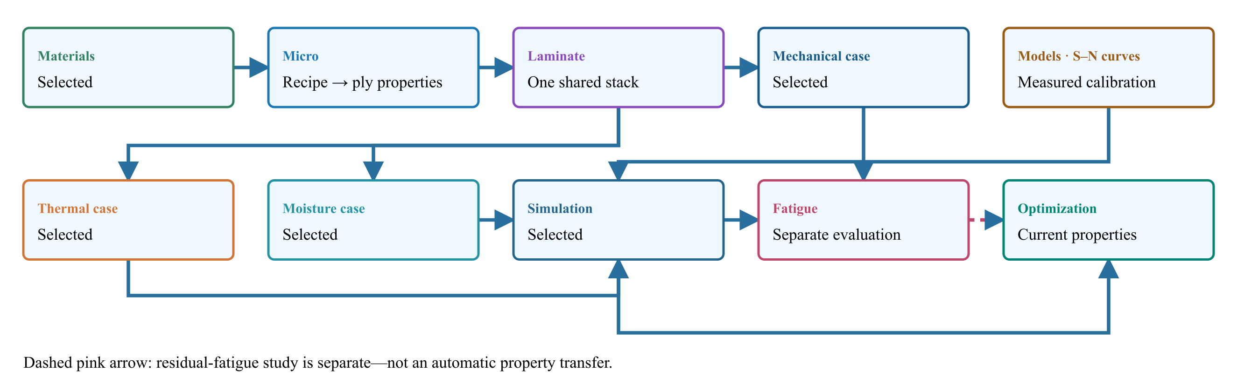
Materials → Micro → Laminate.
All exercises, case studies and simulation examples → · Your CDS library: overview, manuals and database downloads →

Inspect the selected model in Live Sim
SIMULATE opens with Live Sim, an input-driven view of the selected cases. The four selectors remain available above the scene. Switch to Blocks to manage candidate records and trace their connections.
- Select Geometry, Laminate, a constituent or a case to inspect the inputs that are actually used. Clicking a used block heading also opens its Live Sim inspection.
- Select a ply in the stack or geometry view to inspect its source. Micro-derived and stored-property plies are identified separately. Woven sources show the fabric unit-cell preview when applicable.
- Select the Thermal or Moisture case to inspect its surface boundary schedule. Move the step slider to compare prescribed conditions. This is not a solved internal temperature or moisture field.
- Use Edit input to open the source record. The scene follows the changed inputs; rerun the simulation before trusting previous results.
Good practice
Geometry, ply bands and arrows are input illustrations, not a finite-element mesh or solved deformation. Display-only thickness enlargement and any model-specific visualization assumptions are identified in the preview.

Use the current CASES database format
This release reads and saves the current CASES database format only. Thermal and Moisture schedules are stored directly with their cases. There is no separate Process record or old-format migration on opening a file.
- Download a current starter or exercise database from the library. Older-format files are rejected with a clear message rather than converted silently.
- Save and reopen the current database to retain case selections, schedules, candidate records and editable names.
- Missing folders, duplicate identifiers and cycles attached to absent cases prevent saving or opening. Blank physical inputs remain editable and must be completed before Run.
Good practice
This change concerns Workbench database files only. It does not erase account, licensing or payment history.

Choose the run in the SIMULATION block
SIMULATION is the control point for the run. Select a Thermal case, Moisture case, Mechanical case and EM case, or None in any slot. Each selected case shows its analysis model, laminate and applicable geometry.
- Keep candidate records in the surrounding blocks. Adding a candidate does not select it for execution.
- Select the required cases in SIMULATION and review their inputs before Run. At least one case is required.
- Use the same laminate for a supported combined run. Run standalone studies separately with the other selectors set to None.
- Run executes the selected combination. A connection or Used marker is not evidence of a successful solve.
Good practice
Selecting several cases does not add unsupported physics coupling. EM screening studies do not automatically heat the thermal case.

Review every downstream geometry dependency
A geometry record can be shared by several cases and simulations. Editing its dimensions or type affects all linked consumers, including studies that are not currently open. Unrelated records are unchanged.
- After editing geometry, open Solver messages and expand Review affected cases and simulations. Select a linked name to inspect that record.
- Check the selected model, load basis, dimensions and boundary conditions. Loads are not automatically replaced when the geometry changes.
- Resolve incompatible geometry and model combinations before running. An I-section does not turn a plate theory into a beam theory.
- Rerun affected simulations before relying on previous results. Inputs changed warnings indicate that stored results no longer match their connected inputs.
Good practice
Geometry affects only dimensions consumed by the selected model. One-dimensional transport retains its through-thickness assumptions; standalone studies may own their dimensions. Under fixed total edge loads, changing plate width changes force per unit width. Under prescribed resultants, it does not.

Build the simulation from interactive blocks
Choose Block view above the left navigator for a vertical, editable workflow, or Blocks inside SIMULATE for the larger connection view. Live Sim inspects the selected model. Record dropdowns remain visible in Lite view.
- Choose the active simulation, then select compatible materials, Micro recipes, laminates, geometry and cases inside its blocks. Hybrid laminates can retain both stored-material and solved-Micro ply sources.
- Use the local Blocks Lite–Advanced switch for extra details without changing the rest of the workspace. Existing search and current-simulation filters still apply.
- Use the side connections to trace the input path. Hide connections or pause their animation locally; reduced-motion preferences are respected. Animation indicates connection direction, not solver progress.
Good practice
The current-simulation filter includes used dependencies and added candidate records, even when those candidates are not selected for the run. Show all to browse other allowed library records.

Read the blue Used marker
Connected, available record selections have a soft blue glow and a Used marker in the corner. Hover or focus the marker to see which downstream record and field uses that input.
- Check the marker before editing a shared input: more than one case can consume it.
- A Used marker means connected, not solved or validated. Review solver status and outdated-result warnings separately.
- Missing or incompatible selections need repair; do not interpret an empty result as zero response.

Add replace or disconnect a block input
The + control adds another available record to a block, excluding records already present. Use that record row dropdown to change the candidate, its link to open it, and − to remove it from the block. Library records are not deleted.
- Choose + and search for a compatible candidate not already in the block. Decide what actually runs with the four selectors in SIMULATION.
- If no compatible record exists, create one in Inputs. Each case owns its analysis model and applicable cycle. There is no separate Process block to connect.
- A used input must first be disconnected or changed at its consuming field. Review downstream warnings before confirming a removal; cancel to keep it.
- After removal, required missing inputs remain flagged and their selectors allow reconnection. Optional cases may stay disconnected. Rerun affected analyses before relying on their results.
Good practice
Disconnecting a shared laminate input may affect several cases. Removing a ply-source connection preserves the other ply sources, angles and thicknesses; it does not delete the ply stack.

Keep starter laminates in one classification
Generated Standard starter Conventional Laminates folders are consolidated into the main Conventional Laminates folder. Distinct laminate record IDs and their simulation links are preserved; identical titles alone are not a reason to delete a record.
Good practice
Custom folders and exercise collections remain separate. Save the workspace to retain its cleaned organization in your local database.

CASES organizes the conditions you apply
CASES is the Workbench section formerly called LOAD or Loading. Its four types are Thermal, Moisture, Mechanical and Electromagnetic. A case defines the model, conditions and linked inputs for one study; SIMULATE connects the cases into the supported workflow.
- Choose the appropriate case type. Thermal and moisture cases use their compatible transport properties and boundary schedules; structural cases define forces, pressure, restraints or prescribed motion; EM cases define field, frequency and supported wave-study inputs.
- Each case selects one analysis model and owns its applicable cycle. Configure thermal initial conditions and upper/lower surface schedules in that case; moisture and mechanical schedules remain separate. Select cases in SIMULATION, not a separate Process block.
- Use an existing case or create one, check its laminate, geometry and model, then apply it to the current simulation. Review missing-input messages before running.
Good practice
Load still means a physical force or applied condition in equations and results. Earlier screenshots may show LOAD or Loading: use CASES in the current interface. Renaming the navigation does not add model coupling or change a saved calculation.

Test section stiffness during cure
The x–z section can use the linked matrix’s CHILE cure-dependent modulus, with the Micro recipe recomputing longitudinal, transverse and shear stiffnesses through the thickness.
- Link cure kinetics and a cure-modulus model to the matrix used by the Micro recipe. All section plies must use that same recipe and equal ply thicknesses for the current cure integration.
- Include a transient thermal/cure analysis in the simulation and select that Thermal case in the x-z section. Select Cure history under Section stiffness state. Exactly one matching transient thermal/cure history is required.
- Enter Section cure time in minutes, or -1 for the final process time. Run again: the section consumes cure data generated in that same run, not an older saved result.
- Read the reported time and cure range with the stress, displacement and apparent z-modulus results. Compare several cure times. Refine both the thermal mesh and section nodes per ply to resolve gradients.
Good practice
This applies stiffness at a selected cure state under the entered mechanical tractions. It does not transfer accumulated thermal or cure-shrinkage residual stress into the section, predict cure-dependent strength, or model uncured resin flow. Reference mode retains the original elastic calculation; leave its optional Thermal case blank.

Through-thickness testing with an x z section
The layerwise x–z section model resolves through-thickness displacement, normal stress and shear using the linked laminate and a finite rectangular Plate. It is separate from the existing plane-stress laminate solver. The omitted y direction has zero normal strain; z remains free to deform.
- Create a structural case and choose x-z section. Link a finite Plate and the laminate. Plate Length sets the x extent; the laminate supplies ply thickness, angle and material references.
- Verify complete 3D elastic properties on each material, or the linked Micro recipe’s homogenized outputs. A missing E3 or transverse shear modulus is not supplied by selecting the model.
- Enter Section traction Z in MPa: positive for tension, negative for compression. Section traction X acts on the right face; Section traction XZ applies x-directed shear on the top face. These are face tractions, not total forces.
- Set Section length elements and Section nodes per ply. The mesh shares interface displacements. Run the linked simulation and open structural Response to view the dedicated section map and scrollable table.
- Compare σz, τxz, displacement and strain. Refine both mesh directions and review the equation residual and force imbalance before interpreting local peaks.
Good practice
Snapshot linear elasticity at the selected reference or cure state, with perfect bonding. Left-edge ux and bottom-edge uz are restrained; uy is pinned at the origin but otherwise allowed to warp. Apparent z test modulus includes these supports and the y restraint: it is not free-lateral E3. Tension/compression stiffness is identical at a given cure state; strengths, delamination, cure/thermal preload and damage are not predicted. Element-centre stresses are unsmoothed; corner/interface peaks may be mesh dependent.

Geometry-driven virtual testing
Choose a Load basis in the structural case inputs. Infinite plate is the default geometry for new membrane studies and uses force per unit width. A finite Plate can instead use total edge forces and moments. Existing saved resultants retain their original units until you explicitly choose a different load basis.
- For Infinite plate, enter Nx, Ny and Nxy in force per unit width and Mx, My and Mxy in moment per unit width. Changing a schematic width does not change these resultants.
- For a finite Plate, choose Total edge loads. Force X is divided by Width, Force Y by Length, and Shear force by Width to obtain uniform laminate resultants. Bending moments use the corresponding edge length. Changing geometry therefore changes the stress and strain under a fixed total load.
- For a beam, choose Beam test and link a rectangular, I-section, circular section, or plate-strip geometry. Select simple supports or a cantilever, then central/tip point loading or a uniform distributed load. The support span must fit within the member length.
- Review section area and inertia, critical moment and shear, support reaction, top/bottom axial stress and strain, and maximum deflection. Beam stiffness uses effective axial Ex and the linked section inertia.
- Keep the load case, geometry, laminate and material records together when saving the simulation.
Good practice
Plate results assume uniform edge traction and do not resolve grip effects or hole stress concentrations. Beam results use small-deflection Euler–Bernoulli theory with an equivalent uniform axial modulus; they exclude shear deflection, local buckling, joints and ply-level beam failure.

A dependency chain not a set of isolated forms
A simulation selects its Thermal, Moisture, Mechanical and EM cases. Each case references the inputs consumed by its model and owns its applicable cycle. A laminate contains ordered plies, each referencing a material or solved lamina. A micromechanics record links constituent materials and an architecture-compatible homogenization model. Reusing a record means reusing the same underlying data; duplicating it creates a separate record.
- Begin with material units, density, elastic constants and strength allowables. Starter values are representative—not certified design allowables. See screenshot
- Choose the microstructure and compatible model, then constituents, volume fractions and geometric inputs. Check the live cross-section and effective properties. See screenshot
- Build the laminate: verify source, angle, thickness, ordering, symmetry, balance and visible plies. See screenshot
- Link the applicable geometry and laminate inside each case. Choose the case combination in SIMULATION and review Summary before Run. See screenshot
- Save a dependency-complete CDS_DB checkpoint so references travel with the study.
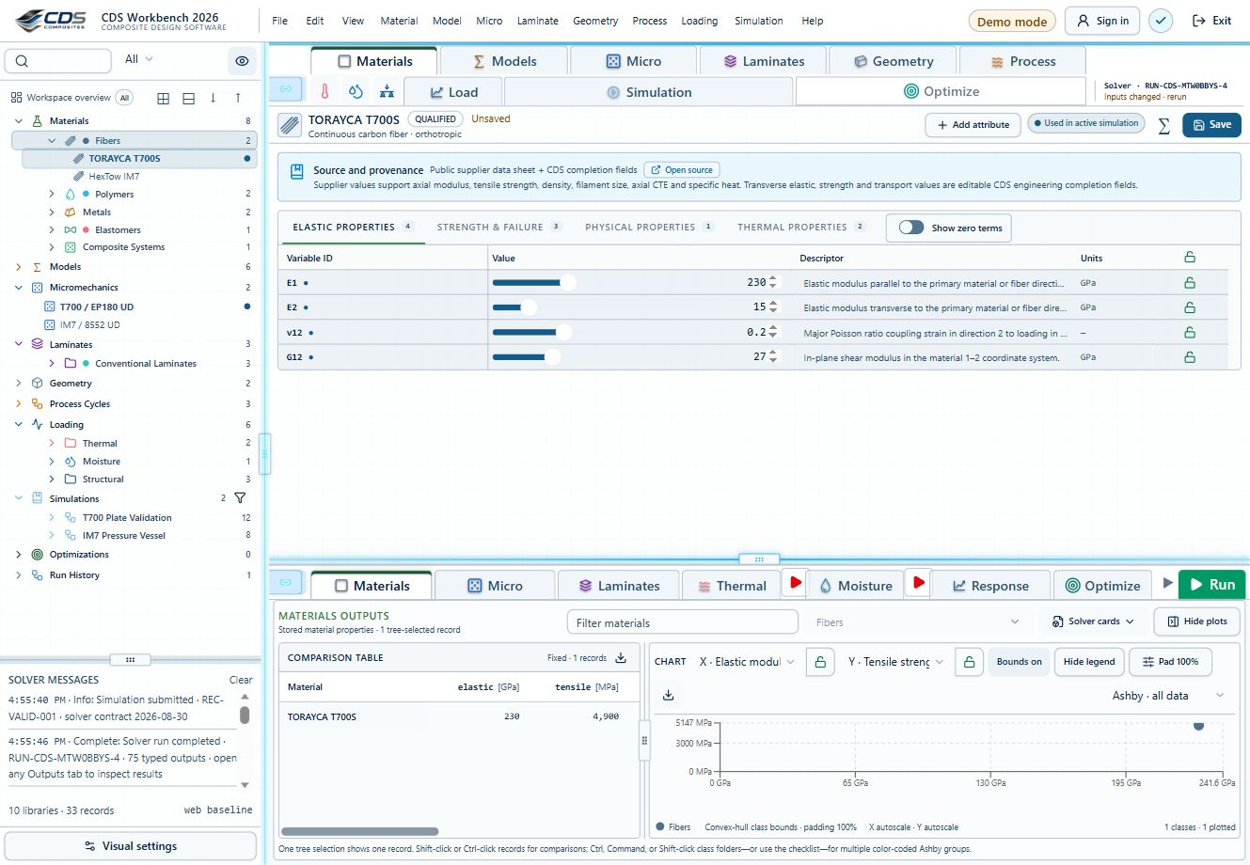
Steps 1 · Begin with sourced constituent properties. Open full size GUI capture · September 10, 2026 . Control locations may differ in later releases; not benchmark evidence.
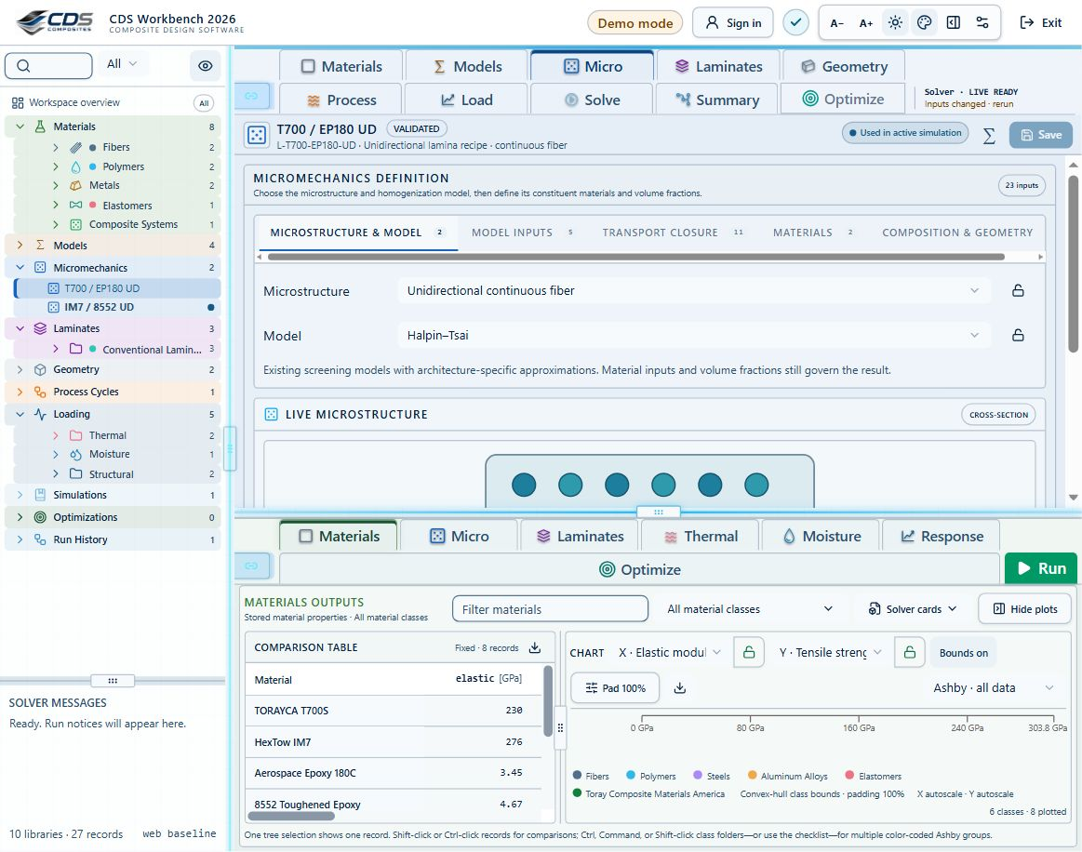
Steps 2 · Select the micromechanics architecture and model. Open full size GUI capture · September 7, 2026 . Control locations may differ in later releases; not benchmark evidence.
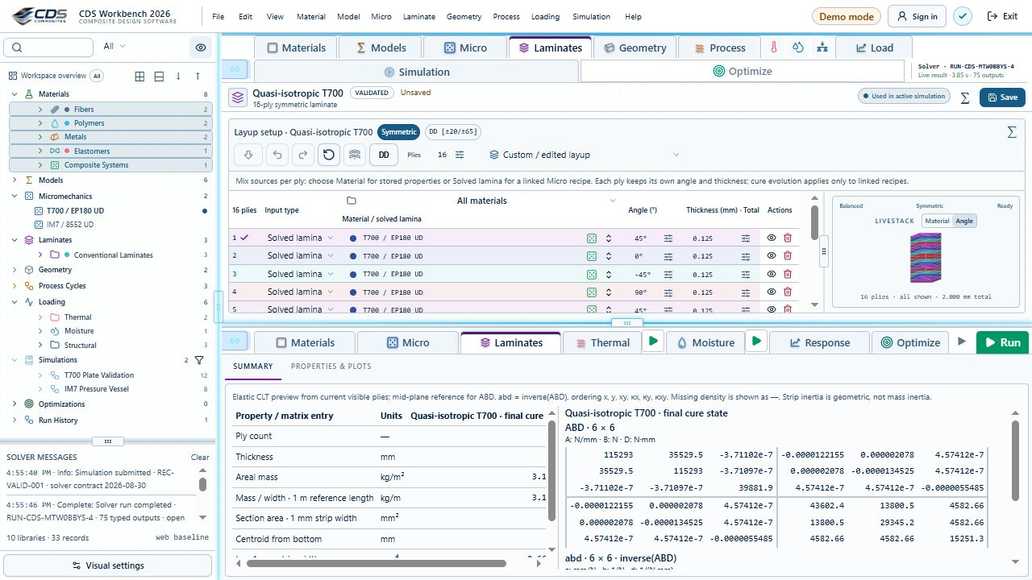
Steps 3 · Review the ply sequence, source and thickness. Open full size GUI capture · September 10, 2026 . Control locations may differ in later releases; not benchmark evidence.
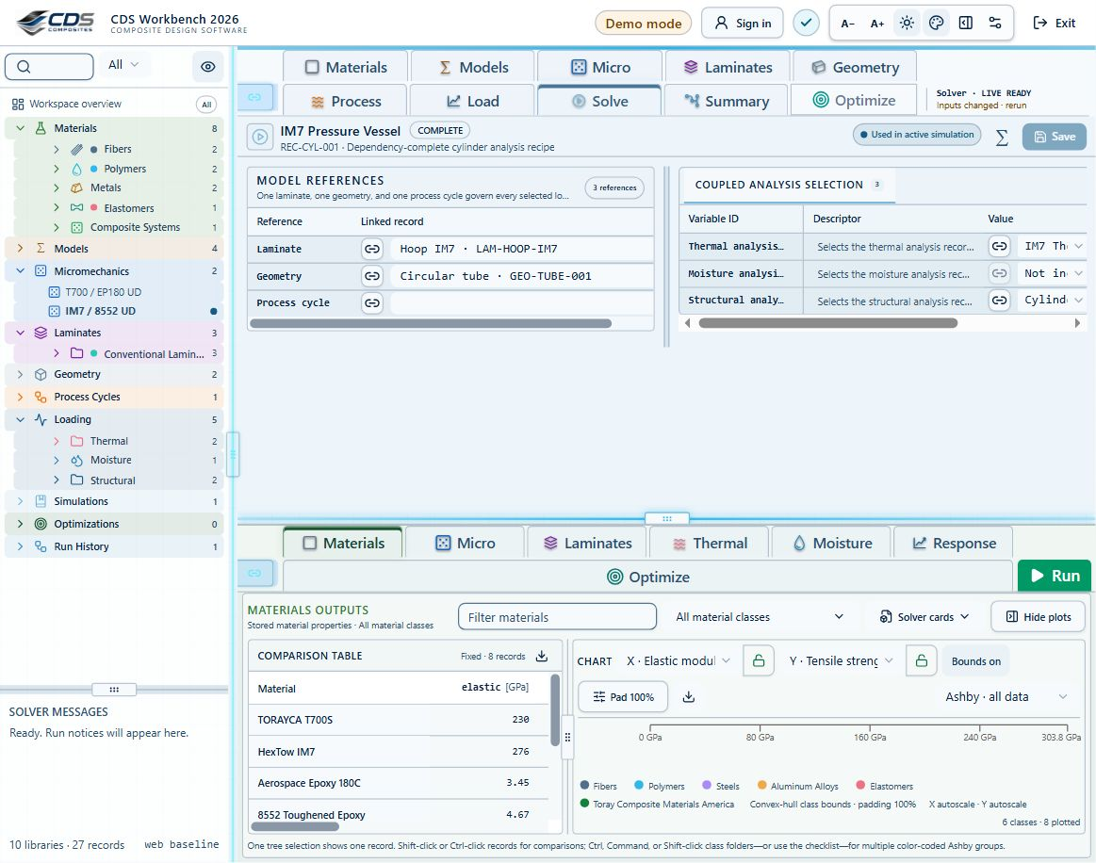
Steps 4 · Earlier interface shown for reference. Connect laminate and applicable geometry inside each case, then select the case combination in SIMULATION. Open full size GUI capture · September 7, 2026 . Control locations may differ in later releases; not benchmark evidence.
Good practice
A display icon or selected theory does not supply missing material parameters. Inspect the consumed inputs and solver messages.

Live sync navigation and calculation are different
Inputs and Outputs have independent menu-response controls. With a control enabled, selecting a tree record updates that pane. Turn one off to keep its current view while navigating the other. An explicit open/double-click can open the chosen record even when ordinary menu response is off.
- Use the Inputs/Outputs link controls to decide which pane follows tree selection. See screenshot
- Use Ctrl/Command-click or Shift-click for comparison selections; check the selected record names, not just the active tab.
- Drag the main and internal dividers to allocate space. Plot resizing changes presentation, not numerical fidelity. See screenshot
Steps 1, 3 · The chain controls at the left of the input and output tabs control which pane follows selection. Dividers allocate space between the tree, inputs and outputs. Open full size GUI capture · September 10, 2026 . Control locations may differ in later releases; not benchmark evidence.
Good practice
Live sync is not automatic cloud collaboration, a saved snapshot, or a guarantee that every solver result has been recalculated.

Know whether you are viewing live or saved results
Live CLT uses the current visible ply materials, thicknesses, angles and mechanical loads. A material change can therefore update elastic stress/strain previews without a full service run. Thermal, cure and moisture residuals may still come from the last saved solver run.
- Read the response source and process-time controls in Response. Combined, mechanical and environmental contributions are different views.
- After changing a material, laminate or process history, rerun the solver before relying on coupled residual results.
- Treat Inputs changed, rerun, incomplete inputs and unavailable-contribution messages as part of the result—not cosmetic warnings.
- Use Run History to identify the completed run and its messages. Save input records and export the complete study when it becomes a review baseline.
Good practice
Increasing plotted recovery nodes per ply improves sampling; it does not add a new three-dimensional constitutive model or recover unmodeled physics.

Material classes icons and searchable selection
Built-in material classes have stable visual identities: fibers, polymers, hexagonal cores, metal ingots, elastomer dogbones and green composite microstructure icons. User-defined classes can have a selected icon and color. A new material also needs a material type because type determines its input records.
- Search the laminate material selector by material or class. Use the All materials filter above Material / solved lamina to narrow long lists.
- Confirm the full material name and source type before selecting a ply source. Color helps recognition; it is not a substitute for identity or units.
- Use a selected column’s fill-down arrow to copy the selected row’s value. Review the affected plies before saving.
- Use Duplicate and enter a count for design studies. Copies get separate identities; linked records remain references unless separately duplicated.
Good practice
Record locks prevent accidental edits. Slider bounds and increments assist input; they do not certify that a value is valid for your material, temperature or loading regime.

Keep sources and completion assumptions visible
Material records can store a source URL, citation, status, basis and notes. Supplier-supported values and CDS engineering completion fields remain distinguishable in the same record.
- Open Source and provenance above the material property groups and follow any supplier links. Multiple source links are shown separately. See screenshot
- Use Show zero terms when a stored zero-value property needs to be reviewed or edited. Zero does not mean unavailable; confirm its physical meaning. See screenshot
- Treat public supplier values, internal qualified records, representative starter values and model fallbacks as different evidence levels.
- When a material lacks a required transport or strength property, enter qualified data or use an explicitly visible editable model input. Do not assume a successful solve proves the source material record was complete.
Steps 1, 2 · Source and provenance is above the property groups. Open source follows the supporting document; Show zero terms is at the right. Open full size GUI capture · September 10, 2026 . Control locations may differ in later releases; not benchmark evidence.
Good practice
Source metadata documents where a value came from; it does not make a typical supplier value a design allowable.

Move and duplicate study records in groups
Multi-selection applies to records throughout the master tree. This supports design-study setup without repeating the same move or duplicate command one item at a time.
- Select records with Ctrl/Command-click or a contiguous range with Shift-click.
- Choose Move, search for a compatible destination class, review the count and confirm the operation. See screenshot
- Choose Duplicate and enter the required copy count. Each copy receives its own identity. See screenshot
- The Optimizations branch remains visible under Simulations even when empty. Saved laminate, lamina/micro and process studies appear there for reopening and comparison.
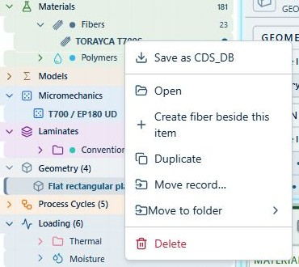
Steps 2, 3 · Record context menus contain Duplicate and Move commands. Confirm the selection and scope before proceeding. Open full size GUI capture · September 7, 2026 . Control locations may differ in later releases; not benchmark evidence.
Good practice
Moving a record does not rewrite its reference identity. Review dependent simulations after reorganizing linked inputs.

Laminate construction and LiveStack
The ply table and LiveStack share the same layup. The material and angle color modes answer different questions: which material is used, and how fibers are oriented. Presets, symmetry, balance and Double-Double actions change the layup and must be reviewed as engineering edits.
- Check the ply count, total thickness and source material after a preset or fill operation. See screenshot
- Use the geometry-type dropdown to expose the relevant dimensions. Per-type values are retained when changing types.
- Inspect laminate properties alongside ABD and inverse-ABD matrices. Off-diagonal coupling can be real; it is not automatically an error.
- A hidden ply is excluded from the current visible-ply preview. Resolve hidden plies before optimization rather than silently optimizing a different stack. See screenshot
Steps 1, 4 · Ply count, material source, visibility and total thickness can be checked directly against LiveStack. Open full size GUI capture · September 10, 2026 . Control locations may differ in later releases; not benchmark evidence.

Independent boundaries and shared pressure
Upper and lower thermal boundary schedules can differ. Their time, temperature and boundary condition records define the applied history. Pressure shown alongside both boundary tables is a shared process load—not two independent pressures to add together.
- Define ordered cycle steps and check units before using Temperature, boundary-condition or pressure fill-down. See screenshot
- Set the thermal or moisture analysis resolution and output interval in its input record. See screenshot
- Use the solver-level 2D grid. The former coarse display grid has been removed; the default 51 × 33 example reflects its time and through-thickness settings, not a universal mesh.
- Inspect the 2D history with time-history and through-thickness sections alongside it. Move the cursor to examine a matching time/depth state.
- Check film coefficients, initial conditions and any missing heat-of-reaction or kinetic-model messages before interpreting residual stress.
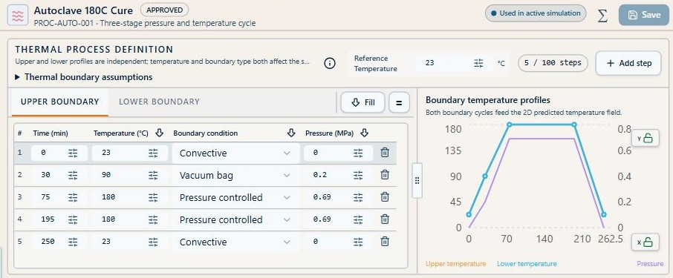
Steps 1 · Upper and lower schedules have separate tabs; pressure is shared. Open full size GUI capture · September 7, 2026 . Control locations may differ in later releases; not benchmark evidence.
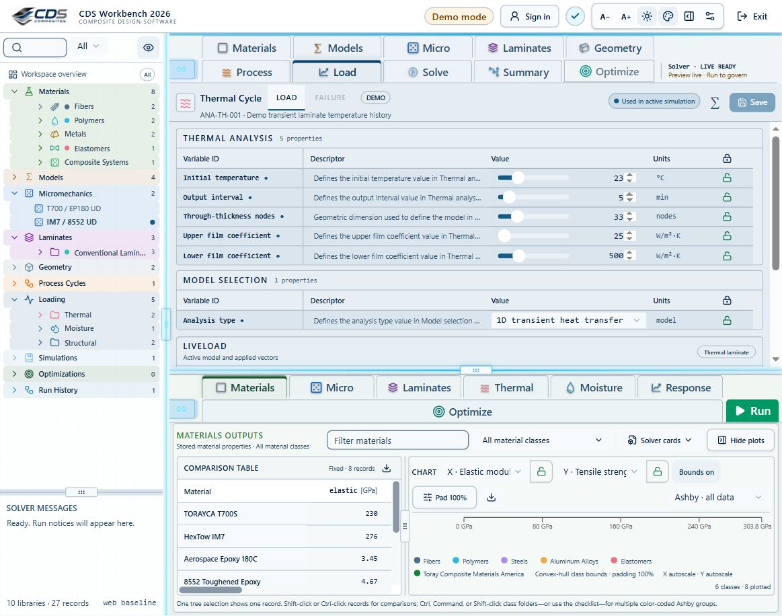
Steps 2 · Thermal case inputs expose initial temperature, output interval, through-thickness nodes and film coefficients. Open full size GUI capture · September 7, 2026 . Control locations may differ in later releases; not benchmark evidence.
Good practice
The field view is a one-dimensional through-thickness solution plotted against time. A colorful 2D history is not a two-dimensional spatial finite-element mesh.

Compare preserve and reopen evidence
Materials and saved optimization cases offer a comparison table and Ashby, bar and line plots. Axes, units, filtering, markers and bounds control what is shown; they do not change the source calculations.
- Choose comparable properties and compatible units before comparing records.
- Use plot bounds and axis locks deliberately; a locked axis can hide an out-of-range point.
- Save a record, subtree or workspace as CDS_DB for portability. Keep the dependent material, model, laminate, geometry and case records.
- Save optimization results with Save snapshot beside the structural-case selector. Open saved cases from the permanent Optimizations tree entry below Simulations.
- Select multiple optimization snapshots to compare them. A saved case is read-only evidence of its saved inputs, not a fresh solve against current materials.
Good practice
Saving an optimization snapshot, saving a material, and running a simulation are separate actions. Keep all required artifacts for a reproducible review.
Workbench availability: released models, inputs and compatible study paths . The wider theory library includes reference formulations not available in every Workbench solve.

3 Explore capacity and trade-offs without losing the assumptions
Online chapter
Practical operation of Response, failure envelopes, progressive failure, 2D/3D carpet plots, lamina/micro studies, laminate searches and saved optimization evidence.
Current Workbench, reference editions and downloads
Use the online User Guide for current controls, the released model directory for selectable models and compatibility, and the Training Manual for connected exercises. Wider theory references do not mean every formulation is enabled in Workbench.
Dated GUI captures and compiled Web r18 PDF manuals retain their stated scope; they are not a substitute for current hosted Workbench instructions. Find the overview PDF, guides and exercise databases in Your CDS library .
Read the WB equations and limitations →
Trace the selected input path
Ply property source
Include thermal analysis
Include moisture analysis
Include optional fatigue assessment
Stored ply properties bypass Micro. Mixed stacks keep both paths. Gray blocks are not selected. Geometry, process schedules and other model records are omitted here for clarity; a real run must include all required references.
Fatigue uses intact CLT endpoint stresses and measured S–N calibration. It is evaluated separately from Run and progressive failure. The dashed handoff is not active: optimization still uses current properties until a degradation law is supplied.
Materials → Micro → Laminate.
All exercises, case studies and simulation examples → · Your CDS library: overview, manuals and database downloads →

Explore a failure step and explain a hotspot
The slider above the progressive 2D plot is connected to its cursor. Drag either to inspect a saved step; the arrow controls jump between activations. The depth selector sits with the other plot controls.
- Select the step and ply, then expand Explain selected hotspot for its criterion, mode, local stress and theory link.
- Use the vertical Fiber, Matrix and Shear strip: gray means not activated, color means activated, and a gold outline marks a new activation at this step. Select a strip segment to inspect that ply.
- Use the output expand control for more space and restore Split when returning to input editing.
Good practice
A governing mode at a sampled point is not proof of a new failure. Counts are plies with activations, not percentage strength loss. The CLT plot does not establish a delamination event.

Include delamination in progressive steps
The ordinary CLT progressive ramp degrades plies; it does not separate their interfaces. For supported coupled growth, choose Layerwise x-z plane strain and set Delamination model to Coupled growth.
- Link finite Plate geometry and a laminate with complete 3D stiffness.
- Supply calibrated interface stiffness, normal/shear strengths, fracture energies and BK exponent, plus ply strengths and load-step controls. No interface properties are inferred from a laminate name.
- Run the linked simulation, then open Response → Progressive failure · plies + delamination.
- Check mesh and step convergence and compare with the connected simulation-20 exercise and cohesive theory.
Good practice
Mechanical-only, small-strain x–z section. This is not a general 3D, cylinder or thermal-residual delamination prediction; completion is not a design pass.

Optimization cases Micro Process and Laminate
Optimizations contains Micro, Process and Laminate subfolders. New saved cases retain the numerical study, all search variables and constraints, and a frozen archive of linked source records and process boundary schedules. Older snapshots remain readable but cannot recover source records that were never saved.
- Configure and run the selected optimizer, name the case and choose Save snapshot. The case is added to its mode folder and downloaded as a CDS_DB. Save the workspace as well to retain all cases together.
- Reopen the case and expand All saved optimization inputs. Inspect search variables, objectives and constraints; effective solver properties and loads; linked material, model, laminate, geometry and case records where used; and saved process schedules.
- The archived source records document the database at save time. Effective solver inputs separately preserve selected overrides and the values actually supplied to the optimizer. These two views need not be identical.
- Use the shared exercise tree and search for optimization: Micro stiffness, voids and density; Laminate minimum mass under axial loading; Process cycle time and thermal uniformity. The same exercise IDs and instructions appear in Workbench Training, this manual and licensed CDS_DB downloads.
Good practice
These are guided design studies, not prevalidated optima. Configure the documented search and generate results yourself. Frozen cases do not change when the live database changes; start a new optimization to evaluate revised inputs.

Start from a checked structural case
Select the structural load case and verify its linked laminate. Failure and optimization need elastic ply properties and compatible strength allowables, not just a plausible-looking layup.
- In Input: CASES, review Loads and Failure. Select which Nx, Ny, Nxy, Mx, My and Mxy components ramp; the same load selection is reflected in the diagram and failure controls.
- Check the actual numbers and signs. The WB optimizer shows membrane resultants in N/mm and moments in N; a source record in N/m is converted for this calculation.
- Do not treat pressure, point force or torque labels as an automatic replacement for membrane/bending resultants. Resolve the load case into the quantities required by the selected analysis.
- Review missing-input diagnostics and the ply strength table. Unsupported or incomplete theories must not be interpreted as zero failure index.

Read stress and strain before failure
Response gives through-thickness stress and strain in selected components and coordinates. Compare like contributions at the same process time.
- Choose response source, global or local axes, components and scale. See screenshot
- Select thickness from bottom or the available alternate depth coordinate. Inspect ply interfaces and angle labels. See screenshot
- Increase recovery nodes per ply in Settings when more sampling is useful, then check that the result source is still appropriate.
- Use the resizable output region and axis locks to inspect the complete plot. See screenshot
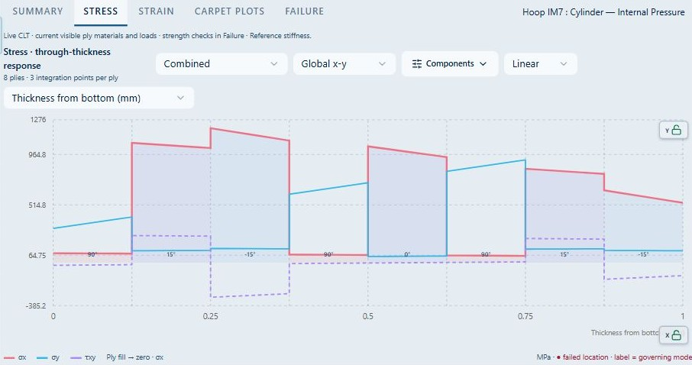
Steps 1, 2, 4 · Select the response contribution, axes, components and scale above the plot; depth coordinates and axis locks control inspection. Open full size GUI capture · September 7, 2026 . Control locations may differ in later releases; not benchmark evidence.
Good practice
Elastic stress is not a failure prediction. A high stress must be evaluated against the correct ply direction, sign and material allowable.

Build and interpret a failure envelope
An envelope traces first-failure capacity in a selected pair of load components. Each ray is evaluated with the selected material criterion and laminate response; the displayed curve joins sampled directions.
- Choose the envelope axes, supported theories and the fixed/background load state in Failure inputs.
- Generate or update the envelope; inspect the completion/evaluation status and units.
- Right-click the envelope plot to show markers when you need to see the calculated samples.
- Compare criteria only when each has valid material data. A curve farther from the origin is not proof that its theory is more accurate.
Good practice
Ray spacing, numerical search limits and fixed loads influence the plot. Do not extrapolate the polygon or treat the interior as a certified safe operating region.

Follow progressive failure
Progressive analysis ramps the selected loads, evaluates ply criteria and updates damage/stiffness according to the chosen method. First-ply failure and last-ply/terminal response answer different questions.
- Set criterion, ramp, step count, search limit and stopping rule in the Failure inputs.
- Choose whether saved thermal/cure effects, cure shrinkage and moisture expansion are reused; rerun the relevant solver after changing those inputs.
- Read first activations, damaged plies, load factor and retained stiffness together.
- Use the selected event, ply and pseudo-time controls to inspect the corresponding response. Pseudo-time in the proportional ramp is the load multiplier, not seconds.
Good practice
Results depend on the degradation rule and stopping criterion. The WB screening view must not be confused with every cohesive, fatigue or out-of-plane capability described for the compiled backend.

Explore elastic design space with 2D and 3D carpet plots
Carpet plots sweep two existing absolute-angle families while retaining ply materials, thicknesses, ordering and angle signs. Choose two different outputs such as Ex, Ey, Gxy, νxy, A11/A22 or D11/D22, then select a 2D carpet or 3D surface.
- Choose distinct α and β families already present in the laminate and set increasing 0–90° bounds with 2–21 samples per sweep. See screenshot
- In 3D, choose which sweep lies in the plane and which output is vertical. Filled surfaces default on at 55% opacity; switch fill, mesh, autoscale, extrema and other display aids independently. See screenshot
- Drag the divider to give controls or plot more room. The 2D/3D selector stays at the top, and the live laminate remains beside the 3D plot. See screenshot
- Hover a point to inspect the exact color-coded candidate. Display minima and maxima when locating the evaluated extrema, then verify balance, symmetry and manufacturability for that candidate. See screenshot
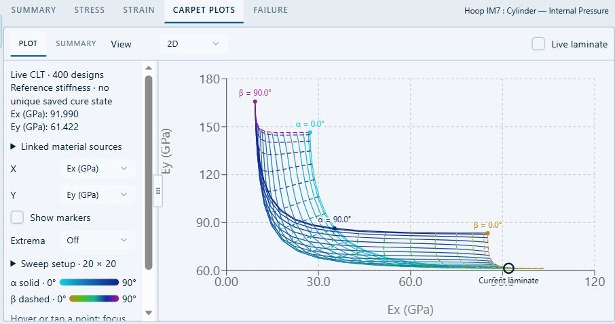
Steps 1, 4 · Select axes and open Sweep setup in the left column. Extrema highlights evaluated minima and maxima. Open full size GUI capture · September 7, 2026 . Control locations may differ in later releases; not benchmark evidence.
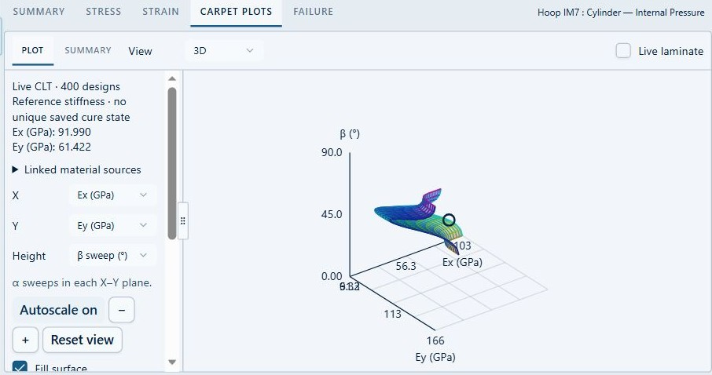
Steps 2, 3 · The 3D view offers a Height selector, autoscale and fill controls. The divider separates controls from the plotted surface. Open full size GUI capture · September 7, 2026 . Control locations may differ in later releases; not benchmark evidence.
Good practice
A carpet plot is an elastic sensitivity study, not a strength envelope or an optimized solution. Extrema are limited to the sampled design space.

Optimize lamina and microstructure inputs
Lamina / Micro mode builds the same 2D and 3D study workflow around microstructure inputs rather than ply angles. It uses the selected micromechanics model, linked constituents, editable empirical parameters, and available thermal or moisture data.
- Choose the micromechanics record and confirm its linked fiber, matrix, filler or void records. Missing required inputs stop the study instead of silently substituting a hidden constant.
- Select two inputs from the variables relevant to that model: composition, aspect ratio, orientation, crimp, weave or braid terms, void knockdown, constituent-retention factors, or editable transport closures.
- Choose elastic, strength, density, specific heat, conductivity, thermal diffusivity, moisture diffusivity or moisture saturation as the mapped output.
- Set bounds, fixed slices and constraints. Use 2D contours or filled 3D surfaces with extrema and autoscale controls to examine maxima, minima and trade-offs.
- Save the snapshot before applying a candidate. Applying writes the chosen active model parameters back to the micromechanics record; downstream laminate and structural results should then be rerun.
Good practice
Only variables supported by the chosen architecture are offered. A generated property is a model prediction and retains the source and limitation of its constituent data and empirical closures.

Run a bounded laminate optimization
Laminate mode searches discrete ply angles for a selected mechanical load case. Objectives are lowest feasible areal mass, greatest first-failure load factor, or greatest absolute selected mid-plane strain at first failure.
- Choose Laminate in Optimize Inputs, then select the structural case, objective, first-ply criterion, allowed angles and required load factor.
- For mass, set minimum/maximum ply counts. Strength and strain hold the current ply count fixed.
- Choose symmetric construction, balanced pairs and minimum angle content as needed. Review the angle-content guidance.
- Set a repeatable seed and evaluation budget in Search settings. The supported range is 1–64 plies and 20–2000 evaluations.
- Click Optimize. Read evaluated/feasible counts, convergence, trade-off plot and Best Found together. Drag the panel dividers to inspect the plots.
- Apply candidate updates the existing laminate after confirmation. Create new laminate creates a separate candidate-based record and leaves the original laminate and simulation link unchanged. Both actions remain disabled until a feasible candidate is available.
Good practice
Mechanical-only, one material and uniform ply thickness are required. Thermal/cure/moisture residuals are not reused after redesign. Re-link a new laminate deliberately, then rerun and validate the complete coupled simulation.

Save and compare optimization cases
Use Save snapshot in Inputs, beside the structural-case dropdown, after a result is available. Name the case so its objective and loading are recognizable.
- Saving captures the inputs, load vector, search settings, candidates, convergence and best-found result; it also provides a CDS_DB download.
- Open a saved case from Optimizations below Simulations. Saved inputs are read-only.
- Select multiple cases for the comparison table and Ashby, bar or line views. Use axis properties and filters just as in Materials results.
- Start New optimization for a fresh search. Changing current inputs does not rewrite an earlier snapshot.
Good practice
Load factors are relative to each case’s own load vector. Strain objectives also depend on the selected component. A feasible-candidate count of zero means no design met all constraints.

Know what the search does not establish
Small spaces are exhaustively enumerated; larger spaces use seeded multi-start search. A budget limit or flat convergence curve is not proof of a global optimum.
- Repeat large searches with different seeds and budgets.
- Check contiguity, disorientation, manufacturing rules and damage tolerance separately.
- Validate buckling, fatigue, joints, defects, delamination and environmental effects with suitable models and data.
- Treat any claimed “best” design as best found within this defined search space and model.
Good practice
For the equations and implementation boundaries, see WB failure, envelope and optimization methods in Theories.
Workbench availability: released models, inputs and compatible study paths . The wider theory library includes reference formulations not available in every Workbench solve.

4 Use the interface deliberately and efficiently
Online chapter
A practical operating pattern for compact navigation, model checks, result comparison, and portable data.
Current Workbench, reference editions and downloads
Use the online User Guide for current controls, the released model directory for selectable models and compatibility, and the Training Manual for connected exercises. Wider theory references do not mean every formulation is enabled in Workbench.
Dated GUI captures and compiled Web r18 PDF manuals retain their stated scope; they are not a substitute for current hosted Workbench instructions. Find the overview PDF, guides and exercise databases in Your CDS library .
All exercises, case studies and simulation examples → · Your CDS library: overview, manuals and database downloads →

Right-click help throughout the Workbench
Right-click a record, input, workflow block, result plot or workspace area and choose its Help link. Existing edit, export and plotting actions remain in their menus; help opens the relevant manual section in a separate tab.
- Use the help item on the area you are working in: Inputs and Outputs have separate context, and workflow blocks use their own module.
- Press F1 for help on the focused control, or Shift+F10 to open its context menu using the keyboard.
- Use Shift+right-click when you need the browser's native menu, including text editing and link actions.
- Open the Exercise manual for the complete searchable curriculum, then use the user portal Database library to download current exercise copies.
Good practice
Help links explain controls and model limitations; they do not validate your material data or mark a solution as passing.

Use Project Manager consistently
Project Manager mirrors record right-click operations. Use whichever access point is faster, but always verify the selected item and action scope first.
The record context menu exposes Open, Create, Duplicate, Move, Save and Delete actions for the selected record. Open full size GUI capture · September 7, 2026 . Control locations may differ in later releases; not benchmark evidence.

Adjust and retain interface settings
Open Settings: Visual for font size and appearance. Settings: General is available from the top menu and the pop-up settings panel. Preferences are stored on the user’s local system, including optional automatic simulation on opening when the connected model is complete. Choose a density that keeps descriptors readable without hiding the connection summary.

Filter without losing context
Prefer the compact All records dropdown and virtual-folder filters over collapsing the entire tree manually. Filters retain the menu structure, highlight the active state, and change the heading to Workspace filtered result. Single-click selects; use the chevron or double-click to open child items.
Search and filter controls sit above the project tree. Open full size GUI capture · September 10, 2026 . Control locations may differ in later releases; not benchmark evidence.

Use locks bounds and increments
Keep trusted properties locked. Unlock only the values being changed, use physically meaningful bounds, select an increment appropriate to the property scale, and relock after review.
Row locks sit beside the units; the group lock is in the table header. Open full size GUI capture · September 10, 2026 . Control locations may differ in later releases; not benchmark evidence.

Choose the result view that fits the task
Materials, Micromechanics, Laminates and saved optimizations share Table, Ashby, Bar, and Line views. Use the clearly highlighted active tab for one-record inspection or multi-record comparison. Run leaves that selected tab in place. Wide and tall tables scroll inside the application rather than extending beyond the window.
The lower output pane separates comparison data and chart controls with an adjustable divider. Open full size GUI capture · September 10, 2026 . Control locations may differ in later releases; not benchmark evidence.
Good practice
For multiple selections, the table places properties in rows and selected records in columns.

Control 2D and 3D plots
Three-dimensional plots default to a filled surface at 55% opacity. Use Fill, opacity, mesh, extrema and Autoscale on/off to expose the shape without losing the sampled data. Carpet plots place their 2D/3D selector at the top and provide an adjustable divider between controls, plot and live laminate.
The 2D view keeps axes, extrema and sweep setup beside the plot. Open full size GUI capture · September 7, 2026 . Control locations may differ in later releases; not benchmark evidence.
Use View to select 3D, Height to choose the vertical quantity, and Autoscale or Reset view to frame the surface. Open full size GUI capture · September 7, 2026 . Control locations may differ in later releases; not benchmark evidence.
Good practice
Turning autoscale off preserves the current limits for comparison; verify that new points have not moved outside those limits.

Export tabular evidence
Right-click supported tables to save or hand off the visible data in common formats, including CSV and XLSX, with presentation-oriented PPTX export where available. Export uses the current selection, property set and units; confirm those before distribution.

Read the two-layer simulation workflow
The simulation summary separates connected records from their selected models. Use Titles, Details or Table and the zoom controls to fit the overview. Select a block to focus it, then select it again to open its record.
- Show data reveals the key properties passed between modules; hiding it only reduces visual detail.
- Show model workflow reveals the first model layer. Expand Submodels and Scope & theory to inspect formulation choices, calibration and limitations.
- Right-click a model block or the Models browser for that model family's theory. Nested fatigue help opens the separate fatigue assessment.
- Arrow animation is optional. An animated connection does not mean a calculation is running or that its result is current.
Use the linked-record view in Simulation (shown as Solve in this capture) to check simulation dependencies. Open full size GUI capture · September 7, 2026 . Control locations may differ in later releases; not benchmark evidence.
Good practice
Tree nesting shows related methods, not automatic solver compatibility. CLT/FSDT finite-plate studies, progressive failure, cohesive growth and fatigue have distinct supported paths.

Make room without losing your place
Use Lite for a compact workspace and Advanced to expose additional controls. The global switch affects the workspace; local switches expand only their own area. Neither changes model permissions or disables linked physics.
- Use Inputs, Split and Outputs at the top, or the expand icon on either pane, to give editing or results more room. Restore Split to return to the divided layout.
- On narrow windows, toolbar text reduces to icons. Hover for a label, or focus the control with the keyboard.
- Use Back and Forward to revisit input/output scenes. This changes navigation, not your saved data; it is not Undo.

Start with CREATE DISCOVER or SIMULATE
CREATE guides a starter design; DISCOVER explores the live laminate; SIMULATE opens the normal workspace. Levels in CREATE and DISCOVER introduce more detail without turning teaching defaults into qualified design data.
- In SIMULATE, open Walkthrough highlights and choose an exercise. It opens an independent example with blue step-by-step callouts.
- Move through the steps at your own pace. Run remains a deliberate action and account permissions still apply.
- Stop walkthrough is always available during the guide; Escape also stops it. Exit Discovery returns to the opening page.

Compare designs and review what changed
Expand Compare designs to pin current single-laminate results as A and B. Compare dry weight per area, axial stiffness, available transverse deflection and failure margin.
- Complete a current run before pinning. Open Response → Failure first if you want its assessed margin included.
- Match geometry, loads, units and failure criteria. Not assessed means missing evidence, not zero.
- Expand What changed? to compare inputs against the last successful run. Select a changed input to return to its record; rerun when results are marked outdated.
Good practice
Pinned results are historical snapshots retained for the workspace session, not live calculations or a saved database backup.

Know when to press Run
Eligible quick connected calculations refresh after editing pauses. Process histories, mesh and iterative calculations require Run after upstream changes; larger workloads and calculations exceeding the live time budget also switch to Run.
Good practice
Live refresh does not reduce accuracy or bypass compatibility checks. Follow the visible result status; an old plot is not evidence for changed inputs.

Promote effective results to materials
The Create Material menu in lamina and laminate results converts predicted effective properties into a normal material record. Select a class, name the record, choose whether to preserve source identity, and decide whether unpredicted fields remain empty or receive class assumptions.

Save portable data
Use Save Data or the SQLite database actions for a selected record, subtree, or full database. A laminate export should include its dependent laminas and materials so it can be opened on another instance. Context-menu table exports create separate review artifacts; they do not replace a dependency-complete CDS database checkpoint.
Save as CDS_DB is available for the selected record. Verify export dependencies when moving a study to another instance. Open full size GUI capture · September 7, 2026 . Control locations may differ in later releases; not benchmark evidence.

Recommended working sequence
Organize materials, micromechanics, laminates and geometry, then define Thermal, Moisture, Mechanical or EM cases with their own model and applicable cycle. Choose the combination in the SIMULATION block, using None for unused case types. Review the linked inputs and compatibility warnings before Run, then compare current results. Export a portable data checkpoint before substantial restructuring.
Earlier interface shown for reference. In the current SIMULATION block, select cases that reference the required laminate and geometry; each case owns its applicable cycle. Open full size GUI capture · September 7, 2026 . Control locations may differ in later releases; not benchmark evidence.
Good practice
Small, named, dependency-complete checkpoints are easier to review and recover than one large unstructured database.

5 Build laminas and laminate families
Online chapter
Connect materials, edit compact ply stacks, review effective results, and create reusable material records.
Current Workbench, reference editions and downloads
Use the online User Guide for current controls, the released model directory for selectable models and compatibility, and the Training Manual for connected exercises. Wider theory references do not mean every formulation is enabled in Workbench.
Dated GUI captures and compiled Web r18 PDF manuals retain their stated scope; they are not a substitute for current hosted Workbench instructions. Find the overview PDF, guides and exercise databases in Your CDS library .
Inspect a ply stack
Angle pair ±θ: 45 °
Ply to resize
Selected ply thickness: 0.125 mm
8 plies · 1.000 mm total. Thickness is proportional in the section; line direction indicates angle, not a stress field.
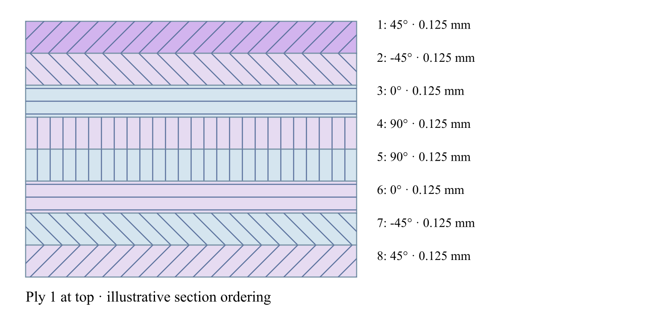
[θ / −θ / 0 / 90 / 90 / 0 / −θ / θ]
All exercises, case studies and simulation examples → · Your CDS library: overview, manuals and database downloads →

Create a lamina
Create or duplicate a lamina record, then connect its constituent materials through the editor selectors. Material filters can limit selections to a virtual material family.
- Select the lamina type. See screenshot
- Choose constituent materials.
- Enter architecture and volume-fraction inputs.
- Review constituent references in the editor and model summary.
Steps 1 · Microstructure & Model selects the architecture and compatible model. Materials and Composition & Geometry are separate input tabs. Open full size GUI capture · September 7, 2026 . Control locations may differ in later releases; not benchmark evidence.
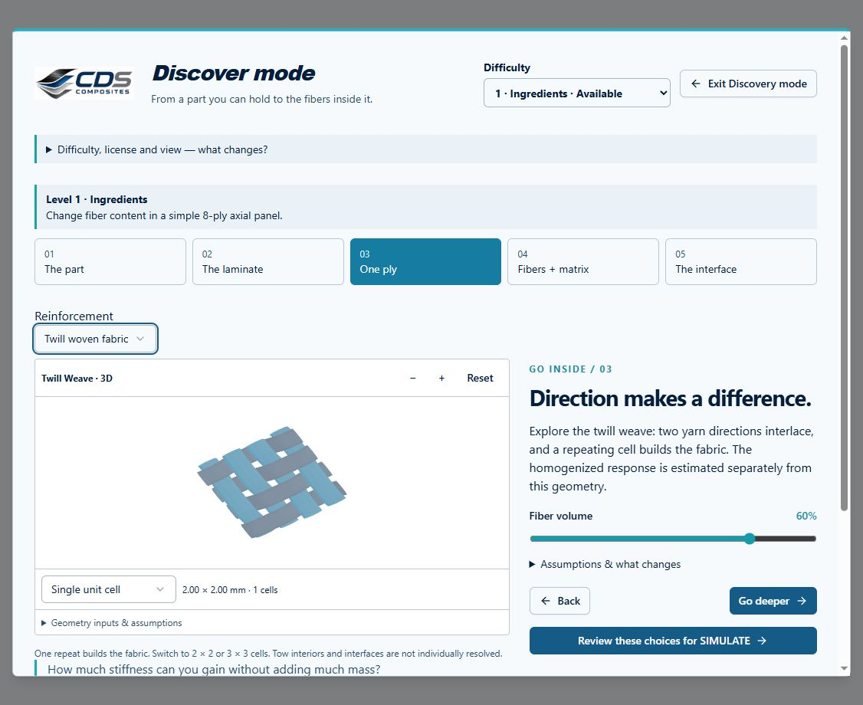
Woven fabric detail: rotate a cell or repeat it into a tiled patch. This local Workbench component capture shows illustrative yarn surfaces; missing dimensions are listed under Geometry inputs & assumptions. The same viewer is available in Micro and Live Stack. Open full size GUI capture · September 17, 2026 . Control locations may differ in later releases; not benchmark evidence.

Organize laminate families
Create virtual folders under Laminates to group conventional, Double-Double, program-specific, or qualification laminates. The protected Conventional Laminates folder remains available as a base family.
The Laminates branch organizes families; the selected laminate opens its ply table and LiveStack. Open full size GUI capture · September 10, 2026 . Control locations may differ in later releases; not benchmark evidence.

Use the compact laminate editor
The setup inputs and laminate status are condensed above the ply table. Select each lamina, set its angle with the −90° to +90° popup slider in 5° increments, and enter a thickness greater than zero. LiveStack defaults to angle coloring; switch to material coloring when checking sources.
Read each row across: source, material or solved lamina, angle, thickness and visibility. LiveStack shows the resulting sequence. Open full size GUI capture · September 10, 2026 . Control locations may differ in later releases; not benchmark evidence.
Good practice
A zero ply thickness is invalid and cannot be submitted to the solver.

Apply laminate relations
Apply Symmetry, Apply Balance, and Apply DD sit with their matching status indicators above the table. Each action updates the stack toward the indicated relation and becomes disabled when the current laminate already satisfies it or already matches the predicted DD stack.
Relation indicators and actions sit above the ply table. Review the updated stack after applying a relation. Open full size GUI capture · September 10, 2026 . Control locations may differ in later releases; not benchmark evidence.

Fill from the selected cell
In the single-laminate ply table, select or right-click the source cell. The row, column and cell highlight show the target. Fill entire column from ply copies that cell’s value to every ply in that column, including rows above the source.
- Check the source ply and column named in the menu or toolbar tooltip.
- Choose Fill only after confirming that every ply should receive that value.
- Review the full sequence and save only when intended. Invert and Symmetry act on their selected column too.
Good practice
The multi-laminate comparison table has a different orientation: rows are laminates and columns are ply positions. Its Fill column from first value acts across the selected laminates, not down the plies of one stack.

Start from common layups
Use the available templates for unidirectional, cross-ply, and quasi-isotropic stacks. When compatible, the editor can propose a stiffness-matched Double-Double candidate for comparison.
The layup preset selector is above the material column, beside the ply-count control. Open full size GUI capture · September 10, 2026 . Control locations may differ in later releases; not benchmark evidence.

Review effective properties
Lamina and laminate Results use Table, Ashby, Bar, and Line views. A single selection shows that record’s predicted property indicators. Multiple selections produce a table with properties as rows and selected laminas or laminates as columns.

Create a material from effective results
Open Create Material in a lamina or laminate result view, then choose the destination material class. The dialog proposes the source lamina or laminate name and lets you rename the new record.
- Choose the target class so its relevant property assumptions are available.
- Choose properties only or include source-identifying information.
- Leave unpredicted properties empty or fill them with the selected class assumptions, such as tension equals compression.
- Review the new material record before using it in another model.
Workbench availability: released models, inputs and compatible study paths . The wider theory library includes reference formulations not available in every Workbench solve.

6 Create and manage material records
Online chapter
A practical guide to adding, editing, organizing, duplicating, and safely deleting materials.
Current Workbench, reference editions and downloads
Use the online User Guide for current controls, the released model directory for selectable models and compatibility, and the Training Manual for connected exercises. Wider theory references do not mean every formulation is enabled in Workbench.
Dated GUI captures and compiled Web r18 PDF manuals retain their stated scope; they are not a substitute for current hosted Workbench instructions. Find the overview PDF, guides and exercise databases in Your CDS library .
All exercises, case studies and simulation examples → · Your CDS library: overview, manuals and database downloads →

Research and import materials with ChatGPT
In Workbench, choose Material → Find / Import with AI. This is a local review workflow, not an automatic web-search or PDF-extraction service inside CDS.
- Enter the grades or properties you need and copy the research prompt. Paste it into ChatGPT, using manufacturer datasheets or primary publications. Attach private documents there only if you intend to share them with that service.
- Download the JSON template if needed. Bring the structured JSON response back to Workbench through Choose research JSON or paste it and select Load JSON for review.
- Optionally attach up to three local PDF, PNG or JPEG datasheets for comparison. They are not uploaded or automatically extracted. A manual review card is available for direct entry.
- Review material identity, constitutive symmetry, original and converted units, each source document and page/table, and test conditions. Correct or deselect unsupported values. Keep different temperatures, cure states and product forms in separate records.
- Select the properties you verified. Conflicting values require choosing one per property. Unknown values are not converted to zero; estimated values require explicit opt-in.
- Choose an existing material folder or create an import class. Confirm the review acknowledgement, then import new records. Existing materials are never overwritten.
- Expand Imported property evidence in the material source panel to review original values and references. Later edits are marked as changed relative to the import snapshot. Save the workspace as CDS_DB to retain the new records.
Good practice
AI research and format validation do not establish qualified design allowables. Check every source before engineering use. Download a review draft before leaving if review is incomplete. Source files are not embedded in CDS_DB: retain originals separately; the import stores their filenames and SHA-256 fingerprints.

Add materials
Right-click Materials or an allowed material folder and choose Create. Enter a clear title and select the material class so the record appears in the correct virtual folder.
- Choose Fiber, Polymer, Metal, Elastomer, or Core & Filler.
- Enter source and identification details. See screenshot
- Populate the applicable property groups. See screenshot
- Save the new record and verify its folder classification. See screenshot
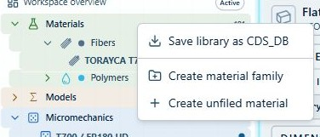
Right-click Materials to create a material family or an unfiled material. Open full size GUI capture · September 7, 2026 . Control locations may differ in later releases; not benchmark evidence.
Steps 2, 3, 4 · The material editor shows source provenance, property groups, units, locks and Save. Open full size GUI capture · September 10, 2026 . Control locations may differ in later releases; not benchmark evidence.
Good practice
Base material folders are protected. Create records inside them; do not try to replace the folders.

Edit property values
The material editor uses compact rows for variable ID, descriptor, value, units, and lock state. Hover over truncated descriptors for the full meaning.
- Click the lock to enable editing. See screenshot
- Enter numeric values only in numeric fields. See screenshot
- Confirm units before leaving the row. See screenshot
- Use the value slider for bounded adjustments. See screenshot
- Right-click a value to set lower bound, upper bound, default, and increment jump.
Steps 1, 2, 3, 4 · Use the lock column, numeric values and units in the property table. Show zero terms reveals additional stored inputs. Open full size GUI capture · September 10, 2026 . Control locations may differ in later releases; not benchmark evidence.
Good practice
Bounds and increments will later support optimization and parametric studies, so choose physically defensible values.

Move and organize materials
Create virtual folders to match suppliers, programs, material families, or qualification status. Moving a material changes its working classification for later selection filters.
- Create a virtual folder under Materials. See screenshot
- Right-click a record and choose Move to folder.
- Confirm the destination.
- Use the material-folder filter to verify the new organization.
Steps 1 · Create a material family from the Materials context menu before organizing records into it. Open full size GUI capture · September 7, 2026 . Control locations may differ in later releases; not benchmark evidence.

Duplicate and delete records
Duplicate is the safest starting point for a related material. Delete removes an eligible user record only after dependency review.
- Right-click the record. See screenshot
- Choose Duplicate and immediately rename the copy. See screenshot
- For deletion, review every downstream lamina, laminate, or simulation dependency shown in the warning.
- Cancel if the record is still required; otherwise confirm deletion.
Steps 1, 2 · Right-click the exact material to find Duplicate, Move and Delete. Opening this menu does not alter the record; review dependencies before confirming deletion. Open full size GUI capture · September 7, 2026 . Control locations may differ in later releases; not benchmark evidence.
Good practice
Protected base folders and critical system records cannot be deleted.

Use right-click options
Context menus provide the same record actions available through Project Manager: create, duplicate, rename, move, save, export, and delete. Parent-level actions apply to the selected subtree where supported.
- Right-click the exact record or parent folder you intend to affect. See screenshot
- Read the scope shown in the menu. See screenshot
- Use Save Data or local database export when a portable copy is needed. See screenshot
- Check dependency warnings before destructive actions.
Steps 1, 2, 3 · The menu title and actions depend on the selected scope. This example is the whole Materials library. Open full size GUI capture · September 7, 2026 . Control locations may differ in later releases; not benchmark evidence.
Workbench availability: released models, inputs and compatible study paths . The wider theory library includes reference formulations not available in every Workbench solve.

7 Prepare visualize optimize and run analysis cases
Online chapter
Define connected process and structural inputs, include cure-aware physics, optimize cycles, verify loads graphically, run the solver, and review result provenance.
Current Workbench, reference editions and downloads
Use the online User Guide for current controls, the released model directory for selectable models and compatibility, and the Training Manual for connected exercises. Wider theory references do not mean every formulation is enabled in Workbench.
Dated GUI captures and compiled Web r18 PDF manuals retain their stated scope; they are not a substitute for current hosted Workbench instructions. Find the overview PDF, guides and exercise databases in Your CDS library .
Read time and travel distance
Boundary peak: 120 °C
Pull speed: 10 mm/min
Time cursor: 30 min
Show length instead of time
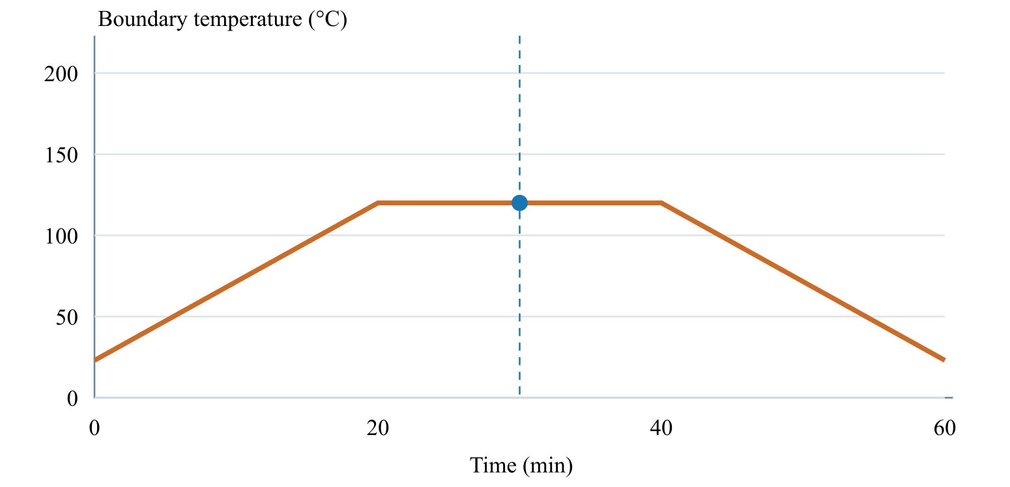
Cursor: 30 min · 300 mm · 120.0 °C
All exercises, case studies and simulation examples → · Your CDS library: overview, manuals and database downloads →

Choose the run in the SIMULATION block
SIMULATION is the control point for the run. Select a Thermal case, Moisture case, Mechanical case and EM case, or None in any slot. Each selected case shows its analysis model, laminate and applicable geometry.
- Keep candidate records in the surrounding blocks. Adding a candidate does not select it for execution.
- Select the required cases in SIMULATION and review their inputs before Run. At least one case is required.
- Use the same laminate for a supported combined run. Run standalone studies separately with the other selectors set to None.
- Run executes the selected combination. A connection or Used marker is not evidence of a successful solve.
Good practice
Selecting several cases does not add unsupported physics coupling. EM screening studies do not automatically heat the thermal case.

Review every downstream geometry dependency
A geometry record can be shared by several cases and simulations. Editing its dimensions or type affects all linked consumers, including studies that are not currently open. Unrelated records are unchanged.
- After editing geometry, open Solver messages and expand Review affected cases and simulations. Select a linked name to inspect that record.
- Check the selected model, load basis, dimensions and boundary conditions. Loads are not automatically replaced when the geometry changes.
- Resolve incompatible geometry and model combinations before running. An I-section does not turn a plate theory into a beam theory.
- Rerun affected simulations before relying on previous results. Inputs changed warnings indicate that stored results no longer match their connected inputs.
Good practice
Geometry affects only dimensions consumed by the selected model. One-dimensional transport retains its through-thickness assumptions; standalone studies may own their dimensions. Under fixed total edge loads, changing plate width changes force per unit width. Under prescribed resultants, it does not.

Read the blue Used marker
Connected, available record selections have a soft blue glow and a Used marker in the corner. Hover or focus the marker to see which downstream record and field uses that input.
- Check the marker before editing a shared input: more than one case can consume it.
- A Used marker means connected, not solved or validated. Review solver status and outdated-result warnings separately.
- Missing or incompatible selections need repair; do not interpret an empty result as zero response.

Add replace or disconnect a block input
The + control adds another available record to a block, excluding records already present. Use that record row dropdown to change the candidate, its link to open it, and − to remove it from the block. Library records are not deleted.
- Choose + and search for a compatible candidate not already in the block. Decide what actually runs with the four selectors in SIMULATION.
- If no compatible record exists, create one in Inputs. Each case owns its analysis model and applicable cycle. There is no separate Process block to connect.
- A used input must first be disconnected or changed at its consuming field. Review downstream warnings before confirming a removal; cancel to keep it.
- After removal, required missing inputs remain flagged and their selectors allow reconnection. Optional cases may stay disconnected. Rerun affected analyses before relying on their results.
Good practice
Disconnecting a shared laminate input may affect several cases. Removing a ply-source connection preserves the other ply sources, angles and thicknesses; it does not delete the ply stack.

Create a case with its own cycle
Choose a Thermal, Moisture, Mechanical or EM case. Each case selects one analysis model and owns its applicable conditions and cycle. There is no separate Process block.
Earlier cycle editor shown for reference. In the current interface, open the Thermal case and edit its own Initial conditions, Upper and Lower tabs; no separate Process record is needed. Open full size GUI capture · September 7, 2026 . Control locations may differ in later releases; not benchmark evidence.

Edit the cycle inside the case
In a thermal case, use Initial conditions for analysis setup and the Upper and Lower tabs for independent surface schedules. Set each surface condition and film coefficient in this case. Moisture and mechanical schedules belong to their own cases and do not share the thermal cycle.
- Enter monotonically increasing time values. See screenshot
- Enter temperature and pressure for each step. See screenshot
- Set upper and lower boundary types and values. See screenshot
- Inspect the plot beside the table for discontinuities or unit errors. See screenshot
Steps 1, 2, 3, 4 · Enter time, temperature, boundary condition and shared pressure by row. Switch Upper/Lower Boundary for the second surface; compare both temperature curves on the right. Open full size GUI capture · September 7, 2026 . Control locations may differ in later releases; not benchmark evidence.

Assemble a simulation input record
In SIMULATION select Thermal, Moisture, Mechanical and EM cases, each with None available. The other blocks hold used and available records. Check the model, laminate and applicable geometry beneath each selected case.
Simulation combines the earlier Solve and Summary views; this capture shows the linked laminate, geometry, process cycle and coupled analysis selectors. Review every required reference; a blank selector is not a completed connection. Open full size GUI capture · September 7, 2026 . Control locations may differ in later releases; not benchmark evidence.

Review the LiveLoad schematic
The LiveLoad block appears beside Loads and Thermal inputs for analysis cases. Its plate, cylinder, or thermal schematic updates with the selected geometry, boundary conditions, loads, and directions. A zero-valued load vector is greyed so active loading is immediately recognizable.

Run the model
Resolve missing selections, invalid numbers, broken references, invalid ply angles, and zero laminate thickness before choosing Run. Use the Simulation workflow for a final dependency and model check.
- Confirm the LiveLoad schematic matches the intended model.
- Keep the desired Results tab selected. See screenshot
- Choose Run when required; the interface preserves that tab while the model executes. See screenshot
- Review result values, freshness and solver messages.
Steps 2, 3 · Check the simulation references in Simulation (shown as Solve in this capture), select the intended output tab below, then use Run at the right. Open full size GUI capture · September 7, 2026 . Control locations may differ in later releases; not benchmark evidence.

Understand solver provenance
Workbench uses its embedded production solver when no external solver endpoint is configured. When an external endpoint is configured, a timeout, rejected request or incompatible response is reported as an error; it is not silently replaced by a successful fallback result.
Good practice
Keep run context, inputs and solver messages with exported evidence. The compiled Web r18 integration manuals describe a separate deployment contract, not every hosted Workbench calculation.

Check thermal setup and accuracy
A thermal result needs a compatible thermal case model, linked laminate, transport properties, initial conditions and its embedded cycle where required by that model. Missing setup is not a zero-temperature result.
- Follow the missing-setup message to the linked source record rather than interpreting an empty plot.
- After upstream edits, rerun before using a saved temperature, cure or moisture history.
- Refine through-thickness resolution and review temperature gradients and numerical diagnostics.
- Output spacing controls saved samples; it is not the integration accuracy target. The transient solver checks full-step/two-half-step agreement.
Good practice
A visually smooth temperature field is not evidence of convergence. An accuracy or integration failure must be resolved before relying on coupled results.

Include cure exotherm and evolving modulus
Transient thermal analysis can include the heat released by cure. The selected cure-dependent modulus model then changes the stiffness used to develop process stress as degree of cure evolves.
- Assign a cure-kinetics model, total heat of reaction, density and heat capacity to the material or ply.
- Enable cure exotherm when the thermal solution should include reaction heat; leave it off for externally imposed thermal histories that intentionally exclude self-heating. See screenshot
- Assign the cure-dependent modulus model and review its editable transition, rubbery/glassy modulus and shape parameters.
- Rerun after changing kinetics, transport, cure heat, modulus evolution or shrinkage. These inputs affect later residual-stress and failure results.
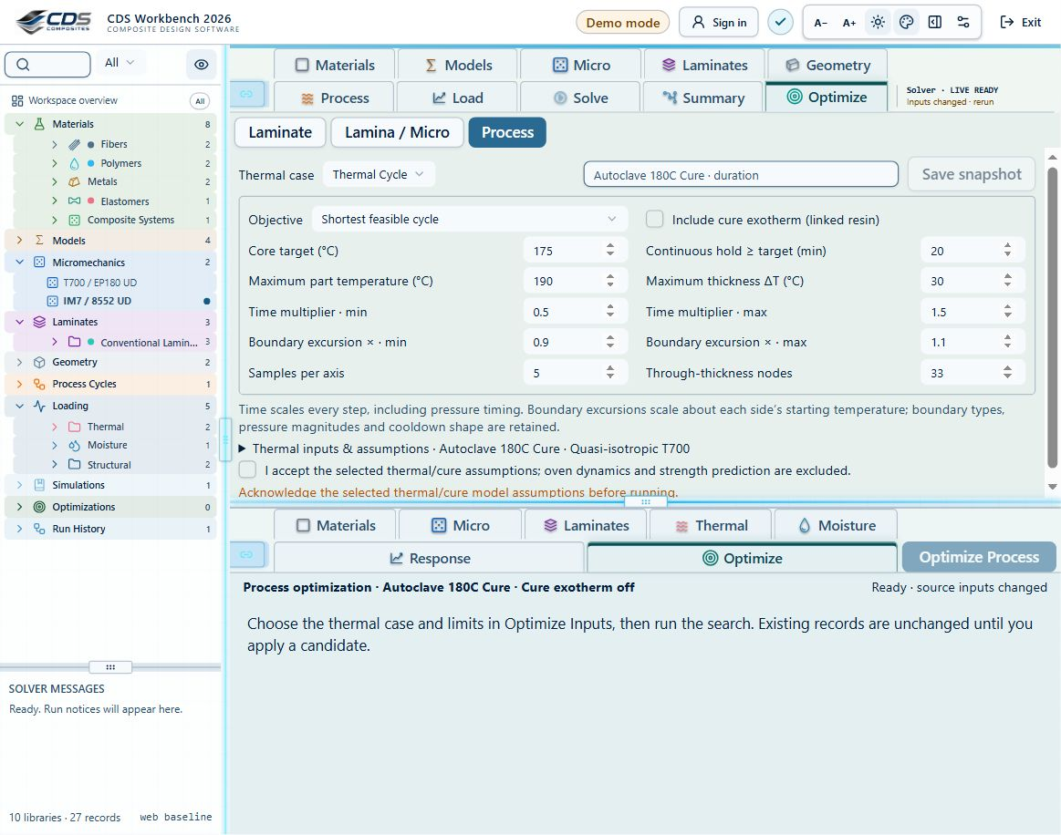
Steps 2 · Include cure exotherm is an explicit option in Process optimization. It uses the linked resin; it does not supply missing kinetics or heat-of-reaction data. Open full size GUI capture · September 7, 2026 . Control locations may differ in later releases; not benchmark evidence.
Good practice
Steady-state conduction can solve a final temperature field, but cure evolution, exotherm and time-dependent stress development require a transient history.

Optimize an oven or process cycle
Process optimization varies selected surface-cycle controls to meet a target core temperature or cure state while reducing time, overshoot or other configured penalties.
- Choose Process in Optimize Inputs and select the thermal case and its laminate. Review the cycle owned by that case. See screenshot
- Choose a target such as core temperature, degree of cure, maximum temperature difference, overshoot or total cycle time. See screenshot
- Select the editable boundary variables—surface temperatures, ramp rates, dwell temperatures or dwell durations—and define bounds and constraints. See screenshot
- Choose steady-state only for equilibrium targets. Use transient mode for ramps, dwells, core lag, cure exotherm, evolving modulus and stress development.
- Run the bounded search, inspect feasibility and convergence, save a snapshot, then apply the candidate to the case-owned cycle and review the resulting case.
- Rerun the full coupled simulation before accepting residual stress, distortion or failure results from the optimized cycle.
Steps 1, 2, 3 · Choose Process in Optimize, select the thermal case, then set the core target, hold time, temperature limits and bounded time/boundary multipliers. Review assumptions before running. Open full size GUI capture · September 7, 2026 . Control locations may differ in later releases; not benchmark evidence.
Good practice
The optimizer is only as physical as the linked conductivity, density, heat capacity, convection, kinetics and cure-heat data. Missing transport data must be supplied or explicitly represented by visible editable fallback inputs.
Workbench availability: released models, inputs and compatible study paths . The wider theory library includes reference formulations not available in every Workbench solve.

8 Get started with the CDS Workbench
Online chapter
A short path from sign-in and a safe first edit to a verified solver run.
Current Workbench, reference editions and downloads
Use the online User Guide for current controls, the released model directory for selectable models and compatibility, and the Training Manual for connected exercises. Wider theory references do not mean every formulation is enabled in Workbench.
Dated GUI captures and compiled Web r18 PDF manuals retain their stated scope; they are not a substitute for current hosted Workbench instructions. Find the overview PDF, guides and exercise databases in Your CDS library .
Trace the selected input path
Ply property source
Include thermal analysis
Include moisture analysis
Include optional fatigue assessment
Stored ply properties bypass Micro. Mixed stacks keep both paths. Gray blocks are not selected. Geometry, process schedules and other model records are omitted here for clarity; a real run must include all required references.
Fatigue uses intact CLT endpoint stresses and measured S–N calibration. It is evaluated separately from Run and progressive failure. The dashed handoff is not active: optimization still uses current properties until a degradation law is supplied.
Materials → Micro → Laminate.
All exercises, case studies and simulation examples → · Your CDS library: overview, manuals and database downloads →

Open the Workbench
Register and verify your CDS account, then sign in and choose SIMULATE to launch Workbench. Account registration is required, including for the 30-day demo. Your active license determines permitted modules and models.
- Confirm the correct account is signed in.
- Choose a starter exercise or open your saved CDS database. Save current work before replacing the workspace.
- Use CREATE for a guided starting design, DISCOVER for exploration, or SIMULATE for the standard workspace.

Understand the workspace
The compact project tree is on the left, the selected record editor occupies the main workspace, and the result summary remains visually separate. Single-click selects a record; use its chevron or double-click the row to open children.
Navigate in the left tree, edit the selected record above, and review outputs below. Open full size GUI capture · September 10, 2026 . Control locations may differ in later releases; not benchmark evidence.
Good practice
Use Materials, Micro, Laminates and Geometry to prepare inputs. Thermal, Moisture, Mechanical and EM CASES own their models and cycles. Choose the run combination in the SIMULATION block.

Make your first edit
Duplicate a teaching record, unlock one property, enter a valid numeric value, confirm its units, and lock it again.
- Select the record. See screenshot
- Find the property by its name and description. See screenshot
- Unlock the row, edit the value, then lock it. See screenshot
- Save the record and keep a dependency-complete CDS database checkpoint.
Steps 1, 2, 3 · Find the variable, confirm its units, then use the row lock and numeric value. Save is at the top right. Open full size GUI capture · September 10, 2026 . Control locations may differ in later releases; not benchmark evidence.

Run and review a case
Select a simulation and inspect its connected inputs and model choices in the Simulation workflow. Eligible quick studies refresh after editing pauses; longer calculations require Run.
- Resolve missing setup, invalid inputs and incompatible model selections. See screenshot
- Check geometry, boundary conditions and loading in LiveLoad.
- Choose Run when required and wait for completion. See screenshot
- Review the relevant output and its freshness, units, assumptions and convergence.
Steps 1, 3 · Review the linked records in Simulation (shown as Solve in this capture) and use Run on the output toolbar. Open full size GUI capture · September 7, 2026 . Control locations may differ in later releases; not benchmark evidence.
Good practice
A completed calculation is not a design pass. Changing upstream inputs can make saved results outdated; navigation, animated arrows and old plots do not confirm a new solve.

Find the manuals and exercise databases
Open Your account → Your CDS library for the current overview PDF, User Guide, Theory Manual and complete exercise collection. Read the exercise instructions and two-layer workflow before opening its database.
Good practice
An active license is required for database downloads. Teaching inputs are not certified design allowables; models still require the appropriate permissions.
Workbench availability: released models, inputs and compatible study paths . The wider theory library includes reference formulations not available in every Workbench solve.

9 Exercise validation study evidence not blanket passes
Online chapter
Comparison values are rounded for readability. The linked validation evidence retains full-precision values, exact input records and reproducibility identifiers.
Recorded production-solver comparisons against published equations and source-matched public calculations.
Current Workbench, reference editions and downloads
Use the online User Guide for current controls, the released model directory for selectable models and compatibility, and the Training Manual for connected exercises. Wider theory references do not mean every formulation is enabled in Workbench.
Dated GUI captures and compiled Web r18 PDF manuals retain their stated scope; they are not a substitute for current hosted Workbench instructions. Find the overview PDF, guides and exercise databases in Your CDS library .

Study 2026-09-18
104 of 104 exercise baselines executed. 39 passed scoped analytical comparisons; 0 have benchmark discrepancies; 65 have no completed quantitative benchmark; 0 failed execution.
No exercise has experimental validation from this study. A successful run, supplier property or similar-looking plot is not validation. Badges apply only to the listed outputs, recorded inputs and solver revision. Edited inputs and new solver revisions require revalidation.

Case combination regression checks
On 18 September 2026, 52,416 discrete catalog case-selector combinations, including None, were checked against selection compatibility rules: 406 were accepted and 52,010 rejected. These are selection checks, not numerical solutions of every combination. All seven nonempty thermal, moisture and mechanical subsets of the T700 starter executed successfully. Geometry dependency, model-pairing and stale-result checks also passed. This does not validate every material, geometry, load magnitude or coupled physical response.

Method and acceptance
Production solver executed on immutable copies of every exercise. Independent published-equation references use exact baseline inputs where eligible. Scoped analytical badges are not experimental validation, strength approval or validation of edited inputs. Full coupled studies remain unvalidated until matched external evidence and convergence studies exist. Tolerances were declared before numerical comparisons: analytical constants 0.01% + 0.00002 units; beam/strain 0.05% + absolute allowance; rounded NASA table values 1% + 0.00002.
Each evidence panel states its quantities, predeclared tolerances and sources. Independent laminate references use strain/stress coordinate transformations and thickness integration, not production stiffness helpers. Separate NASA fixtures use the report's numerical inputs; they do not confer validation on the unmatched exercise starter.

Findings and outstanding work
- The recorded thin-wall pressure cases pass scoped equilibrium and orthotropic biaxial strain comparisons, including Poisson coupling. This is not a blanket validation of every pressure-vessel exercise or of unverified micromechanics inputs; use each evidence panel for its tested scope.
- The NASA tube fixture matches three published calculated stiffness properties within 1%. This is not an experimental strength or failure validation.
- NASA MAC/GMC micro-property comparisons do not all match the CDS ROM/Halpin–Tsai models. Different model formulations and their discrepancies are retained, not hidden.
- Coupled cure, UV, pultrusion, moisture, sandwich/bonding and progressive delamination require matched constitutive data, boundary conditions, field measurements and convergence studies before a full coupled validation claim.
Download complete reproducible comparison evidence (JSON) · Search exercise tree
Hybrid short fibers: orientation and volume balance — Not benchmark validated

Reference validation 2026-09-18
Not benchmark validated
No matched quantitative reference comparison completed for the full exercise.
Recorded baseline only—not a certification of the current database, edited inputs, or every output. Analytical agreement is not experimental material or failure validation.
Source validation, comparisons and tested inputs
Execution: Completed (not validation)
Architecture needs a separate benchmark

Tested inputs
- Prescribed orientation, common filament dimensions and resin. Voigt stiffness averaging; not a manufacturing orientation prediction or progressive failure model. Thermal transport retains aligned closure assumptions.
Download source-validation evidence (JSON) · Full 104 -exercise study
Short fibers: aspect ratio and shear-lag transfer — Not benchmark validated

Reference validation 2026-09-18
Not benchmark validated
No matched quantitative reference comparison completed for the full exercise.
Recorded baseline only—not a certification of the current database, edited inputs, or every output. Analytical agreement is not experimental material or failure validation.
Source validation, comparisons and tested inputs
Execution: Completed (not validation)
Architecture needs a separate benchmark

Tested inputs
- Aligned monodisperse elastic fibers, perfect interface and concentric-cell shear lag. Halpin–Tsai transverse/shear screening closure. Existing constituent data are reused; the short-fiber composite and its strength allowables are a hypothetical teaching system.
Download source-validation evidence (JSON) · Full 104 -exercise study
Rule of mixtures: fibre volume fraction — Benchmark validated — analytical scope

Reference validation 2026-09-18
Benchmark validated — analytical scope
Listed reference-elastic extensional constants only; free curvature, ply stresses, strength and every user variation are outside this badge.
Recorded baseline only—not a certification of the current database, edited inputs, or every output. Analytical agreement is not experimental material or failure validation.
Source validation, comparisons and tested inputs
Execution: Completed (not validation)
Quantity | CDS | Reference | Error % | Tolerance (relative + absolute) | Result
Ex ( GPa ) | 51.01956 | 51.01956 | 1.71373e-06 | 0.01 % + 0.00002 GPa | Pass
Ey ( GPa ) | 51.01956 | 51.01956 | 1.71373e-06 | 0.01 % + 0.00002 GPa | Pass
Gxy ( GPa ) | 19.35659 | 19.35659 | -2.84568e-06 | 0.01 % + 0.00002 GPa | Pass
νxy ( — ) | 0.31789 | 0.317886 | 0.00126045 | 0.01 % + 0.00002 — | Pass
Micro E1 ( GPa ) | 139.38 | 139.38 | 0 | 0.01 % + 0.00002 GPa | Pass
Micro E2 ( GPa ) | 6.41264 | 6.412639 | 9.27536e-06 | 0.01 % + 0.00002 GPa | Pass
Micro G12 ( GPa ) | 2.98755 | 2.987552 | -0.0000625 | 0.01 % + 0.00002 GPa | Pass
Micro ν12 ( — ) | 0.26 | 0.26 | 0 | 0.01 % + 0.00002 — | Pass

- MIT / David Roylance — Laminated Composite Plates Transformed plane-stress constitutive law and laminate extensional stiffness, equations 10–11 and 20–25 . Independent strain/stress transformation and thickness integration; prescribed input elasticity is not validated.
- MIT / David Roylance — Introduction to Composites Equations 1–3, printed pages 3–4 . Published analytical equations; not experimental material validation.

Tested inputs
Reference ply list (GPa, mm, degrees)
Exact numerical inputs are retained in the linked validation evidence.
- Ideal continuous, aligned reinforcement with zero voids. This is a teaching comparison, not a measured material allowable.
Download source-validation evidence (JSON) · Full 104 -exercise study
Compare transverse micromechanics models — Not benchmark validated

Reference validation 2026-09-18
Not benchmark validated
No matched quantitative reference comparison completed for the full exercise.
Recorded baseline only—not a certification of the current database, edited inputs, or every output. Analytical agreement is not experimental material or failure validation.
Source validation, comparisons and tested inputs
Execution: Completed (not validation)
Nonzero-void closure has no matched published calibration in this study

Tested inputs
- Use the editable model inputs and their documented assumptions; matching a trend does not validate a strength prediction.
Download source-validation evidence (JSON) · Full 104 -exercise study
Laminate orientation and tensile response — Benchmark validated — analytical scope

Reference validation 2026-09-18
Benchmark validated — analytical scope
Listed reference-elastic extensional constants only; free curvature, ply stresses, strength and every user variation are outside this badge.
Recorded baseline only—not a certification of the current database, edited inputs, or every output. Analytical agreement is not experimental material or failure validation.
Source validation, comparisons and tested inputs
Execution: Completed (not validation)
Quantity | CDS | Reference | Error % | Tolerance (relative + absolute) | Result
Ex ( GPa ) | 51.92147 | 51.92147 | -7.45556e-06 | 0.01 % + 0.00002 GPa | Pass
Ey ( GPa ) | 51.92147 | 51.92147 | -7.45556e-06 | 0.01 % + 0.00002 GPa | Pass
Gxy ( GPa ) | 19.81407 | 19.81407 | 1.95976e-05 | 0.01 % + 0.00002 GPa | Pass
νxy ( — ) | 0.31022 | 0.3102175 | 0.000793473 | 0.01 % + 0.00002 — | Pass

- MIT / David Roylance — Laminated Composite Plates Transformed plane-stress constitutive law and laminate extensional stiffness, equations 10–11 and 20–25 . Independent strain/stress transformation and thickness integration; prescribed input elasticity is not validated.

Tested inputs
Reference ply list (GPa, mm, degrees)
Exact numerical inputs are retained in the linked validation evidence.
- ASTM-based teaching geometry, not certification. Grips, tabs, alignment and physical test validity are not simulated.
Download source-validation evidence (JSON) · Full 104 -exercise study
±45° coupon: in-plane shear — Benchmark validated — analytical scope

Reference validation 2026-09-18
Benchmark validated — analytical scope
Listed reference-elastic extensional constants only; free curvature, ply stresses, strength and every user variation are outside this badge.
Recorded baseline only—not a certification of the current database, edited inputs, or every output. Analytical agreement is not experimental material or failure validation.
Source validation, comparisons and tested inputs
Execution: Completed (not validation)
Quantity | CDS | Reference | Error % | Tolerance (relative + absolute) | Result
Ex ( GPa ) | 17.02827 | 17.02827 | 2.7757e-05 | 0.01 % + 0.00002 GPa | Pass
Ey ( GPa ) | 17.02827 | 17.02827 | 2.7757e-05 | 0.01 % + 0.00002 GPa | Pass
Gxy ( GPa ) | 34.82813 | 34.82813 | -6.41391e-06 | 0.01 % + 0.00002 GPa | Pass
νxy ( — ) | 0.77378 | 0.7737776 | 0.000305947 | 0.01 % + 0.00002 — | Pass

- MIT / David Roylance — Laminated Composite Plates Transformed plane-stress constitutive law and laminate extensional stiffness, equations 10–11 and 20–25 . Independent strain/stress transformation and thickness integration; prescribed input elasticity is not validated.

Tested inputs
Reference ply list (GPa, mm, degrees)
Exact numerical inputs are retained in the linked validation evidence.
- Small-strain elastic teaching model; fibre rotation and nonlinear termination rules are not represented.
Download source-validation evidence (JSON) · Full 104 -exercise study
Three-point bending: span and stiffness — Benchmark validated — analytical scope

Reference validation 2026-09-18
Benchmark validated — analytical scope
Central-load beam deflection and shear, conditional on the reported effective Ex. Material elasticity, ply stress and failure not validated.
Recorded baseline only—not a certification of the current database, edited inputs, or every output. Analytical agreement is not experimental material or failure validation.
Source validation, comparisons and tested inputs
Execution: Completed (not validation)
Quantity | CDS | Reference | Error % | Tolerance (relative + absolute) | Result
Ex ( GPa ) | 51.92147 | 51.92147 | -7.45556e-06 | 0.01 % + 0.00002 GPa | Pass
Ey ( GPa ) | 51.92147 | 51.92147 | -7.45556e-06 | 0.01 % + 0.00002 GPa | Pass
Gxy ( GPa ) | 19.81407 | 19.81407 | 1.95976e-05 | 0.01 % + 0.00002 GPa | Pass
νxy ( — ) | 0.31022 | 0.3102175 | 0.000793473 | 0.01 % + 0.00002 — | Pass
Maximum deflection ( mm ) | 1.213667 | 1.213667 | 7.45556e-06 | 0.05 % + 0.00002 mm | Pass
Maximum shear ( N ) | 50 | 50 | 0 | 0.01 % + 0.00002 N | Pass

- MIT / David Roylance — Laminated Composite Plates Transformed plane-stress constitutive law and laminate extensional stiffness, equations 10–11 and 20–25 . Independent strain/stress transformation and thickness integration; prescribed input elasticity is not validated.
- MIT / David Roylance — Beam Displacements Equation 7, printed page 3: central-load simply supported beam . Euler–Bernoulli analytical check; excludes shear, contact, damage and empirical stiffness validation.

Tested inputs
Reference ply list (GPa, mm, degrees)
Exact numerical inputs are retained in the linked validation evidence.
Beam benchmark inputs
Exact numerical inputs are retained in the linked validation evidence.
- Procedure A teaching setup. Transverse shear deformation, roller contact and indentation are excluded.
Download source-validation evidence (JSON) · Full 104 -exercise study
Thin-wall pressure vessel — Benchmark validated — analytical scope

Reference validation 2026-09-18
Benchmark validated — analytical scope
Thin-wall pressure equilibrium and orthotropic biaxial strain comparison; stiffness inputs are conditional where Micro closure has not been verified.
Recorded baseline only—not a certification of the current database, edited inputs, or every output. Analytical agreement is not experimental material or failure validation.
Source validation, comparisons and tested inputs
Execution: Completed (not validation)
Nonzero-void closure has no matched published calibration in this study
Quantity | CDS | Reference | Error % | Tolerance (relative + absolute) | Result
Hoop stress ( MPa ) | 56.4 | 56.4 | 0 | 0.01 % + 0.00002 MPa | Pass
Axial stress ( MPa ) | 28.2 | 28.2 | 0 | 0.01 % + 0.00002 MPa | Pass
Hoop strain including Poisson coupling ( µε ) | 755.3712 | 755.3698 | 0.000182403 | 0.05 % + 0.01 µε | Pass
Axial strain including Poisson coupling ( µε ) | 246.3161 | 246.3132 | 0.00114902 | 0.05 % + 0.01 µε | Pass

- MIT / David Roylance — Pressure Vessels Equations 2–3, printed page 3; orthotropic strain compliance from laminated plates reference . Thin-wall, closed-end pristine cylinder. No slit, fracture or failure-pressure validation.
- MIT / David Roylance — Laminated Composite Plates Transformed plane-stress constitutive law and laminate extensional stiffness, equations 10–11 and 20–25 . Independent strain/stress transformation and thickness integration; prescribed input elasticity is not validated.

Tested inputs
Pressure reference inputs
Exact numerical inputs are retained in the linked validation evidence.
- Thin-wall membrane theory: no through-wall radial stress profile or local end effects.
Download source-validation evidence (JSON) · Full 104 -exercise study
Thermal cycle: surface-to-core lag — Not benchmark validated

Reference validation 2026-09-18
Not benchmark validated
No matched quantitative reference comparison completed for the full exercise.
Recorded baseline only—not a certification of the current database, edited inputs, or every output. Analytical agreement is not experimental material or failure validation.
Source validation, comparisons and tested inputs
Execution: Completed (not validation)
A coupled, damage, transport or local-field comparison needs matched constitutive data, boundary conditions and field/mesh convergence. Execution alone is insufficient.

Tested inputs
- One-dimensional through-thickness transport; lateral heat loss and oven airflow are not resolved. Inspect linked cure settings before interpreting reaction heating.
Download source-validation evidence (JSON) · Full 104 -exercise study
Moisture conditioning and diffusion — Not benchmark validated

Reference validation 2026-09-18
Not benchmark validated
No matched quantitative reference comparison completed for the full exercise.
Recorded baseline only—not a certification of the current database, edited inputs, or every output. Analytical agreement is not experimental material or failure validation.
Source validation, comparisons and tested inputs
Execution: Completed (not validation)
A coupled, damage, transport or local-field comparison needs matched constitutive data, boundary conditions and field/mesh convergence. Execution alone is insufficient.

Tested inputs
- One-dimensional Fickian transport with the selected constitutive inputs, not a prediction of chemical degradation.
Download source-validation evidence (JSON) · Full 104 -exercise study
Bonded joint: two adherends and adhesive — Not benchmark validated

Reference validation 2026-09-18
Not benchmark validated
No matched quantitative reference comparison completed for the full exercise.
Recorded baseline only—not a certification of the current database, edited inputs, or every output. Analytical agreement is not experimental material or failure validation.
Source validation, comparisons and tested inputs
Execution: Completed (not validation)
A coupled, damage, transport or local-field comparison needs matched constitutive data, boundary conditions and field/mesh convergence. Execution alone is insufficient.

Tested inputs
- Perfectly bonded linear-elastic interfaces. Mesh-sensitive edge peaks are not joint strength, debonding or damage predictions.
Download source-validation evidence (JSON) · Full 104 -exercise study
Coupled cure, thermal, moisture and structural response — Not benchmark validated

Reference validation 2026-09-18
Not benchmark validated
No matched quantitative reference comparison completed for the full exercise.
Recorded baseline only—not a certification of the current database, edited inputs, or every output. Analytical agreement is not experimental material or failure validation.
Source validation, comparisons and tested inputs
Execution: Completed (not validation)
A coupled, damage, transport or local-field comparison needs matched constitutive data, boundary conditions and field/mesh convergence. Execution alone is insufficient.

Tested inputs
- Use the solver’s reported coupling state and limits. Do not assume this constitutes a general 3D coupled finite-element model or a calibrated cure-residual-stress prediction.
Download source-validation evidence (JSON) · Full 104 -exercise study
NASA · T700/PR520 lamina analysis — Not benchmark validated

Reference validation 2026-09-18
Not benchmark validated
No matched quantitative reference comparison completed for the full exercise.
Recorded baseline only—not a certification of the current database, edited inputs, or every output. Analytical agreement is not experimental material or failure validation.
Source validation, comparisons and tested inputs
Execution: Completed (not validation)
The copied T700/EP180 database is a connected starter, not T700/PR520. Complete the constituent setup below before comparing with NASA.
- NASA/TM—2015-218814 — Experimental and Numerical Analysis of Triaxially Braided Composites Utilizing a Modified Subcell Modeling Approach Tables 3–4, printed page 7 / PDF page 11 . MAC/GMC calculated effective ply data, not measured UD coupon properties.

Tested inputs
- Constituent-to-lamina screening only. The NASA braid subcells, calibrated LS-DYNA damage and coupon validation are not reproduced.
Separate published-data fixture: Benchmark discrepancy
Source-matched constituent fixture compared with NASA MAC/GMC, 1% exploratory equivalence criterion declared before running. A different homogenization model need not match; mismatch is retained, not fitted away.
Quantity | CDS | Reference | Error % | Tolerance (relative + absolute) | Result
E1 at Vf=0.375 ( GPa ) | 88.75 | 88.5 | 0.2824859 | 1 % + 0.00002 GPa | Pass
E2 at Vf=0.375 ( GPa ) | 5.51724 | 6.22 | -11.29839 | 1 % + 0.00002 GPa | Discrepancy
G12 at Vf=0.375 ( GPa ) | 2.23256 | 2.6 | -14.13231 | 1 % + 0.00002 GPa | Discrepancy
E1 at Vf=0.733 ( GPa ) | 169.658 | 169.5 | 0.09321534 | 1 % + 0.00002 GPa | Pass
E2 at Vf=0.733 ( GPa ) | 8.64927 | 9.9 | -12.63364 | 1 % + 0.00002 GPa | Discrepancy
G12 at Vf=0.733 ( GPa ) | 4.70445 | 7 | -32.79357 | 1 % + 0.00002 GPa | Discrepancy
E1 at Vf=0.8 ( GPa ) | 184.8 | 184.7 | 0.05414185 | 1 % + 0.00002 GPa | Pass
E2 at Vf=0.8 ( GPa ) | 9.67742 | 10.9 | -11.21633 | 1 % + 0.00002 GPa | Discrepancy
G12 at Vf=0.8 ( GPa ) | 5.93407 | 6 | -1.098833 | 1 % + 0.00002 GPa | Discrepancy

- NASA/TM—2015-218814 — Experimental and Numerical Analysis of Triaxially Braided Composites Utilizing a Modified Subcell Modeling Approach Tables 3–4, printed page 7 / PDF page 11 . MAC/GMC calculated effective ply data, not measured UD coupon properties.
Fixture inputs
Exact numerical inputs are retained in the linked validation evidence.
Separate published-data fixture: Benchmark discrepancy
Source-matched constituent fixture compared with NASA MAC/GMC, 1% exploratory equivalence criterion declared before running. A different homogenization model need not match; mismatch is retained, not fitted away.
Quantity | CDS | Reference | Error % | Tolerance (relative + absolute) | Result
E1 at Vf=0.375 ( GPa ) | 88.75 | 88.5 | 0.2824859 | 1 % + 0.00002 GPa | Pass
E2 at Vf=0.375 ( GPa ) | 6.62252 | 6.22 | 6.471383 | 1 % + 0.00002 GPa | Discrepancy
G12 at Vf=0.375 ( GPa ) | 2.90406 | 2.6 | 11.69462 | 1 % + 0.00002 GPa | Discrepancy
E1 at Vf=0.733 ( GPa ) | 169.658 | 169.5 | 0.09321534 | 1 % + 0.00002 GPa | Pass
E2 at Vf=0.733 ( GPa ) | 10.47761 | 9.9 | 5.834444 | 1 % + 0.00002 GPa | Discrepancy
G12 at Vf=0.733 ( GPa ) | 7.00011 | 7 | 0.00157143 | 1 % + 0.00002 GPa | Pass
E1 at Vf=0.8 ( GPa ) | 184.8 | 184.7 | 0.05414185 | 1 % + 0.00002 GPa | Pass
E2 at Vf=0.8 ( GPa ) | 11.43662 | 10.9 | 4.923119 | 1 % + 0.00002 GPa | Discrepancy
G12 at Vf=0.8 ( GPa ) | 8.80865 | 6 | 46.81083 | 1 % + 0.00002 GPa | Discrepancy

- NASA/TM—2015-218814 — Experimental and Numerical Analysis of Triaxially Braided Composites Utilizing a Modified Subcell Modeling Approach Tables 3–4, printed page 7 / PDF page 11 . MAC/GMC calculated effective ply data, not measured UD coupon properties.
Fixture inputs
Exact numerical inputs are retained in the linked validation evidence.
Download source-validation evidence (JSON) · Full 104 -exercise study
NASA · Balanced T700/epoxy tube laminate — Not benchmark validated

Reference validation 2026-09-18
Not benchmark validated
No matched quantitative reference comparison completed for the full exercise.
Recorded baseline only—not a certification of the current database, edited inputs, or every output. Analytical agreement is not experimental material or failure validation.
Source validation, comparisons and tested inputs
Execution: Completed (not validation)
The copied IM7 pressure-vessel records are scaffolding. Replace the ply source and dimensions with the published T700/epoxy inputs; a pressure load is not an axial or torsional test.
- NASA/TM—2014-216635 — Engineered Polymer Composites Through Electrospun Nanofiber Coating of Fiber Tows Tables 1–2, printed pages 11–12 / PDF pages 15–16 . Published estimated ply inputs and CLPT tube properties, not qualified or experimentally validated strengths.

Tested inputs
- Classical-laminate and first-ply screening. Manufacturing variation and qualification are excluded; the source describes estimated ply data.
Separate published-data fixture: Benchmark validated — published calculation
Separate source-matched stiffness fixture, NOT the unchanged IM7 starter. Only Ex, Gxy and νxy. No experimental or strength validation.
Quantity | CDS | Reference | Error % | Tolerance (relative + absolute) | Result
Ex ( GPa ) | 27.71415 | 27.7 | 0.05108303 | 1 % + 0.00002 GPa | Pass
Gxy ( GPa ) | 39.54424 | 39.6 | -0.1408081 | 1 % + 0.00002 GPa | Pass
νxy ( — ) | 0.67558 | 0.68 | -0.65 | 1 % + 0.00002 — | Pass

- NASA/TM—2014-216635 — Engineered Polymer Composites Through Electrospun Nanofiber Coating of Fiber Tows Tables 1–2, printed pages 11–12 / PDF pages 15–16 . Published estimated ply inputs and CLPT tube properties, not qualified or experimentally validated strengths.
Fixture inputs
Exact numerical inputs are retained in the linked validation evidence.
Download source-validation evidence (JSON) · Full 104 -exercise study
NASA · Thick T700S/TC380 cure process — Not benchmark validated

Reference validation 2026-09-18
Not benchmark validated
No matched quantitative reference comparison completed for the full exercise.
Recorded baseline only—not a certification of the current database, edited inputs, or every output. Analytical agreement is not experimental material or failure validation.
Source validation, comparisons and tested inputs
Execution: Completed (not validation)
The starter resin and cycle are not TC380 calibration. The source supplies the schedule and measured checkpoints, but not all kinetics, heat-of-reaction or transport inputs. Source those inputs before a quantitative comparison.
- NASA — Evaluation of Temperature Gradients During Cure of a Thick Carbon Fiber/Epoxy Composite Source study identified; quantitative reproduction not established . TC380 kinetics, reaction heat, transport, boundary characterization and digitized measurements still required.

Tested inputs
- One-dimensional through-thickness study, not oven airflow or a general 3D process model. Missing TC380 calibration remains a setup requirement, never a default validated result.
Download source-validation evidence (JSON) · Full 104 -exercise study
NASA · AS4/3501-6 pressure-cylinder screening — Not benchmark validated

Reference validation 2026-09-18
Not benchmark validated
No matched quantitative reference comparison completed for the full exercise.
Recorded baseline only—not a certification of the current database, edited inputs, or every output. Analytical agreement is not experimental material or failure validation.
Source validation, comparisons and tested inputs
Execution: Completed (not validation)
The starter uses IM7/8552, not AS4/3501-6. Supply traceable AS4/3501-6 ply properties, thickness and the source diameter convention before comparison. Slits are intentionally outside this pristine-cylinder model.
- NASA-CR-195101 — Damage Tolerance of Pressurized Graphite/Epoxy Tape Cylinders Under Uniaxial and Biaxial Loading Source study identified; matched slit-cylinder dataset not reproduced . Slit-tip damage and failure pressure are outside pristine membrane scope.

Tested inputs
- Pristine-cylinder screening only. Slit-tip fracture, splitting, delamination, nonlinear local response and the source’s subcritical damage are not solved here.
Download source-validation evidence (JSON) · Full 104 -exercise study
Pultrusion: heated die and residence time — Not benchmark validated

Reference validation 2026-09-18
Not benchmark validated
No matched quantitative reference comparison completed for the full exercise.
Recorded baseline only—not a certification of the current database, edited inputs, or every output. Analytical agreement is not experimental material or failure validation.
Source validation, comparisons and tested inputs
Execution: Completed (not validation)
A coupled, damage, transport or local-field comparison needs matched constitutive data, boundary conditions and field/mesh convergence. Execution alone is insufficient.

Tested inputs
- Hypothetical teaching process using existing T700/epoxy laminate properties and illustrative cure parameters, not a calibrated pultrusion recipe. Constant-speed moving section; no axial conduction, impregnation, leakage, die thermal mass or pulling-force prediction. Use Thermal Run, not batch-cycle optimization.
Download source-validation evidence (JSON) · Full 104 -exercise study
Pultrusion: multi-zone die and pulling speed — Not benchmark validated

Reference validation 2026-09-18
Not benchmark validated
No matched quantitative reference comparison completed for the full exercise.
Recorded baseline only—not a certification of the current database, edited inputs, or every output. Analytical agreement is not experimental material or failure validation.
Source validation, comparisons and tested inputs
Execution: Completed (not validation)
A coupled, damage, transport or local-field comparison needs matched constitutive data, boundary conditions and field/mesh convergence. Execution alone is insufficient.

Tested inputs
- Hypothetical teaching process using existing T700/epoxy laminate properties and illustrative cure parameters, not a calibrated pultrusion recipe. Constant-speed moving section; no axial conduction, impregnation, leakage, die thermal mass or pulling-force prediction. Use Thermal Run, not batch-cycle optimization.
Download source-validation evidence (JSON) · Full 104 -exercise study
UV cure: exposure, penetration and exotherm — Not benchmark validated

Reference validation 2026-09-18
Not benchmark validated
No matched quantitative reference comparison completed for the full exercise.
Recorded baseline only—not a certification of the current database, edited inputs, or every output. Analytical agreement is not experimental material or failure validation.
Source validation, comparisons and tested inputs
Execution: Completed (not validation)
A coupled, damage, transport or local-field comparison needs matched constitutive data, boundary conditions and field/mesh convergence. Execution alone is insufficient.

Tested inputs
- Hypothetical UV-compatible teaching composite: inherited T700/epoxy elastic and transport values do not establish commercial resin UV compatibility or carbon-composite transparency. Effective optics, kinetics and enthalpy require calibration. No oxygen transport, shadowing, multiple scattering or radical dark cure. Use Run, not UV process optimization.
Download source-validation evidence (JSON) · Full 104 -exercise study
01 · Rule of mixtures · continuous fibers — Benchmark validated — analytical scope

Reference validation 2026-09-18
Benchmark validated — analytical scope
Listed reference-elastic extensional constants only; free curvature, ply stresses, strength and every user variation are outside this badge.
Recorded baseline only—not a certification of the current database, edited inputs, or every output. Analytical agreement is not experimental material or failure validation.
Source validation, comparisons and tested inputs
Execution: Completed (not validation)
Quantity | CDS | Reference | Error % | Tolerance (relative + absolute) | Result
Ex ( GPa ) | 51.01956 | 51.01956 | 1.71373e-06 | 0.01 % + 0.00002 GPa | Pass
Ey ( GPa ) | 51.01956 | 51.01956 | 1.71373e-06 | 0.01 % + 0.00002 GPa | Pass
Gxy ( GPa ) | 19.35659 | 19.35659 | -2.84568e-06 | 0.01 % + 0.00002 GPa | Pass
νxy ( — ) | 0.31789 | 0.317886 | 0.00126045 | 0.01 % + 0.00002 — | Pass
Micro E1 ( GPa ) | 139.38 | 139.38 | 0 | 0.01 % + 0.00002 GPa | Pass
Micro E2 ( GPa ) | 6.41264 | 6.412639 | 9.27536e-06 | 0.01 % + 0.00002 GPa | Pass
Micro G12 ( GPa ) | 2.98755 | 2.987552 | -0.0000625 | 0.01 % + 0.00002 GPa | Pass
Micro ν12 ( — ) | 0.26 | 0.26 | 0 | 0.01 % + 0.00002 — | Pass

- MIT / David Roylance — Laminated Composite Plates Transformed plane-stress constitutive law and laminate extensional stiffness, equations 10–11 and 20–25 . Independent strain/stress transformation and thickness integration; prescribed input elasticity is not validated.
- MIT / David Roylance — Introduction to Composites Equations 1–3, printed pages 3–4 . Published analytical equations; not experimental material validation.

Tested inputs
Reference ply list (GPa, mm, degrees)
Exact numerical inputs are retained in the linked validation evidence.
- Ideal continuous, aligned reinforcement with zero voids. This is a teaching comparison, not a measured material allowable.
Download source-validation evidence (JSON) · Full 104 -exercise study
02 · Halpin–Tsai · transverse stiffness — Not benchmark validated

Reference validation 2026-09-18
Not benchmark validated
No matched quantitative reference comparison completed for the full exercise.
Recorded baseline only—not a certification of the current database, edited inputs, or every output. Analytical agreement is not experimental material or failure validation.
Source validation, comparisons and tested inputs
Execution: Completed (not validation)
Nonzero-void closure has no matched published calibration in this study

Tested inputs
- Use the editable model inputs and their documented assumptions; matching a trend does not validate a strength prediction.
Download source-validation evidence (JSON) · Full 104 -exercise study
03 · Short fibers · shear-lag transfer — Not benchmark validated

Reference validation 2026-09-18
Not benchmark validated
No matched quantitative reference comparison completed for the full exercise.
Recorded baseline only—not a certification of the current database, edited inputs, or every output. Analytical agreement is not experimental material or failure validation.
Source validation, comparisons and tested inputs
Execution: Completed (not validation)
Architecture needs a separate benchmark

Tested inputs
- Aligned monodisperse elastic fibers, perfect interface and concentric-cell shear lag. Halpin–Tsai transverse/shear screening closure. Existing constituent data are reused; the short-fiber composite and its strength allowables are a hypothetical teaching system.
Download source-validation evidence (JSON) · Full 104 -exercise study
04 · Hybrid fibers · orientation distribution — Not benchmark validated

Reference validation 2026-09-18
Not benchmark validated
No matched quantitative reference comparison completed for the full exercise.
Recorded baseline only—not a certification of the current database, edited inputs, or every output. Analytical agreement is not experimental material or failure validation.
Source validation, comparisons and tested inputs
Execution: Completed (not validation)
Architecture needs a separate benchmark

Tested inputs
- Prescribed orientation, common filament dimensions and resin. Voigt stiffness averaging; not a manufacturing orientation prediction or progressive failure model. Thermal transport retains aligned closure assumptions.
Download source-validation evidence (JSON) · Full 104 -exercise study
05 · Tensile coupon · laminate orientation — Benchmark validated — analytical scope

Reference validation 2026-09-18
Benchmark validated — analytical scope
Listed reference-elastic extensional constants only; free curvature, ply stresses, strength and every user variation are outside this badge.
Recorded baseline only—not a certification of the current database, edited inputs, or every output. Analytical agreement is not experimental material or failure validation.
Source validation, comparisons and tested inputs
Execution: Completed (not validation)
Quantity | CDS | Reference | Error % | Tolerance (relative + absolute) | Result
Ex ( GPa ) | 51.92147 | 51.92147 | -7.45556e-06 | 0.01 % + 0.00002 GPa | Pass
Ey ( GPa ) | 51.92147 | 51.92147 | -7.45556e-06 | 0.01 % + 0.00002 GPa | Pass
Gxy ( GPa ) | 19.81407 | 19.81407 | 1.95976e-05 | 0.01 % + 0.00002 GPa | Pass
νxy ( — ) | 0.31022 | 0.3102175 | 0.000793473 | 0.01 % + 0.00002 — | Pass

- MIT / David Roylance — Laminated Composite Plates Transformed plane-stress constitutive law and laminate extensional stiffness, equations 10–11 and 20–25 . Independent strain/stress transformation and thickness integration; prescribed input elasticity is not validated.

Tested inputs
Reference ply list (GPa, mm, degrees)
Exact numerical inputs are retained in the linked validation evidence.
- ASTM-based teaching geometry, not certification. Grips, tabs, alignment and physical test validity are not simulated.
Download source-validation evidence (JSON) · Full 104 -exercise study
06 · ±45° laminate · in-plane shear — Benchmark validated — analytical scope

Reference validation 2026-09-18
Benchmark validated — analytical scope
Listed reference-elastic extensional constants only; free curvature, ply stresses, strength and every user variation are outside this badge.
Recorded baseline only—not a certification of the current database, edited inputs, or every output. Analytical agreement is not experimental material or failure validation.
Source validation, comparisons and tested inputs
Execution: Completed (not validation)
Quantity | CDS | Reference | Error % | Tolerance (relative + absolute) | Result
Ex ( GPa ) | 17.02827 | 17.02827 | 2.7757e-05 | 0.01 % + 0.00002 GPa | Pass
Ey ( GPa ) | 17.02827 | 17.02827 | 2.7757e-05 | 0.01 % + 0.00002 GPa | Pass
Gxy ( GPa ) | 34.82813 | 34.82813 | -6.41391e-06 | 0.01 % + 0.00002 GPa | Pass
νxy ( — ) | 0.77378 | 0.7737776 | 0.000305947 | 0.01 % + 0.00002 — | Pass

- MIT / David Roylance — Laminated Composite Plates Transformed plane-stress constitutive law and laminate extensional stiffness, equations 10–11 and 20–25 . Independent strain/stress transformation and thickness integration; prescribed input elasticity is not validated.

Tested inputs
Reference ply list (GPa, mm, degrees)
Exact numerical inputs are retained in the linked validation evidence.
- Small-strain elastic teaching model; fibre rotation and nonlinear termination rules are not represented.
Download source-validation evidence (JSON) · Full 104 -exercise study
07 · Stored lamina material · bypass Micro — Benchmark validated — analytical scope

Reference validation 2026-09-18
Benchmark validated — analytical scope
Listed reference-elastic extensional constants only; free curvature, ply stresses, strength and every user variation are outside this badge.
Recorded baseline only—not a certification of the current database, edited inputs, or every output. Analytical agreement is not experimental material or failure validation.
Source validation, comparisons and tested inputs
Execution: Completed (not validation)
Quantity | CDS | Reference | Error % | Tolerance (relative + absolute) | Result
Ex ( GPa ) | 51.92147 | 51.92147 | -7.45556e-06 | 0.01 % + 0.00002 GPa | Pass
Ey ( GPa ) | 51.92147 | 51.92147 | -7.45556e-06 | 0.01 % + 0.00002 GPa | Pass
Gxy ( GPa ) | 19.81407 | 19.81407 | 1.95976e-05 | 0.01 % + 0.00002 GPa | Pass
νxy ( — ) | 0.31022 | 0.3102175 | 0.000793473 | 0.01 % + 0.00002 — | Pass

- MIT / David Roylance — Laminated Composite Plates Transformed plane-stress constitutive law and laminate extensional stiffness, equations 10–11 and 20–25 . Independent strain/stress transformation and thickness integration; prescribed input elasticity is not validated.

Tested inputs
Reference ply list (GPa, mm, degrees)
Exact numerical inputs are retained in the linked validation evidence.
- Stored representative lamina properties, not a solved Micro recipe or qualified design allowables.
Download source-validation evidence (JSON) · Full 104 -exercise study
08 · Mixed stored/solved plies · unequal thickness — Benchmark validated — analytical scope

Reference validation 2026-09-18
Benchmark validated — analytical scope
Listed reference-elastic extensional constants only; free curvature, ply stresses, strength and every user variation are outside this badge.
Recorded baseline only—not a certification of the current database, edited inputs, or every output. Analytical agreement is not experimental material or failure validation.
Source validation, comparisons and tested inputs
Execution: Completed (not validation)
Quantity | CDS | Reference | Error % | Tolerance (relative + absolute) | Result
Ex ( GPa ) | 51.56151 | 51.56151 | -5.55386e-06 | 0.01 % + 0.00002 GPa | Pass
Ey ( GPa ) | 51.56151 | 51.56151 | -5.55386e-06 | 0.01 % + 0.00002 GPa | Pass
Gxy ( GPa ) | 19.63108 | 19.63108 | 2.09337e-05 | 0.01 % + 0.00002 GPa | Pass
νxy ( — ) | 0.31326 | 0.3132625 | -0.0008083 | 0.01 % + 0.00002 — | Pass
Micro E1 ( GPa ) | 139.38 | 139.38 | 0 | 0.01 % + 0.00002 GPa | Pass
Micro E2 ( GPa ) | 6.41264 | 6.412639 | 9.27536e-06 | 0.01 % + 0.00002 GPa | Pass
Micro G12 ( GPa ) | 2.98755 | 2.987552 | -0.0000625 | 0.01 % + 0.00002 GPa | Pass
Micro ν12 ( — ) | 0.26 | 0.26 | 0 | 0.01 % + 0.00002 — | Pass

- MIT / David Roylance — Laminated Composite Plates Transformed plane-stress constitutive law and laminate extensional stiffness, equations 10–11 and 20–25 . Independent strain/stress transformation and thickness integration; prescribed input elasticity is not validated.
- MIT / David Roylance — Introduction to Composites Equations 1–3, printed pages 3–4 . Published analytical equations; not experimental material validation.

Tested inputs
Reference ply list (GPa, mm, degrees)
Exact numerical inputs are retained in the linked validation evidence.
- Reference-state elastic laminate comparison; different ply sources and thicknesses are intentional. Representative properties are not qualified allowables.
Download source-validation evidence (JSON) · Full 104 -exercise study
09 · Three-point bend · deflection — Benchmark validated — analytical scope

Reference validation 2026-09-18
Benchmark validated — analytical scope
Central-load beam deflection and shear, conditional on the reported effective Ex. Material elasticity, ply stress and failure not validated.
Recorded baseline only—not a certification of the current database, edited inputs, or every output. Analytical agreement is not experimental material or failure validation.
Source validation, comparisons and tested inputs
Execution: Completed (not validation)
Quantity | CDS | Reference | Error % | Tolerance (relative + absolute) | Result
Ex ( GPa ) | 51.92147 | 51.92147 | -7.45556e-06 | 0.01 % + 0.00002 GPa | Pass
Ey ( GPa ) | 51.92147 | 51.92147 | -7.45556e-06 | 0.01 % + 0.00002 GPa | Pass
Gxy ( GPa ) | 19.81407 | 19.81407 | 1.95976e-05 | 0.01 % + 0.00002 GPa | Pass
νxy ( — ) | 0.31022 | 0.3102175 | 0.000793473 | 0.01 % + 0.00002 — | Pass
Maximum deflection ( mm ) | 1.213667 | 1.213667 | 7.45556e-06 | 0.05 % + 0.00002 mm | Pass
Maximum shear ( N ) | 50 | 50 | 0 | 0.01 % + 0.00002 N | Pass

- MIT / David Roylance — Laminated Composite Plates Transformed plane-stress constitutive law and laminate extensional stiffness, equations 10–11 and 20–25 . Independent strain/stress transformation and thickness integration; prescribed input elasticity is not validated.
- MIT / David Roylance — Beam Displacements Equation 7, printed page 3: central-load simply supported beam . Euler–Bernoulli analytical check; excludes shear, contact, damage and empirical stiffness validation.

Tested inputs
Reference ply list (GPa, mm, degrees)
Exact numerical inputs are retained in the linked validation evidence.
Beam benchmark inputs
Exact numerical inputs are retained in the linked validation evidence.
- Procedure A teaching setup. Transverse shear deformation, roller contact and indentation are excluded.
Download source-validation evidence (JSON) · Full 104 -exercise study
10 · Cylinder · internal pressure — Benchmark validated — analytical scope

Reference validation 2026-09-18
Benchmark validated — analytical scope
Thin-wall pressure equilibrium and orthotropic biaxial strain comparison; stiffness inputs are conditional where Micro closure has not been verified.
Recorded baseline only—not a certification of the current database, edited inputs, or every output. Analytical agreement is not experimental material or failure validation.
Source validation, comparisons and tested inputs
Execution: Completed (not validation)
Nonzero-void closure has no matched published calibration in this study
Quantity | CDS | Reference | Error % | Tolerance (relative + absolute) | Result
Hoop stress ( MPa ) | 56.4 | 56.4 | 0 | 0.01 % + 0.00002 MPa | Pass
Axial stress ( MPa ) | 28.2 | 28.2 | 0 | 0.01 % + 0.00002 MPa | Pass
Hoop strain including Poisson coupling ( µε ) | 755.3712 | 755.3698 | 0.000182403 | 0.05 % + 0.01 µε | Pass
Axial strain including Poisson coupling ( µε ) | 246.3161 | 246.3132 | 0.00114902 | 0.05 % + 0.01 µε | Pass

- MIT / David Roylance — Pressure Vessels Equations 2–3, printed page 3; orthotropic strain compliance from laminated plates reference . Thin-wall, closed-end pristine cylinder. No slit, fracture or failure-pressure validation.
- MIT / David Roylance — Laminated Composite Plates Transformed plane-stress constitutive law and laminate extensional stiffness, equations 10–11 and 20–25 . Independent strain/stress transformation and thickness integration; prescribed input elasticity is not validated.

Tested inputs
Pressure reference inputs
Exact numerical inputs are retained in the linked validation evidence.
- Thin-wall membrane theory: no through-wall radial stress profile or local end effects.
Download source-validation evidence (JSON) · Full 104 -exercise study
11 · Lap joint · two adherends and adhesive — Not benchmark validated

Reference validation 2026-09-18
Not benchmark validated
No matched quantitative reference comparison completed for the full exercise.
Recorded baseline only—not a certification of the current database, edited inputs, or every output. Analytical agreement is not experimental material or failure validation.
Source validation, comparisons and tested inputs
Execution: Completed (not validation)
A coupled, damage, transport or local-field comparison needs matched constitutive data, boundary conditions and field/mesh convergence. Execution alone is insufficient.

Tested inputs
- Perfectly bonded linear-elastic interfaces. Mesh-sensitive edge peaks are not joint strength, debonding or damage predictions.
Download source-validation evidence (JSON) · Full 104 -exercise study
12 · Sandwich bend · skins, core and bond screening — Not benchmark validated

Reference validation 2026-09-18
Not benchmark validated
No matched quantitative reference comparison completed for the full exercise.
Recorded baseline only—not a certification of the current database, edited inputs, or every output. Analytical agreement is not experimental material or failure validation.
Source validation, comparisons and tested inputs
Execution: Completed (not validation)
A coupled, damage, transport or local-field comparison needs matched constitutive data, boundary conditions and field/mesh convergence. Execution alone is insufficient.

Tested inputs
- Illustrative strengths only. Local peel and mixed-mode bond growth are not assessed. Completion is not an overall sandwich pass.
Download source-validation evidence (JSON) · Full 104 -exercise study
13 · Thermal cycle · surface/core lag — Not benchmark validated

Reference validation 2026-09-18
Not benchmark validated
No matched quantitative reference comparison completed for the full exercise.
Recorded baseline only—not a certification of the current database, edited inputs, or every output. Analytical agreement is not experimental material or failure validation.
Source validation, comparisons and tested inputs
Execution: Completed (not validation)
A coupled, damage, transport or local-field comparison needs matched constitutive data, boundary conditions and field/mesh convergence. Execution alone is insufficient.

Tested inputs
- One-dimensional through-thickness transport; lateral heat loss and oven airflow are not resolved. Inspect linked cure settings before interpreting reaction heating.
Download source-validation evidence (JSON) · Full 104 -exercise study
14 · Moisture conditioning · diffusion — Not benchmark validated

Reference validation 2026-09-18
Not benchmark validated
No matched quantitative reference comparison completed for the full exercise.
Recorded baseline only—not a certification of the current database, edited inputs, or every output. Analytical agreement is not experimental material or failure validation.
Source validation, comparisons and tested inputs
Execution: Completed (not validation)
A coupled, damage, transport or local-field comparison needs matched constitutive data, boundary conditions and field/mesh convergence. Execution alone is insufficient.

Tested inputs
- One-dimensional Fickian transport with the selected constitutive inputs, not a prediction of chemical degradation.
Download source-validation evidence (JSON) · Full 104 -exercise study
15 · Pultrusion · multi-zone die — Not benchmark validated

Reference validation 2026-09-18
Not benchmark validated
No matched quantitative reference comparison completed for the full exercise.
Recorded baseline only—not a certification of the current database, edited inputs, or every output. Analytical agreement is not experimental material or failure validation.
Source validation, comparisons and tested inputs
Execution: Completed (not validation)
A coupled, damage, transport or local-field comparison needs matched constitutive data, boundary conditions and field/mesh convergence. Execution alone is insufficient.

Tested inputs
- Hypothetical teaching process using existing T700/epoxy laminate properties and illustrative cure parameters, not a calibrated pultrusion recipe. Constant-speed moving section; no axial conduction, impregnation, leakage, die thermal mass or pulling-force prediction. Use Thermal Run, not batch-cycle optimization.
Download source-validation evidence (JSON) · Full 104 -exercise study
16 · UV cure · penetration and exotherm — Not benchmark validated

Reference validation 2026-09-18
Not benchmark validated
No matched quantitative reference comparison completed for the full exercise.
Recorded baseline only—not a certification of the current database, edited inputs, or every output. Analytical agreement is not experimental material or failure validation.
Source validation, comparisons and tested inputs
Execution: Completed (not validation)
A coupled, damage, transport or local-field comparison needs matched constitutive data, boundary conditions and field/mesh convergence. Execution alone is insufficient.

Tested inputs
- Hypothetical UV-compatible teaching composite: inherited T700/epoxy elastic and transport values do not establish commercial resin UV compatibility or carbon-composite transparency. Effective optics, kinetics and enthalpy require calibration. No oxygen transport, shadowing, multiple scattering or radical dark cure. Use Run, not UV process optimization.
Download source-validation evidence (JSON) · Full 104 -exercise study
17 · Moisture expansion + structural load — Not benchmark validated

Reference validation 2026-09-18
Not benchmark validated
No matched quantitative reference comparison completed for the full exercise.
Recorded baseline only—not a certification of the current database, edited inputs, or every output. Analytical agreement is not experimental material or failure validation.
Source validation, comparisons and tested inputs
Execution: Completed (not validation)
A coupled, damage, transport or local-field comparison needs matched constitutive data, boundary conditions and field/mesh convergence. Execution alone is insufficient.

Tested inputs
- Use the solver’s reported coupling state and limits. Do not assume this constitutes a general 3D coupled finite-element model or a calibrated cure-residual-stress prediction.
Download source-validation evidence (JSON) · Full 104 -exercise study
18 · Mixed Micro recipes · cure + structural response — Not benchmark validated

Reference validation 2026-09-18
Not benchmark validated
No matched quantitative reference comparison completed for the full exercise.
Recorded baseline only—not a certification of the current database, edited inputs, or every output. Analytical agreement is not experimental material or failure validation.
Source validation, comparisons and tested inputs
Execution: Completed (not validation)
A coupled, damage, transport or local-field comparison needs matched constitutive data, boundary conditions and field/mesh convergence. Execution alone is insufficient.

Tested inputs
- Use the solver’s reported coupling state and limits. Do not assume this constitutes a general 3D coupled finite-element model or a calibrated cure-residual-stress prediction.
Download source-validation evidence (JSON) · Full 104 -exercise study
19 · Cure + thermal + moisture + structural — Not benchmark validated

Reference validation 2026-09-18
Not benchmark validated
No matched quantitative reference comparison completed for the full exercise.
Recorded baseline only—not a certification of the current database, edited inputs, or every output. Analytical agreement is not experimental material or failure validation.
Source validation, comparisons and tested inputs
Execution: Completed (not validation)
A coupled, damage, transport or local-field comparison needs matched constitutive data, boundary conditions and field/mesh convergence. Execution alone is insufficient.

Tested inputs
- Use the solver’s reported coupling state and limits. Do not assume this constitutes a general 3D coupled finite-element model or a calibrated cure-residual-stress prediction.
Download source-validation evidence (JSON) · Full 104 -exercise study
20 · Coupled ply damage + delamination growth — Not benchmark validated

Reference validation 2026-09-18
Not benchmark validated
No matched quantitative reference comparison completed for the full exercise.
Recorded baseline only—not a certification of the current database, edited inputs, or every output. Analytical agreement is not experimental material or failure validation.
Source validation, comparisons and tested inputs
Execution: Completed (not validation)
A coupled, damage, transport or local-field comparison needs matched constitutive data, boundary conditions and field/mesh convergence. Execution alone is insufficient.

Tested inputs
- Mechanical-only x-z reference-state demonstration coupling cohesive interfaces and in-plane ply damage. No thermal/moisture residual loading, out-of-plane ply failure or full 3D validation. Assumed teaching strengths and fracture energies; never a design certification.
Download source-validation evidence (JSON) · Full 104 -exercise study
T700S / 180C Epoxy UD · stored-ply elasticity — Benchmark validated — analytical scope

Reference validation 2026-09-18
Benchmark validated — analytical scope
Listed reference-elastic extensional constants only; free curvature, ply stresses, strength and every user variation are outside this badge.
Recorded baseline only—not a certification of the current database, edited inputs, or every output. Analytical agreement is not experimental material or failure validation.
Source validation, comparisons and tested inputs
Execution: Completed (not validation)
Quantity | CDS | Reference | Error % | Tolerance (relative + absolute) | Result
Ex ( GPa ) | 134 | 134 | -2.12102e-14 | 0.01 % + 0.00002 GPa | Pass
Ey ( GPa ) | 8.8 | 8.8 | 0 | 0.01 % + 0.00002 GPa | Pass
Gxy ( GPa ) | 4.8 | 4.8 | -1.85037e-14 | 0.01 % + 0.00002 GPa | Pass
νxy ( — ) | 0.31 | 0.31 | 0 | 0.01 % + 0.00002 — | Pass

- MIT / David Roylance — Laminated Composite Plates Transformed plane-stress constitutive law and laminate extensional stiffness, equations 10–11 and 20–25 . Independent strain/stress transformation and thickness integration; prescribed input elasticity is not validated.

Tested inputs
Reference ply list (GPa, mm, degrees)
Exact numerical inputs are retained in the linked validation evidence.
- Stored original ply properties; original homogenization and failure-model selections are not rerun. Maximum-stress screening uses original teaching strengths, not qualified allowables. Linear CLT resultants only: no grip/edge boundary layers, buckling, delamination, progressive growth or process coupling. Completion is not validation or a physical pass.
Download source-validation evidence (JSON) · Full 104 -exercise study
IM7 / Toughened Epoxy UD · stored-ply elasticity — Benchmark validated — analytical scope

Reference validation 2026-09-18
Benchmark validated — analytical scope
Listed reference-elastic extensional constants only; free curvature, ply stresses, strength and every user variation are outside this badge.
Recorded baseline only—not a certification of the current database, edited inputs, or every output. Analytical agreement is not experimental material or failure validation.
Source validation, comparisons and tested inputs
Execution: Completed (not validation)
Quantity | CDS | Reference | Error % | Tolerance (relative + absolute) | Result
Ex ( GPa ) | 165 | 165 | 0 | 0.01 % + 0.00002 GPa | Pass
Ey ( GPa ) | 9 | 9 | 0 | 0.01 % + 0.00002 GPa | Pass
Gxy ( GPa ) | 5.2 | 5.2 | 0 | 0.01 % + 0.00002 GPa | Pass
νxy ( — ) | 0.32 | 0.32 | 0 | 0.01 % + 0.00002 — | Pass

- MIT / David Roylance — Laminated Composite Plates Transformed plane-stress constitutive law and laminate extensional stiffness, equations 10–11 and 20–25 . Independent strain/stress transformation and thickness integration; prescribed input elasticity is not validated.

Tested inputs
Reference ply list (GPa, mm, degrees)
Exact numerical inputs are retained in the linked validation evidence.
- Stored original ply properties; original homogenization and failure-model selections are not rerun. Maximum-stress screening uses original teaching strengths, not qualified allowables. Linear CLT resultants only: no grip/edge boundary layers, buckling, delamination, progressive growth or process coupling. Completion is not validation or a physical pass.
Download source-validation evidence (JSON) · Full 104 -exercise study
T800S / BMI UD · stored-ply elasticity — Benchmark validated — analytical scope

Reference validation 2026-09-18
Benchmark validated — analytical scope
Listed reference-elastic extensional constants only; free curvature, ply stresses, strength and every user variation are outside this badge.
Recorded baseline only—not a certification of the current database, edited inputs, or every output. Analytical agreement is not experimental material or failure validation.
Source validation, comparisons and tested inputs
Execution: Completed (not validation)
Quantity | CDS | Reference | Error % | Tolerance (relative + absolute) | Result
Ex ( GPa ) | 172 | 172 | 0 | 0.01 % + 0.00002 GPa | Pass
Ey ( GPa ) | 9.8 | 9.8 | 1.81261e-14 | 0.01 % + 0.00002 GPa | Pass
Gxy ( GPa ) | 5.6 | 5.6 | -1.58603e-14 | 0.01 % + 0.00002 GPa | Pass
νxy ( — ) | 0.31 | 0.31 | 0 | 0.01 % + 0.00002 — | Pass

- MIT / David Roylance — Laminated Composite Plates Transformed plane-stress constitutive law and laminate extensional stiffness, equations 10–11 and 20–25 . Independent strain/stress transformation and thickness integration; prescribed input elasticity is not validated.

Tested inputs
Reference ply list (GPa, mm, degrees)
Exact numerical inputs are retained in the linked validation evidence.
- Stored original ply properties; original homogenization and failure-model selections are not rerun. Maximum-stress screening uses original teaching strengths, not qualified allowables. Linear CLT resultants only: no grip/edge boundary layers, buckling, delamination, progressive growth or process coupling. Completion is not validation or a physical pass.
Download source-validation evidence (JSON) · Full 104 -exercise study
AS4 / PEEK UD · stored-ply elasticity — Benchmark validated — analytical scope

Reference validation 2026-09-18
Benchmark validated — analytical scope
Listed reference-elastic extensional constants only; free curvature, ply stresses, strength and every user variation are outside this badge.
Recorded baseline only—not a certification of the current database, edited inputs, or every output. Analytical agreement is not experimental material or failure validation.
Source validation, comparisons and tested inputs
Execution: Completed (not validation)
Quantity | CDS | Reference | Error % | Tolerance (relative + absolute) | Result
Ex ( GPa ) | 142 | 142 | 0 | 0.01 % + 0.00002 GPa | Pass
Ey ( GPa ) | 10 | 10 | 0 | 0.01 % + 0.00002 GPa | Pass
Gxy ( GPa ) | 5.5 | 5.5 | 0 | 0.01 % + 0.00002 GPa | Pass
νxy ( — ) | 0.3 | 0.3 | 0 | 0.01 % + 0.00002 — | Pass

- MIT / David Roylance — Laminated Composite Plates Transformed plane-stress constitutive law and laminate extensional stiffness, equations 10–11 and 20–25 . Independent strain/stress transformation and thickness integration; prescribed input elasticity is not validated.

Tested inputs
Reference ply list (GPa, mm, degrees)
Exact numerical inputs are retained in the linked validation evidence.
- Stored original ply properties; original homogenization and failure-model selections are not rerun. Maximum-stress screening uses original teaching strengths, not qualified allowables. Linear CLT resultants only: no grip/edge boundary layers, buckling, delamination, progressive growth or process coupling. Completion is not validation or a physical pass.
Download source-validation evidence (JSON) · Full 104 -exercise study
T700/Epoxy Quasi-Isotropic · stored-data layup — Benchmark validated — analytical scope

Reference validation 2026-09-18
Benchmark validated — analytical scope
Listed reference-elastic extensional constants only; free curvature, ply stresses, strength and every user variation are outside this badge.
Recorded baseline only—not a certification of the current database, edited inputs, or every output. Analytical agreement is not experimental material or failure validation.
Source validation, comparisons and tested inputs
Execution: Completed (not validation)
Quantity | CDS | Reference | Error % | Tolerance (relative + absolute) | Result
Ex ( GPa ) | 51.52598 | 51.52598 | 6.49425e-06 | 0.01 % + 0.00002 GPa | Pass
Ey ( GPa ) | 51.52598 | 51.52598 | 6.49425e-06 | 0.01 % + 0.00002 GPa | Pass
Gxy ( GPa ) | 19.67704 | 19.67704 | 1.95724e-05 | 0.01 % + 0.00002 GPa | Pass
νxy ( — ) | 0.30929 | 0.3092921 | -0.000684654 | 0.01 % + 0.00002 — | Pass

- MIT / David Roylance — Laminated Composite Plates Transformed plane-stress constitutive law and laminate extensional stiffness, equations 10–11 and 20–25 . Independent strain/stress transformation and thickness integration; prescribed input elasticity is not validated.

Tested inputs
Reference ply list (GPa, mm, degrees)
Exact numerical inputs are retained in the linked validation evidence.
- Stored original ply properties; original homogenization and failure-model selections are not rerun. Maximum-stress screening uses original teaching strengths, not qualified allowables. Linear CLT resultants only: no grip/edge boundary layers, buckling, delamination, progressive growth or process coupling. Completion is not validation or a physical pass.
Download source-validation evidence (JSON) · Full 104 -exercise study
IM7/Toughened Epoxy Bending-Optimized · stored-data layup — Benchmark validated — analytical scope

Reference validation 2026-09-18
Benchmark validated — analytical scope
Listed reference-elastic extensional constants only; free curvature, ply stresses, strength and every user variation are outside this badge.
Recorded baseline only—not a certification of the current database, edited inputs, or every output. Analytical agreement is not experimental material or failure validation.
Source validation, comparisons and tested inputs
Execution: Completed (not validation)
Quantity | CDS | Reference | Error % | Tolerance (relative + absolute) | Result
Ex ( GPa ) | 82.81629 | 82.81629 | 7.06366e-07 | 0.01 % + 0.00002 GPa | Pass
Ey ( GPa ) | 53.40213 | 53.40213 | -9.24308e-06 | 0.01 % + 0.00002 GPa | Pass
Gxy ( GPa ) | 20.0385 | 20.0385 | 1.24822e-05 | 0.01 % + 0.00002 GPa | Pass
νxy ( — ) | 0.31134 | 0.3113392 | 0.000250775 | 0.01 % + 0.00002 — | Pass

- MIT / David Roylance — Laminated Composite Plates Transformed plane-stress constitutive law and laminate extensional stiffness, equations 10–11 and 20–25 . Independent strain/stress transformation and thickness integration; prescribed input elasticity is not validated.

Tested inputs
Reference ply list (GPa, mm, degrees)
Exact numerical inputs are retained in the linked validation evidence.
- Stored original ply properties; original homogenization and failure-model selections are not rerun. Maximum-stress screening uses original teaching strengths, not qualified allowables. Linear CLT resultants only: no grip/edge boundary layers, buckling, delamination, progressive growth or process coupling. Completion is not validation or a physical pass.
Download source-validation evidence (JSON) · Full 104 -exercise study
T800/BMI Balanced Cylinder · stored-data layup — Benchmark validated — analytical scope

Reference validation 2026-09-18
Benchmark validated — analytical scope
Listed reference-elastic extensional constants only; free curvature, ply stresses, strength and every user variation are outside this badge.
Recorded baseline only—not a certification of the current database, edited inputs, or every output. Analytical agreement is not experimental material or failure validation.
Source validation, comparisons and tested inputs
Execution: Completed (not validation)
Quantity | CDS | Reference | Error % | Tolerance (relative + absolute) | Result
Ex ( GPa ) | 65.19266 | 65.19266 | -4.25901e-06 | 0.01 % + 0.00002 GPa | Pass
Ey ( GPa ) | 65.19266 | 65.19266 | -4.25901e-06 | 0.01 % + 0.00002 GPa | Pass
Gxy ( GPa ) | 24.88643 | 24.88643 | -1.40484e-05 | 0.01 % + 0.00002 GPa | Pass
νxy ( — ) | 0.3098 | 0.3098032 | -0.00104794 | 0.01 % + 0.00002 — | Pass

- MIT / David Roylance — Laminated Composite Plates Transformed plane-stress constitutive law and laminate extensional stiffness, equations 10–11 and 20–25 . Independent strain/stress transformation and thickness integration; prescribed input elasticity is not validated.

Tested inputs
Reference ply list (GPa, mm, degrees)
Exact numerical inputs are retained in the linked validation evidence.
- Stored original ply properties; original homogenization and failure-model selections are not rerun. Maximum-stress screening uses original teaching strengths, not qualified allowables. Linear CLT resultants only: no grip/edge boundary layers, buckling, delamination, progressive growth or process coupling. Completion is not validation or a physical pass.
Download source-validation evidence (JSON) · Full 104 -exercise study
AS4/PEEK Quasi-Isotropic · stored-data layup — Benchmark validated — analytical scope

Reference validation 2026-09-18
Benchmark validated — analytical scope
Listed reference-elastic extensional constants only; free curvature, ply stresses, strength and every user variation are outside this badge.
Recorded baseline only—not a certification of the current database, edited inputs, or every output. Analytical agreement is not experimental material or failure validation.
Source validation, comparisons and tested inputs
Execution: Completed (not validation)
Quantity | CDS | Reference | Error % | Tolerance (relative + absolute) | Result
Ex ( GPa ) | 55.16287 | 55.16287 | -3.16204e-06 | 0.01 % + 0.00002 GPa | Pass
Ey ( GPa ) | 55.16287 | 55.16287 | -3.16204e-06 | 0.01 % + 0.00002 GPa | Pass
Gxy ( GPa ) | 21.11641 | 21.11641 | 1.51366e-05 | 0.01 % + 0.00002 GPa | Pass
νxy ( — ) | 0.30616 | 0.3061614 | -0.000463438 | 0.01 % + 0.00002 — | Pass

- MIT / David Roylance — Laminated Composite Plates Transformed plane-stress constitutive law and laminate extensional stiffness, equations 10–11 and 20–25 . Independent strain/stress transformation and thickness integration; prescribed input elasticity is not validated.

Tested inputs
Reference ply list (GPa, mm, degrees)
Exact numerical inputs are retained in the linked validation evidence.
- Stored original ply properties; original homogenization and failure-model selections are not rerun. Maximum-stress screening uses original teaching strengths, not qualified allowables. Linear CLT resultants only: no grip/edge boundary layers, buckling, delamination, progressive growth or process coupling. Completion is not validation or a physical pass.
Download source-validation evidence (JSON) · Full 104 -exercise study
T800/BMI Hoop-Dominant Cylinder · stored-data layup — Benchmark validated — analytical scope

Reference validation 2026-09-18
Benchmark validated — analytical scope
Listed reference-elastic extensional constants only; free curvature, ply stresses, strength and every user variation are outside this badge.
Recorded baseline only—not a certification of the current database, edited inputs, or every output. Analytical agreement is not experimental material or failure validation.
Source validation, comparisons and tested inputs
Execution: Completed (not validation)
Quantity | CDS | Reference | Error % | Tolerance (relative + absolute) | Result
Ex ( GPa ) | 55.95968 | 55.95968 | 1.22835e-06 | 0.01 % + 0.00002 GPa | Pass
Ey ( GPa ) | 86.55413 | 86.55413 | -3.40854e-07 | 0.01 % + 0.00002 GPa | Pass
Gxy ( GPa ) | 21.02915 | 21.02915 | 1.52316e-05 | 0.01 % + 0.00002 GPa | Pass
νxy ( — ) | 0.2003 | 0.2003007 | -0.000356041 | 0.01 % + 0.00002 — | Pass

- MIT / David Roylance — Laminated Composite Plates Transformed plane-stress constitutive law and laminate extensional stiffness, equations 10–11 and 20–25 . Independent strain/stress transformation and thickness integration; prescribed input elasticity is not validated.

Tested inputs
Reference ply list (GPa, mm, degrees)
Exact numerical inputs are retained in the linked validation evidence.
- Stored original ply properties; original homogenization and failure-model selections are not rerun. Maximum-stress screening uses original teaching strengths, not qualified allowables. Linear CLT resultants only: no grip/edge boundary layers, buckling, delamination, progressive growth or process coupling. Completion is not validation or a physical pass.
Download source-validation evidence (JSON) · Full 104 -exercise study
T300 / EPON 862 Epoxy UD Prepreg · stored-ply elasticity — Benchmark validated — analytical scope

Reference validation 2026-09-18
Benchmark validated — analytical scope
Listed reference-elastic extensional constants only; free curvature, ply stresses, strength and every user variation are outside this badge.
Recorded baseline only—not a certification of the current database, edited inputs, or every output. Analytical agreement is not experimental material or failure validation.
Source validation, comparisons and tested inputs
Execution: Completed (not validation)
Quantity | CDS | Reference | Error % | Tolerance (relative + absolute) | Result
Ex ( GPa ) | 132 | 132 | 0 | 0.01 % + 0.00002 GPa | Pass
Ey ( GPa ) | 8.4 | 8.4 | 0 | 0.01 % + 0.00002 GPa | Pass
Gxy ( GPa ) | 4.5 | 4.5 | 0 | 0.01 % + 0.00002 GPa | Pass
νxy ( — ) | 0.31 | 0.31 | 0 | 0.01 % + 0.00002 — | Pass

- MIT / David Roylance — Laminated Composite Plates Transformed plane-stress constitutive law and laminate extensional stiffness, equations 10–11 and 20–25 . Independent strain/stress transformation and thickness integration; prescribed input elasticity is not validated.

Tested inputs
Reference ply list (GPa, mm, degrees)
Exact numerical inputs are retained in the linked validation evidence.
- Stored original ply properties; original homogenization and failure-model selections are not rerun. Maximum-stress screening uses original teaching strengths, not qualified allowables. Linear CLT resultants only: no grip/edge boundary layers, buckling, delamination, progressive growth or process coupling. Completion is not validation or a physical pass.
Download source-validation evidence (JSON) · Full 104 -exercise study
T800S / 977-3-Type Epoxy UD Prepreg · stored-ply elasticity — Benchmark validated — analytical scope

Reference validation 2026-09-18
Benchmark validated — analytical scope
Listed reference-elastic extensional constants only; free curvature, ply stresses, strength and every user variation are outside this badge.
Recorded baseline only—not a certification of the current database, edited inputs, or every output. Analytical agreement is not experimental material or failure validation.
Source validation, comparisons and tested inputs
Execution: Completed (not validation)
Quantity | CDS | Reference | Error % | Tolerance (relative + absolute) | Result
Ex ( GPa ) | 174 | 174 | 0 | 0.01 % + 0.00002 GPa | Pass
Ey ( GPa ) | 9.4 | 9.4 | 0 | 0.01 % + 0.00002 GPa | Pass
Gxy ( GPa ) | 5.3 | 5.3 | -1.67581e-14 | 0.01 % + 0.00002 GPa | Pass
νxy ( — ) | 0.31 | 0.31 | 0 | 0.01 % + 0.00002 — | Pass

- MIT / David Roylance — Laminated Composite Plates Transformed plane-stress constitutive law and laminate extensional stiffness, equations 10–11 and 20–25 . Independent strain/stress transformation and thickness integration; prescribed input elasticity is not validated.

Tested inputs
Reference ply list (GPa, mm, degrees)
Exact numerical inputs are retained in the linked validation evidence.
- Stored original ply properties; original homogenization and failure-model selections are not rerun. Maximum-stress screening uses original teaching strengths, not qualified allowables. Linear CLT resultants only: no grip/edge boundary layers, buckling, delamination, progressive growth or process coupling. Completion is not validation or a physical pass.
Download source-validation evidence (JSON) · Full 104 -exercise study
AS4 / LY 1564-Type Epoxy UD Prepreg · stored-ply elasticity — Benchmark validated — analytical scope

Reference validation 2026-09-18
Benchmark validated — analytical scope
Listed reference-elastic extensional constants only; free curvature, ply stresses, strength and every user variation are outside this badge.
Recorded baseline only—not a certification of the current database, edited inputs, or every output. Analytical agreement is not experimental material or failure validation.
Source validation, comparisons and tested inputs
Execution: Completed (not validation)
Quantity | CDS | Reference | Error % | Tolerance (relative + absolute) | Result
Ex ( GPa ) | 137 | 137 | 0 | 0.01 % + 0.00002 GPa | Pass
Ey ( GPa ) | 8.9 | 8.9 | 0 | 0.01 % + 0.00002 GPa | Pass
Gxy ( GPa ) | 4.9 | 4.9 | 1.81261e-14 | 0.01 % + 0.00002 GPa | Pass
νxy ( — ) | 0.31 | 0.31 | 0 | 0.01 % + 0.00002 — | Pass

- MIT / David Roylance — Laminated Composite Plates Transformed plane-stress constitutive law and laminate extensional stiffness, equations 10–11 and 20–25 . Independent strain/stress transformation and thickness integration; prescribed input elasticity is not validated.

Tested inputs
Reference ply list (GPa, mm, degrees)
Exact numerical inputs are retained in the linked validation evidence.
- Stored original ply properties; original homogenization and failure-model selections are not rerun. Maximum-stress screening uses original teaching strengths, not qualified allowables. Linear CLT resultants only: no grip/edge boundary layers, buckling, delamination, progressive growth or process coupling. Completion is not validation or a physical pass.
Download source-validation evidence (JSON) · Full 104 -exercise study
T300 / Phenolic Plain Weave · stored-ply elasticity — Benchmark validated — analytical scope

Reference validation 2026-09-18
Benchmark validated — analytical scope
Listed reference-elastic extensional constants only; free curvature, ply stresses, strength and every user variation are outside this badge.
Recorded baseline only—not a certification of the current database, edited inputs, or every output. Analytical agreement is not experimental material or failure validation.
Source validation, comparisons and tested inputs
Execution: Completed (not validation)
Quantity | CDS | Reference | Error % | Tolerance (relative + absolute) | Result
Ex ( GPa ) | 62 | 62 | 0 | 0.01 % + 0.00002 GPa | Pass
Ey ( GPa ) | 62 | 62 | 0 | 0.01 % + 0.00002 GPa | Pass
Gxy ( GPa ) | 4.2 | 4.2 | 0 | 0.01 % + 0.00002 GPa | Pass
νxy ( — ) | 0.08 | 0.08 | 0 | 0.01 % + 0.00002 — | Pass

- MIT / David Roylance — Laminated Composite Plates Transformed plane-stress constitutive law and laminate extensional stiffness, equations 10–11 and 20–25 . Independent strain/stress transformation and thickness integration; prescribed input elasticity is not validated.

Tested inputs
Reference ply list (GPa, mm, degrees)
Exact numerical inputs are retained in the linked validation evidence.
- Stored original ply properties; original homogenization and failure-model selections are not rerun. Maximum-stress screening uses original teaching strengths, not qualified allowables. Linear CLT resultants only: no grip/edge boundary layers, buckling, delamination, progressive growth or process coupling. Completion is not validation or a physical pass.
Download source-validation evidence (JSON) · Full 104 -exercise study
T700/Epoxy Cross-Ply · stored-data layup — Benchmark validated — analytical scope

Reference validation 2026-09-18
Benchmark validated — analytical scope
Listed reference-elastic extensional constants only; free curvature, ply stresses, strength and every user variation are outside this badge.
Recorded baseline only—not a certification of the current database, edited inputs, or every output. Analytical agreement is not experimental material or failure validation.
Source validation, comparisons and tested inputs
Execution: Completed (not validation)
Quantity | CDS | Reference | Error % | Tolerance (relative + absolute) | Result
Ex ( GPa ) | 71.74858 | 71.74858 | 1.35602e-06 | 0.01 % + 0.00002 GPa | Pass
Ey ( GPa ) | 71.74858 | 71.74858 | 1.35602e-06 | 0.01 % + 0.00002 GPa | Pass
Gxy ( GPa ) | 4.8 | 4.8 | -1.85037e-14 | 0.01 % + 0.00002 GPa | Pass
νxy ( — ) | 0.03821 | 0.03820728 | 0.00711144 | 0.01 % + 0.00002 — | Pass

- MIT / David Roylance — Laminated Composite Plates Transformed plane-stress constitutive law and laminate extensional stiffness, equations 10–11 and 20–25 . Independent strain/stress transformation and thickness integration; prescribed input elasticity is not validated.

Tested inputs
Reference ply list (GPa, mm, degrees)
Exact numerical inputs are retained in the linked validation evidence.
- Stored original ply properties; original homogenization and failure-model selections are not rerun. Maximum-stress screening uses original teaching strengths, not qualified allowables. Linear CLT resultants only: no grip/edge boundary layers, buckling, delamination, progressive growth or process coupling. Completion is not validation or a physical pass.
Download source-validation evidence (JSON) · Full 104 -exercise study
T700/Epoxy Balanced Angle-Ply · stored-data layup — Benchmark validated — analytical scope

Reference validation 2026-09-18
Benchmark validated — analytical scope
Listed reference-elastic extensional constants only; free curvature, ply stresses, strength and every user variation are outside this badge.
Recorded baseline only—not a certification of the current database, edited inputs, or every output. Analytical agreement is not experimental material or failure validation.
Source validation, comparisons and tested inputs
Execution: Completed (not validation)
Quantity | CDS | Reference | Error % | Tolerance (relative + absolute) | Result
Ex ( GPa ) | 17.0109 | 17.0109 | 2.89691e-05 | 0.01 % + 0.00002 GPa | Pass
Ey ( GPa ) | 17.0109 | 17.0109 | 2.89691e-05 | 0.01 % + 0.00002 GPa | Pass
Gxy ( GPa ) | 34.55407 | 34.55407 | -6.6489e-06 | 0.01 % + 0.00002 GPa | Pass
νxy ( — ) | 0.77197 | 0.7719682 | 0.000228419 | 0.01 % + 0.00002 — | Pass

- MIT / David Roylance — Laminated Composite Plates Transformed plane-stress constitutive law and laminate extensional stiffness, equations 10–11 and 20–25 . Independent strain/stress transformation and thickness integration; prescribed input elasticity is not validated.

Tested inputs
Reference ply list (GPa, mm, degrees)
Exact numerical inputs are retained in the linked validation evidence.
- Stored original ply properties; original homogenization and failure-model selections are not rerun. Maximum-stress screening uses original teaching strengths, not qualified allowables. Linear CLT resultants only: no grip/edge boundary layers, buckling, delamination, progressive growth or process coupling. Completion is not validation or a physical pass.
Download source-validation evidence (JSON) · Full 104 -exercise study
IM7/Toughened Epoxy Unidirectional · stored-data layup — Benchmark validated — analytical scope

Reference validation 2026-09-18
Benchmark validated — analytical scope
Listed reference-elastic extensional constants only; free curvature, ply stresses, strength and every user variation are outside this badge.
Recorded baseline only—not a certification of the current database, edited inputs, or every output. Analytical agreement is not experimental material or failure validation.
Source validation, comparisons and tested inputs
Execution: Completed (not validation)
Quantity | CDS | Reference | Error % | Tolerance (relative + absolute) | Result
Ex ( GPa ) | 165 | 165 | 0 | 0.01 % + 0.00002 GPa | Pass
Ey ( GPa ) | 9 | 9 | 0 | 0.01 % + 0.00002 GPa | Pass
Gxy ( GPa ) | 5.2 | 5.2 | 0 | 0.01 % + 0.00002 GPa | Pass
νxy ( — ) | 0.32 | 0.32 | 0 | 0.01 % + 0.00002 — | Pass

- MIT / David Roylance — Laminated Composite Plates Transformed plane-stress constitutive law and laminate extensional stiffness, equations 10–11 and 20–25 . Independent strain/stress transformation and thickness integration; prescribed input elasticity is not validated.

Tested inputs
Reference ply list (GPa, mm, degrees)
Exact numerical inputs are retained in the linked validation evidence.
- Stored original ply properties; original homogenization and failure-model selections are not rerun. Maximum-stress screening uses original teaching strengths, not qualified allowables. Linear CLT resultants only: no grip/edge boundary layers, buckling, delamination, progressive growth or process coupling. Completion is not validation or a physical pass.
Download source-validation evidence (JSON) · Full 104 -exercise study
AS4/PEEK Cross-Ply · stored-data layup — Benchmark validated — analytical scope

Reference validation 2026-09-18
Benchmark validated — analytical scope
Listed reference-elastic extensional constants only; free curvature, ply stresses, strength and every user variation are outside this badge.
Recorded baseline only—not a certification of the current database, edited inputs, or every output. Analytical agreement is not experimental material or failure validation.
Source validation, comparisons and tested inputs
Execution: Completed (not validation)
Quantity | CDS | Reference | Error % | Tolerance (relative + absolute) | Result
Ex ( GPa ) | 76.36559 | 76.36559 | 4.99735e-06 | 0.01 % + 0.00002 GPa | Pass
Ey ( GPa ) | 76.36559 | 76.36559 | 4.99735e-06 | 0.01 % + 0.00002 GPa | Pass
Gxy ( GPa ) | 5.5 | 5.5 | 1.61487e-14 | 0.01 % + 0.00002 GPa | Pass
νxy ( — ) | 0.03947 | 0.03947368 | -0.00933333 | 0.01 % + 0.00002 — | Pass

- MIT / David Roylance — Laminated Composite Plates Transformed plane-stress constitutive law and laminate extensional stiffness, equations 10–11 and 20–25 . Independent strain/stress transformation and thickness integration; prescribed input elasticity is not validated.

Tested inputs
Reference ply list (GPa, mm, degrees)
Exact numerical inputs are retained in the linked validation evidence.
- Stored original ply properties; original homogenization and failure-model selections are not rerun. Maximum-stress screening uses original teaching strengths, not qualified allowables. Linear CLT resultants only: no grip/edge boundary layers, buckling, delamination, progressive growth or process coupling. Completion is not validation or a physical pass.
Download source-validation evidence (JSON) · Full 104 -exercise study
T300/Phenolic Woven Symmetric · stored-data layup — Benchmark validated — analytical scope

Reference validation 2026-09-18
Benchmark validated — analytical scope
Listed reference-elastic extensional constants only; free curvature, ply stresses, strength and every user variation are outside this badge.
Recorded baseline only—not a certification of the current database, edited inputs, or every output. Analytical agreement is not experimental material or failure validation.
Source validation, comparisons and tested inputs
Execution: Completed (not validation)
Quantity | CDS | Reference | Error % | Tolerance (relative + absolute) | Result
Ex ( GPa ) | 44.21802 | 44.21802 | -7.86975e-06 | 0.01 % + 0.00002 GPa | Pass
Ey ( GPa ) | 44.21802 | 44.21802 | -7.86975e-06 | 0.01 % + 0.00002 GPa | Pass
Gxy ( GPa ) | 16.45185 | 16.45185 | -1.12562e-05 | 0.01 % + 0.00002 GPa | Pass
νxy ( — ) | 0.34386 | 0.3438616 | -0.000461544 | 0.01 % + 0.00002 — | Pass

- MIT / David Roylance — Laminated Composite Plates Transformed plane-stress constitutive law and laminate extensional stiffness, equations 10–11 and 20–25 . Independent strain/stress transformation and thickness integration; prescribed input elasticity is not validated.

Tested inputs
Reference ply list (GPa, mm, degrees)
Exact numerical inputs are retained in the linked validation evidence.
- Stored original ply properties; original homogenization and failure-model selections are not rerun. Maximum-stress screening uses original teaching strengths, not qualified allowables. Linear CLT resultants only: no grip/edge boundary layers, buckling, delamination, progressive growth or process coupling. Completion is not validation or a physical pass.
Download source-validation evidence (JSON) · Full 104 -exercise study
T300/EPON 862 Quasi-Isotropic · stored-data layup — Benchmark validated — analytical scope

Reference validation 2026-09-18
Benchmark validated — analytical scope
Listed reference-elastic extensional constants only; free curvature, ply stresses, strength and every user variation are outside this badge.
Recorded baseline only—not a certification of the current database, edited inputs, or every output. Analytical agreement is not experimental material or failure validation.
Source validation, comparisons and tested inputs
Execution: Completed (not validation)
Quantity | CDS | Reference | Error % | Tolerance (relative + absolute) | Result
Ex ( GPa ) | 50.47763 | 50.47763 | 7.56942e-06 | 0.01 % + 0.00002 GPa | Pass
Ey ( GPa ) | 50.47763 | 50.47763 | 7.56942e-06 | 0.01 % + 0.00002 GPa | Pass
Gxy ( GPa ) | 19.25298 | 19.25298 | -4.9716e-06 | 0.01 % + 0.00002 GPa | Pass
νxy ( — ) | 0.3109 | 0.3109042 | -0.00134238 | 0.01 % + 0.00002 — | Pass

- MIT / David Roylance — Laminated Composite Plates Transformed plane-stress constitutive law and laminate extensional stiffness, equations 10–11 and 20–25 . Independent strain/stress transformation and thickness integration; prescribed input elasticity is not validated.

Tested inputs
Reference ply list (GPa, mm, degrees)
Exact numerical inputs are retained in the linked validation evidence.
- Stored original ply properties; original homogenization and failure-model selections are not rerun. Maximum-stress screening uses original teaching strengths, not qualified allowables. Linear CLT resultants only: no grip/edge boundary layers, buckling, delamination, progressive growth or process coupling. Completion is not validation or a physical pass.
Download source-validation evidence (JSON) · Full 104 -exercise study
T800/977-3 Quasi-Isotropic · stored-data layup — Benchmark validated — analytical scope

Reference validation 2026-09-18
Benchmark validated — analytical scope
Listed reference-elastic extensional constants only; free curvature, ply stresses, strength and every user variation are outside this badge.
Recorded baseline only—not a certification of the current database, edited inputs, or every output. Analytical agreement is not experimental material or failure validation.
Source validation, comparisons and tested inputs
Execution: Completed (not validation)
Quantity | CDS | Reference | Error % | Tolerance (relative + absolute) | Result
Ex ( GPa ) | 65.4781 | 65.4781 | 3.44673e-06 | 0.01 % + 0.00002 GPa | Pass
Ey ( GPa ) | 65.4781 | 65.4781 | 3.44673e-06 | 0.01 % + 0.00002 GPa | Pass
Gxy ( GPa ) | 24.96234 | 24.96234 | 1.22841e-05 | 0.01 % + 0.00002 GPa | Pass
νxy ( — ) | 0.31154 | 0.3115378 | 0.000700943 | 0.01 % + 0.00002 — | Pass

- MIT / David Roylance — Laminated Composite Plates Transformed plane-stress constitutive law and laminate extensional stiffness, equations 10–11 and 20–25 . Independent strain/stress transformation and thickness integration; prescribed input elasticity is not validated.

Tested inputs
Reference ply list (GPa, mm, degrees)
Exact numerical inputs are retained in the linked validation evidence.
- Stored original ply properties; original homogenization and failure-model selections are not rerun. Maximum-stress screening uses original teaching strengths, not qualified allowables. Linear CLT resultants only: no grip/edge boundary layers, buckling, delamination, progressive growth or process coupling. Completion is not validation or a physical pass.
Download source-validation evidence (JSON) · Full 104 -exercise study
AS4/LY 1564 Quasi-Isotropic · stored-data layup — Benchmark validated — analytical scope

Reference validation 2026-09-18
Benchmark validated — analytical scope
Listed reference-elastic extensional constants only; free curvature, ply stresses, strength and every user variation are outside this badge.
Recorded baseline only—not a certification of the current database, edited inputs, or every output. Analytical agreement is not experimental material or failure validation.
Source validation, comparisons and tested inputs
Execution: Completed (not validation)
Quantity | CDS | Reference | Error % | Tolerance (relative + absolute) | Result
Ex ( GPa ) | 52.64301 | 52.64301 | -1.61583e-06 | 0.01 % + 0.00002 GPa | Pass
Ey ( GPa ) | 52.64301 | 52.64301 | -1.61583e-06 | 0.01 % + 0.00002 GPa | Pass
Gxy ( GPa ) | 20.10799 | 20.10799 | 6.4923e-06 | 0.01 % + 0.00002 GPa | Pass
νxy ( — ) | 0.30901 | 0.3090074 | 0.000850657 | 0.01 % + 0.00002 — | Pass

- MIT / David Roylance — Laminated Composite Plates Transformed plane-stress constitutive law and laminate extensional stiffness, equations 10–11 and 20–25 . Independent strain/stress transformation and thickness integration; prescribed input elasticity is not validated.

Tested inputs
Reference ply list (GPa, mm, degrees)
Exact numerical inputs are retained in the linked validation evidence.
- Stored original ply properties; original homogenization and failure-model selections are not rerun. Maximum-stress screening uses original teaching strengths, not qualified allowables. Linear CLT resultants only: no grip/edge boundary layers, buckling, delamination, progressive growth or process coupling. Completion is not validation or a physical pass.
Download source-validation evidence (JSON) · Full 104 -exercise study
IM7/8552-Type Quasi-Isotropic · stored-data layup — Benchmark validated — analytical scope

Reference validation 2026-09-18
Benchmark validated — analytical scope
Listed reference-elastic extensional constants only; free curvature, ply stresses, strength and every user variation are outside this badge.
Recorded baseline only—not a certification of the current database, edited inputs, or every output. Analytical agreement is not experimental material or failure validation.
Source validation, comparisons and tested inputs
Execution: Completed (not validation)
Quantity | CDS | Reference | Error % | Tolerance (relative + absolute) | Result
Ex ( GPa ) | 62.27019 | 62.27019 | 5.65262e-06 | 0.01 % + 0.00002 GPa | Pass
Ey ( GPa ) | 62.27019 | 62.27019 | 5.65262e-06 | 0.01 % + 0.00002 GPa | Pass
Gxy ( GPa ) | 23.74812 | 23.74812 | -7.88882e-06 | 0.01 % + 0.00002 GPa | Pass
νxy ( — ) | 0.31105 | 0.311055 | -0.00159819 | 0.01 % + 0.00002 — | Pass

- MIT / David Roylance — Laminated Composite Plates Transformed plane-stress constitutive law and laminate extensional stiffness, equations 10–11 and 20–25 . Independent strain/stress transformation and thickness integration; prescribed input elasticity is not validated.

Tested inputs
Reference ply list (GPa, mm, degrees)
Exact numerical inputs are retained in the linked validation evidence.
- Stored original ply properties; original homogenization and failure-model selections are not rerun. Maximum-stress screening uses original teaching strengths, not qualified allowables. Linear CLT resultants only: no grip/edge boundary layers, buckling, delamination, progressive growth or process coupling. Completion is not validation or a physical pass.
Download source-validation evidence (JSON) · Full 104 -exercise study
Quasi-Isotropic Plate in Uniaxial Tension · resultant response — Benchmark validated — analytical scope

Reference validation 2026-09-18
Benchmark validated — analytical scope
Listed reference-elastic extensional constants only; free curvature, ply stresses, strength and every user variation are outside this badge.
Recorded baseline only—not a certification of the current database, edited inputs, or every output. Analytical agreement is not experimental material or failure validation.
Source validation, comparisons and tested inputs
Execution: Completed (not validation)
Quantity | CDS | Reference | Error % | Tolerance (relative + absolute) | Result
Ex ( GPa ) | 51.52598 | 51.52598 | 6.49425e-06 | 0.01 % + 0.00002 GPa | Pass
Ey ( GPa ) | 51.52598 | 51.52598 | 6.49425e-06 | 0.01 % + 0.00002 GPa | Pass
Gxy ( GPa ) | 19.67704 | 19.67704 | 1.95724e-05 | 0.01 % + 0.00002 GPa | Pass
νxy ( — ) | 0.30929 | 0.3092921 | -0.000684654 | 0.01 % + 0.00002 — | Pass

- MIT / David Roylance — Laminated Composite Plates Transformed plane-stress constitutive law and laminate extensional stiffness, equations 10–11 and 20–25 . Independent strain/stress transformation and thickness integration; prescribed input elasticity is not validated.

Tested inputs
Reference ply list (GPa, mm, degrees)
Exact numerical inputs are retained in the linked validation evidence.
- Stored original ply properties; original homogenization and failure-model selections are not rerun. Maximum-stress screening uses original teaching strengths, not qualified allowables. Linear CLT resultants only: no grip/edge boundary layers, buckling, delamination, progressive growth or process coupling. Completion is not validation or a physical pass.
Download source-validation evidence (JSON) · Full 104 -exercise study
Cross-Ply Plate under Pure Bending · resultant response — Benchmark validated — analytical scope

Reference validation 2026-09-18
Benchmark validated — analytical scope
Listed reference-elastic extensional constants only; free curvature, ply stresses, strength and every user variation are outside this badge.
Recorded baseline only—not a certification of the current database, edited inputs, or every output. Analytical agreement is not experimental material or failure validation.
Source validation, comparisons and tested inputs
Execution: Completed (not validation)
Quantity | CDS | Reference | Error % | Tolerance (relative + absolute) | Result
Ex ( GPa ) | 71.74858 | 71.74858 | 1.35602e-06 | 0.01 % + 0.00002 GPa | Pass
Ey ( GPa ) | 71.74858 | 71.74858 | 1.35602e-06 | 0.01 % + 0.00002 GPa | Pass
Gxy ( GPa ) | 4.8 | 4.8 | -1.85037e-14 | 0.01 % + 0.00002 GPa | Pass
νxy ( — ) | 0.03821 | 0.03820728 | 0.00711144 | 0.01 % + 0.00002 — | Pass

- MIT / David Roylance — Laminated Composite Plates Transformed plane-stress constitutive law and laminate extensional stiffness, equations 10–11 and 20–25 . Independent strain/stress transformation and thickness integration; prescribed input elasticity is not validated.

Tested inputs
Reference ply list (GPa, mm, degrees)
Exact numerical inputs are retained in the linked validation evidence.
- Stored original ply properties; original homogenization and failure-model selections are not rerun. Maximum-stress screening uses original teaching strengths, not qualified allowables. Linear CLT resultants only: no grip/edge boundary layers, buckling, delamination, progressive growth or process coupling. Completion is not validation or a physical pass.
Download source-validation evidence (JSON) · Full 104 -exercise study
Angle-Ply Plate under Biaxial Load and Shear · resultant response — Benchmark validated — analytical scope

Reference validation 2026-09-18
Benchmark validated — analytical scope
Listed reference-elastic extensional constants only; free curvature, ply stresses, strength and every user variation are outside this badge.
Recorded baseline only—not a certification of the current database, edited inputs, or every output. Analytical agreement is not experimental material or failure validation.
Source validation, comparisons and tested inputs
Execution: Completed (not validation)
Quantity | CDS | Reference | Error % | Tolerance (relative + absolute) | Result
Ex ( GPa ) | 17.0109 | 17.0109 | 2.89691e-05 | 0.01 % + 0.00002 GPa | Pass
Ey ( GPa ) | 17.0109 | 17.0109 | 2.89691e-05 | 0.01 % + 0.00002 GPa | Pass
Gxy ( GPa ) | 34.55407 | 34.55407 | -6.6489e-06 | 0.01 % + 0.00002 GPa | Pass
νxy ( — ) | 0.77197 | 0.7719682 | 0.000228419 | 0.01 % + 0.00002 — | Pass

- MIT / David Roylance — Laminated Composite Plates Transformed plane-stress constitutive law and laminate extensional stiffness, equations 10–11 and 20–25 . Independent strain/stress transformation and thickness integration; prescribed input elasticity is not validated.

Tested inputs
Reference ply list (GPa, mm, degrees)
Exact numerical inputs are retained in the linked validation evidence.
- Stored original ply properties; original homogenization and failure-model selections are not rerun. Maximum-stress screening uses original teaching strengths, not qualified allowables. Linear CLT resultants only: no grip/edge boundary layers, buckling, delamination, progressive growth or process coupling. Completion is not validation or a physical pass.
Download source-validation evidence (JSON) · Full 104 -exercise study
FSDT plate bending: thin-to-thick comparison — Not benchmark validated

Reference validation 2026-09-18
Not benchmark validated
No matched quantitative reference comparison completed for the full exercise.
Recorded baseline only—not a certification of the current database, edited inputs, or every output. Analytical agreement is not experimental material or failure validation.
Source validation, comparisons and tested inputs
Execution: Completed (not validation)
FSDT module regression checks cover independent analytical plate solutions and refinement. This particular exercise has not received a full quantitative benchmark badge; do not inherit a CLT-only pass for its FSDT fields.

Tested inputs
- Reference-elastic symmetric rectangular FSDT plate. Idealized teaching data, no calibrated material/strength claim. No thermal/moisture preload, thickness stretch, contact, debonding, damage or postbuckling. Directional energy-equivalent shear correction is an approximation; refine numerical order and compare published solutions.
Download source-validation evidence (JSON) · Full 104 -exercise study
FSDT cross-ply plate: buckling and natural frequencies — Not benchmark validated

Reference validation 2026-09-18
Not benchmark validated
No matched quantitative reference comparison completed for the full exercise.
Recorded baseline only—not a certification of the current database, edited inputs, or every output. Analytical agreement is not experimental material or failure validation.
Source validation, comparisons and tested inputs
Execution: Completed (not validation)
FSDT module regression checks cover independent analytical plate solutions and refinement. This particular exercise has not received a full quantitative benchmark badge; do not inherit a CLT-only pass for its FSDT fields.

Tested inputs
- Reference-elastic symmetric rectangular FSDT plate. Idealized teaching data, no calibrated material/strength claim. No thermal/moisture preload, thickness stretch, contact, debonding, damage or postbuckling. Directional energy-equivalent shear correction is an approximation; refine numerical order and compare published solutions.
Download source-validation evidence (JSON) · Full 104 -exercise study
FSDT soft-core plate: shear-dominated bending — Not benchmark validated

Reference validation 2026-09-18
Not benchmark validated
No matched quantitative reference comparison completed for the full exercise.
Recorded baseline only—not a certification of the current database, edited inputs, or every output. Analytical agreement is not experimental material or failure validation.
Source validation, comparisons and tested inputs
Execution: Completed (not validation)
FSDT module regression checks cover independent analytical plate solutions and refinement. This particular exercise has not received a full quantitative benchmark badge; do not inherit a CLT-only pass for its FSDT fields.

Tested inputs
- Reference-elastic symmetric rectangular FSDT plate. Idealized teaching data, no calibrated material/strength claim. No thermal/moisture preload, thickness stretch, contact, debonding, damage or postbuckling. Directional energy-equivalent shear correction is an approximation; refine numerical order and compare published solutions.
Download source-validation evidence (JSON) · Full 104 -exercise study
Sandwich FSDT: clamped panel bending — Not benchmark validated

Reference validation 2026-09-18
Not benchmark validated
No matched quantitative reference comparison completed for the full exercise.
Recorded baseline only—not a certification of the current database, edited inputs, or every output. Analytical agreement is not experimental material or failure validation.
Source validation, comparisons and tested inputs
Execution: Completed (not validation)
FSDT module regression checks cover independent analytical plate solutions and refinement. This particular exercise has not received a full quantitative benchmark badge; do not inherit a CLT-only pass for its FSDT fields.

Tested inputs
- Reference-elastic symmetric rectangular FSDT plate. Idealized teaching data, no calibrated material/strength claim. No thermal/moisture preload, thickness stretch, contact, debonding, damage or postbuckling. Directional energy-equivalent shear correction is an approximation; refine numerical order and compare published solutions.
Download source-validation evidence (JSON) · Full 104 -exercise study
Sandwich FSDT: biaxial compression buckling — Not benchmark validated

Reference validation 2026-09-18
Not benchmark validated
No matched quantitative reference comparison completed for the full exercise.
Recorded baseline only—not a certification of the current database, edited inputs, or every output. Analytical agreement is not experimental material or failure validation.
Source validation, comparisons and tested inputs
Execution: Completed (not validation)
FSDT module regression checks cover independent analytical plate solutions and refinement. This particular exercise has not received a full quantitative benchmark badge; do not inherit a CLT-only pass for its FSDT fields.

Tested inputs
- Reference-elastic symmetric rectangular FSDT plate. Idealized teaching data, no calibrated material/strength claim. No thermal/moisture preload, thickness stretch, contact, debonding, damage or postbuckling. Directional energy-equivalent shear correction is an approximation; refine numerical order and compare published solutions.
Download source-validation evidence (JSON) · Full 104 -exercise study
Sandwich FSDT: directional-core natural frequencies — Not benchmark validated

Reference validation 2026-09-18
Not benchmark validated
No matched quantitative reference comparison completed for the full exercise.
Recorded baseline only—not a certification of the current database, edited inputs, or every output. Analytical agreement is not experimental material or failure validation.
Source validation, comparisons and tested inputs
Execution: Completed (not validation)
FSDT module regression checks cover independent analytical plate solutions and refinement. This particular exercise has not received a full quantitative benchmark badge; do not inherit a CLT-only pass for its FSDT fields.

Tested inputs
- Reference-elastic symmetric rectangular FSDT plate. Idealized teaching data, no calibrated material/strength claim. No thermal/moisture preload, thickness stretch, contact, debonding, damage or postbuckling. Directional energy-equivalent shear correction is an approximation; refine numerical order and compare published solutions.
Download source-validation evidence (JSON) · Full 104 -exercise study
D6641 · Compression coupon — Not benchmark validated

Reference validation 2026-09-18
Not benchmark validated
No matched quantitative reference comparison completed for the full exercise.
Recorded baseline only—not a certification of the current database, edited inputs, or every output. Analytical agreement is not experimental material or failure validation.
Source validation, comparisons and tested inputs
Execution: Completed (not validation)
Illustrative calibration only. Start with a 16-ply cross-ply reference laminate; this is a separate, reference-state study.
- NASA/TM—2014-216635 — Engineered Polymer Composites Through Electrospun Nanofiber Coating of Fiber Tows Tables 1–2, printed pages 11–12 / PDF pages 15–16 . Published estimated ply inputs and CLPT tube properties, not qualified or experimentally validated strengths.

Tested inputs
- Uniform small-strain compression using linked laminate Ex and thickness. Measured compressive strength supplies a screening ratio; fixture, tabs, buckling and failure evolution are not simulated.
Download source-validation evidence (JSON) · Full 104 -exercise study
D5379 / D7078 · Shear coupon — Not benchmark validated

Reference validation 2026-09-18
Not benchmark validated
No matched quantitative reference comparison completed for the full exercise.
Recorded baseline only—not a certification of the current database, edited inputs, or every output. Analytical agreement is not experimental material or failure validation.
Source validation, comparisons and tested inputs
Execution: Completed (not validation)
Illustrative calibration only. Start with a 16-ply cross-ply reference laminate; this is a separate, reference-state study.
- NASA/TM—2014-216635 — Engineered Polymer Composites Through Electrospun Nanofiber Coating of Fiber Tows Tables 1–2, printed pages 11–12 / PDF pages 15–16 . Published estimated ply inputs and CLPT tube properties, not qualified or experimentally validated strengths.

Tested inputs
- Uniform nominal shear between notches using linked laminate Gxy and thickness. Not a notch/fixture stress field or nonlinear shear solution. Gauge length is the effective shear deformation length, not crosshead travel.
Download source-validation evidence (JSON) · Full 104 -exercise study
D5528 · DCB opening — Not benchmark validated

Reference validation 2026-09-18
Not benchmark validated
No matched quantitative reference comparison completed for the full exercise.
Recorded baseline only—not a certification of the current database, edited inputs, or every output. Analytical agreement is not experimental material or failure validation.
Source validation, comparisons and tested inputs
Execution: Completed (not validation)
Illustrative calibration only. Start with a 16-ply cross-ply reference laminate; this is a separate, reference-state study.
- NASA/TM—2014-216635 — Engineered Polymer Composites Through Electrospun Nanofiber Coating of Fiber Tows Tables 1–2, printed pages 11–12 / PDF pages 15–16 . Published estimated ply inputs and CLPT tube properties, not qualified or experimentally validated strengths.

Tested inputs
- Ideal Euler–Bernoulli DCB with equal homogeneous 0° arms, each half the linked laminate thickness. No root rotation, shear, large displacement or cohesive growth. Critical load is an initiation estimate from supplied GIc.
Download source-validation evidence (JSON) · Full 104 -exercise study
D7905 · ENF sliding — Not benchmark validated

Reference validation 2026-09-18
Not benchmark validated
No matched quantitative reference comparison completed for the full exercise.
Recorded baseline only—not a certification of the current database, edited inputs, or every output. Analytical agreement is not experimental material or failure validation.
Source validation, comparisons and tested inputs
Execution: Completed (not validation)
Illustrative calibration only. Start with a 16-ply cross-ply reference laminate; this is a separate, reference-state study.
- NASA/TM—2014-216635 — Engineered Polymer Composites Through Electrospun Nanofiber Coating of Fiber Tows Tables 1–2, printed pages 11–12 / PDF pages 15–16 . Published estimated ply inputs and CLPT tube properties, not qualified or experimentally validated strengths.

Tested inputs
- Ideal equal-arm, homogeneous 0° ENF beam; support span is twice the half-span. Crack must be shorter than the half-span. No shear/root correction or unstable crack growth. GIIc is supplied, not fitted automatically.
Download source-validation evidence (JSON) · Full 104 -exercise study
D6671 · Mixed-mode fracture envelope — Not benchmark validated

Reference validation 2026-09-18
Not benchmark validated
No matched quantitative reference comparison completed for the full exercise.
Recorded baseline only—not a certification of the current database, edited inputs, or every output. Analytical agreement is not experimental material or failure validation.
Source validation, comparisons and tested inputs
Execution: Completed (not validation)
Illustrative calibration only. Start with a 16-ply cross-ply reference laminate; this is a separate, reference-state study.
- NASA/TM—2014-216635 — Engineered Polymer Composites Through Electrospun Nanofiber Coating of Fiber Tows Tables 1–2, printed pages 11–12 / PDF pages 15–16 . Published estimated ply inputs and CLPT tube properties, not qualified or experimentally validated strengths.

Tested inputs
- Benzeggagh–Kenane envelope from calibrated GIc, GIIc and exponent. Supplied GI/GII are energy-release rates from a separate test reduction or analysis. This does not resolve the MMB lever fixture or propagate a crack.
Download source-validation evidence (JSON) · Full 104 -exercise study
D5229 · Moisture uptake calibration — Not benchmark validated

Reference validation 2026-09-18
Not benchmark validated
No matched quantitative reference comparison completed for the full exercise.
Recorded baseline only—not a certification of the current database, edited inputs, or every output. Analytical agreement is not experimental material or failure validation.
Source validation, comparisons and tested inputs
Execution: Completed (not validation)
Illustrative calibration only. Start with a 16-ply cross-ply reference laminate; this is a separate, reference-state study.
- NASA/TM—2014-216635 — Engineered Polymer Composites Through Electrospun Nanofiber Coating of Fiber Tows Tables 1–2, printed pages 11–12 / PDF pages 15–16 . Published estimated ply inputs and CLPT tube properties, not qualified or experimentally validated strengths.

Tested inputs
- Homogeneous slab, initially dry, both faces held at equilibrium moisture. Fits diffusivity from two early uptake measurements (both ≤50% saturation) using the square-root-time approximation. Edge ingress and temperature dependence are excluded. Does not overwrite material properties.
Download source-validation evidence (JSON) · Full 104 -exercise study
D5961 · Bearing / bypass screening — Not benchmark validated

Reference validation 2026-09-18
Not benchmark validated
No matched quantitative reference comparison completed for the full exercise.
Recorded baseline only—not a certification of the current database, edited inputs, or every output. Analytical agreement is not experimental material or failure validation.
Source validation, comparisons and tested inputs
Execution: Completed (not validation)
Illustrative calibration only. Start with a 16-ply cross-ply reference laminate; this is a separate, reference-state study.
- NASA/TM—2014-216635 — Engineered Polymer Composites Through Electrospun Nanofiber Coating of Fiber Tows Tables 1–2, printed pages 11–12 / PDF pages 15–16 . Published estimated ply inputs and CLPT tube properties, not qualified or experimentally validated strengths.

Tested inputs
- Single-pin nominal bearing, net-section and shear-out checks with independent measured allowables. Bypass tension is added to net-section load only. No contact, bolt preload, load redistribution or validated bearing–bypass interaction envelope.
Download source-validation evidence (JSON) · Full 104 -exercise study
D6484 · Open-hole compression — Not benchmark validated

Reference validation 2026-09-18
Not benchmark validated
No matched quantitative reference comparison completed for the full exercise.
Recorded baseline only—not a certification of the current database, edited inputs, or every output. Analytical agreement is not experimental material or failure validation.
Source validation, comparisons and tested inputs
Execution: Completed (not validation)
Illustrative calibration only. Start with a 16-ply cross-ply reference laminate; this is a separate, reference-state study.
- NASA/TM—2014-216635 — Engineered Polymer Composites Through Electrospun Nanofiber Coating of Fiber Tows Tables 1–2, printed pages 11–12 / PDF pages 15–16 . Published estimated ply inputs and CLPT tube properties, not qualified or experimentally validated strengths.

Tested inputs
- Nominal gross/net stress and demand relative to measured open-hole compressive strength for this geometry and layup. This is test-data screening, not an uncalibrated notch-strength prediction. No local buckling or kink-band simulation.
Download source-validation evidence (JSON) · Full 104 -exercise study
D6742 · Filled-hole comparison — Not benchmark validated

Reference validation 2026-09-18
Not benchmark validated
No matched quantitative reference comparison completed for the full exercise.
Recorded baseline only—not a certification of the current database, edited inputs, or every output. Analytical agreement is not experimental material or failure validation.
Source validation, comparisons and tested inputs
Execution: Completed (not validation)
Illustrative calibration only. Start with a 16-ply cross-ply reference laminate; this is a separate, reference-state study.
- NASA/TM—2014-216635 — Engineered Polymer Composites Through Electrospun Nanofiber Coating of Fiber Tows Tables 1–2, printed pages 11–12 / PDF pages 15–16 . Published estimated ply inputs and CLPT tube properties, not qualified or experimentally validated strengths.

Tested inputs
- Compares user-measured open- and filled-hole compressive strengths using gross-section stress. Use matched layup, hole, environment and fastener condition. Filling a hole does not automatically recover strength; no fastener contact/preload model is applied.
Download source-validation evidence (JSON) · Full 104 -exercise study
D7136 / D7137 · Impact & CAI assessment — Not benchmark validated

Reference validation 2026-09-18
Not benchmark validated
No matched quantitative reference comparison completed for the full exercise.
Recorded baseline only—not a certification of the current database, edited inputs, or every output. Analytical agreement is not experimental material or failure validation.
Source validation, comparisons and tested inputs
Execution: Completed (not validation)
Illustrative calibration only. Start with a 16-ply cross-ply reference laminate; this is a separate, reference-state study.
- NASA/TM—2014-216635 — Engineered Polymer Composites Through Electrospun Nanofiber Coating of Fiber Tows Tables 1–2, printed pages 11–12 / PDF pages 15–16 . Published estimated ply inputs and CLPT tube properties, not qualified or experimentally validated strengths.

Tested inputs
- Incident energy from measured impact velocity; residual compressive strength from measured peak CAI force. Rebound energy estimates energy not returned to the striker, NOT damage energy. No impact/contact solver, damage-area prediction or energy-to-strength extrapolation.
Download source-validation evidence (JSON) · Full 104 -exercise study
Wiener series and parallel — Not benchmark validated

Reference validation 2026-09-18
Not benchmark validated
No matched quantitative reference comparison completed for the full exercise.
Recorded baseline only—not a certification of the current database, edited inputs, or every output. Analytical agreement is not experimental material or failure validation.
Source validation, comparisons and tested inputs
Execution: Completed (not validation)
Explicit dielectric teaching inputs. Mechanical laminate properties are not used in this separate RF study.
- NASA/TM—2014-216635 — Engineered Polymer Composites Through Electrospun Nanofiber Coating of Fiber Tows Tables 1–2, printed pages 11–12 / PDF pages 15–16 . Published estimated ply inputs and CLPT tube properties, not qualified or experimentally validated strengths.

Tested inputs
- Positive lossless dielectric bounds; complex directional estimates. Positive-permittivity, passive, nonmagnetic RF screening only. This separate study uses explicit EM inputs, not mechanical or cure properties. Illustrative defaults are not measured T700 properties.
Download source-validation evidence (JSON) · Full 104 -exercise study
Looyenga / Landau–Lifshitz–Looyenga — Not benchmark validated

Reference validation 2026-09-18
Not benchmark validated
No matched quantitative reference comparison completed for the full exercise.
Recorded baseline only—not a certification of the current database, edited inputs, or every output. Analytical agreement is not experimental material or failure validation.
Source validation, comparisons and tested inputs
Execution: Completed (not validation)
Explicit dielectric teaching inputs. Mechanical laminate properties are not used in this separate RF study.
- NASA/TM—2014-216635 — Engineered Polymer Composites Through Electrospun Nanofiber Coating of Fiber Tows Tables 1–2, printed pages 11–12 / PDF pages 15–16 . Published estimated ply inputs and CLPT tube properties, not qualified or experimentally validated strengths.

Tested inputs
- One cube-root mixing law, not two independent models. Positive-permittivity, passive, nonmagnetic RF screening only. This separate study uses explicit EM inputs, not mechanical or cure properties. Illustrative defaults are not measured T700 properties.
Download source-validation evidence (JSON) · Full 104 -exercise study
Maxwell–Garnett — Not benchmark validated

Reference validation 2026-09-18
Not benchmark validated
No matched quantitative reference comparison completed for the full exercise.
Recorded baseline only—not a certification of the current database, edited inputs, or every output. Analytical agreement is not experimental material or failure validation.
Source validation, comparisons and tested inputs
Execution: Completed (not validation)
Explicit dielectric teaching inputs. Mechanical laminate properties are not used in this separate RF study.
- NASA/TM—2014-216635 — Engineered Polymer Composites Through Electrospun Nanofiber Coating of Fiber Tows Tables 1–2, printed pages 11–12 / PDF pages 15–16 . Published estimated ply inputs and CLPT tube properties, not qualified or experimentally validated strengths.

Tested inputs
- Dilute subwavelength spherical inclusions in a host. Positive-permittivity, passive, nonmagnetic RF screening only. This separate study uses explicit EM inputs, not mechanical or cure properties. Illustrative defaults are not measured T700 properties.
Download source-validation evidence (JSON) · Full 104 -exercise study
Normal-incidence laminate TMM — Not benchmark validated

Reference validation 2026-09-18
Not benchmark validated
No matched quantitative reference comparison completed for the full exercise.
Recorded baseline only—not a certification of the current database, edited inputs, or every output. Analytical agreement is not experimental material or failure validation.
Source validation, comparisons and tested inputs
Execution: Completed (not validation)
Explicit dielectric teaching inputs. Mechanical laminate properties are not used in this separate RF study.
- NASA/TM—2014-216635 — Engineered Polymer Composites Through Electrospun Nanofiber Coating of Fiber Tows Tables 1–2, printed pages 11–12 / PDF pages 15–16 . Published estimated ply inputs and CLPT tube properties, not qualified or experimentally validated strengths.

Tested inputs
- Coherent isotropic nonmagnetic layers between air half-spaces. Positive-permittivity, passive, nonmagnetic RF screening only. This separate study uses explicit EM inputs, not mechanical or cure properties. Illustrative defaults are not measured T700 properties.
Download source-validation evidence (JSON) · Full 104 -exercise study
Bruggeman symmetric EMT — Not benchmark validated

Reference validation 2026-09-18
Not benchmark validated
No matched quantitative reference comparison completed for the full exercise.
Recorded baseline only—not a certification of the current database, edited inputs, or every output. Analytical agreement is not experimental material or failure validation.
Source validation, comparisons and tested inputs
Execution: Completed (not validation)
Explicit dielectric teaching inputs. Mechanical laminate properties are not used in this separate RF study.
- NASA/TM—2014-216635 — Engineered Polymer Composites Through Electrospun Nanofiber Coating of Fiber Tows Tables 1–2, printed pages 11–12 / PDF pages 15–16 . Published estimated ply inputs and CLPT tube properties, not qualified or experimentally validated strengths.

Tested inputs
- Two positive-permittivity phases; no explicit contact network. Positive-permittivity, passive, nonmagnetic RF screening only. This separate study uses explicit EM inputs, not mechanical or cure properties. Illustrative defaults are not measured T700 properties.
Download source-validation evidence (JSON) · Full 104 -exercise study
EM Mori–Tanaka — Not benchmark validated

Reference validation 2026-09-18
Not benchmark validated
No matched quantitative reference comparison completed for the full exercise.
Recorded baseline only—not a certification of the current database, edited inputs, or every output. Analytical agreement is not experimental material or failure validation.
Source validation, comparisons and tested inputs
Execution: Completed (not validation)
Explicit dielectric teaching inputs. Mechanical laminate properties are not used in this separate RF study.
- NASA/TM—2014-216635 — Engineered Polymer Composites Through Electrospun Nanofiber Coating of Fiber Tows Tables 1–2, printed pages 11–12 / PDF pages 15–16 . Published estimated ply inputs and CLPT tube properties, not qualified or experimentally validated strengths.

Tested inputs
- Scalar principal-axis ellipsoidal field approximation. Positive-permittivity, passive, nonmagnetic RF screening only. This separate study uses explicit EM inputs, not mechanical or cure properties. Illustrative defaults are not measured T700 properties.
Download source-validation evidence (JSON) · Full 104 -exercise study
EM self-consistent — Not benchmark validated

Reference validation 2026-09-18
Not benchmark validated
No matched quantitative reference comparison completed for the full exercise.
Recorded baseline only—not a certification of the current database, edited inputs, or every output. Analytical agreement is not experimental material or failure validation.
Source validation, comparisons and tested inputs
Execution: Completed (not validation)
Explicit dielectric teaching inputs. Mechanical laminate properties are not used in this separate RF study.
- NASA/TM—2014-216635 — Engineered Polymer Composites Through Electrospun Nanofiber Coating of Fiber Tows Tables 1–2, printed pages 11–12 / PDF pages 15–16 . Published estimated ply inputs and CLPT tube properties, not qualified or experimentally validated strengths.

Tested inputs
- Scalar principal-axis self-consistency; spherical case equals Bruggeman. Positive-permittivity, passive, nonmagnetic RF screening only. This separate study uses explicit EM inputs, not mechanical or cure properties. Illustrative defaults are not measured T700 properties.
Download source-validation evidence (JSON) · Full 104 -exercise study
Differential effective medium — Not benchmark validated

Reference validation 2026-09-18
Not benchmark validated
No matched quantitative reference comparison completed for the full exercise.
Recorded baseline only—not a certification of the current database, edited inputs, or every output. Analytical agreement is not experimental material or failure validation.
Source validation, comparisons and tested inputs
Execution: Completed (not validation)
Explicit dielectric teaching inputs. Mechanical laminate properties are not used in this separate RF study.
- NASA/TM—2014-216635 — Engineered Polymer Composites Through Electrospun Nanofiber Coating of Fiber Tows Tables 1–2, printed pages 11–12 / PDF pages 15–16 . Published estimated ply inputs and CLPT tube properties, not qualified or experimentally validated strengths.

Tested inputs
- Incremental mixing with time-step refinement check. Positive-permittivity, passive, nonmagnetic RF screening only. This separate study uses explicit EM inputs, not mechanical or cure properties. Illustrative defaults are not measured T700 properties.
Download source-validation evidence (JSON) · Full 104 -exercise study
Coated sphere and interphase — Not benchmark validated

Reference validation 2026-09-18
Not benchmark validated
No matched quantitative reference comparison completed for the full exercise.
Recorded baseline only—not a certification of the current database, edited inputs, or every output. Analytical agreement is not experimental material or failure validation.
Source validation, comparisons and tested inputs
Execution: Completed (not validation)
Explicit dielectric teaching inputs. Mechanical laminate properties are not used in this separate RF study.
- NASA/TM—2014-216635 — Engineered Polymer Composites Through Electrospun Nanofiber Coating of Fiber Tows Tables 1–2, printed pages 11–12 / PDF pages 15–16 . Published estimated ply inputs and CLPT tube properties, not qualified or experimentally validated strengths.

Tested inputs
- Concentric subwavelength coated spheres; no dynamic Mie scattering. Positive-permittivity, passive, nonmagnetic RF screening only. This separate study uses explicit EM inputs, not mechanical or cure properties. Illustrative defaults are not measured T700 properties.
Download source-validation evidence (JSON) · Full 104 -exercise study
Generalized multiphase EMT — Not benchmark validated

Reference validation 2026-09-18
Not benchmark validated
No matched quantitative reference comparison completed for the full exercise.
Recorded baseline only—not a certification of the current database, edited inputs, or every output. Analytical agreement is not experimental material or failure validation.
Source validation, comparisons and tested inputs
Execution: Completed (not validation)
Explicit dielectric teaching inputs. Mechanical laminate properties are not used in this separate RF study.
- NASA/TM—2014-216635 — Engineered Polymer Composites Through Electrospun Nanofiber Coating of Fiber Tows Tables 1–2, printed pages 11–12 / PDF pages 15–16 . Published estimated ply inputs and CLPT tube properties, not qualified or experimentally validated strengths.

Tested inputs
- Spherical multiphase Bruggeman with convergence checks. Positive-permittivity, passive, nonmagnetic RF screening only. This separate study uses explicit EM inputs, not mechanical or cure properties. Illustrative defaults are not measured T700 properties.
Download source-validation evidence (JSON) · Full 104 -exercise study
Oblique polarized laminate TMM — Not benchmark validated

Reference validation 2026-09-18
Not benchmark validated
No matched quantitative reference comparison completed for the full exercise.
Recorded baseline only—not a certification of the current database, edited inputs, or every output. Analytical agreement is not experimental material or failure validation.
Source validation, comparisons and tested inputs
Execution: Completed (not validation)
Explicit dielectric teaching inputs. Mechanical laminate properties are not used in this separate RF study.
- NASA/TM—2014-216635 — Engineered Polymer Composites Through Electrospun Nanofiber Coating of Fiber Tows Tables 1–2, printed pages 11–12 / PDF pages 15–16 . Published estimated ply inputs and CLPT tube properties, not qualified or experimentally validated strengths.

Tested inputs
- TE or TM waves; scalar isotropic layers, no polarization conversion. Positive-permittivity, passive, nonmagnetic RF screening only. This separate study uses explicit EM inputs, not mechanical or cure properties. Illustrative defaults are not measured T700 properties.
Download source-validation evidence (JSON) · Full 104 -exercise study
1D transmission line matrix — Not benchmark validated

Reference validation 2026-09-18
Not benchmark validated
No matched quantitative reference comparison completed for the full exercise.
Recorded baseline only—not a certification of the current database, edited inputs, or every output. Analytical agreement is not experimental material or failure validation.
Source validation, comparisons and tested inputs
Execution: Completed (not validation)
Explicit dielectric teaching inputs. Mechanical laminate properties are not used in this separate RF study.
- NASA/TM—2014-216635 — Engineered Polymer Composites Through Electrospun Nanofiber Coating of Fiber Tows Tables 1–2, printed pages 11–12 / PDF pages 15–16 . Published estimated ply inputs and CLPT tube properties, not qualified or experimentally validated strengths.

Tested inputs
- Normal-incidence lossless delay-line mesh with pulse decay, energy and mesh-refinement safeguards. Explicit Run required; not a 3D solver. Positive-permittivity, passive, nonmagnetic RF screening only. This separate study uses explicit EM inputs, not mechanical or cure properties. Illustrative defaults are not measured T700 properties.
Download source-validation evidence (JSON) · Full 104 -exercise study
1D Floquet–Bloch periodic layers — Not benchmark validated

Reference validation 2026-09-18
Not benchmark validated
No matched quantitative reference comparison completed for the full exercise.
Recorded baseline only—not a certification of the current database, edited inputs, or every output. Analytical agreement is not experimental material or failure validation.
Source validation, comparisons and tested inputs
Execution: Completed (not validation)
Explicit dielectric teaching inputs. Mechanical laminate properties are not used in this separate RF study.
- NASA/TM—2014-216635 — Engineered Polymer Composites Through Electrospun Nanofiber Coating of Fiber Tows Tables 1–2, printed pages 11–12 / PDF pages 15–16 . Published estimated ply inputs and CLPT tube properties, not qualified or experimentally validated strengths.

Tested inputs
- Lossless isotropic A/B unit-cell eigenvalues, folded Bloch phase and stop-band attenuation at normal incidence. Not arbitrary-cell homogenization. Positive-permittivity, passive, nonmagnetic RF screening only. This separate study uses explicit EM inputs, not mechanical or cure properties. Illustrative defaults are not measured T700 properties.
Download source-validation evidence (JSON) · Full 104 -exercise study
Open-hole strength — Not benchmark validated

Reference validation 2026-09-18
Not benchmark validated
No matched quantitative reference comparison completed for the full exercise.
Recorded baseline only—not a certification of the current database, edited inputs, or every output. Analytical agreement is not experimental material or failure validation.
Source validation, comparisons and tested inputs
Execution: Completed (not validation)
Illustrative calibration only. Start with a 16-ply cross-ply reference laminate; this is a separate, reference-state study.
- NASA/TM—2014-216635 — Engineered Polymer Composites Through Electrospun Nanofiber Coating of Fiber Tows Tables 1–2, printed pages 11–12 / PDF pages 15–16 . Published estimated ply inputs and CLPT tube properties, not qualified or experimentally validated strengths.

Tested inputs
- Infinite-width, specially orthotropic tension screening. Point and average stress distances must be calibrated independently for this laminate. Not compression, bearing or a joint allowable.
Download source-validation evidence (JSON) · Full 104 -exercise study
Creep & stress relaxation — Not benchmark validated

Reference validation 2026-09-18
Not benchmark validated
No matched quantitative reference comparison completed for the full exercise.
Recorded baseline only—not a certification of the current database, edited inputs, or every output. Analytical agreement is not experimental material or failure validation.
Source validation, comparisons and tested inputs
Execution: Completed (not validation)
Illustrative calibration only. Start with a 16-ply cross-ply reference laminate; this is a separate, reference-state study.
- NASA/TM—2014-216635 — Engineered Polymer Composites Through Electrospun Nanofiber Coating of Fiber Tows Tables 1–2, printed pages 11–12 / PDF pages 15–16 . Published estimated ply inputs and CLPT tube properties, not qualified or experimentally validated strengths.

Tested inputs
- Linear uniaxial response at the calibration temperature. Reference Ex is the instantaneous modulus. Three Maxwell branches; creep is solved from stress equilibrium, not the reciprocal relaxation modulus. No thermal shifting or nonlinear creep.
Download source-validation evidence (JSON) · Full 104 -exercise study
Analytical bonded joint — Not benchmark validated

Reference validation 2026-09-18
Not benchmark validated
No matched quantitative reference comparison completed for the full exercise.
Recorded baseline only—not a certification of the current database, edited inputs, or every output. Analytical agreement is not experimental material or failure validation.
Source validation, comparisons and tested inputs
Execution: Completed (not validation)
Illustrative calibration only. Start with a 16-ply cross-ply reference laminate; this is a separate, reference-state study.
- NASA/TM—2014-216635 — Engineered Polymer Composites Through Electrospun Nanofiber Coating of Fiber Tows Tables 1–2, printed pages 11–12 / PDF pages 15–16 . Published estimated ply inputs and CLPT tube properties, not qualified or experimentally validated strengths.

Tested inputs
- Identical equivalent-elastic adherends, long free arms and a thin elastic adhesive. Compare shear-only Volkersen with eccentric single-lap shear and peel. Not a debonding, plasticity or strength calculation.
Download source-validation evidence (JSON) · Full 104 -exercise study
LaRC04 failure initiation — Not benchmark validated

Reference validation 2026-09-18
Not benchmark validated
No matched quantitative reference comparison completed for the full exercise.
Recorded baseline only—not a certification of the current database, edited inputs, or every output. Analytical agreement is not experimental material or failure validation.
Source validation, comparisons and tested inputs
Execution: Completed (not validation)
Illustrative calibration only. Start with a 16-ply cross-ply reference laminate; this is a separate, reference-state study.
- NASA/TM—2014-216635 — Engineered Polymer Composites Through Electrospun Nanofiber Coating of Fiber Tows Tables 1–2, printed pages 11–12 / PDF pages 15–16 . Published estimated ply inputs and CLPT tube properties, not qualified or experimentally validated strengths.

Tested inputs
- NASA LaRC04 linear-shear specialization, evaluated at both faces of every ply under membrane and bending loads. Supplied ply strengths are effective/in-situ values; no automatic thin-ply enhancement. Initiation only, not degradation or nonlinear-shear instability.
Download source-validation evidence (JSON) · Full 104 -exercise study
Tool-release shape — Not benchmark validated

Reference validation 2026-09-18
Not benchmark validated
No matched quantitative reference comparison completed for the full exercise.
Recorded baseline only—not a certification of the current database, edited inputs, or every output. Analytical agreement is not experimental material or failure validation.
Source validation, comparisons and tested inputs
Execution: Completed (not validation)
Illustrative calibration only. Start with a 16-ply cross-ply reference laminate; this is a separate, reference-state study.
- NASA/TM—2014-216635 — Engineered Polymer Composites Through Electrospun Nanofiber Coating of Fiber Tows Tables 1–2, printed pages 11–12 / PDF pages 15–16 . Published estimated ply inputs and CLPT tube properties, not qualified or experimentally validated strengths.

Tested inputs
- Free CLT release from prescribed ply-local shrinkage/thermal eigenstrains. Corner spring-in is a separate uniform-strain estimate. Stress-free temperature and effective post-gel shrinkage need calibration. No tool friction, cure kinetics or viscoelastic restraint history.
Download source-validation evidence (JSON) · Full 104 -exercise study
Fatigue residual properties — Not benchmark validated

Reference validation 2026-09-18
Not benchmark validated
No matched quantitative reference comparison completed for the full exercise.
Recorded baseline only—not a certification of the current database, edited inputs, or every output. Analytical agreement is not experimental material or failure validation.
Source validation, comparisons and tested inputs
Execution: Completed (not validation)
Illustrative calibration only. Start with a 16-ply cross-ply reference laminate; this is a separate, reference-state study.
- NASA/TM—2014-216635 — Engineered Polymer Composites Through Electrospun Nanofiber Coating of Fiber Tows Tables 1–2, printed pages 11–12 / PDF pages 15–16 . Published estimated ply inputs and CLPT tube properties, not qualified or experimentally validated strengths.

Tested inputs
- Prescribed power-law retention fitted to constant-amplitude tests at a fixed stress ratio, amplitude and temperature. Stiffness and strength have independent coefficients. S–N life alone cannot calibrate either. Does not modify the saved laminate.
Download source-validation evidence (JSON) · Full 104 -exercise study
Cylinder buckling — Not benchmark validated

Reference validation 2026-09-18
Not benchmark validated
No matched quantitative reference comparison completed for the full exercise.
Recorded baseline only—not a certification of the current database, edited inputs, or every output. Analytical agreement is not experimental material or failure validation.
Source validation, comparisons and tested inputs
Execution: Completed (not validation)
Illustrative calibration only. Start with a 16-ply cross-ply reference laminate; this is a separate, reference-state study.
- NASA/TM—2014-216635 — Engineered Polymer Composites Through Electrospun Nanofiber Coating of Fiber Tows Tables 1–2, printed pages 11–12 / PDF pages 15–16 . Published estimated ply inputs and CLPT tube properties, not qualified or experimentally validated strengths.

Tested inputs
- Simply supported, thin, specially orthotropic cylinder under uniform axial compression. Discrete Donnell modes; prescribed knockdown factor explores imperfection sensitivity, not a prediction from measured imperfection amplitude. No pressure, torsion, postbuckling or strength pass.
Download source-validation evidence (JSON) · Full 104 -exercise study
Uncertainty & sensitivity — Not benchmark validated

Reference validation 2026-09-18
Not benchmark validated
No matched quantitative reference comparison completed for the full exercise.
Recorded baseline only—not a certification of the current database, edited inputs, or every output. Analytical agreement is not experimental material or failure validation.
Source validation, comparisons and tested inputs
Execution: Completed (not validation)
Illustrative calibration only. Start with a 16-ply cross-ply reference laminate; this is a separate, reference-state study.
- NASA/TM—2014-216635 — Engineered Polymer Composites Through Electrospun Nanofiber Coating of Fiber Tows Tables 1–2, printed pages 11–12 / PDF pages 15–16 . Published estimated ply inputs and CLPT tube properties, not qualified or experimentally validated strengths.

Tested inputs
- Seeded independent uniform sampling of shared modulus, ply-thickness and angle offsets. Recomputes laminate ABD for each sample. Bounds are assumptions, not measured distributions. Percentiles and sensitivity are exploratory, not reliability certification.
Download source-validation evidence (JSON) · Full 104 -exercise study
Micro optimization: stiffness, voids and density — Benchmark validated — analytical scope

Reference validation 2026-09-18
Benchmark validated — analytical scope
Listed reference-elastic extensional constants only; free curvature, ply stresses, strength and every user variation are outside this badge.
Recorded baseline only—not a certification of the current database, edited inputs, or every output. Analytical agreement is not experimental material or failure validation.
Source validation, comparisons and tested inputs
Execution: Completed (not validation)
Quantity | CDS | Reference | Error % | Tolerance (relative + absolute) | Result
Ex ( GPa ) | 51.01956 | 51.01956 | 1.71373e-06 | 0.01 % + 0.00002 GPa | Pass
Ey ( GPa ) | 51.01956 | 51.01956 | 1.71373e-06 | 0.01 % + 0.00002 GPa | Pass
Gxy ( GPa ) | 19.35659 | 19.35659 | -2.84568e-06 | 0.01 % + 0.00002 GPa | Pass
νxy ( — ) | 0.31789 | 0.317886 | 0.00126045 | 0.01 % + 0.00002 — | Pass
Micro E1 ( GPa ) | 139.38 | 139.38 | 0 | 0.01 % + 0.00002 GPa | Pass
Micro E2 ( GPa ) | 6.41264 | 6.412639 | 9.27536e-06 | 0.01 % + 0.00002 GPa | Pass
Micro G12 ( GPa ) | 2.98755 | 2.987552 | -0.0000625 | 0.01 % + 0.00002 GPa | Pass
Micro ν12 ( — ) | 0.26 | 0.26 | 0 | 0.01 % + 0.00002 — | Pass

- MIT / David Roylance — Laminated Composite Plates Transformed plane-stress constitutive law and laminate extensional stiffness, equations 10–11 and 20–25 . Independent strain/stress transformation and thickness integration; prescribed input elasticity is not validated.
- MIT / David Roylance — Introduction to Composites Equations 1–3, printed pages 3–4 . Published analytical equations; not experimental material validation.

Tested inputs
Reference ply list (GPa, mm, degrees)
Exact numerical inputs are retained in the linked validation evidence.
- Guided optimization case study using shared database records. Configure the documented search in Optimize, then save its results and inputs. No precomputed optimum or benchmark-validation claim. Ideal continuous, aligned reinforcement with zero voids. This is a teaching comparison, not a measured material allowable.
Download source-validation evidence (JSON) · Full 104 -exercise study
Laminate optimization: minimum mass under axial loading — Benchmark validated — analytical scope

Reference validation 2026-09-18
Benchmark validated — analytical scope
Listed reference-elastic extensional constants only; free curvature, ply stresses, strength and every user variation are outside this badge.
Recorded baseline only—not a certification of the current database, edited inputs, or every output. Analytical agreement is not experimental material or failure validation.
Source validation, comparisons and tested inputs
Execution: Completed (not validation)
Quantity | CDS | Reference | Error % | Tolerance (relative + absolute) | Result
Ex ( GPa ) | 51.92147 | 51.92147 | -7.45556e-06 | 0.01 % + 0.00002 GPa | Pass
Ey ( GPa ) | 51.92147 | 51.92147 | -7.45556e-06 | 0.01 % + 0.00002 GPa | Pass
Gxy ( GPa ) | 19.81407 | 19.81407 | 1.95976e-05 | 0.01 % + 0.00002 GPa | Pass
νxy ( — ) | 0.31022 | 0.3102175 | 0.000793473 | 0.01 % + 0.00002 — | Pass

- MIT / David Roylance — Laminated Composite Plates Transformed plane-stress constitutive law and laminate extensional stiffness, equations 10–11 and 20–25 . Independent strain/stress transformation and thickness integration; prescribed input elasticity is not validated.

Tested inputs
Reference ply list (GPa, mm, degrees)
Exact numerical inputs are retained in the linked validation evidence.
- Guided optimization case study using shared database records. Configure the documented search in Optimize, then save its results and inputs. No precomputed optimum or benchmark-validation claim. ASTM-based teaching geometry, not certification. Grips, tabs, alignment and physical test validity are not simulated.
Download source-validation evidence (JSON) · Full 104 -exercise study
Process optimization: cycle time and thermal uniformity — Not benchmark validated

Reference validation 2026-09-18
Not benchmark validated
No matched quantitative reference comparison completed for the full exercise.
Recorded baseline only—not a certification of the current database, edited inputs, or every output. Analytical agreement is not experimental material or failure validation.
Source validation, comparisons and tested inputs
Execution: Completed (not validation)
A coupled, damage, transport or local-field comparison needs matched constitutive data, boundary conditions and field/mesh convergence. Execution alone is insufficient.

Tested inputs
- Guided optimization case study using shared database records. Configure the documented search in Optimize, then save its results and inputs. No precomputed optimum or benchmark-validation claim. One-dimensional through-thickness transport; lateral heat loss and oven airflow are not resolved. Inspect linked cure settings before interpreting reaction heating.
Download source-validation evidence (JSON) · Full 104 -exercise study
All exercises, case studies and simulation examples → · Your CDS library: overview, manuals and database downloads →
Workbench availability: released models, inputs and compatible study paths . The wider theory library includes reference formulations not available in every Workbench solve.

10 Navigate the Workbench workspace
Online chapter
Understand the latest Project Manager, project tree, filters, record editor, and live connection summary.
Current Workbench, reference editions and downloads
Use the online User Guide for current controls, the released model directory for selectable models and compatibility, and the Training Manual for connected exercises. Wider theory references do not mean every formulation is enabled in Workbench.
Dated GUI captures and compiled Web r18 PDF manuals retain their stated scope; they are not a substitute for current hosted Workbench instructions. Find the overview PDF, guides and exercise databases in Your CDS library .
Explore the connected input path below. The dated GUI captures in the instructions show record controls; the current Simulation tab combines the earlier Solve and Summary views.
Trace the selected input path
Ply property source
Include thermal analysis
Include moisture analysis
Include optional fatigue assessment
Stored ply properties bypass Micro. Mixed stacks keep both paths. Gray blocks are not selected. Geometry, process schedules and other model records are omitted here for clarity; a real run must include all required references.
Fatigue uses intact CLT endpoint stresses and measured S–N calibration. It is evaluated separately from Run and progressive failure. The dashed handoff is not active: optimization still uses current properties until a degradation law is supplied.
Materials → Micro → Laminate.
All exercises, case studies and simulation examples → · Your CDS library: overview, manuals and database downloads →

Inspect the selected model in Live Sim
SIMULATE opens with Live Sim, an input-driven view of the selected cases. The four selectors remain available above the scene. Switch to Blocks to manage candidate records and trace their connections.
- Select Geometry, Laminate, a constituent or a case to inspect the inputs that are actually used. Clicking a used block heading also opens its Live Sim inspection.
- Select a ply in the stack or geometry view to inspect its source. Micro-derived and stored-property plies are identified separately. Woven sources show the fabric unit-cell preview when applicable.
- Select the Thermal or Moisture case to inspect its surface boundary schedule. Move the step slider to compare prescribed conditions. This is not a solved internal temperature or moisture field.
- Use Edit input to open the source record. The scene follows the changed inputs; rerun the simulation before trusting previous results.
Good practice
Geometry, ply bands and arrows are input illustrations, not a finite-element mesh or solved deformation. Display-only thickness enlargement and any model-specific visualization assumptions are identified in the preview.

Use the current CASES database format
This release reads and saves the current CASES database format only. Thermal and Moisture schedules are stored directly with their cases. There is no separate Process record or old-format migration on opening a file.
- Download a current starter or exercise database from the library. Older-format files are rejected with a clear message rather than converted silently.
- Save and reopen the current database to retain case selections, schedules, candidate records and editable names.
- Missing folders, duplicate identifiers and cycles attached to absent cases prevent saving or opening. Blank physical inputs remain editable and must be completed before Run.
Good practice
This change concerns Workbench database files only. It does not erase account, licensing or payment history.

Choose the run in the SIMULATION block
SIMULATION is the control point for the run. Select a Thermal case, Moisture case, Mechanical case and EM case, or None in any slot. Each selected case shows its analysis model, laminate and applicable geometry.
- Keep candidate records in the surrounding blocks. Adding a candidate does not select it for execution.
- Select the required cases in SIMULATION and review their inputs before Run. At least one case is required.
- Use the same laminate for a supported combined run. Run standalone studies separately with the other selectors set to None.
- Run executes the selected combination. A connection or Used marker is not evidence of a successful solve.
Good practice
Selecting several cases does not add unsupported physics coupling. EM screening studies do not automatically heat the thermal case.

Review every downstream geometry dependency
A geometry record can be shared by several cases and simulations. Editing its dimensions or type affects all linked consumers, including studies that are not currently open. Unrelated records are unchanged.
- After editing geometry, open Solver messages and expand Review affected cases and simulations. Select a linked name to inspect that record.
- Check the selected model, load basis, dimensions and boundary conditions. Loads are not automatically replaced when the geometry changes.
- Resolve incompatible geometry and model combinations before running. An I-section does not turn a plate theory into a beam theory.
- Rerun affected simulations before relying on previous results. Inputs changed warnings indicate that stored results no longer match their connected inputs.
Good practice
Geometry affects only dimensions consumed by the selected model. One-dimensional transport retains its through-thickness assumptions; standalone studies may own their dimensions. Under fixed total edge loads, changing plate width changes force per unit width. Under prescribed resultants, it does not.

Build the simulation from interactive blocks
Choose Block view above the left navigator for a vertical, editable workflow, or Blocks inside SIMULATE for the larger connection view. Live Sim inspects the selected model. Record dropdowns remain visible in Lite view.
- Choose the active simulation, then select compatible materials, Micro recipes, laminates, geometry and cases inside its blocks. Hybrid laminates can retain both stored-material and solved-Micro ply sources.
- Use the local Blocks Lite–Advanced switch for extra details without changing the rest of the workspace. Existing search and current-simulation filters still apply.
- Use the side connections to trace the input path. Hide connections or pause their animation locally; reduced-motion preferences are respected. Animation indicates connection direction, not solver progress.
Good practice
The current-simulation filter includes used dependencies and added candidate records, even when those candidates are not selected for the run. Show all to browse other allowed library records.

Read the blue Used marker
Connected, available record selections have a soft blue glow and a Used marker in the corner. Hover or focus the marker to see which downstream record and field uses that input.
- Check the marker before editing a shared input: more than one case can consume it.
- A Used marker means connected, not solved or validated. Review solver status and outdated-result warnings separately.
- Missing or incompatible selections need repair; do not interpret an empty result as zero response.

Add replace or disconnect a block input
The + control adds another available record to a block, excluding records already present. Use that record row dropdown to change the candidate, its link to open it, and − to remove it from the block. Library records are not deleted.
- Choose + and search for a compatible candidate not already in the block. Decide what actually runs with the four selectors in SIMULATION.
- If no compatible record exists, create one in Inputs. Each case owns its analysis model and applicable cycle. There is no separate Process block to connect.
- A used input must first be disconnected or changed at its consuming field. Review downstream warnings before confirming a removal; cancel to keep it.
- After removal, required missing inputs remain flagged and their selectors allow reconnection. Optional cases may stay disconnected. Rerun affected analyses before relying on their results.
Good practice
Disconnecting a shared laminate input may affect several cases. Removing a ply-source connection preserves the other ply sources, angles and thicknesses; it does not delete the ply stack.

Keep starter laminates in one classification
Generated Standard starter Conventional Laminates folders are consolidated into the main Conventional Laminates folder. Distinct laminate record IDs and their simulation links are preserved; identical titles alone are not a reason to delete a record.
Good practice
Custom folders and exercise collections remain separate. Save the workspace to retain its cleaned organization in your local database.

Project Manager
The Project Manager at the upper left combines navigation actions with the selected record’s context menu. Use it for create, open, save, load, export, and settings actions.
- Select a tree item first.
- Open Project Manager.
- Confirm the action scope: selected record, subtree, or entire database.
- Choose the required action.

Compact project tree
The left tree follows the engineering data chain: Materials, Micromechanics, Laminates, Geometry, CASES and Simulations. CASES contains Thermal, Moisture, Mechanical and EM records, each with its own applicable cycle. A single click selects a row; its chevron expands or closes its children.
The left tree organizes modeling records; its chevrons expand classes and its rows select records. Open full size GUI capture · September 10, 2026 . Control locations may differ in later releases; not benchmark evidence.
Good practice
Selecting the Materials heading no longer sends every material to the plot; choose one or more actual material records for comparison.

Search filter and visibility
Search locates records by title or descriptor. The All records dropdown and type filters narrow the visible records while preserving the primary tree. The eye control switches between the current simulation's records and all allowed records. Current simulation includes available candidates you added, even when they are not yet Used by the selected run.
- Enter a search term or choose a type filter. See screenshot
- Look for the blue active-filter treatment.
- Review Workspace filtered result.
- Clear search and filter to restore the full tree. See screenshot
Steps 1, 4 · Search, the All filter and visibility control sit directly above the tree. Open full size GUI capture · September 10, 2026 . Control locations may differ in later releases; not benchmark evidence.

Expand or contract the tree
Workspace overview and its tree controls remain above the scrolling records. The open-book icon expands all; the closed-book icon collapses all. The arrows expand or contract one level.
Good practice
Clear a text search before using the expansion controls. Structural models contain nested CLT/FSDT, cylinder, failure, fatigue and related submodels; nesting does not imply solver compatibility.

Selected record editor
Selecting an item opens its property editor. Compact tables show property names, descriptions, values, units and lock state. Predicted micromechanics and laminate properties remain read-only indicators; edit their connected source inputs instead.
The selected record editor occupies the upper pane; units and locks are beside each value. Open full size GUI capture · September 10, 2026 . Control locations may differ in later releases; not benchmark evidence.

Simulation workflow and scene controls
The Simulation tab combines the connected inputs and model workflow. Use Titles, Details, Table and zoom to fit it; Show data and Show model workflow reveal separate layers. The first click focuses a block and the next opens its record.
- Use the searchable simulation selector above the left tree to change the active case.
- Use the global Lite–Advanced switch for the workspace, or a local switch for one area.
- Inputs, Split and Outputs allocate pane space. Back and Forward revisit scenes, not previous data values.
- Use the visible Solver status to distinguish live updates, Run required and outdated results.
Review linked inputs in Simulation (shown as Solve in this capture) before using Run. Open full size GUI capture · September 7, 2026 . Control locations may differ in later releases; not benchmark evidence.

Results workspace
Materials, Micromechanics, and Laminates use the same four result views: Table, Ashby, Bar, and Line. The active tab is clearly highlighted. A single selected record shows its property view; multiple selected records use properties as rows and records as columns.
The lower pane contains output selection, comparison table, chart controls and the plot. Open full size GUI capture · September 10, 2026 . Control locations may differ in later releases; not benchmark evidence.
Good practice
Choose actual records from the tree or selection menu. Category headings organize the data but are not plot-all shortcuts.
Workbench availability: released models, inputs and compatible study paths . The wider theory library includes reference formulations not available in every Workbench solve.

